Animal and Plant Health
Inspection Service

Veterinary Services

Dairy 2014

Environmental Fecal

Collection Record
National Animal Health Monitoring System

2150 Centre Ave, Bldg B
Fort Collins, CO 80526

Form Approved
OMB Number 0579-0205
Approval expires: XX/XXXX

Collection Schedule

Although there is no collection schedule for environmental samples, samples need
to be collected Sunday through Wednesday of the scheduled week and shipped
within 24 hours.

Of the producers who complete the VS Visit Questionnaire, 385 will be asked to participate in Environmental Sampling. Samples will be tested for Salmonella, E. coli, and Campylobacter and summary results will be returned to the Producer. The “Farm Composite Fecal/Environmental Kit” contains 8 whirlpak bags, this submission form, labels, and a FedEx airbill.

Collect manure/slurry samples from 6 different adult cow AREAS where manure accumulates in the overall waste flow of the farm. Good places for environmental sampling may include, but are not limited to, common alleyways, manure pit, holding pens, around the gutter cleaner, and from flush water.

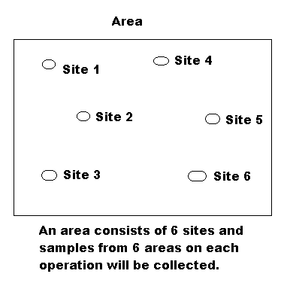
- Complete the top of the Collection Record (next page). The Kit Number is printed on the attached labels. On each of the sample labels, write the State/Operation numbers and a brief description of the sample area. On the form, check the appropriate column for the sample number and area collected. Be sure the Sample number checked on the form matches the number on the label.

- Collect about 2 ounces (~ 2 tablespoons) of manure/slurry from each of six SITES within an AREA and place in one whirlpak bag. Do not collect from heifer environments!

- Express excess air, roll the whirlpak down twice, and secure. Wipe bag and place label on firmly. Do not use the label to seal the bag.

- Place the 6 sample bags back in the gallon-size Ziploc bag provided and cool down with ice packs. Keep cool and, if necessary, replace ice packs so samples are shipped cold. DO NOT freeze samples.

- Ship to ARS, Athens, GA within 24 hours using the supplied Fed Ex airbill.

According to the Paperwork Reduction Act of 1995, no persons are required to respond to a collection of information unless
it displays a valid OMB control number. The valid OMB control number for this information collection is 0579-0205. The time required to complete this information collection is estimated to average .25 hours per response, including the time to review instructions, search existing data resources, gather the data needed, and complete and review the information collected.
NAHMS-310

JAN 2014

Dairy 2014 – Environmental Collection Record

- Collect from Adult Cow Environments Only

Check the appropriate area for the sample collected.
State FIPS: | Operation #: | Primary Collector: | Date: | Kit Number:
2 digits | 4 digits | Initials | (mm/dd/yy)

Area | Sample 1 | Sample 2 | Sample 3 | Sample 4 | Sample 5 | Sample 6
Common alleyway
Common pen, such as loafing barn, open lot / drylot
Exit way from parlor
Floor of holding pen to parlor
Flush water
Gutter cleaner
Lagoon
Manure pit
Manure spreader
Other – Specify:

- Complete the following information

How many people in each category helped with the collection of the environmental samples?
_____ Fed VMO _____ Fed AHT _____ State Gov’t _____ Producer _____ Other (specify in margin)

How many hours did it take everyone to collect and prepare for shipping: ________ hours

How many round-trip hours did it take for everyone to get to the farm and back: ________ hours

