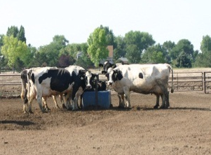

Animal and Plant Health
Inspection Service

Veterinary Services

Dairy 2014

Scorecard

National Animal Health Monitoring System

2150 Centre Ave, Bldg B
Fort Collins, CO 80526

Form Approved
OMB Number 0579-0205
Approval expires: XX/XXXX

NAHMS ID: |  | Pen description:  High production Medium production  Average 60–120 days in milk  121–180 days in milk  Other (specify: )
Date:
# of cows in pen:
Scoring surface Concrete Dirt Other (specify: )
SCORE | Locomotion score |  |  | Hock score
1 | Do not need to score – calculate after scoring |  |  | Do not need to score – calculate after scoring
Total:
2

Total:
3

Total:
SCORE | Body condition score ≤2.25
Yes

Total:
No | Do not need to score—calculate after scoring
Total:

Locomotion score:
1 = Sound (no gait abnormality)
2 = Mildly lame (slight gait abnormality)
3 = Moderate to severely lame (obvious limp in one or more limbs)
Hock score:
1 = No lesion (no swelling or hair loss)
2 = Mild lesion (hair loss but no evidence of swelling)
3 = Severe lesion (swelling and/or ulceration)

According to the Paperwork Reduction Act of 1995, an agency may not conduct or sponsor, and a person is not required to respond to a collection of information unless it displays a valid OMB control number. The valid OMB control number for this information collection is 0579-0205. The time required to complete this information collection is estimated to average
.75 hours per response, including the time for reviewing instructions, searching existing data resources, gathering the data needed, and completing and reviewing the collection of information.
NAHMS-312

JAN 2014

