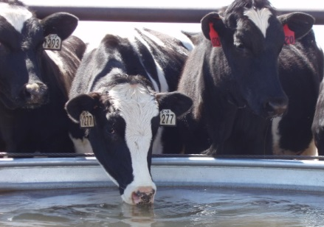
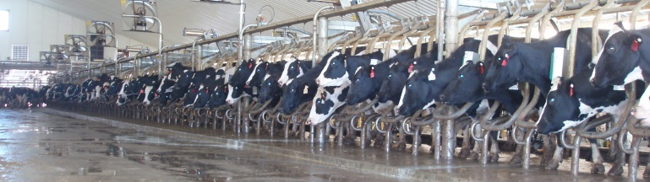
NAHMS Dairy 2014 Study

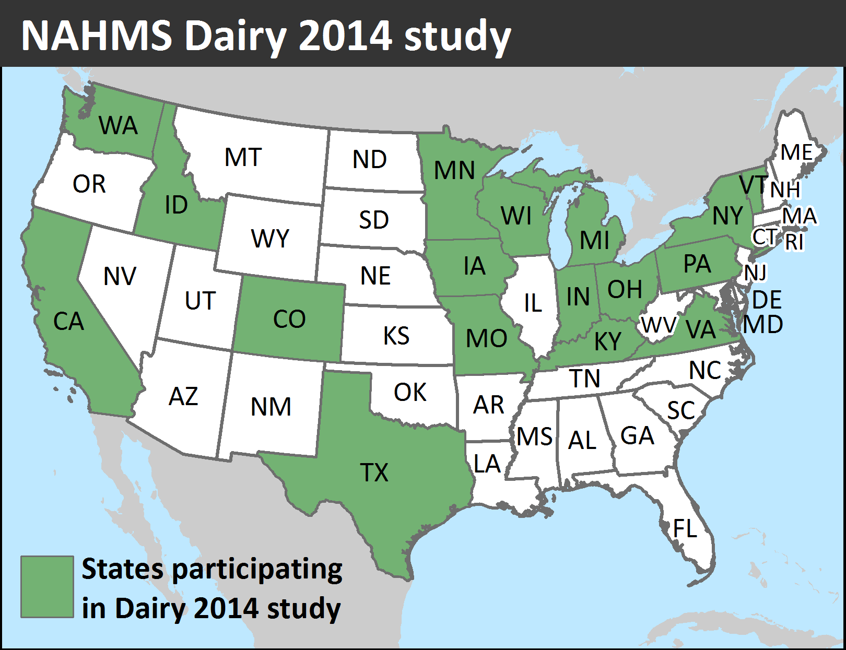
In January 2014, the USDA’s National Animal Health Monitoring System (NAHMS) will launch its fifth national dairy study. Dairy 2014 will take an in-depth look at U.S. dairy operations, and provide the industry with new and valuable information regarding trends in the dairy industry from 1991 to 2014.

Study focus

For the study, NAHMS asked dairy producers, industry stakeholders, and government officials to provide input and define the information needs of the dairy industry. During this process, six study objectives were identified:
- Describe trends in dairy cattle health and management practices.
- Describe management practices and production measures related to animal welfare.
- Estimate the prevalence of lameness, and evaluate housing and management factors associated with lameness.
- Evaluate calf health from birth to weaning.
- Describe antibiotic use and residue prevention methods used to ensure milk and meat quality.
- Estimate the prevalence and antimicrobial resistance patterns of select foodborne pathogens.

“The NAHMS process for many years identified industry benchmarks that provided a snapshot of industry practices that other producers could use to see where they stand relative to their peers. The NAHMS 2014 dairy study provides an opportunity for today's producers to be part of this proud process. We encourage dairymen to participate in this new study, and we look forward to being part of the team that describes the emerging trends and identifies opportunities for years to come.”

—Dr. Cassandra Tucker
Department of Animal Science
University of California, Davis

—Drs. Dan Weary and Nina von Keyserlingk
Animal Welfare Program
University of British Columbia, Canada

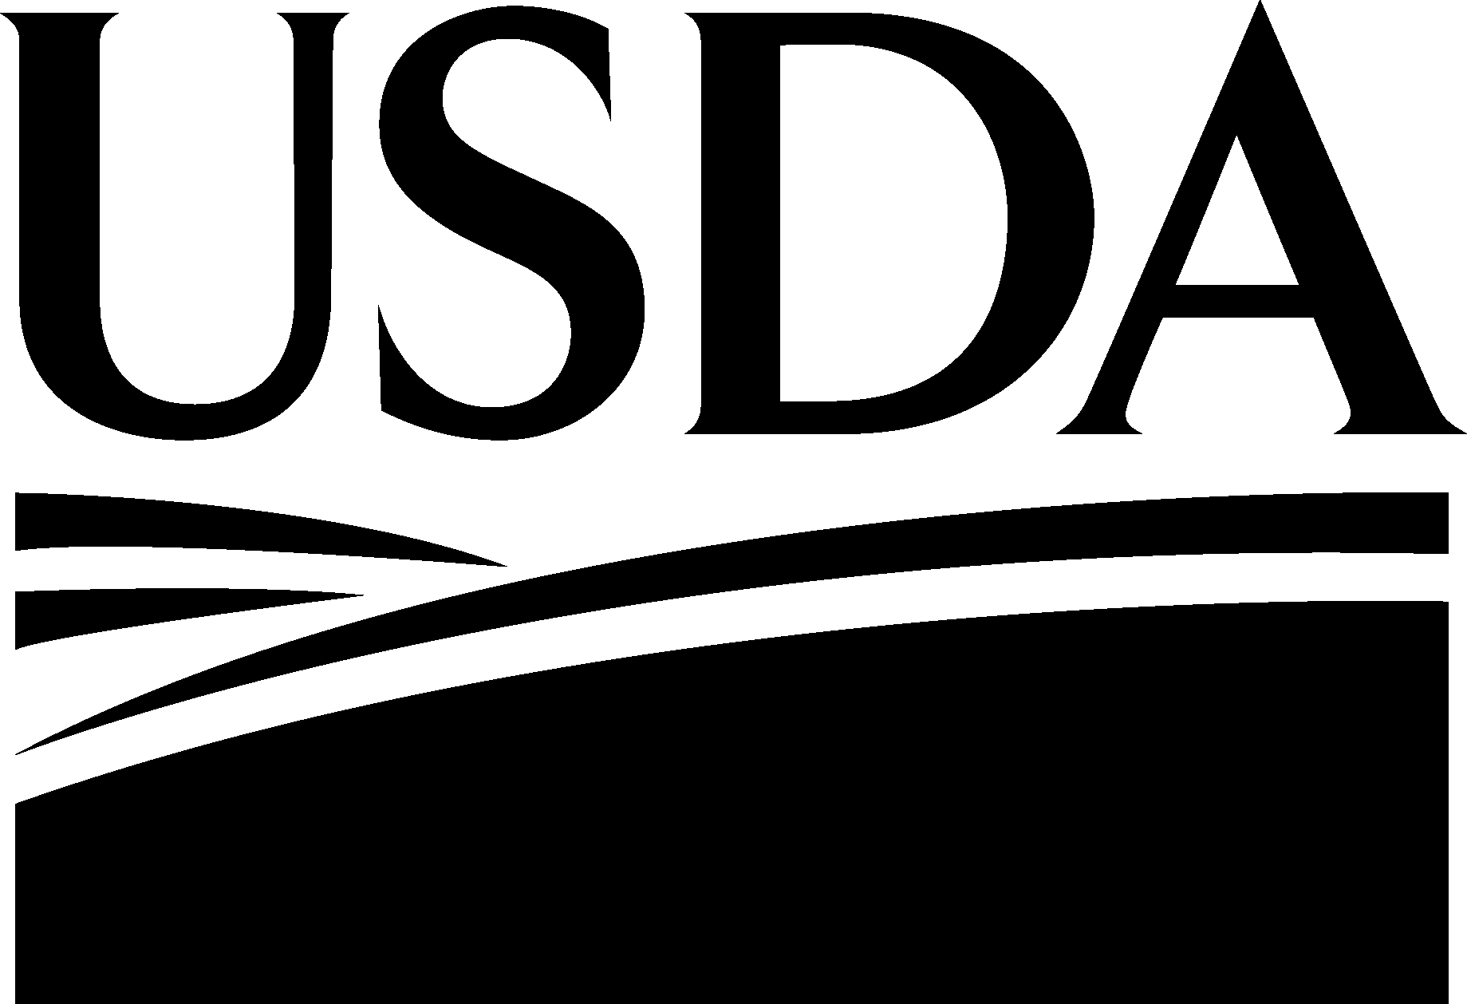
June 2013
June 2013

What your participation involves

In January 2014, representatives from the USDA’s National Agricultural Statistics Service (NASS) will contact selected producers in 17 States. NASS representatives will conduct personal interviews with all participating operations with 30 or more cows. NASS will mail a brief questionnaire to all other participating operations (fewer than 30 cows). Operations that do not respond to the mail-in questionnaire by the deadline will be contacted via telephone by NASS representatives, who will complete the questionnaire at that time.
For operations that are eligible and choose to continue in the study:
- Representatives from USDA’s Veterinary Services will visit from March to May 2014 to administer a second questionnaire, perform a lameness evaluation, and collect milk and fecal samples.
- A subset of these operations will have the opportunity to participate in a year-long calf-monitoring study.
“Our dairy farm participated in the last NAHMS dairy study and I was amazed at the data that was generated. I would urge all dairy producers to participate.”

—Velmar Green, dairy producer
Green Meadow Farms

Benefits of the Dairy 2014 study
“The NAHMS 2014 dairy study focuses on key areas important to dairy producers and consumers alike, including lameness, calf health, animal welfare, and food safety. Current data collected from U.S. dairy farms will be valuable to the dairy industry in establishing benchmarks and opportunities. I encourage all dairy producers to participate in this valuable study; it is a win-win situation for the U.S. dairy industry.”

—Dr. Michael Hutjens
Extension Dairy Specialist
Professor Animal Sciences Emeritus
University of Illinois, Urbana

Participating producers will receive:
- Customized reports describing animal welfare measures, heifer-calf growth and productivity, the risks of drug residues in meat and milk, and how to address these risks. Based on questionnaire responses, these reports will allow producers to compare their practices and productivity measures with those of other dairies. Best management practices/industry goals will also be included.
- The opportunity to improve the health and productivity of heifer calves, from birth to weaning.
- Reports and information sheets.

The dairy industry will benefit from:
- Current and scientifically valid estimates of management practices, disease prevalence, and other information important for trade and the health of the dairy industry (e.g., benchmarking).
- Trends in the implementation of management practices and the prevalence of foodborne pathogens.

“The NAHMS Dairy 2014 study will provide valuable information for our dairy industry, and for our dairy research scientists and advisors. Information from NAHMS Dairy 2014 will help focus research efforts and dollars on dairy animal health and well-being, as well as biosecurity issues of most concern to dairy farmers across our Nation. I hope all producers participating in this study realize the importance of Dairy 2014 to our industry.”

—Karen Jordan, DVM
Dairy producer, Veterinarian
Chair–Animal Health and Welfare Committee of National Milk Producers Federation

A scientific approach

NAHMS collects and reports accurate and useful information on animal health and management in the United States. Since 1990, NAHMS has developed national estimates on disease prevalence and other factors related to the health of U.S. beef cattle, sheep, goat, dairy cattle, swine, equine, poultry, and catfish populations. The science-based results produced by NAHMS have proven to be of considerable value to the U.S. livestock, poultry, and aquaculture industries, as well as other animal health stakeholders.

NAHMS studies are
- National in scope
- Science based
- Statistically valid
- Collaborative
- Voluntary
- Confidential
Confidentiality

Because NAHMS studies rely on voluntary participation, the privacy of every participant is protected. Only those collecting the data know the identity of the respondent. No name or contact information will be associated with individual data, and no data will be reported in a way that could reveal the identity of a participant. Data are presented only in an aggregate manner.
____________________________

For more information, contact:

USDA–APHIS–VS–CEAH–NAHMS
NRRC Building B, M.S. 2E7
2150 Centre Avenue
Fort Collins, CO 80526-8117
970.494.7000
Or visit NAHMS at http://nahms.aphis.usda.gov

#679.0613
____________________________________

The U.S. Department of Agriculture (USDA) prohibits discrimination in all its programs and activities on the basis of race, color, national origin, age, disability, and where applicable, sex, marital status, familial status, parental status, religion, sexual orientation, genetic information, political beliefs, reprisal, or because all or part of an individual’s income is derived from any public assistance program. (Not all prohibited bases apply to all programs.) Persons with disabilities who require alternative means for communication of program information (Braille, large print, audiotape, etc.) should contact USDA’s TARGET Center at (202) 720–2600 (voice and TDD). To file a complaint of discrimination, write to USDA, Director, Office of Civil Rights, 1400 Independence Avenue, S.W., Washington, D.C. 20250–9410, or call (800) 795–3272 (voice) or (202) 720–6382 (TDD). USDA is an equal opportunity provider and employer.

Photographs courtesy of Dr. Jason Lombard

