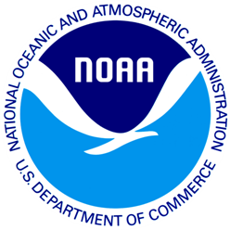

(DATE)

(Proper Name

(Add 1)

(Add 2)

(City), (State) (Zip)

Dear (Proper Name):

A few weeks ago we sent a questionnaire to you about any interactions you may have had with sea turtles. If you have already returned the questionnaire, we thank you. If you have not returned it, we ask you to please complete the enclosed questionnaire and return it as soon as possible.

You have received this survey because you recently participated in a charter boat or head boat recreational fishing trip, and you indicated you would be willing to complete a short follow-up survey. This study is being conducted for the National Oceanic and Atmospheric Administration to learn more about how recreational fishermen interact with sea turtles. Your answers are completely confidential and will be used for statistical purposes only in accordance with the Privacy Act of 1974. Your participation is voluntary.

The enclosed questionnaire will ask you about any interactions you may have had with sea turtles. This survey includes three sections. The first section is specific to charter/head boat fishing trips you have taken in May and June 2013. The second section is specific to charter/head boat trips taken in the last 12 months. The third section asks about sea turtle interactions that have occurred in your lifetime, during any recreational fishing efforts. For the results to be meaningful, we need everybody who receives this survey to complete it and send it back to us.

If you have any questions or comments about this study, we would be happy to talk with you. Please direct any questions about this questionnaire to Jennifer Lee at 1-800-xxx or [Jennifer.Lee@noaa.gov](mailto:Jennifer.Lee@noaa.gov).

Thank you very much for your help with this important study. Please return your completed questionnaire in the postage paid envelope.

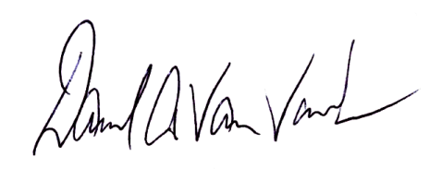Yours sincerely,

Dave Van Voorhees

National Oceanic and Atmospheric Administration

(3b)