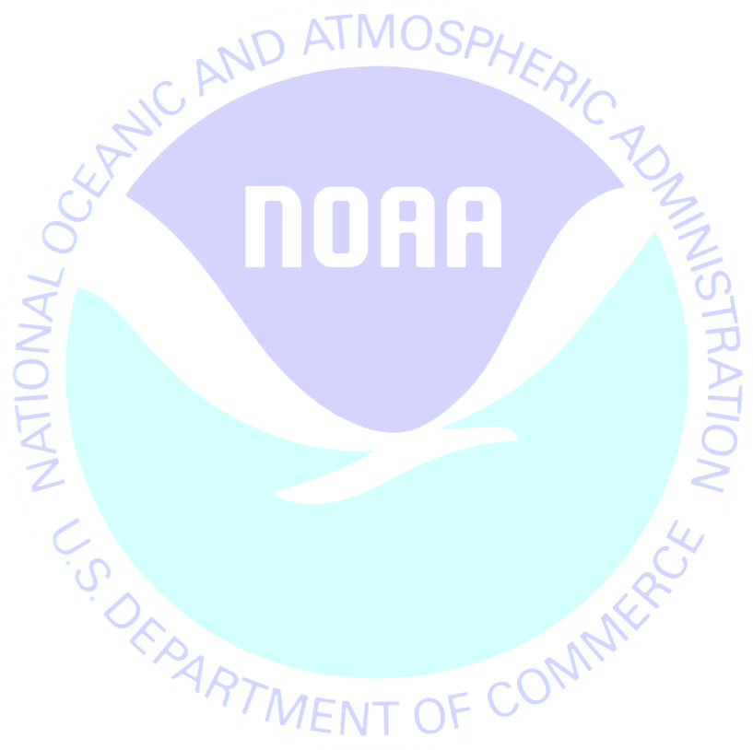
<<DATE>>

Last week we sent you the Survey of Charter and Head boat Angler Interactions with Sea Turtles on behalf of the National Oceanic and Atmospheric Administration (NOAA). If you have already completed and returned the survey, please accept our sincere thanks. If not, I encourage you to do so today.
Information collected in this study will help us to better understand anglers’ interactions with sea turtles and the impact of recreational fishing on natural resources. Please know that your answers are completely confidential and will be used only for this study in accordance with the Privacy Act of 1974.
If you did not receive the survey or need another copy, please call to Jennifer Lee at 1-800-xxxx, or send an email Jennifer.Lee@noaa.gov .
Sincerely,
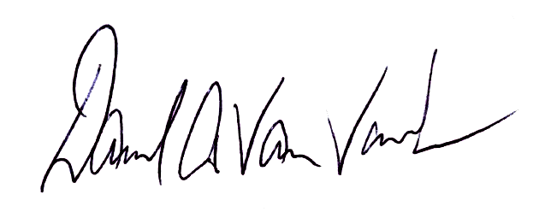

Dave Van Voorhees
Chief, Fisheries Statistics Division
NOAA Fisheries, Office of Science and Technology
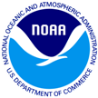
Survey of Angler Interactions with Sea Turtles
55 Wheeler Street Cambridge, MA 02138

<<Name>>
Add1
Add2
City, St Zip

