Qualitative Testing of Creative Materials Focus Group Guide
Items listed in this section would be used during qualitative data collection, specifically during focus groups. These data collection efforts may take place in person, or on the internet.

Insurance Status
- What is your current insurance status? [ING1]
- What are the main reasons you are uninsured/decided to become insured? [ING4]
- How do you feel about your insurance status? [ISG1]

Concept Presentation
Moderator: “I am about to show you some advertising concepts. These concepts are not the final advertisements, so I ask that you consider the information and concept in the advertisement, not the pictures or voices.”
Moderator shows concept. For example:
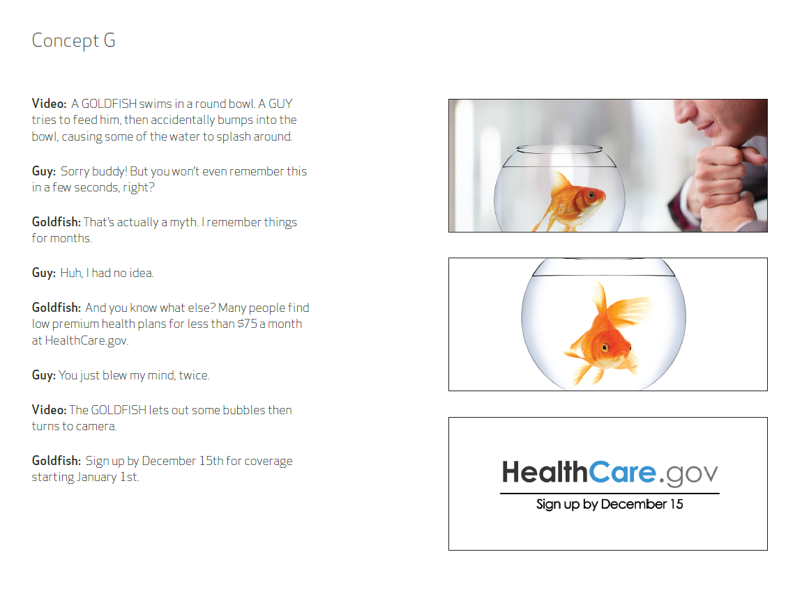

Concept Rating Questionnaire [completed after presentation of concept]
Please rate how much you agree or disagree with the following statements regarding the ad you just reviewed. Use a scale of 1 to 10, with 1 being “strongly disagree” and 10 being “strongly agree”.
- The concept shows that there are health insurance plans available that I could afford. [PE2]
- The concept would make me want to visit www.healthcare.gov to get more information. [PE6]
- The concept would get my attention. [AW2]
- The concept talks about things that are important to me. [PE8]
- The concept has information I find believable. [PE15]
- Write a sentence describing what you think about this concept. [PR4]

Concept Discussion
- Overall, do you like this concept? [PR4]
  - Were there particular things that made it stand out or made it unique? Things like images, scenes, words, etc. [AW2]
- Was there anything you disliked about the ad? [PE2]
  - Was there anything confusing, negative, or inappropriate? [K1B/K1C]
- After seeing this ad, what’s next for you? [PE12]
- Do you think you’d remember this concept if you saw it on TV? What makes it memorable? How does this concept compare to others you are seeing on TV? [PE2]
- What does this concept make you think about? What’s the main reason for that? [PE13]
- How believable is this ad? What don’t you believe in the ad? [PE15]
- How affordable does this concept make plans seem? What part of the concept makes the affordability seem realistic? What part makes it seem unrealistic? [PE2/PE15]
- What would make this concept more believable? [PE15B]
- How does this concept make you feel? What’s the main reason for that? [PE13/PE13A]
- What in this concept captures your attention? What sticks with you the most? [AW2]
- What in this concept feels relevant to you personally? What doesn’t feel relevant to you? [PE8/PE8A]
- What, if anything, does this concept make you want to do? [PE6]
- What specifically about this concept would make you want to visit Healthcare.gov? Is there anything that doesn’t make you want to visit? [PE6]
- How can we improve this ad? What is missing? What would absolutely make you go? [PE7/PE6B]
- In real life, do you think you would have watched this concept all the way through? If not, where would you have stopped watching? [B1]
Process is repeated with up to four more concepts.

Compare & Contrast
- Which concept do you like best? [PR1]
- What do you like about it? [PR6]
- Were there particular things that made it stand out or made it unique? [PR1B]
- What do you dislike about it? [PR6]
- Was there anything confusing, negative, or inappropriate? [K1B/K1C]

Language and Delivery Preferences
- How easy were the concepts presented to you to understand? [PE1]
  - What could make it easier for people to understand this information? [PE1A]
  - What was a particularly difficult concept? [PE1B]
- Many/Some of the concepts used the term “affordability”—what do you think that term means? [PE8B]
- Many/Some of the concepts used the term “monthly premium”—what do you think that term means? [PE8B]
- The concepts shown to you today used different kinds of communication strategies, including <examples: comedic, inspirational, testimonial>. Which strategy did you like best? [PR1]
  - What do you like about it? [PR6]
  - What do you dislike about it? [PR6]
  - Was there anything confusing, negative, or inappropriate about any of the strategies? [K1B/K1C]

Marketplace Advertisements and Information
- How many of you have recently seen any advertisements for Healthcare.gov? [AWG2]
  - Tell me about the ads you’ve seen. [AWG2A]
- What have you recently heard about the Health Insurance Marketplace or the Healthcare Law? [AWG2]
- How does what you have seen or heard impact your likelihood to get health insurance? [ATG5]
- What is your impression of the Health Insurance Marketplace? [PE2]

Awareness and Understanding of Healthcare.gov
- What, if anything, have you recently heard about Healthcare.gov? [AW1]
- How many of you have visited Healthcare.gov? [BG1]
- What was your experience like on the site? [PE2]
- For those who have heard of the site, but have not visited, why didn’t you go there? [B2]
- What would get you to go visit the website? [PE6B]

Intent
- How many of you plan to look for information on health insurance in the next year? [ISG1]
  - Where will you look for that information? [SOI5]
  - How likely would you be to use Healthcare.gov look for that information? [SOI2]
- How many of you plan to enroll in health insurance within the next year? [BG1]
  - Where do you plan to go to find a health insurance plan? (employer-sponsored, direct from insurance companies, Marketplace, etc.) [SOIA]
  - How likely would you be to use Healthcare.gov to enroll in health insurance? [SOI2]
- In your opinion, how important is it to have health insurance? [PG5]
- What have you heard about the tax penalty for not having health insurance? [AW1]
  - Does the tax penalty make it more likely that you will enroll in health insurance? [ATG5]
- Do you plan to enroll in health insurance within the next year? [BG1]

Wrap-Up and Closing
- Those are all the questions I have for you. Do any of you have any final thoughts you would like to add? [G5]

PRA Disclosure Statement
According to the Paperwork Reduction Act of 1995, no persons are required to respond to a collection of information unless it displays a valid OMB control number. The valid OMB control number for this information collection is 0938-1247. The time required to complete this information collection is estimated to average 90 minutes per response [the discussion session duration], including the time to review instructions, search existing data resources, gather the data needed, and complete and review the information collection. If you have comments concerning the accuracy of the time estimate(s) or suggestions for improving this form, please write to: CMS, 7500 Security Boulevard, Attn: PRA Reports Clearance Officer, Mail Stop C4-26-05, Baltimore, Maryland 21244-1850. ***CMS Disclaimer***Please do not send applications, claims, payments, medical records or any documents containing sensitive information to the PRA Reports Clearance Office. Please note that any correspondence not pertaining to the information collection burden approved under the associated OMB control number listed on this form will not be reviewed, forwarded, or retained. If you have questions or concerns regarding where to submit your documents, please contact Kymeiria Ingram at (410)786-8431 or Kymeiria.ingram@cms.hhs.gov.

