Web-based Data Collection Tools for Living Healthier, Living Longer
As noted in Living Healthier Living Longer Part A Supporting Statement, 26 questions (one survey) will be available to participants in electronic PDF-format (form completion) for email or paper format (Attachment Living Healthier Living Longer Health History Questionnaire_Form).
Additionally, 83 questions (two surveys) will be available to participants in an online or paper format. The following links preview the test versions of each of these survey tools:
Survey | Hyperlink
Baseline Survey | Survey Available Here
Study Completion Survey | Survey Available Here
The introduction to each of the online surveys will read as follows:
“Thank you for participating in the Living Healthier, Living Longer [survey title]. This survey will take approximately YYY minutes to complete, and your participation is completely voluntary. If you prefer not to answer a question, skip it and continue on with the survey. We are collecting this information for research purposes only. Your answers will be combined with the answers of others and reported in such a way that no single individual could ever be identified. You can be assured that the information you give us on the survey will be kept private under the guidelines of the Privacy Act.”
Selected Screenshots
The full online survey tools can be access at the hyperlinks provided above; however, the following are select screenshots from each of the survey tools.
Baseline Survey 1
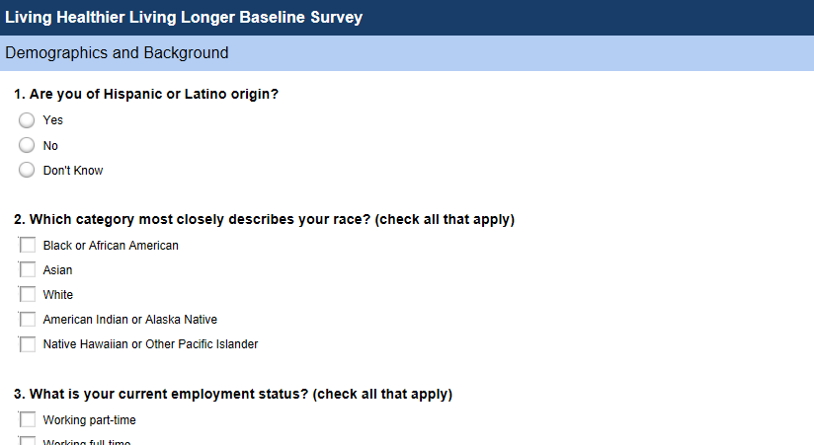

Baseline Survey 2
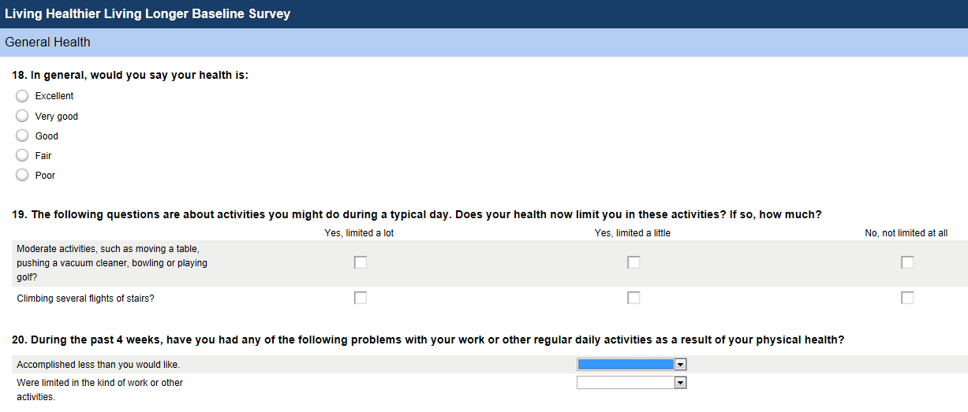
Baseline Survey 3
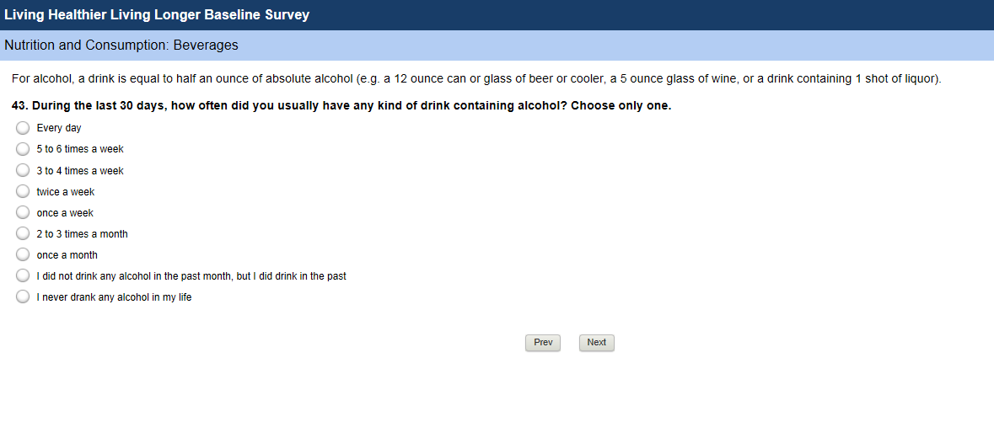

End of Study Survey 1
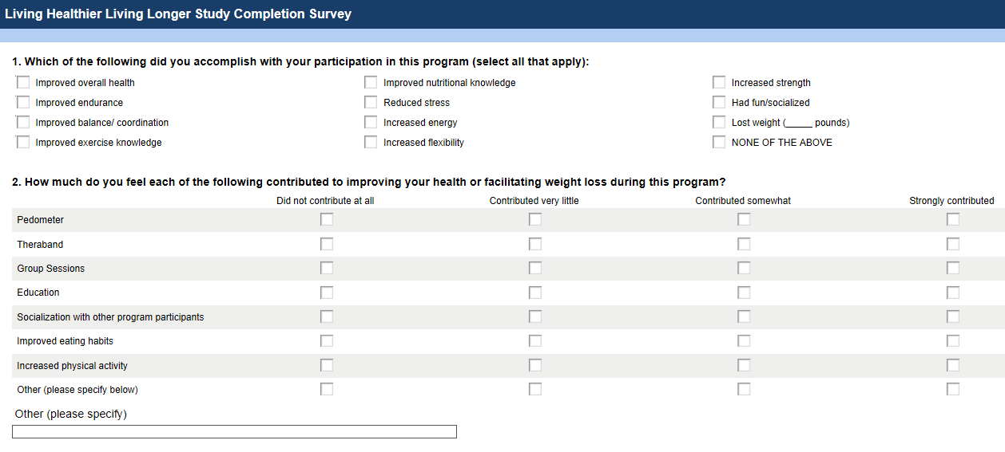
End of Study Survey 2
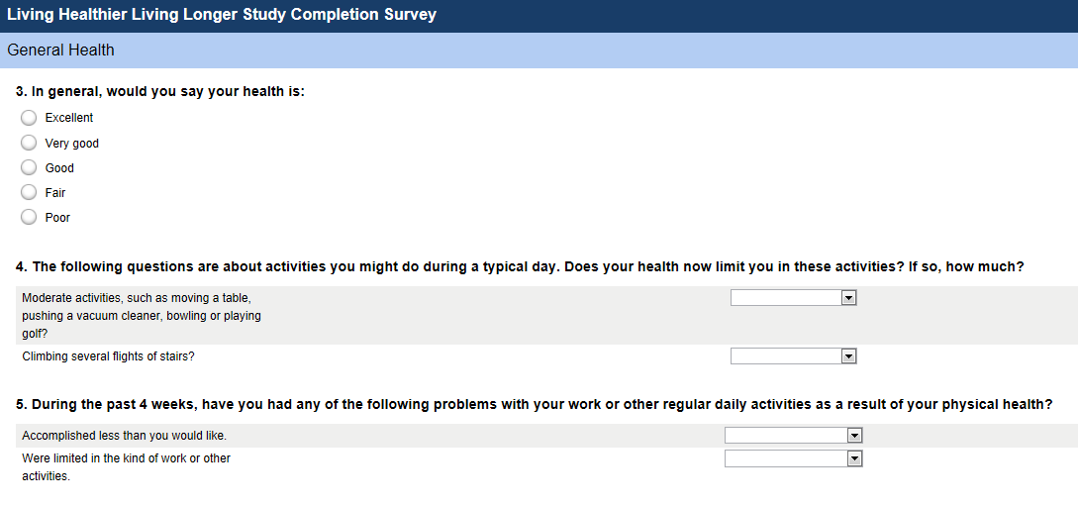

End of Study Survey 3
