Form Approved
OMB No. 0990-____________
Exp. Date 03/01/2015

Measurement name MOVE: Making Our Vitality Evident
OWH Striving for a Healthy Community
LB Adult Women, 18+
Administer At Program Start, Midpoint, and Conclusion

- What is your date of birth (MO/DD/YY)?

_________________

- Which of the following best represents how you think of yourself?
  - Lesbian or gay
  - Straight, that is, not lesbian or gay
  - Bisexual
  - Something else
  - I don’t know the answer

- If you answered “something else” for Question 2:
What do you mean by something else?
  - You are not straight, but identify with another label such as queer, trisexual, omnisexual or pansexual
- You are transgender, transsexual or gender variant
- You have not figured out or are in the process of figuring out your sexuality
- You do not think of yourself as having sexuality
- You do not use labels to identify yourself
  - You mean something else

- Which of the following best describe your present relationship?

      - In a committed relationship with a woman (for example, cohabiting, domestic partnership, or legally married)
      - In a committed relationship with a man (for example, cohabiting, domestic partnership, or legally married)
      - Single, but somewhat involved with a woman, man or both
      - Single, and not involved with anyone

- If in a committed relationship, do you currently live with your partner…

- All or most of the time
- Some of the time
- None of the time
- I do not have a partner

- Are you of Hispanic or Latino origin?
- Yes
- No
- I don’t know
- Refused

- Which one or more of the following would you say is your race?
      - White
      - Black or African American
      - Asian
      - Native Hawaiian or Other Pacific Islander
      - American Indian or Alaska Native

- What is your current employment status?
      - Working part-time (less than 32 hours/week)
      - Working full-time (32 or more hours/week)
      - Unemployed, laid off, on strike
      - Retired
      - Disabled or unable to work
      - In school full time and not working
      - Full-time homemaker

- What is the highest level of education you have completed?
      - Less than high school
      - High school or GED
      - Technical school -- no degree
      - Some college -- no degree
      - 2-year college degree/technical school degree
      - 4-year college degree
      - Post-graduate work or degree

- Do you have any kind of health care coverage, including health insurance, prepaid plans such as HMOs, or government plans such as Medicare?
      - Yes
      - No
      - Don’t know/Not sure

- How “out” are you about your sexuality with your health care providers (doctors, nurses, nutritionists, mental health professionals, personal trainers, etc.)

      - Out to all
      - Out to some
      - Out to a few
      - Out to None
      - N/A

- Have you had at least one menstrual period in the past 12 months? (Please do not include bleedings caused by medical conditions, hormone therapy, or surgeries.)
- Yes
- No

- In the past, have you tried to lose weight?

- No Skip to Question 15
- Yes [Check all methods that apply]

      - Ate less food
      - Switched to foods with lower calories
      - Ate less fat
      - Exercised
      - Skipped meals
      - Used a liquid diet formula such as Slimfast or Optifast
      - Joined a weight loss program such as Weight Watchers, Jenny Craig, or Overeaters Anonymous
      - Followed a special diet such as Dr. Atkins, Pritikin, or specific high protein or low carbohydrate
      - Took diet pills prescribed by a doctor
      - Took other pills, medicines, herbs, supplements not needing a prescription
      - Took laxatives or vomited
      - Drank extra water
      - Other: __________ ___

- Have you ever had weight loss surgery?

      - No
      - Yes; which type of surgery: ____ _____

The next section is about the foods you ate or drank during the past month, that is, the past 30 days, including meals and snacks. Remember to include any sweetened beverages used as a mixer.

- During the past month, how often did you drink regular soda or pop that contains sugar? Do not include diet soda.

________Times per (circle one:) day week month don’t know

- During the past month, how often did you drink sports or energy drinks such as Gatorade, Red Bull and Vitamin Water? Do not include diet or sugar-free kinds.

________Times per (circle one:) day week month don’t know

- During the past month, how often did you drink sweetened fruit drinks such as Kool-aid, cranberry drink and lemonade? Include fruit drinks you made at home and added sugar to. Do not include 100% fruit juices and drinks with things like Splenda or Equal.

________Times per (circle one:) day week month don’t know

- During the past month, how often did you drink coffee or tea with sugar or honey added? Do not include drinks with things like Splenda or Equal. Include pre-sweetened tea and coffee drinks such as Arizona Iced Tea and Frappuccino.

________Times per (circle one:) day week month don’t know

- In the past month, how often did you drink water (including tap, bottled, and carbonated water)?

________Times per (circle one:) day week month don’t know

- Each time you drank water, how much did you usually drink?

      - Less than 6 fl oz (3/4 cup)
      - 8 fl oz (1 cup)
      - 12 fl oz (1 1/2 cups)
      - 16 fl oz (2 cups)
      - More than 20 fl oz (2 1/2 cups)

- During the last 30 days, how often did you usually have any kind of drink containing alcohol? Choose only one.

      - Every day
      - 5 to 6 times a week
      - 3 to 4 times a week
      - twice a week
      - once a week
      - 2 to 3 times a month
      - once a month
      - I did not drink any alcohol in the past month, but I did drink in the past (done with alcohol Q) Skip to Question 25
      - I have never drunk any alcohol in my life Skip to Question 25

- During the last 30 days, how many alcoholic drinks did you have on a typical day when you drank alcohol?

      - 25 or more drinks
      - 19 to 24 drinks
      - 16 to 18 drinks
      - 12 to 15 drinks
      - 9 to 11 drinks
      - 7 to 8 drinks
      - 5 to 6 drinks
      - 3 to 4 drinks
      - 2 drinks
      - 1 drink

- During the last 30 days, how often did you have 4 or more drinks containing any kind of alcohol in within a two-hour period? Choose only one.

      - Every day
      - 5 to 6 days a week
      - 3 to 4 days a week
      - two days a week
      - one day a week
      - 2 to 3 days a month
      - one day a month

- How often on average, do you think you drink the following weekly?

- BEER -- one bottle, glass or can of beer, hard cider, wine cooler or Mike's Hard Lemonade, per week

      - less than 1 drink
      - 1-7 drinks
      - 8-14 drinks
      - 15-21 drinks
      - 22-28 drinks
      - 28 or more drinks

- WINE -- one 5 ounce glass of wine, per week

      - less than 1 drink
      - 1-7 drinks
      - 8-14 drinks
      - 15-21 drinks
      - 22-28 drinks
      - 28 or more drinks

- HARD LIQUOR- one drink equals 1.25 ounces, or large shot, of brandy, whiskey, gin, vodka, liqueurs, cordials, or sake, per week

      - less than 1 drink
      - 1-7 drinks
      - 8-14 drinks
      - 15-21 drinks
      - 22-28 drinks
      - 28 or more drinks

- During the past month, how many times per day, week or month did you drink 100% PURE fruit juices? Do not include fruit-flavored drinks with added sugar or fruit juice you made at home and added sugar to. Only include 100% juice.

________Times per (circle one:) day week month never don’t know

- During the past month, not counting juice, how many times per day, week or month did you eat fruit? Count fresh, frozen or canned fruit.

________Times per (circle one:) day week month never don’t know

- During the past month, how many times per day, week, or month did you eat cooked or canned beans, such as refried, baked, black, garbanzo beans, beans in soup, soybeans, edamame, tofu or lentils. Do NOT include long green beans.

________Times per (circle one:) day week month never don’t know

- During the past month, how many times per day, week or month did you eat dark green vegetables for example broccoli or dark leafy greens including romaine, chard, collard greens or spinach?

________Times per (circle one:) day week month never don’t know

- During the past month, how many times per day, week or month did you eat orange colored vegetables such as sweet potatoes, pumpkin, winter squash or carrots?

________Times per (circle one:) day week month never don’t know

- Not counting questions 26-28, during the past month, about how many times per day, week or month did you eat OTHER vegetables? Examples of other vegetables include tomatoes, tomato juice or V-8 juice, corn, eggplant, peas, lettuce, cabbage and white potatoes that are not fried such as baked or mashed potatoes.

________Times per (circle one:) day week month never don’t know

- How many servings of fruits and vegetables do you usually have per day? (1 serving = 1 medium piece of fruit; ½ cup fresh, frozen or canned fruits/vegetables; ¾ cup fruit/vegetable juice; 1 cup salad greens; or ¼ cup dried fruit)

      - 0 servings per day
      - 1-2 servings per day
      - 3-4 servings per day
      - 5 or more servings per day

- During the last 7 days, on how many days did you do vigorous physical activities?

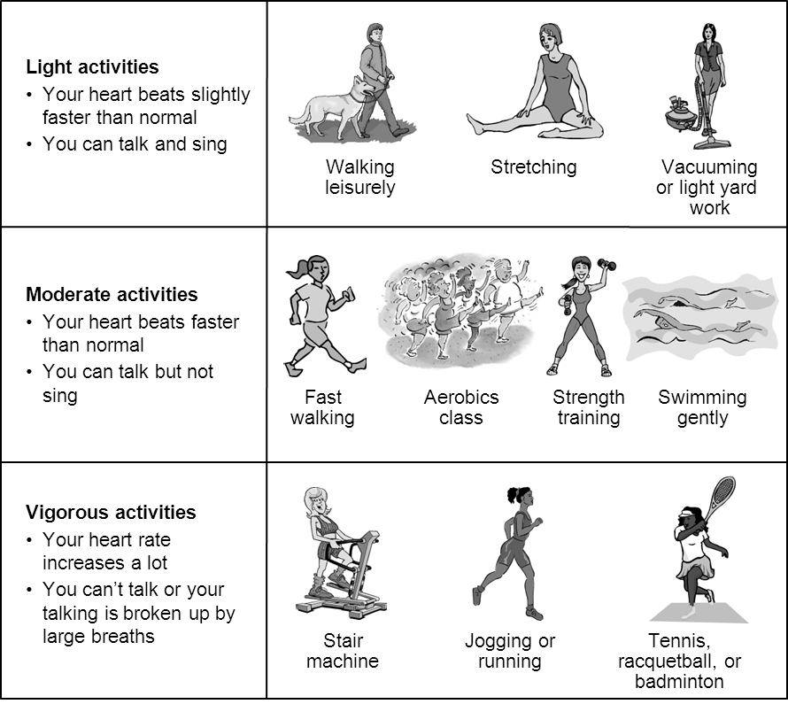

      - ___ days per week
      - No vigorous physical activities Skip to Question 34

- How much time did you usually spend doing vigorous physical activities on one of those days?

      - _ __hours per day
      - _ __minutes per day
      - Don't know/not sure

- During the last 7 days, on how many days did you do moderate physical activities? Do not include walking.

      - _ __days per week
      - No moderate physical activities Skip to Question 36

- How much time did you usually spend doing moderate physical activities on one of those days?

      - _ __hours per day
      - _ __minutes per day
      - Don't know/not sure

- During the last 7 days, on how many days did you walk for at least 10 minutes at a time?

      - _ __days per week
      - No walking Skip to Question 38

- How much time did you usually spend walking on one of those days?

      - _ __hours per day
      - _ __minutes per day
      - Don't know/not sure

- During the last 7 days, how much time did you spend sitting on a week day?

      - _ __hours per day
      - _ __minutes per day
      - Don't know/not sure

- Have you smoked at least 100 cigarettes in your lifetime? (NOTE: 5 packs = 100 cigarettes)

      - Yes
      - No
      - Don’t know/Not sure

- Do you NOW smoke every day, some days or not at all?

- Every day
- Some days
- Not at all
- Don't know/Not sure

- Circle the number of the diagram below that best depicts the approximate outline of your partner

- Don't know
- Don't have a partner

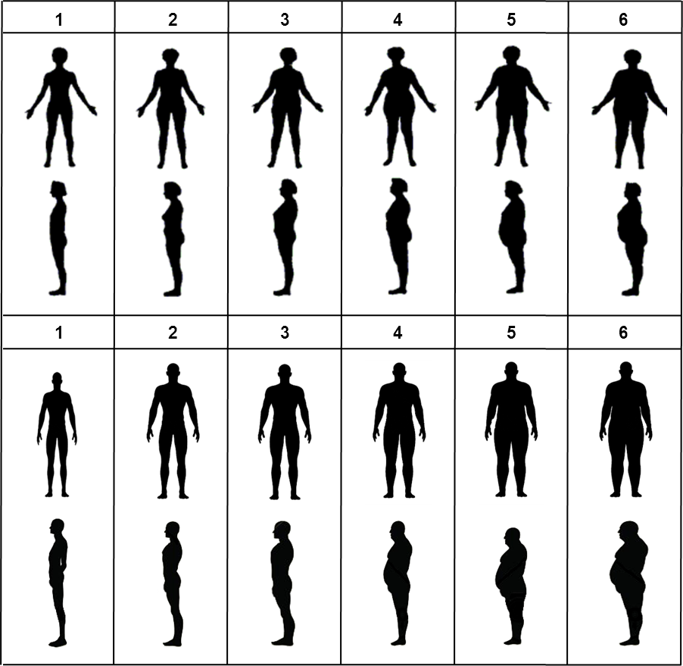
- Do you have a long-term physical or mental impairment that substantially limits one or more major life activities?

- Yes
- No Skip to Question 44

- If yes, in which activities are you limited?

      - caring for myself
      - performing manual tasks
      - walking or standing
      - lifting or reaching
      - seeing
      - hearing, speaking or communicating
      - learning, thinking or concentrating
      - working

- In general, would you say your health is:
- Excellent
- Very good
- Good
- Fair
- Poor

The following questions are about activities you might do during a typical day. Does your health now limit you in these activities? If so, how much?

- Moderate activities, such as moving a table, pushing a vacuum cleaner, bowling or playing golf?
- Yes, limited a lot
- Yes, limited a little
- No, not limited at all

- Climbing several flights of stairs?
- Yes, limited a lot
- Yes, limited a little
- No, not limited at all

During the past 4 weeks, have you had any of the following problems with your work or other regular daily activities as a result of your physical health?

- Accomplished less than you would like.
- No, none of the time
- Yes, a little of the time
- Yes, some of the time
- Yes, most of the time
- Yes, all of the time
- Were limited in the kind of work or other activities
- No, none of the time
- Yes, a little of the time
- Yes, some of the time
- Yes, most of the time .
- Yes, all of the time

For questions 49-50: During the past 4 weeks, have you had any of the following problems with your work or other regular daily activities as a result of emotional problems?

- Accomplished less than you would like.
- No, none of the time
- Yes, a little of the time
- Yes, some of the time
- Yes, most of the time
- Yes, all of the time

- Didn’t do work or other activities as carefully as usual.
- No, none of the time
- Yes, a little of the time
- Yes, some of the time
- Yes, most of the time
- Yes, all of the time

- During the past four weeks, how much did pain interfere with your normal work (including both work outside the home and housework)?
- Not at all
- A little bit
- Moderately
- Quite a bit
- Extremely

These questions are about how you feel and how things have been with your during the past 4 weeks. For each question, please give the one answer that comes closest to the way you have been feeling.

- How much of the time during the past 4 weeks have you felt calm and peaceful?
- All of the time
- Most of the time
- A good bit of the time
- Some of the time
- A little of the time
- None of the time

- How much of the time during the past 4 weeks did you have a lot of energy?
- All of the time
- Most of the time
- A good bit of the time
- Some of the time
- A little of the time
- None of the time

- How much of the time during the past 4 weeks have you felt downhearted and blue?
- All of the time
- Most of the time
- A good bit of the time
- Some of the time
- A little of the time
- None of the time

- During the past 4 weeks, how much of the time has your physical health or emotional problems interfered with your social activities (like visiting friends, relatives, etc.)?
- All of the time
- Most of the time
- Some of the time
- A little of the time
- None of the time
Now we’d like to ask you some questions about how your health may have changed.

- Compared to one year ago, how would you rate your physical health in general now?
- Much better
- Slightly better
- About the same
- Slightly worse
- Much worse

- Compared to one year ago, how would you rate your emotional problems (such as feeling anxious, depressed or irritable) now?
- Much better
- Slightly better
- About the same
- Slightly worse
- Much worse

Please indicate how much you agree with the following statements as they apply to you over the last month. If a particular situation has not occurred recently, answer according to how you think you would have felt.

- I am able to adapt when changes occur.

      - Not true at all (0)
      - Rarely true (1)
      - Sometimes true (2)
      - Often true (3)
      - True nearly all of the time (4)

- I can deal with whatever comes my way.

      - Not true at all (0)
      - Rarely true (1)
      - Sometimes true (2)
      - Often true (3)
      - True nearly all of the time (4)

- I try to see the humorous side of things when I am faced with problems.

      - Not true at all (0)
      - Rarely true (1)
      - Sometimes true (2)
      - Often true (3)
      - True nearly all of the time (4)

- Having to cope with stress can make me stronger.

      - Not true at all (0)
      - Rarely true (1)
      - Sometimes true (2)
      - Often true (3)
      - True nearly all of the time (4)

- I tend to bounce back after illness, injury, or other hardships.

      - Not true at all (0)
      - Rarely true (1)
      - Sometimes true (2)
      - Often true (3)
      - True nearly all of the time (4)

- I believe I can achieve my goals, even if there are obstacles.

      - Not true at all (0)
      - Rarely true (1)
      - Sometimes true (2)
      - Often true (3)
      - True nearly all of the time (4)

- Under pressure, I stay focused and think clearly.

      - Not true at all (0)
      - Rarely true (1)
      - Sometimes true (2)
      - Often true (3)
      - True nearly all of the time (4)

- I am not easily discouraged by failure.

      - Not true at all (0)
      - Rarely true (1)
      - Sometimes true (2)
      - Often true (3)
      - True nearly all of the time (4)

- I think of myself as a strong person when dealing with life's challenges and difficulties.

      - Not true at all (0)
      - Rarely true (1)
      - Sometimes true (2)
      - Often true (3)
      - True nearly all of the time (4)

- I am able to handle unpleasant or painful feelings like sadness, fear, and anger.

      - Not true at all (0)
      - Rarely true (1)
      - Sometimes true (2)
      - Often true (3)
      - True nearly all of the time (4)

FAMILY: Considering the people to whom you are related by birth, marriage, adoption, partners, etc…

- How many relatives do you see or hear from at least once a month?

0 = none
1 = one
2 = two
3 = three or four
4 = five thru eight
5 = nine or more

- How many relatives do you feel at ease with that you can talk about private matters?

0 = none
1 = one
2 = two
3 = three or four
4 = five thru eight
5 = nine or more

- How many relatives do you feel close to such that you could call on them for help?

0 = none
1 = one
2 = two
3 = three or four
4 = five thru eight
5 = nine or more

FRIENDS: Considering all of your friends including those who live in your neighborhood:

- How many of your friends do you see or hear from at least once a month?

0 = none
1 = one
2 = two
3 = three or four
4 = five thru eight
5 = nine or more

- How many friends do you feel at ease with that you can talk about private matters?

0 = none
1 = one
2 = two
3 = three or four
4 = five thru eight
5 = nine or more

- How many friends do you feel close to such that you could call on them for help?

0 = none
1 = one
2 = two
3 = three or four
4 = five thru eight
5 = nine or more

According to the Paperwork Reduction Act of 1995, no persons are required to respond to a collection of information unless it displays a valid OMB control number. The valid OMB control number for this information collection is 0990-xxxx . The time required to complete this information collection is estimated to average 4 minutes per response, including the time to review instructions, search existing data resources, gather the data needed, and complete and review the information collection. If you have comments concerning the accuracy of the time estimate(s) or suggestions for improving this form, please write to: U.S. Department of Health & Human Services, OS/OCIO/PRA, 200 Independence Ave., S.W., Suite 336-E, Washington D.C. 20201, Attention: PRA Reports Clearance Officer

