After completing the Multiple Worksite Report (MWR), respondents are taken to the Industry Verification page. Here they are given a brief description of the Industry Verification as well as a Time of Completion statement. They can select their individual UI accounts in order to verify the industry information.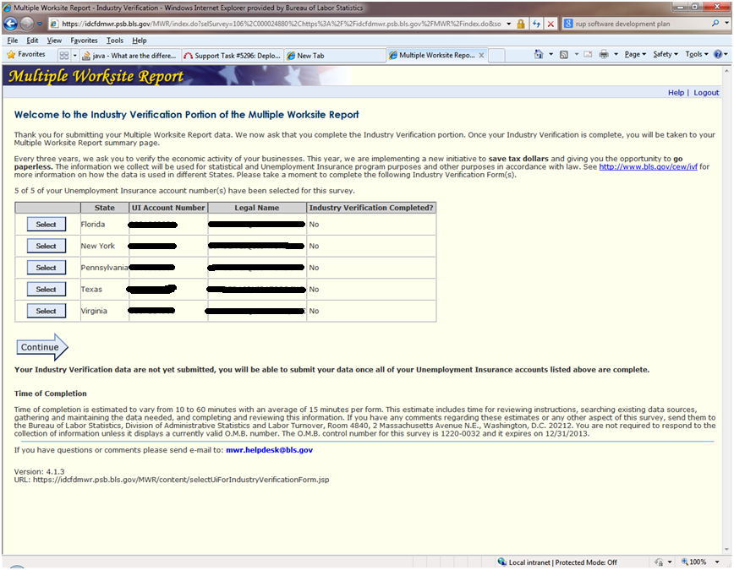
When they select a UI account, they are taken to the page with their state law and OMB number to verify the industry description for each worksite. The paper version of the Industry Verification form also asks that they verify their worksite addresses. However, respondents have already verified the addresses through MWRweb so it is not necessary to ask again. On this page, they can also opt out of web reporting and request a paper form.
An NVMweb voluntary state example is shown below and continued on the next page.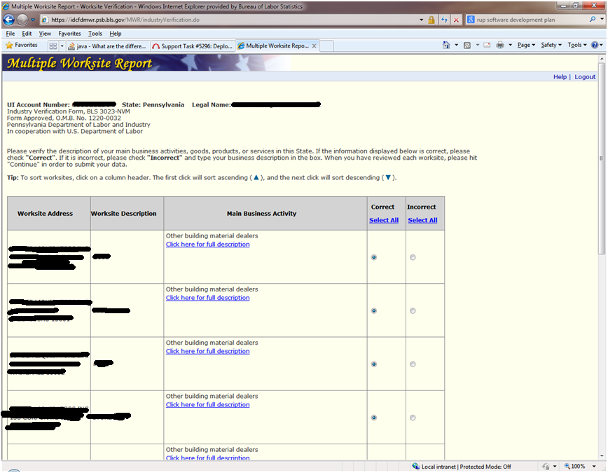
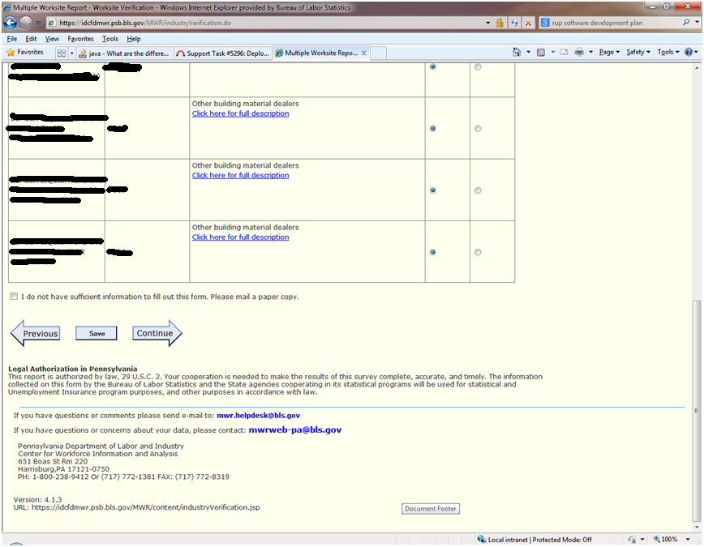
An NVMweb mandatory state example is shown below and continued on the next page.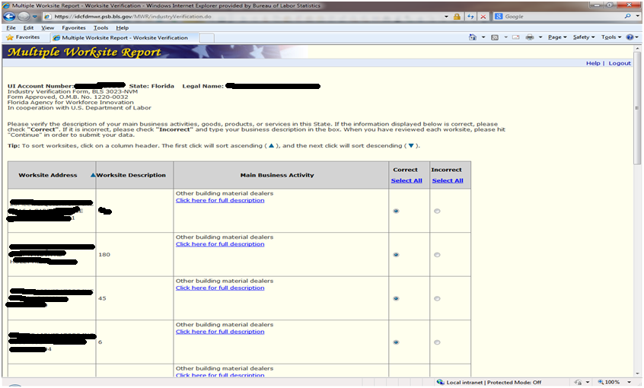
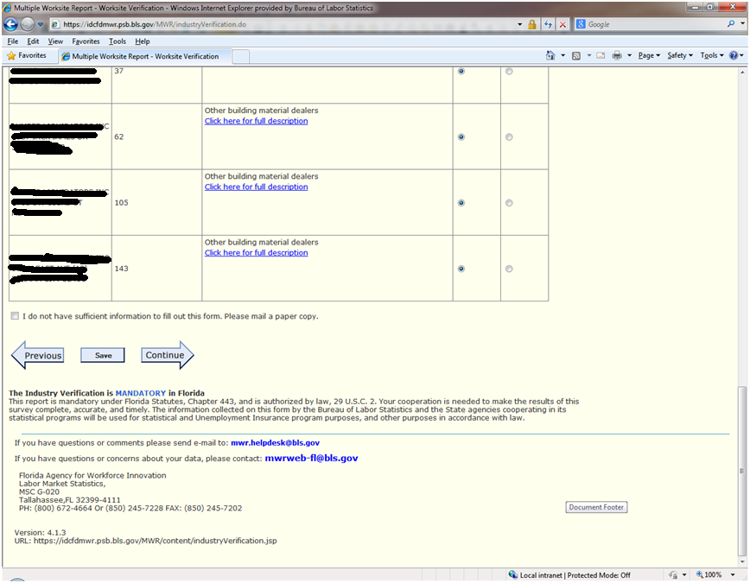
Once respondents complete all of the information for their UI accounts, they are taken to a summary page. On this summary page, respondents can view, edit, and print their data prior to submitting to BLS.