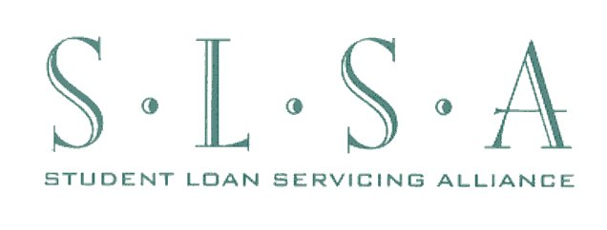

June 14, 2013

Filed electronically at: http://www.regulations.gov

DEPARTMENT OF EDUCATION
Docket No.: ED–2013–ICCD–0051

Agency Information Collection Activities; Comment Request; FFEL/Direct Loan/Perkins Military Service Deferment/Post-Active Duty Student Deferment Request & SCRA Request
The Student Loan Servicing Alliance (SLSA) wishes to thank the Department of Education (ED) for the opportunity to comment on these two forms. And SLSA respectfully urges ED not to proceed with a separate SCRA Request form (SCRA form) but to include a simple request for the SCRA interest rate reduction as part of the Military Service Deferment and Post-Active Duty Student Deferment Request form (MIL form).
ED’s proposed SCRA form does a very thorough job of explaining the qualifications necessary to receive the 6% interest rate cap on federal student loans. However, given that the SCRA interest rate benefit is available to many, many servicemembers, that its eligibility requirements are fairly straightforward, and that it is easy enough to verify active duty status using the borrower’s orders or the Department of Defense’s SCRA website (DoD’s SCRA website), we do not believe that such a thorough explanation is necessary. Lenders and servicers already have SCRA eligibility information on their websites and in written materials, including instructions on how to easily request the 6% interest rate cap. Many provide a sample letter that the borrower has only to download, sign and send in, with attached orders. Other servicers provide instructions to the borrower how to write an SCRA request on a copy of their orders. Using the borrower’s orders and/or the DoD’s SCRA website, it is relatively simple to verify the borrower’s active duty status. Using a three-page form to request the 6% interest rate cap seems overly complex and intimidating and may actually deter borrowers from requesting their SCRA benefit.
Borrowers who are eligible for the MIL deferment are almost always also eligible for the SCRA’s 6% interest rate cap. Including an SCRA request on the MIL form ensures that MIL-eligible borrowers are reminded that they are also eligible for the SCRA interest rate benefit, and to allow those borrowers to apply easily as part of the MIL application. Our goal is to make it as easy as possible for all borrowers who think that they are eligible for the MIL deferments to apply for the SCRA benefit at the same time.
We understand and appreciate ED’s concerns over potential confusion caused by the fact that the eligibility requirements for the MIL deferments are more rigorous than the eligibility requirements for the SCRA interest rate benefit, and can be satisfied using different documentation. However, as stated above, we need to make sure that borrowers who are potentially eligible for the MIL deferments are also applying for the SCRA interest benefit, and including an SCRA request on the MIL form appears to us the best way to accomplish that goal.
It is our understanding that both NCHER and the federal servicers have recommended a single form, but that the formats which they recommend may be slightly different. SLSA endorses the concept of a single form and supports either of the proposed formats.
Even if ED decides to proceed with a stand-alone optional SCRA form, we would respectfully request that an SCRA request be included as part of the MIL form so that borrowers who are eligible for a MIL deferment are reminded to request their SCRA benefit at the same time. Including an SCRA request on the MIL form serves exactly the same purpose as adding an SCRA request to the PUB form; it ensures that borrowers who are eligible for a federal benefit that overlaps with the SCRA benefit are also reminded about and allowed to apply easily for their 6% interest rate cap as well.
Thank you for your consideration of SLSA’s views on this matter.

ED Response: After discussions with other Federal agencies, we no longer believe it is necessary to incorporate an SCRA request into this form or have a standalone version of an SCRA request form. It is very simple to request SCRA benefits. In addition, incorporating the SCRA request into a form that request that the borrower certify their request under the penalties of 20 USC 1097 may not be legally permissible under the SCRA.

