**OMB Request for Approval of USAJOBS Veterans Preference Question Update (as of 7/18/13)**

**Requirement 1:**

Modify the existing “Do you claim Veterans’ Preference?” question as follows:

1. Add a new option for “0-point Sole Survivorship Preference (SSP)” under the “No, I do not claim Veterans’ Preference” option.
2. Update the last option to read, “10 point preference based on widow/widower or mother of a deceased veteran, or spouse or mother of a disabled veteran (XP)”

**Business Reason:**

USAJOBS needs to be able to provide the ability to capture Sole Survivorship Preference immediately in order for agencies to be able to properly account for Veterans’ Preference in hiring. Additional text changes for mother and spouse are based on policy recommendations.

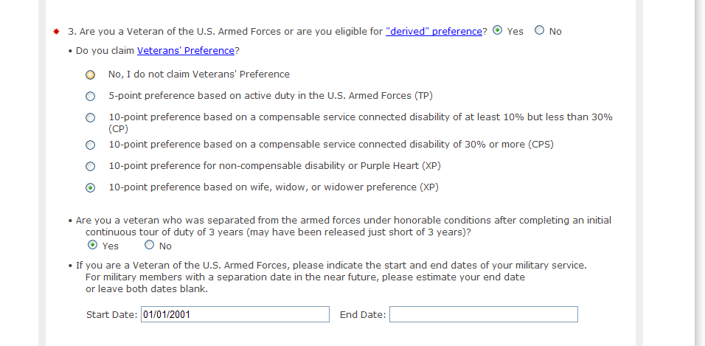

Modify existing “Do you claim Veterans’ Preference?” Question

**Requirement 2:** Modify text on Profile > Hiring Eligibility, Document Upload section to reflect that a DD-214 is no longer required for all of those claiming veterans preference.

Text will now read, “When claiming veterans’ preference, preference eligibles must provide a copy of their DD 214, *Certificate of Release or Discharge from Active Duty*, or other acceptable documentation.  Applicants claiming 10 point preference will need to submit an [SF 15, *Application for 10-point Veterans' Preference*.](http://www.opm.gov/forms/pdf_fill/SF15.pdf)  For current service members who have not yet been discharged, a certification letter of expected discharge or release from active duty within 120 days under honorable conditions is required at the time of application.  Ensure your documentation reflects the character of discharge.”

**Business Reason:**

Not everybody is required to submit a DD-214 or other evidence of discharge, because there is now a new statutory provision permitting individuals who anticipate being honorably discharged shortly to provide a certification of that fact instead.  We need to explain that for current service members (who have not yet been discharged) it is sufficient to attach a certification of expected discharge or release from active duty within 120 days under honorable conditions.

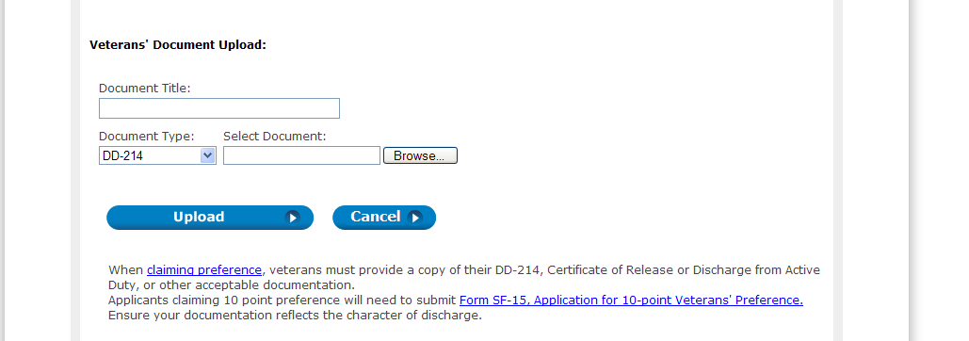

Modify Veteran Document upload text to no longer require DD-214