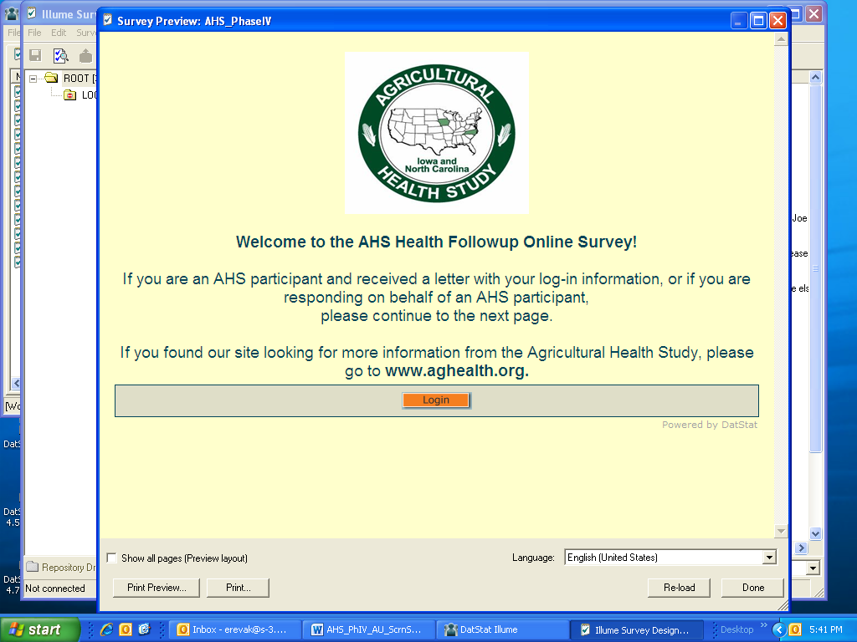

Attachment 25.1: Phase IV Health Follow-Up CAWI Participant Introductory Interview Script

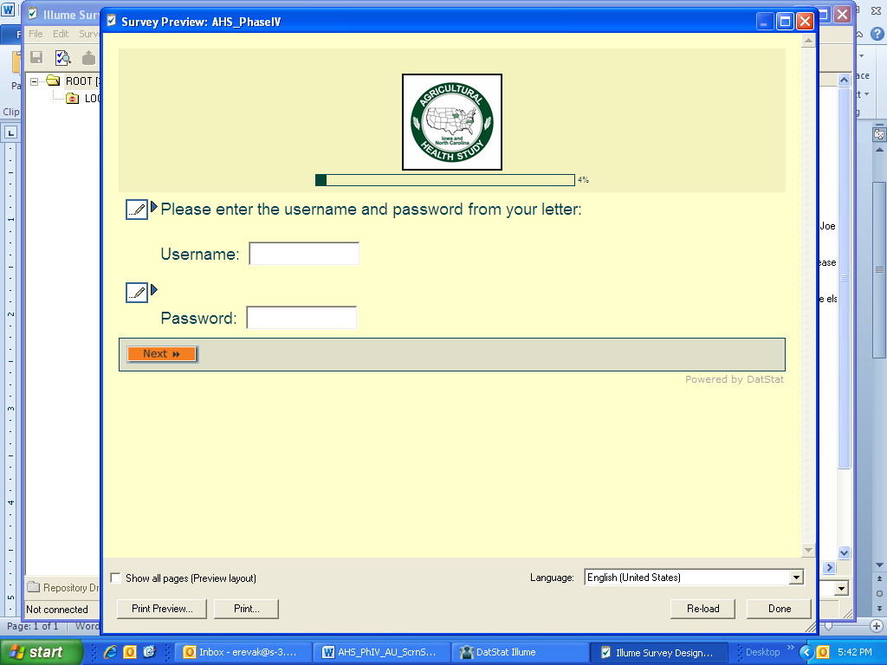

**OMB No.: 0925-0406**

**Expiration Date: xx/xx/2016**

Collection of this information is authorized by The Public Health Service Act (42 USC 285l). Rights of study participants are protected by The Privacy Act of 1974. Participation is voluntary, and there are no penalties for not participating or withdrawing from the study at any time. Refusal to participate will not affect your benefits in any way. The information collected in this study will be kept private to the extent provided by law. Names and other identifiers will not appear in any report of the study. Information provided will be combined for all study participants and reported as summaries. You are being contacted by mail to complete this online health follow-up survey because as a member of the Agricultural Health Study your continued involvement can help us learn more about how agricultural and environmental factors may affect the health of farmers and their families.

Public reporting burden for this collection of information is estimated to average 25 minutes per response, including the time for reviewing instructions, searching existing data sources, gathering and maintaining the data needed, and completing and reviewing the collection of information. **An agency may not conduct or sponsor, and a person is not required to respond to, a collection of information unless it displays a currently valid OMB control number.** Send comments regarding this burden estimate or any other aspect of this collection of information, including suggestions for reducing this burden to: NIH, Project Clearance Branch, 6705 Rockledge Drive, MSC 7974, Bethesda, MD 20892-7974, ATTN: PRA (0925-0406). Do not return the completed form to this address.

