The Retirement Estimator (RE)
and
The Spanish Retirement Estimator (SRE)
Production Screens
March 2012
Table of Contents

1.0 RETIREMENT ESTIMATOR SCREENS 4
1.1 ACU – Terms for Use of Online Services 4
1.2 ACU - Information We Need web page 5
1.3 ACU – Verify Your Information web page 6
1.4 RP003 - Create Your Retirement Benefit Estimate web page 7
1.5 RP004 - Your Retirement Benefit Estimate web page 8
1.6 RP005 - Create Additional Retirement Scenarios web page 9
1.7 RP006 - Your Additional Retirement Scenarios web page 10
1.8 RP007 - Your Retirement Benefit Estimate – Printer Friendly Version web page 11
1.9 MSG027 - Unable To Complete Your Request At This Time web page 12
1.10 MSG028 - This Service Is Not Available At This Time web page 12
1.11 MSG045 - This Retirement Estimator Application is scheduled to shut down for the day within a half-hour web page 13
1.12 MSG067 - We Cannot Process Your Request web page 13
1.13 MSG073 - How To Print/Save This Page 14
1.14 MSG105 - We Cannot Process Your Request at This Time web page 14
1.15 MSG005 - You are About to Leave the Retirement Estimator web page 15
2.0 Spanish Retirement Estimator Screens 16
2.1 ACU – Condiciones de uso de los servicios por Internet 16
2.2 ACU – Información que necesitamos 17
2.3 ACU – Verifique su informacíon 18
2.4 SRP003 - PREPARE SU ESTIMACIÓN DE BENEFICIOS POR JUBILACIÓN WEB PAGE 19
2.5 SRP004 - Su estimación de beneficios por jubilación web page 20
2.6 SRP005 - Calcule otros posibles escenarios de jubilación web page 21
2.7 SRP006 - ESCENARIOS ADICIONALES PARA SU JUBILACIÓN WEB PAGE 22
2.8 SRP007 - SU ESTIMACIÓN DE BENEFICIOS POR JUBILACIÓN - VERSIÓN PARA IMPRIMIR WEB PAGE 23
2.9 SMSG027 - No es posible procesar su solicitud en este momento web page 24
2.10 SMSG028 - Este servicio no está disponible en este momento web page 24
2.11 SMSG045 - El calculador de beneficios por jubilación está programado para cerrarse durante el resto del día dentro de media hora web page 24
2.12 SMSG067 - No podemos procesar su solicitud web page 25
2.13 SMSG073 - Cómo imprimir/guardar esta página web page 26
2.14 SMSG105 - No podemos procesar su solicitud en este momento web page 27
2.15 SMSG005 - Está a punto de cerrar el calculador de beneficios por jubilación web page 28

RETIREMENT ESTIMATOR SCREENS

ACU – Terms for Use of Online Services
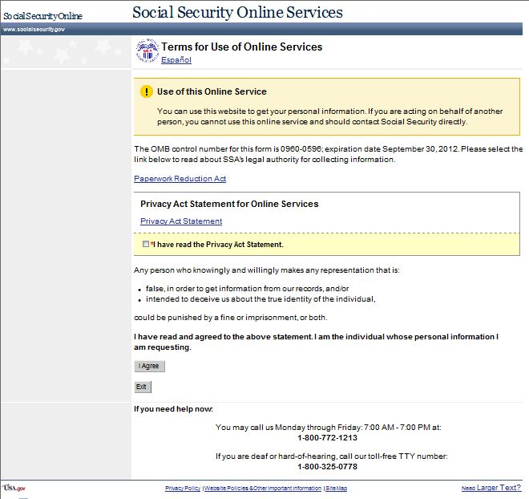

ACU - Information We Need web page
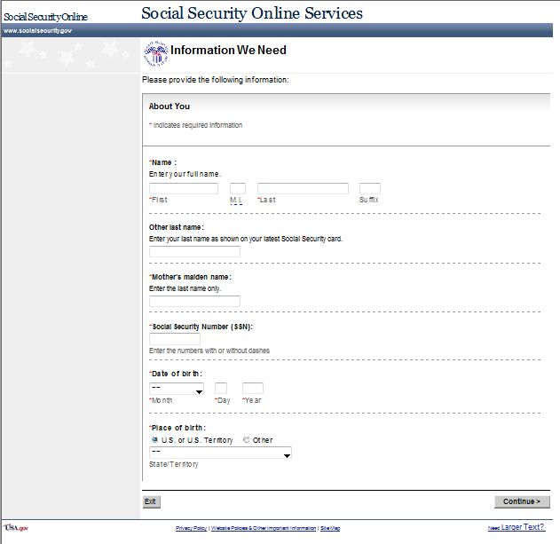

ACU – Verify Your Information web page

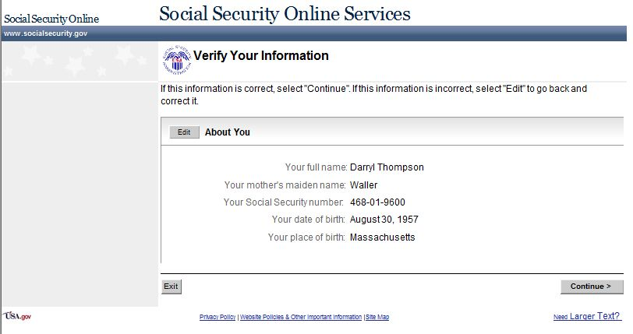

RP003 - Create Your Retirement Benefit Estimate web page
The Create Your Retirement Benefit Estimate web page allows users to receive a snapshot of estimated retirement benefits.
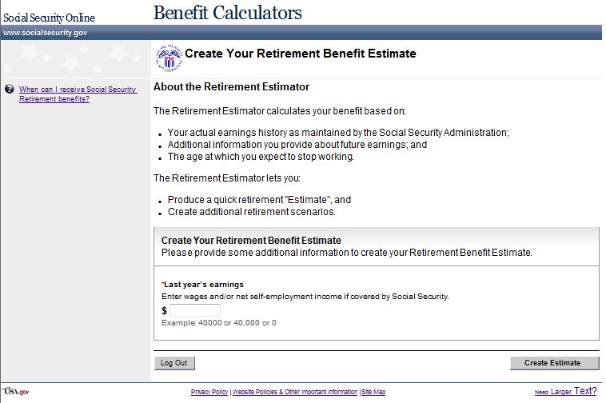

RP004 - Your Retirement Benefit Estimate web page
The Your Retirement Benefit Estimate web page displays the user’s estimated results and provides the option to create additional scenarios. This web page can be accessed from the following:
- Via “Create Estimate” button on RP003, and
- Via “< Previous” button on RP005.
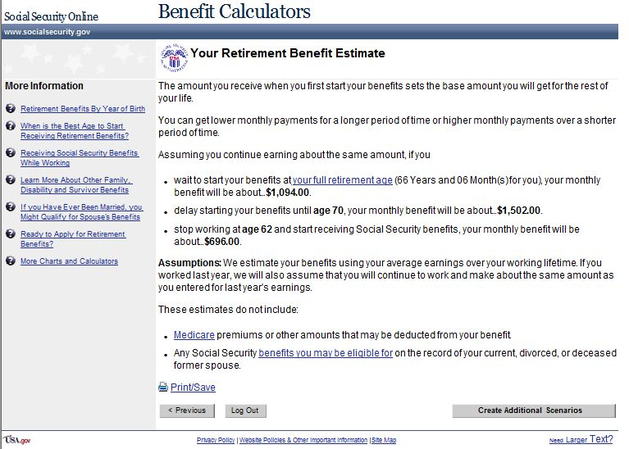

RP005 - Create Additional Retirement Scenarios web page
The Create Additional Retirement Scenarios web page allows the user to create scenarios using different retirement ages and earnings.
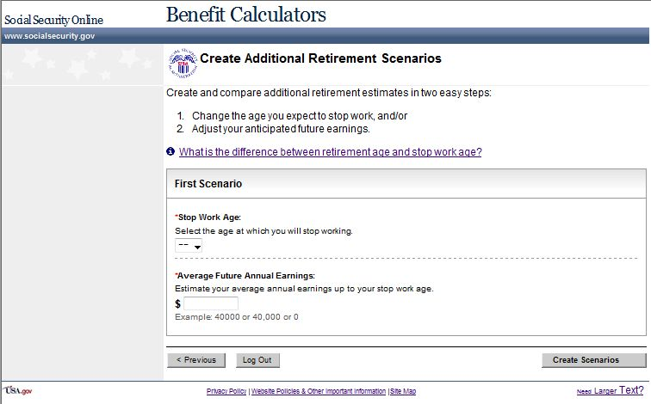

RP006 - Your Additional Retirement Scenarios web page
Note: RP006 layout displays the UEF focus point feature on the “Scenario Results” table header.
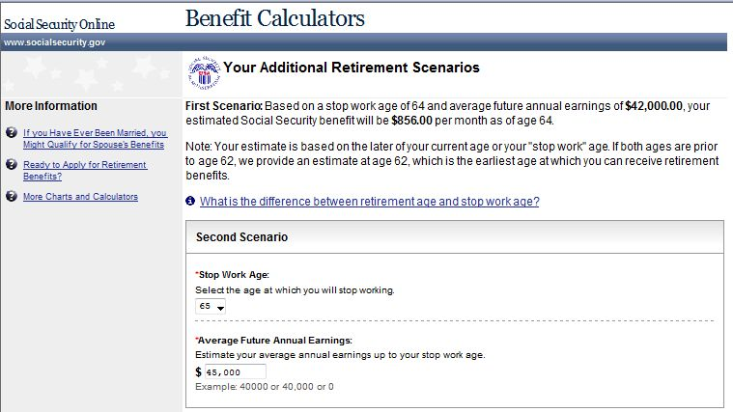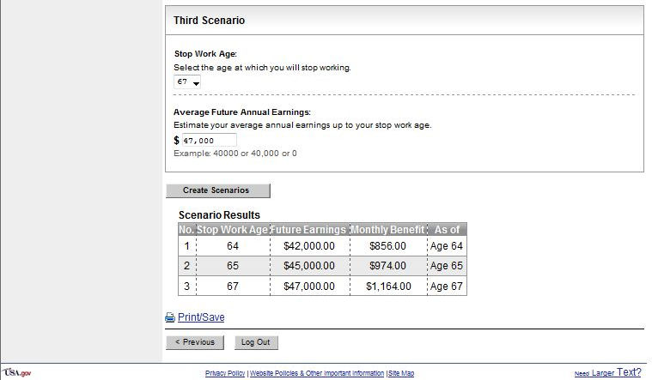

RP007 - Your Retirement Benefit Estimate – Printer Friendly Version web page
The Your Retirement Benefit Estimate – Printer Friendly Version web page allows users to print their retirement estimate in a printer-friendly version. Access the web page via the Print/Save hyperlink on RP004 or RP006.
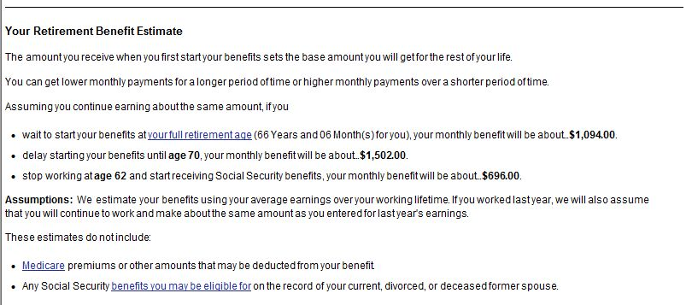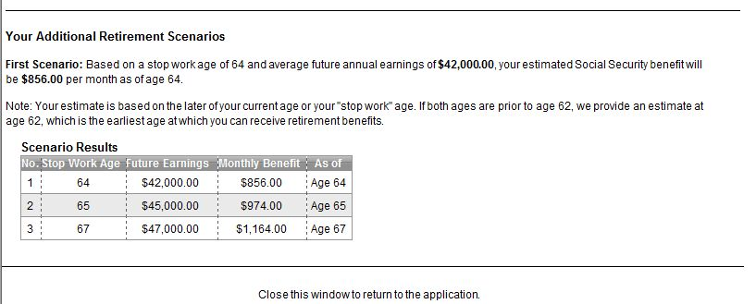

MSG027 - Unable To Complete Your Request At This Time web page
The Unable to Complete Your Request at this Time web page displays after a request cannot be process due to a system error. This web page informs users that the request cannot be processed at this time.
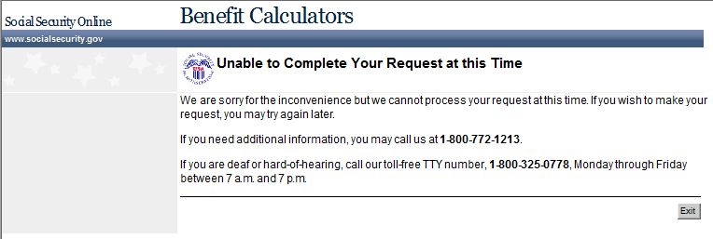

MSG028 - This Service Is Not Available At This Time web page
The This Service Is Not Available At This Time web page displays when a request is made during unavailable hours (hours other than what is displayed in MSG028). This web page informs users that the service they are requesting is not available at that time.
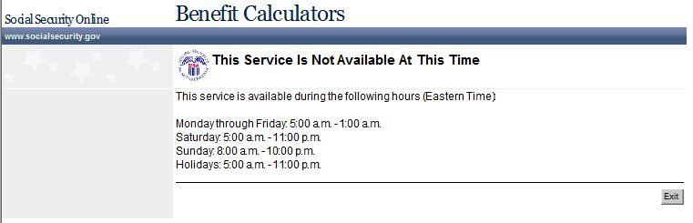

MSG045 - This Retirement Estimator Application is scheduled to shut down for the day within a half-hour web page
The This Retirement Estimator Application is scheduled to shut down for the day within a half-hour web page displays when the RE will be shutting down within half an hour.
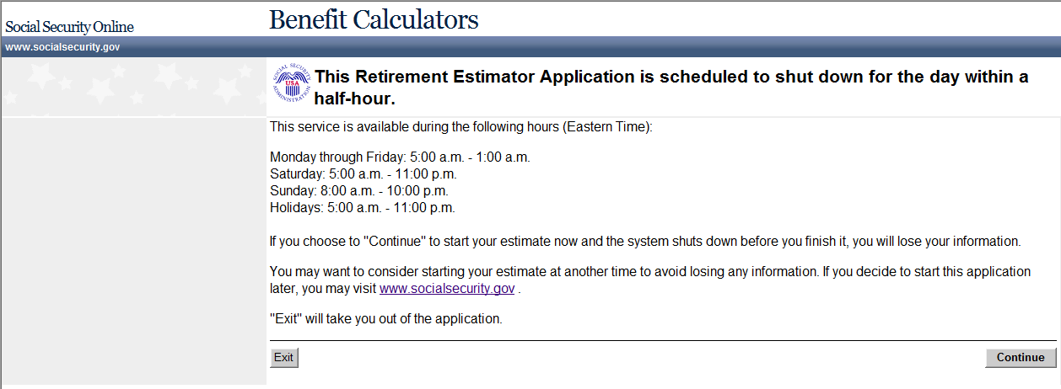

MSG067 - We Cannot Process Your Request web page
The We Cannot Process Your Request web page alerts users that the system is not able to continue with their request. This web page displays when any application specific permanent exclusion occurs.
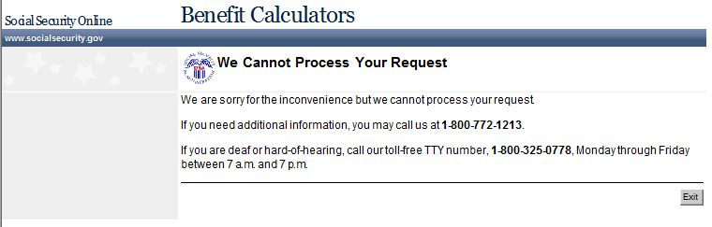

MSG073 - How To Print/Save This Page
The How To Print/Save This Page web page informs users how to print/save on the RP007-Your Retirement Estimate – Printer Friendly Version web page.
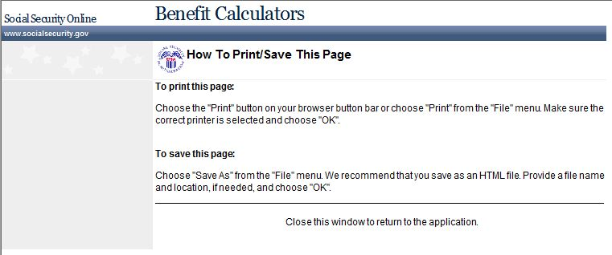

MSG105 - We Cannot Process Your Request at This Time web page
The We Cannot Process Your Request at This Time web page alerts users that SSA is unable to continue with their request. This web page displays when PEBES exclusion occurs on RP003.
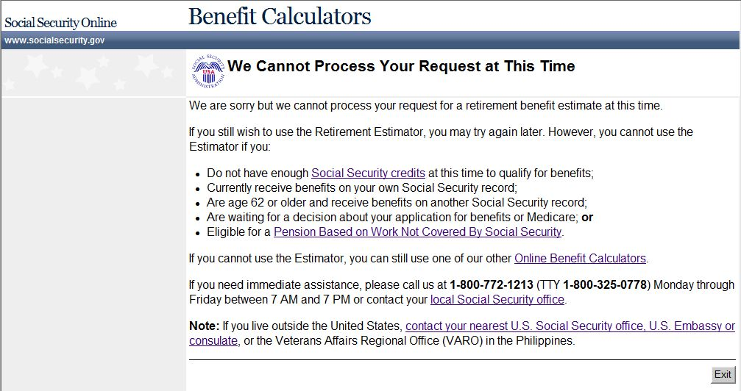

MSG005 - You are About to Leave the Retirement Estimator web page
The You are About to Leave the Retirement Estimator web page alerts users that they have chosen to leave RE and begin a new Retirement Benefit (iClaim) application. This web page displays when selecting the Ready to Apply for Retirement Benefits? link on the RP004 and RP006 web pages.
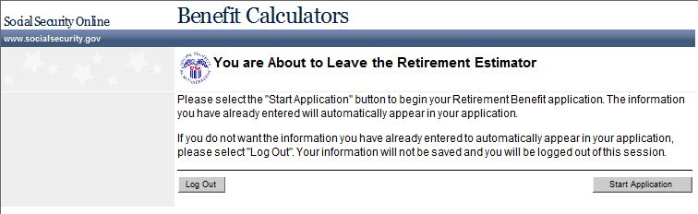

Spanish Retirement Estimator Screens

ACU – Condiciones de uso de los servicios por Internet
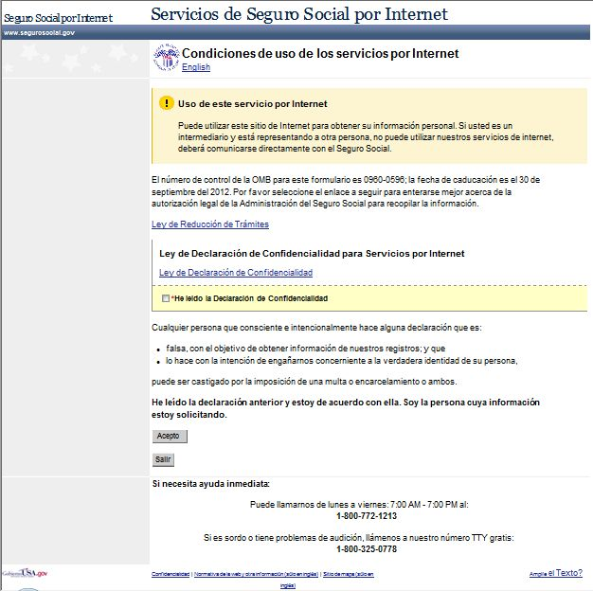

ACU – Información que necesitamos
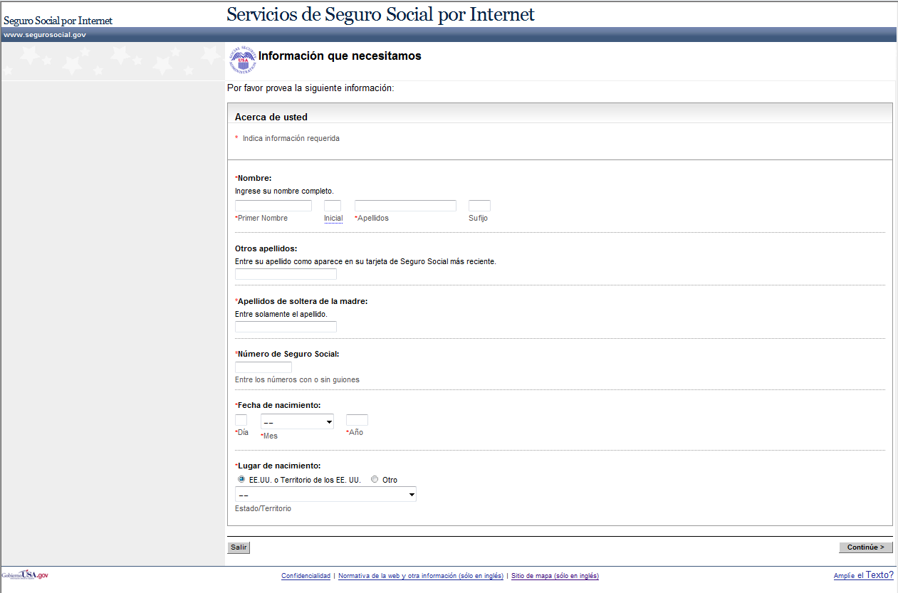

ACU – Verifique su informacíon
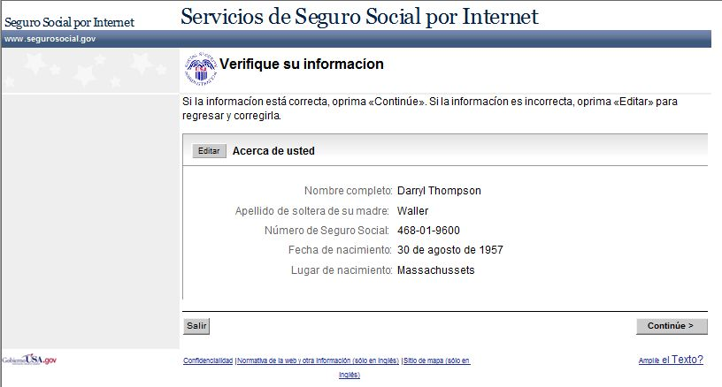

SRP003 - PREPARE SU ESTIMACIÓN DE BENEFICIOS POR JUBILACIÓN WEB PAGE
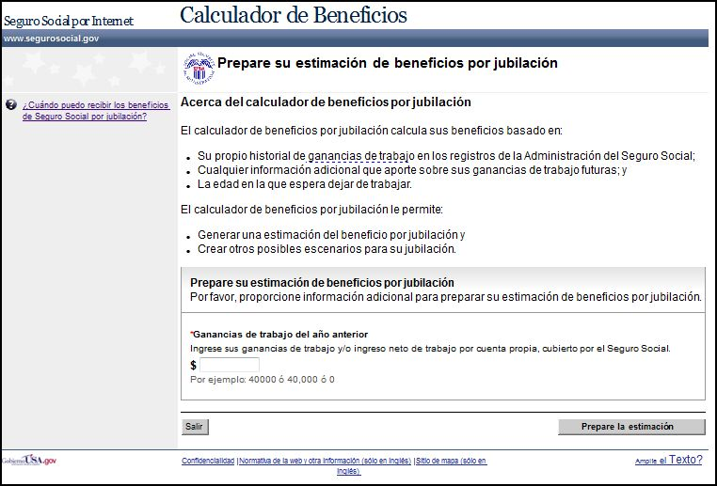

SRP004 - Su estimación de beneficios por jubilación web page
The Su estimación de beneficios por jubilación (Your Retirement Benefit Estimate) web page displays the user’s estimated results and provides the option to create additional scenarios. This web page can be reached as follows:
- Via “Prepare la estimación” (Create Estimate) button on SRP003, and
- Via “< Anterior” (<Previous) button on SRP005.

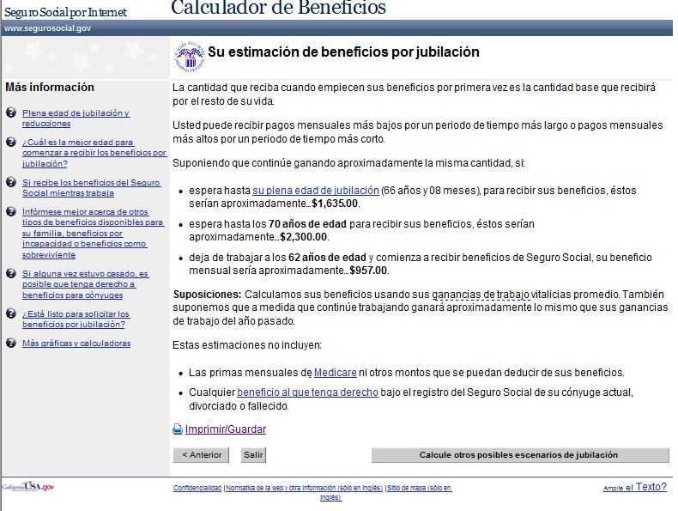

SRP005 - Calcule otros posibles escenarios de jubilación web page
The Calcule otros posibles escenarios de jubilación (Create Additional Retirement Scenarios) web page allows the user to create scenarios using different retirement ages and earnings.
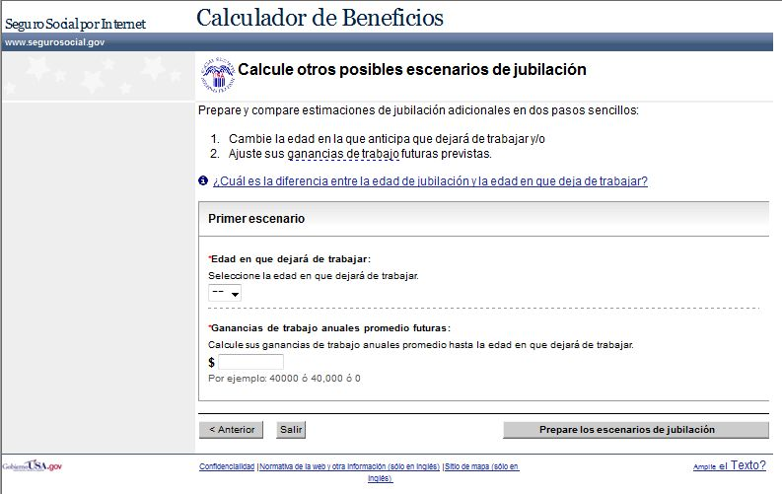

SRP006 - ESCENARIOS ADICIONALES PARA SU JUBILACIÓN WEB PAGE
The Escenarios adicionales para su jubilación (Your Additional Retirement Scenarios) web page allows users to create two more retirement scenarios based on their ages and earnings when they retire.
Note: SRP006 layout displays the UEF focus point feature on the “Resultados de los escenarios” table header.
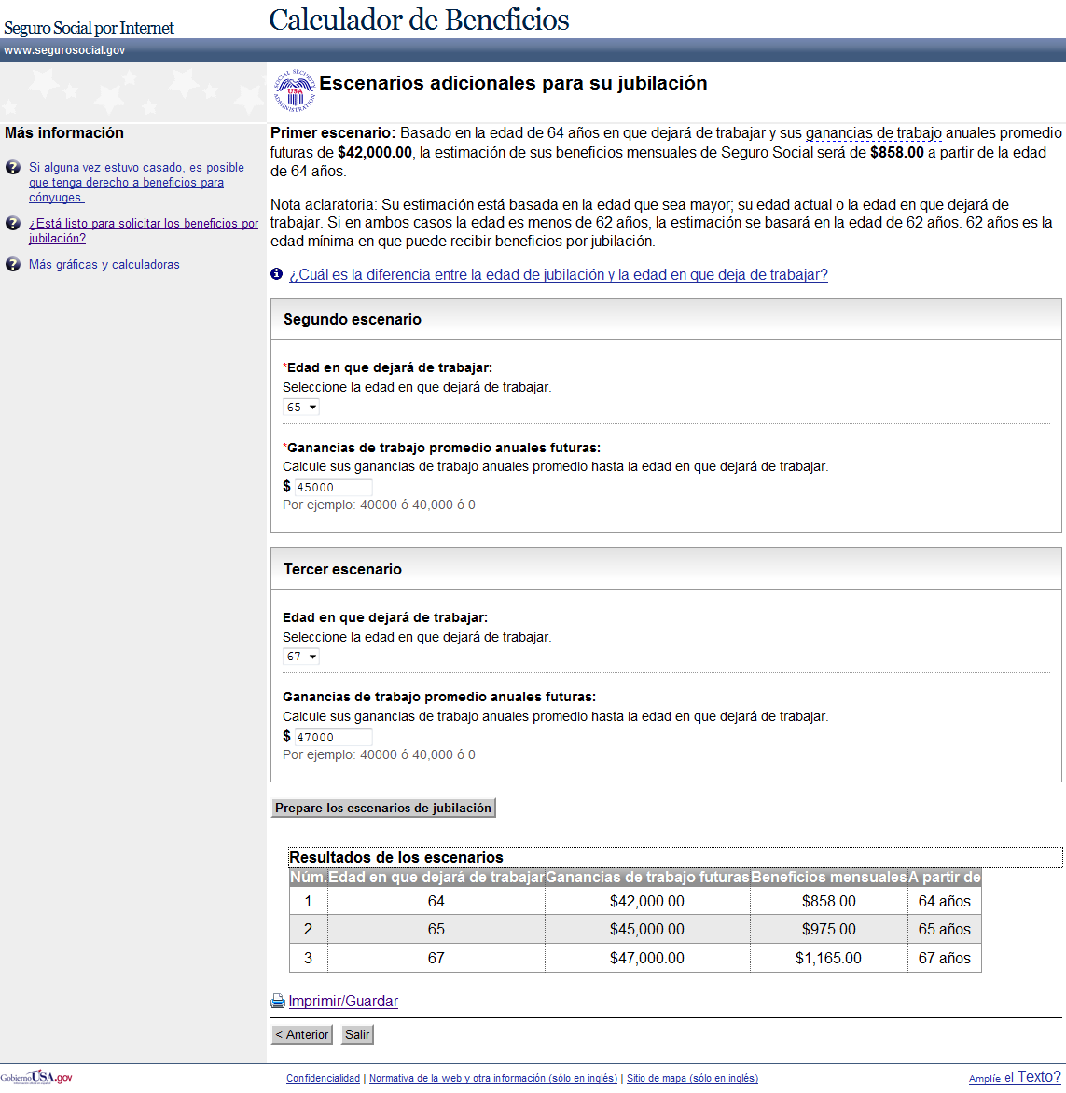

SRP007 - SU ESTIMACIÓN DE BENEFICIOS POR JUBILACIÓN - VERSIÓN PARA IMPRIMIR WEB PAGE
The Su estimación de beneficios por jubilación - Versión para imprimir (Your Retirement Benefit Estimate – Printer Friendly Version) web page allows users to print their retirement estimate in a printer-friendly version. Access the web page via the Imprimir/Guardar hyperlink on SRP004 or SRP006.

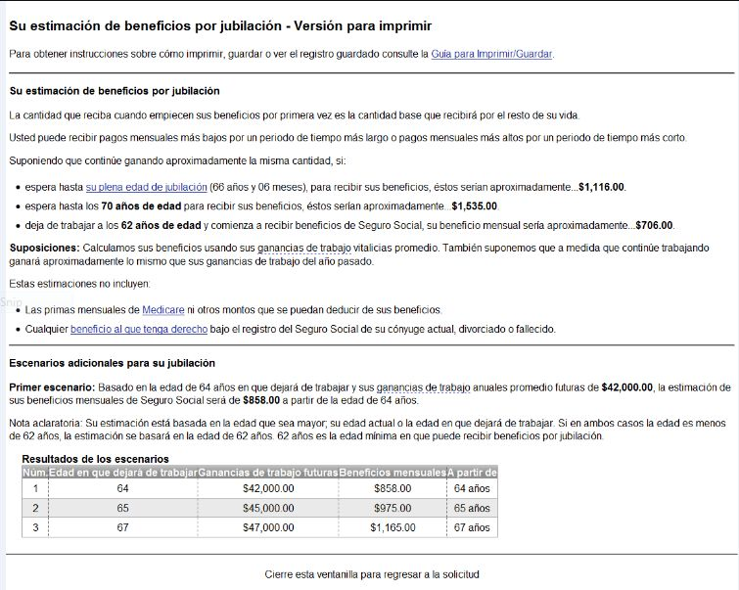

SMSG027 - No es posible procesar su solicitud en este momento web page
The No es posible procesar su solicitud en este momento (Unable to Complete Your Request at this Time) web page will be displayed after a request can not be processed due to a system error. This web page informs the user that the request can not be processed at this time.
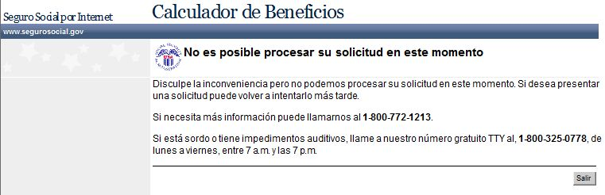

SMSG028 - Este servicio no está disponible en este momento web page
The Este servicio no está disponible en este momento (This Service Is Not Available At This Time) web page will be displayed when a request is made during unavailable hours (hours other than what is displayed in SMSG028). This web page informs users that the service they are requesting is not available at that time.
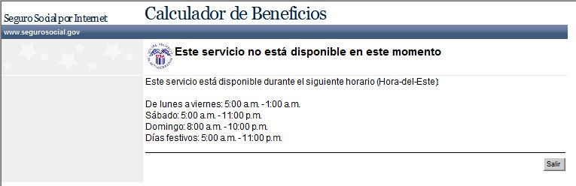

SMSG045 - El calculador de beneficios por jubilación está programado para cerrarse durante el resto del día dentro de media hora web page
The El calculador de beneficios por jubilación está programado para cerrarse durante el resto del día dentro de media hora (This Retirement Estimator Application is scheduled to shut down for the day within a half-hour) web page informs the users that the S-RE will be shutting down within half an hour.
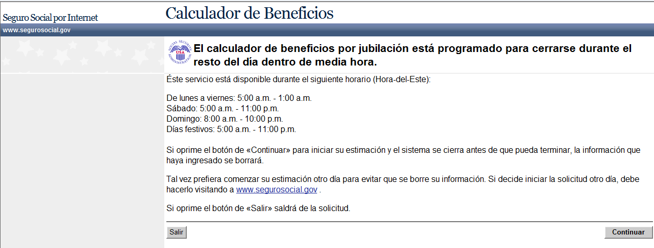

SMSG067 - No podemos procesar su solicitud web page
The No podemos procesar su solicitud (We Cannot Process Your Request) web page alerts users that the system is not able to continue with their request. This web page is displayed when any application specific permanent exclusion occurs.
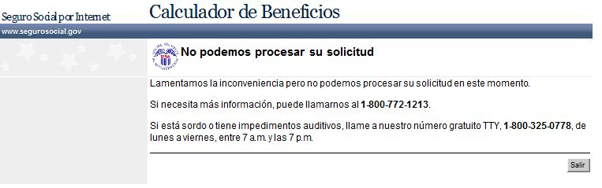

SMSG073 - Cómo imprimir/guardar esta página web page
The Cómo imprimir/guardar esta página (How To Print/Save This Page) web page informs the user how to print/save on the SRP007- Su estimación de beneficios por jubilación - Versión para imprimir (Your Retirement Estimate – Printer Friendly Version) web page.

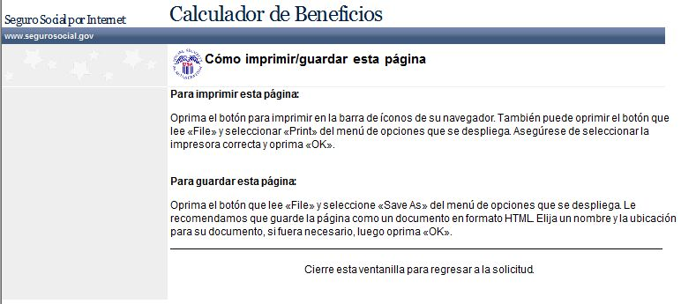

SMSG105 - No podemos procesar su solicitud en este momento web page
The No podemos procesar su solicitud en este momento (We Cannot Process Your Request at This Time) web page alerts users that SSA is unable to continue with their request. This web page displays when PEBES exclusion occurs on SRP003.

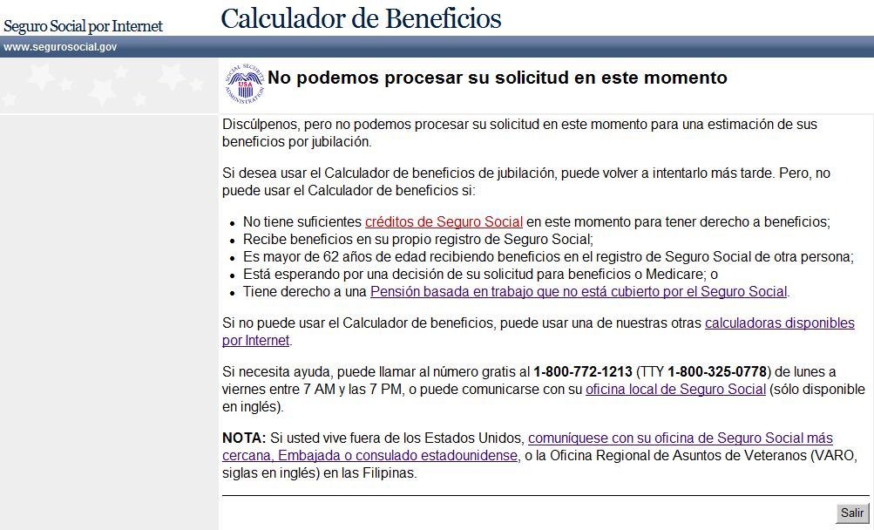

SMSG005 - Está a punto de cerrar el calculador de beneficios por jubilación web page
The Está a punto de cerrar el calculador de beneficios por jubilación (You are About to Leave the Retirement Estimator) web page alerts the user that they have chosen to leave S-RE and begin a new Retirement Benefit (iClaim) application. This web page can be reached by selecting the ¿Está listo para solicitar los beneficios por jubilación? link on the SRP004 and SRP006 web pages.

