OGC-Approved* Final Language to add to Terms of Service (TOS)

- This Format is for the Internet Login Terms of Service page (page 6 in this package):

I assume responsibility for the disclosure of my personal information if the computer or other device that I am using to access the MySocialSecurity application does not adequately safeguard my information. I also understand that Social Security is not responsible for the disclosure of my information due to my negligence or for the wrongful acts of others.

- This Format is for the other 4 Terms of Service pages:

- Remote Registration Terms of Service (page 3)
- In-Person Registration Terms of Service (page 4)
- Reset Extra Security Terms of Service (page 5)
- Add Extra Security Terms of Service (page 7)

Who is responsible if the device you are using is not adequately safeguarded?

You assume responsibility for the disclosure of your personal information if the computer or other device that you are using to access the MySocialSecurity application does not adequately safeguard your information. You also understand that Social Security is not responsible for the disclosure of your information due to your negligence or for the wrongful acts of others.

- Add a link to OnguardOnline in the right-hand alley of the TOS pages.
- Add language to the first bullet of the Internet Login Terms of Service page (page 6 in this package):
Even with a person’s written consent, I understand that I cannot use this online service to access the records of a person:
- With whom I have a business relationship; or
- For whom I am an appointed representative.

NOTE : Systems folks have agreed to implement Items 1 and 2 as soon as possible. Systems will implement Item 3 in a future release. Item 4 is a new request from OCOMM.

*FINAL Language also approved by OES, OTS, OCOMM, OIS, OSES, and OISP.

Revised Electronic Access Terms of Service
Contents
Remote Registration Terms of Service 2
In-person Registration – Finish Setup 3
Reset Extra Security 4
Login 5
Add Extra Security 6

Remote Registration Terms of Service

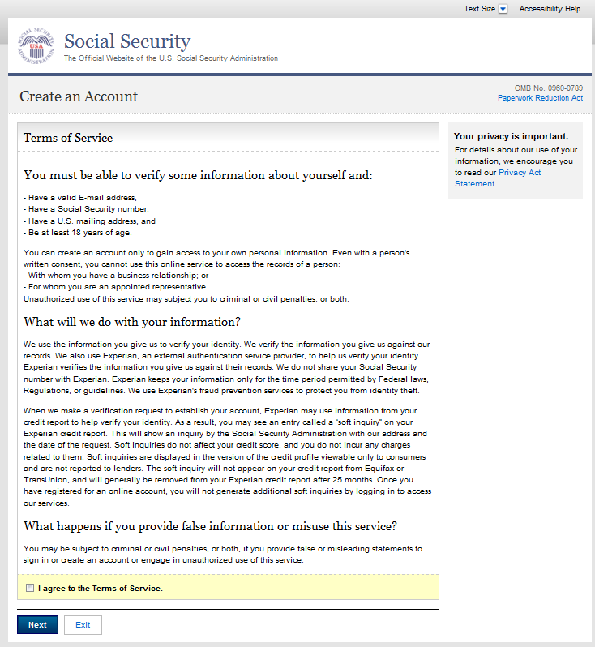
Insert a link to OnguardOnline here.
Add the following text to this page, after the question and answer “What Happens if you provide false information…” and before the “I agree…” checkbox.

Who is responsible if the device you are using is not adequately safeguarded?

You assume responsibility for the disclosure of your personal information if the computer or other device that you are using to access the MySocialSecurity application does not adequately safeguard your information. You also understand that Social Security is not responsible for the disclosure of your information due to your negligence or for the wrongful acts of others.

In-person Registration Terms of Service

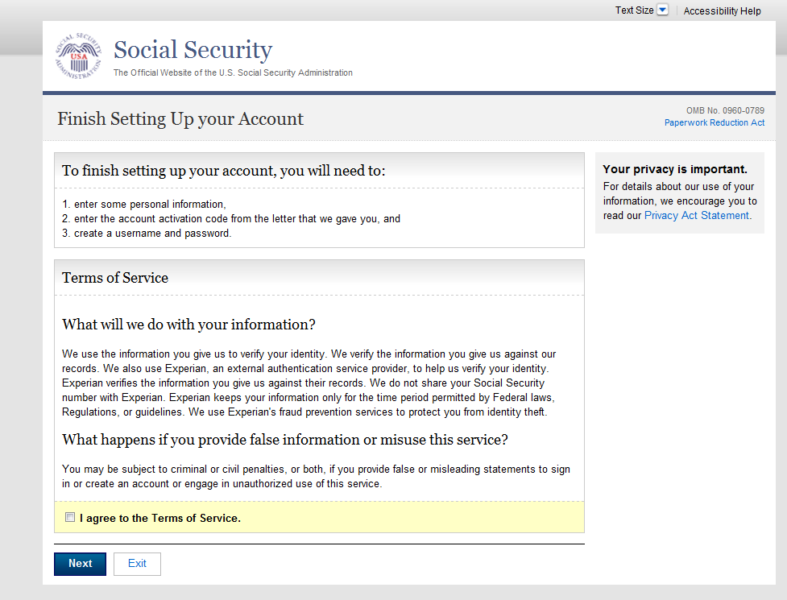
Insert a link to OnguardOnline here.

Add the following text to this page, after the question and answer “What Happens if you provide false information…” and before the “I agree…” checkbox.

Who is responsible if the device you are using is not adequately safeguarded?

You assume responsibility for the disclosure of your personal information if the computer or other device that you are using to access the MySocialSecurity application does not adequately safeguard your information. You also understand that Social Security is not responsible for the disclosure of your information due to your negligence or for the wrongful acts of others.

Reset Extra Security Terms of Service

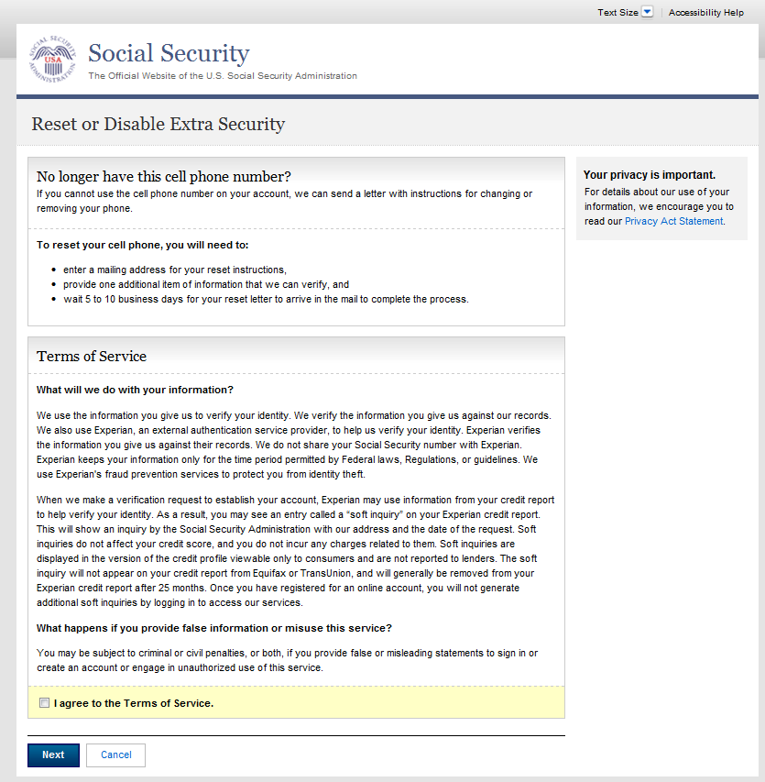
Insert a link to OnguardOnline here.

Add the following text to this page, after the question and answer “What Happens if you provide false information…” and before the “I agree…” checkbox.

Who is responsible if the device you are using is not adequately safeguarded?

You assume responsibility for the disclosure of your personal information if the computer or other device that you are using to access the MySocialSecurity application does not adequately safeguard your information. You also understand that Social Security is not responsible for the disclosure of your information due to your negligence or for the wrongful acts of others.

Login Terms of Service

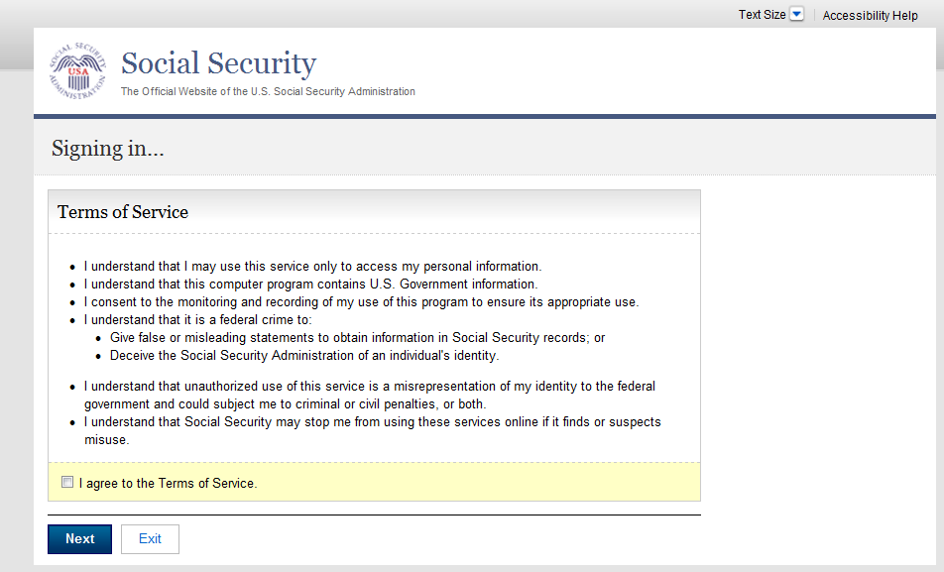
Insert a link to OnguardOnline here.

Add another bullet to the end of this list of bullets:

- I assume responsibility for the disclosure of my personal information if the computer or other device that I am using to access the MySocialSecurity application does not adequately safeguard my information. I also understand that Social Security is not responsible for the disclosure of my information due to my negligence or for the wrongful acts of others.

AND

Add this language to the first bullet (“I understand that I may use this service only to access…”):

Even with a person’s written consent, I understand that I cannot use this online service to access the records of a person:
- With whom I have a business relationship; or
- For whom I am an appointed representative.
Add Extra Security Terms of Service

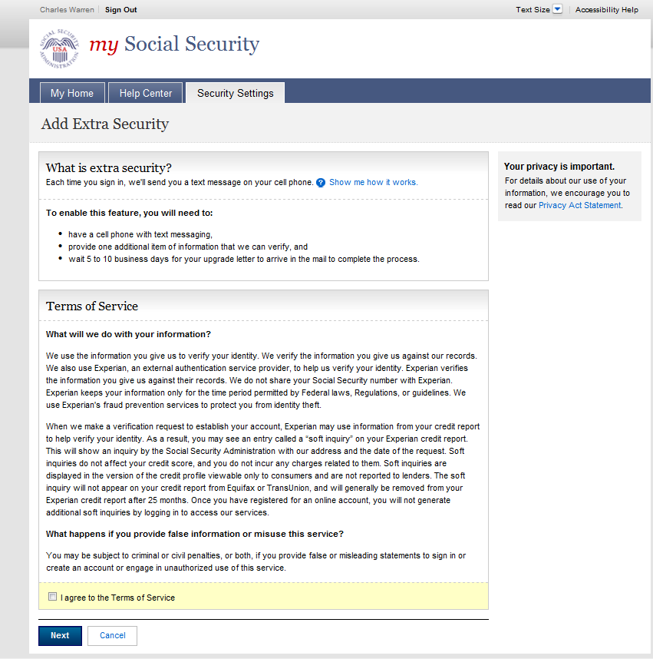
Insert a link to OnguardOnline here.

Add the following text to this page, after the question and answer “What Happens if you provide false information…” and before the “I agree…” checkbox.

Who is responsible if the device you are using is not adequately safeguarded?

You assume responsibility for the disclosure of your personal information if the computer or other device that you are using to access the MySocialSecurity application does not adequately safeguard your information. You also understand that Social Security is not responsible for the disclosure of your information due to your negligence or for the wrongful acts of others.

