Registry of Climate Change Vulnerability Assessments

The Registry of Climate Change Vulnerability Assessments provides access to information about climate change vulnerability assessments. It is a joint effort involving multiple Federal agencies, along with state and nongovernmental partners. The information you provide here will be posted online at the USGS National Climate Change and Wildlife Science Center (https://nccwsc.usgs.gov/) and at the Climate Adaptation Knowledge Exchange (http://www.ecoadapt.org/programs/cake), enabling other potential project designers to gain information about other relevant projects.

Please provide as much information as possible, but partial entries are better than none. Core Data (the following section) is especially important.

Core Project Data

What is the Title of the Assessment >>> FILL BOX
Use a descriptive title that will aid others in identifying the project – species name, location, etc.
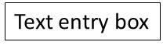

Where is the Assessment Located
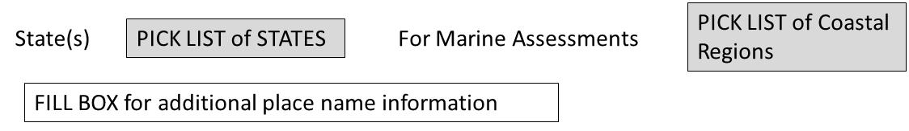
Please provide any additional locational information that will help users know where your project is: e.g. Suffolk County, Blackwater National Wildlife Refuge, Columbia River, Dulles International Airport.

What is the primary entity implementing this Assessment
Select one agency with lead implementation responsibility or largest funding share. If the agency/entity is not listed in the dropdown menu, please add it using the type-in box. Only one entry is permitted here. Other partner agencies can be identified below.

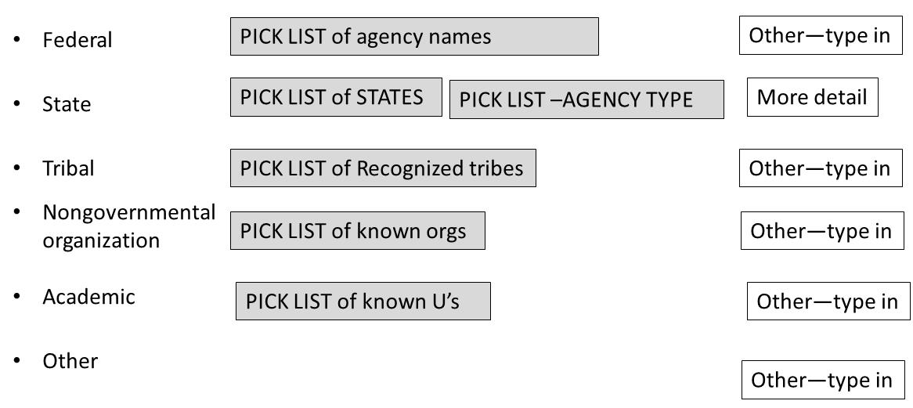

Please identify Partner Agencies for this project
Enter as many partners as are involved in the project. Do not re-enter the lead agency identified above

What resource(s) is the assessment targeted at (endpoints)?
What resource is being assessed to identify climate impacts? You may select more than one assessment target. For all target groups (e.g. species, ecosystems) select the most applicable category from the drop down menu, and add additional details (if appropriate) in the type-in box. For specific species, use the ITIS drop down selector.
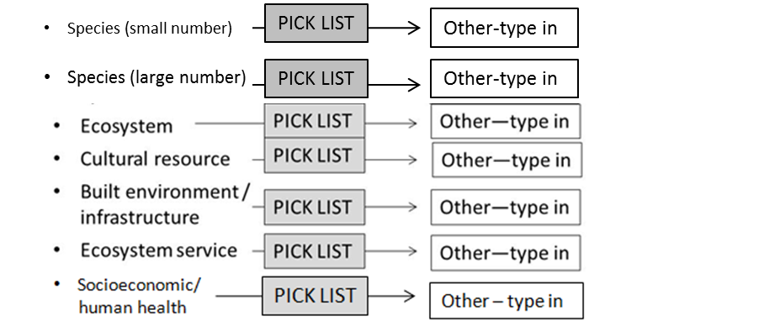
What is the cost, status, and time required to complete the assessment?

Project Status
What is the status of this project?
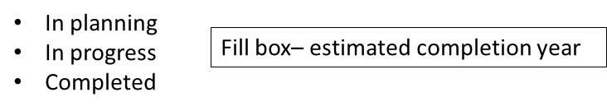
Project Timeframe
How long will / did this project take to complete?
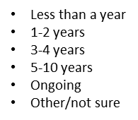
Project Cost
What is / will be the total (estimated) cost of this project:
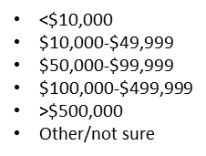

Contact for additional information
Please provide a contact name for additional information about this project.
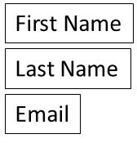

ADDITIONAL ASSESSMENT INFORMATION
If an abstract is available on this project, please insert it in the text box below.

Summary/abstract

Project background
If a web location is available for this project, please insert the URL below

If you wish to provide any other additional information, including maps, photos, report citations, etc. please enter them below.

Additional Project Details
Please complete as much of the remaining data requests as possible. Please feel free to check “Not sure” if applicable.

What is the geographic scope of the assessment?
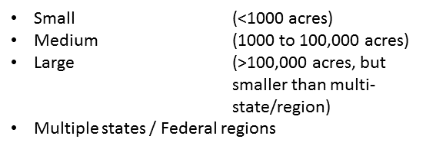

For what purpose is the assessment being conducted?
Is this assessment being conducted for a specific decision, for general planning, research, or other purposes? If possible, provide details
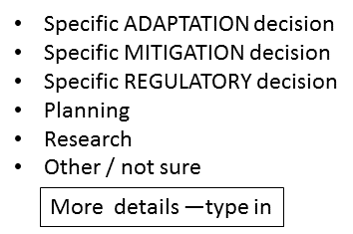

If this assessment is complete and was intended to support a specific decision, have actions been implemented using those assessment results?

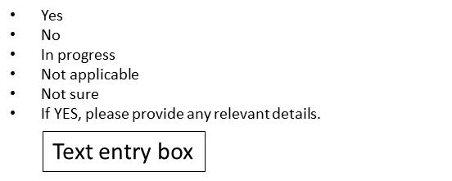
Did this assessment consider any of the following vulnerability components in your assessment?
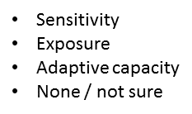

How did / will this project go about assessing the impact climate change will have on your target resource?

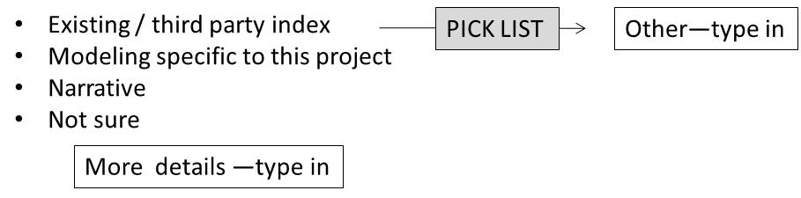

What type of information was / will be used for understanding large-scale drivers of change?
How did this assessment identify possible future climate-driven change? If possible, select from the drop down menu. Otherwise, please provide a short descriptive identifier for your method (e.g., XYZ sea-level rise model; University of ZZ)

What time frame did / will this assessment cover (select all that apply)?

- Within last 100 years
- Within last 50 years
- Current
- Within next 25 years
- Within next 50 years
- Within next 100 or more years
- Unknown/not applicable

