Note: The PRA Burden Statement and OMB Control Number will be added to the login screen.

Figure 1. Screenshot of Reporting Year Web Page for Prison and Jail Collection

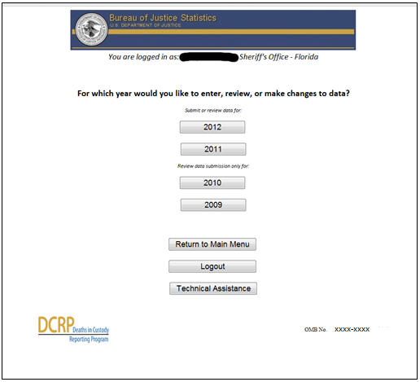

Figure 2. Example Screenshot of Improvements in Web-based Survey Flow

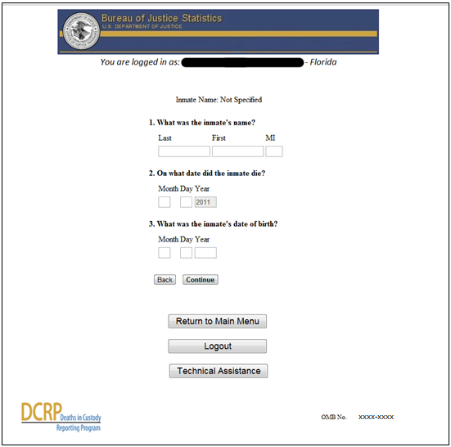

Figure 3. Example Screenshot of Timeout Warning to Respondents

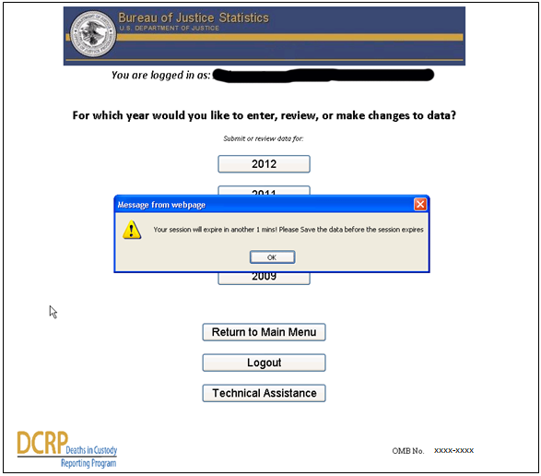

Figure 4. Example Screenshot of Real-time Prompts that Alert Respondents for Potential Errors
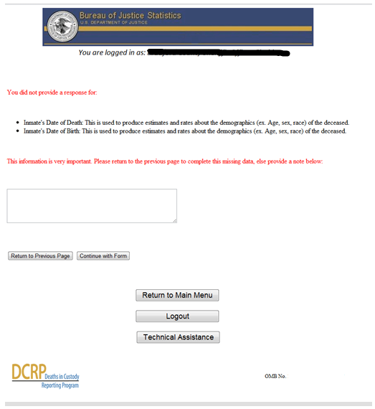
Figure 5. Example Screenshot of Real-time Prompts that Alert Respondents for Potential Errors in Reporting Jail Population Data

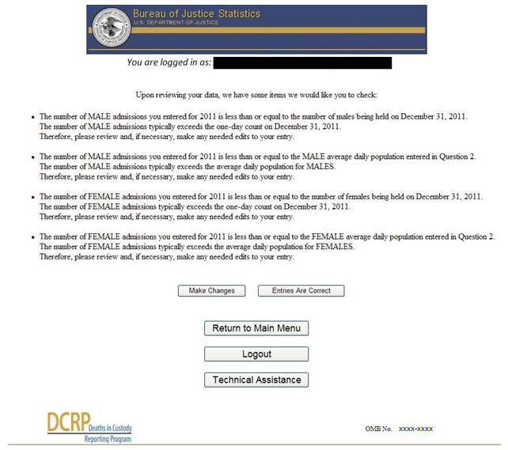

- On-screen Reporting Capabilities. Upon completion of each jail or prison form, agencies receive an on-screen report that summarizes their responses. This enhancement was implemented after respondents relayed to BJS that a summary of the data responses would allow respondents to assess the completeness of their submission while allowing them to review and edit their entries prior to submission (see Figure 6).

Figure 6. Example Screenshot of On-screen Reporting Capabilities

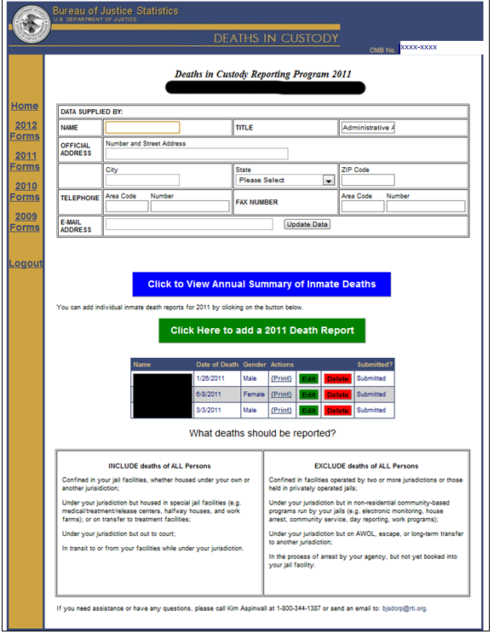

- Explicit confirmation of form completion following online form submission. Upon submitting their data, respondents now receive explicit confirmation that their submission is complete for the relevant reference year (see Figure 6).

Figure 7. Example screen-shot of form completion confirmation
