June 27, 2013

Dear «First_Name» «Last_Name»:

Recently, an interviewer from Mathematica Policy Research tried to contact you to complete an interview for the Green Jobs Health Care Impact Evaluation, which is sponsored by the U.S. Department of Labor (DOL). You may remember agreeing to participate in this study about 18 months ago when you were enrolling in courses at «Site_Name».

As a special thank you for your time, you will receive a check for $45. In order to receive your $45, you *must* call us to complete the interview no later than XX, 2013. You can call us toll free at (866) 778-5905.

Please note that the interview can be scheduled at a time that is convenient for you—during daytime or evening hours, seven days a week. ***Your participation is critical to the success of this study!***

If you have any questions about the study, please call Mathematica toll free at **(866) 778‑5905** and ask for George Johnson.

Sincerely,

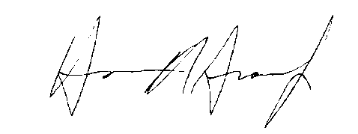

Harrison Greene

Project Director