OMB Approval No: 1840-0640

Expiration Date: xx/xx/xxxx

Ronald E. McNair Postbaccalaureate Achievement (McNair) Program

Instructions for Completing the 2012-13 Annual Performance Report (APR)

Background Information on the McNair APR

The Department of Education (Department) uses the information provided in the McNair Annual Performance report to assess a grantee’s progress in meeting its approved goals and objectives and to determine a grantee’s prior experience points in accordance with the program regulations (34 CFR 647). The following outline is provided to answer questions you may have about the APR submission.

Who
- All grantees funded under the McNair Program must submit an annual performance report as a condition of the grant award.

What
- The APR consists of two sections. Section I gathers project information and Section II gathers detailed information on individual McNair participants as defined in 34 CFR 647.3.

- The project and individual participant information provided in the report must cover the 12-month academic year of the grantee institution instead of the 12-month budget/project year for the grant. For example, the 2012-13 academic year is roughly August/September 2012 through August 2013 while the budget/project year for most McNair grants is October 1, 2012, through September 30, 2013.

- Projects must retain participant records for a period of ten (10) years after the attainment of a bachelor’s degree. In the Fall of 2013, the Department implemented a one-time verification process that required projects to verify the student cohorts for project participants who have already attained a bachelor’s degree between academic years 2002-03 and 2011-12. This process is the McNair Tier 1A—Student Verification for the Bachelor’s Degree Attainment. These verified records are required to be retained for a period of ten years. This ten (10) year period is necessary to accurately report on the doctorate degree objective. In future reporting periods, new bachelor’s degree cohorts will be established at the time the project successfully submits their APR data.

When:
- The annual report is submitted within 90 days after the end of the 12-month budget period.

Where:
- Because the APR requests personal and confidential information on project participants; the secured Web site meets the Department of Education’s data security standards for sensitive data, including password and site access procedures. Further, to ensure that the data is accessible only to authorized individuals and protected from unauthorized uses, a grantee must submit the participant level data via the Web application; under no circumstances should a grantee transmit the data to the Department or the APR Help Desk via e-mail.
- The actual Web application will be available on Month Day, Year at the following Web address:
http://www.ed.gov/programs/triomcnair/report.html
- Web application registration and features are provided below.

Why:
- Title IV, Section 402E, of the Higher Education Act of 1965, as amended (Public Law 102-325), the program regulations in 34 CFR Part 647; and sections 75.590, and 75.720 of the Education Department General Administrative Regulations (EDGAR) requires the collection of this information.
How:
- By constructing a tab delimited (.csv) or Excel (xls or .xlsx) file that contains all of the individual participant information requested in Section II of the APR which is the Record Structure for Participants. The file must mirror the order of the field name and the content of the database column name.
  - Section I, Part 1—Project Identification/Characteristics Certification and Warning Statements
  - Section I, Part 2—Project Services
  - II.A. Project Identifiers (pre-populated)
  - II.B. Participant’s Personal Information
  - II.C. Participant’s Demographic Information
  - II.D. Participant’s Eligibility Status
  - II.E. Participant’s Enrollment Status Information
  - II.F. Participant’s Academic and Degree Status
  - II.G. Participant’s Research and Internships during the Academic Year
  - II.H. Participant’s Graduate School Information

- In the construction of the file, all date fields must be formatted as follows: 2 digits for month; 2 digits for day; 4 digits for year. Also, slashes must be used between the month, day and year (e.g., 09/01/2012).

Web Registration:
- Go to https://trio.ed.gov/mcnair,
- Click on "Register Here Each Year,”
- Enter the project's PR award number (found on the Grant Award Notification),
- Enter project director's first and last names,
- Enter project director’s e-mail address,
- Select and answer two security questions,
- If the project director’s information matches the data that the Department currently has on file, a user ID and temporary password will be sent to the e-mail address on file.
  - If the project director’s information does not match the data that the Department currently has on file, you will be directed to a "Registration Failed" page. Your program specialist and the Help Desk will be sent an e-mail message requesting verification of project director. Verification will occur within 24 hours if the program specialist can readily confirm a change in project director or e-mail address. Once the Help Desk has received verification from the program specialist, you will be notified to continue with registration.
- You may enter the user ID and temporary password right below the Register Here Each Year link.
- You will be guided to select a new password. Password requirements are:
  - at least eight characters, and include combinations of the following,
  - at least one English uppercase character (A-Z),
  - at least one English lowercase character (a-z),
  - at least one numeric number (0-9), and
  - at least one non-alphanumeric special character (e.g.,:, !, @, #, $, &, *, %, /, +, -).
- If you forget your password, a "Forgot Password" link is available on the log-in page. The link will route you to a screen that will allow you to retrieve your password by answering the two security questions you provided at initial registration. Once you answer the two security questions, your password will be sent to the email on file.
- After three failed attempts to access the Web site, you will be locked out and must call the Help Desk to obtain access.

Web Features:
- A Web form for completing Sections I and II on-line.
- Access to a grantee’s bachelor’s degree cohort file (McNair Student Verification for the Bachelor’s Degree Attainment—Tier 1A File) to ensure that all participants that should be on the 2012-13 data file are included.
- Functionality to upload a file with the individual participant records (Section II) to the Web application using a tab delimited (.csv) or EXCEL (.xls, xlsx) file format.
- Functionality to download a file of the individual participant records (Section II).
- Functionality to view/delete/add participant data online.
- Functionality to upload a scanned signed copy of Section I using the online Web application.
- Online data field validations and error checks. In order for a grantee to be able to submit the APR, all of the sections of the APR must pass the first level of data field validations; therefore, following the initial submission of the participant data, additional data quality checks will be run. If any errors or data inconsistencies are found, the grantee will be notified via email of needed corrections and the due date for resubmitting the Section II data.
- A print button to generate a hard copy of the information entered online for Sections I and II.
- A submit button to send the entire report to the Department.
- An e-mail confirmation will be automatically generated and sent to the person on file notifying them that the report has been submitted (a valid e-mail address must be provided in Section I).

Contact the Help Desk or your program specialist if you:
- have technical problems accessing the Web site or using the Web application
- do not receive an e-mail confirmation
- need to revise your performance report data after it has been submitted but prior to the deadline date (mm/dd/yyyy)
- have questions regarding the performance report requirements

Contact Information:
- APR Help Desk at (703) 846-8248 or via e-mail at: mcnairweb@cbmi.com.
- Program Specialist—Use the State listing provided at: http://www.ed.gov/programs/triomcnair/report.html.

Ronald E. McNair Postbaccalaureate Achievement (McNair) Program
Specific Instructions for Completing the Performance Report
For 2012-13

SECTION I, Part 1—Project Identification/Reporting Periods/Contact Information/ Certification and Warning Statements

A. Project Identification
1. Pre-populated
2. Pre-populated
3. Pre-populated
4. Pre-populated
5. Choose one

B. Reporting Periods
6a. Pre-populated
6b. Enter the date for the first day of classes, that is, the official date when courses first began.

B. Contact Information
7a. Pre-populated
7b. Pre-populated
7c. Pre-populated
7d. Pre-populated
8a. Pre-populated
8b. Pre-populated
8c. Pre-populated

D. Certification
Signatures for the both the project director and the certifying official are required in this section. You must fax a signed copy of Section I of the report form to703-832-1360.

With the exception of Section I of the report, please do not fax a paper copy of the performance report.

SECTION I, Part 2—Project Services

Enter the number of participants who received the required services and permissible services. A participant may be counted only one time in each category. For example, if the number of participants served is 30, none of the eleven categories will have a number exceeding 30.

Please refer to the definitions provided in the instructions for the required services and permissible services.

SECTION II: PARTICIPANT RECORD STRUCTURE

Before you begin, please familiarize yourself with the participant data fields and the “Definitions
That Apply” to the APR. The McNair participant record structure contains forty-eight (48) data fields.
The first two fields are project identifiers. The remaining 46 fields are student data fields and may or
may not require/allow updates as noted with an “X” below.

Field  # | Field Name | You cannot update | You should not have to update | You may  update
1 | Pr/Award Number | X
2 | Batch Year | X
3 | Social Security Number | X
4 | Student’s Last Name | X
5 | Student’s First Name | X
6 | Student’s Middle Initial |  | X
7 | Student’s Date of Birth | X
8 | Gender |  |  | X
9 | Ethnicity—Hispanic |  | X
10 | Race—American Indian/Alaskan Native |  | X
11 | Race—Asian |  | X
12 | Race—Black or African American |  | X
13 | Race—White |  | X
14 | Race—Native Hawaiian or Other Pacific Islander |  | X
15 | Low-income |  | X
16 | First-generation |  | X
17 | Under-represented racial/ethnic  group |  | X
18 | First Postsecondary Education Enrollment Date |  | X
19 | Attendance at Community College/2-year Institution |  | X
20 | Project Entry Date |  | X
21 | Grade Level at Project Entry |  | X
22 | Participant Status (during academic year being reported) |  |  | X
23 | Enrollment Status  (during academic year being reported) |  |  | X
24 | Project Participation (during academic year being reported) |  |  | X
25 | Funding Source (during academic year being reported) |  |  | X
26 | STEM Discipline |  | X
27 | Bachelor’s Degree (or equivalent) |  | X
28 | Date of Bachelor’s Degree (or equivalent) |  | X
29 | Graduating Cohort Year of Bachelor’s Degree | X
30 | Main field of Study (Bachelor’s Degree Earned) |  | X
31 | Cumulative GPA (upon graduation with a bachelor’s degree) |  | X
32 | Research Activity (2012–13 academic year) |  |  | X
33 | Other Scholarly Activity (2012–13 academic year) |  |  | X
34 | McNair Research Internship (2012–13 academic year) |  |  | X
35 | Graduate School Admissions Test |  | X
36 | Date of First Graduate School Enrollment |  | X
37 | Graduate Institution First Attended |  | X
38 | Graduate School Enrollment Status  (at the beginning of the 2013–14 academic year) |  |  | X
39 | First-Year Graduate Student Persistence Status  (at the beginning of the 2013–14 academic year) |  |  | X
40 | Current Year of Graduate Study (during academic  year being reported) |  | X
41 | Graduate Student’s Main Field of Study  (at time of entrance) |  | X
42 | Graduate Assistantships  (for 1st year graduate students only) |  | X
43 | Reason Left Graduate School |  | X
44 | Highest Graduate Degree Earned  (as of the end of the academic year) |  |  | X
45 | Date Highest Graduate Degree Earned |  |  | X
46 | Institution Where Doctorate Degree was Earned |  | X
47 | Doctorate Recipient’s Employment Activity |  | X
48 | Student’s Name Change—Optional (Full Name) |  |  | X

Definitions That Apply

Bachelor’s Degree:
- Equivalent of a bachelor’s degree means any McNair participant who did not earn a baccalaureate degree upon completion of their undergraduate studies because their institution does not confer baccalaureate degrees until the student is enrolled in a graduate program or has completed their graduate studies.
- Graduating Cohort Year of Bachelor’s Degree means the year in which the participant earned their bachelor’s degree. For participants who attained their bachelor’s degree prior to the 2012-13 academic year, the cohort year was established via the McNair Tier 1A student verification process. For baccalaureate degree recipients not identified through the McNair Tier 1A process, the graduating cohort year will be established based on the APR data submitted by the project.

Current Participant means a participant who was served by the project in the reporting period. (Note: The sum of new and continuing participants should equal the total number of participants served during the 2012-13 reporting period.)

Eligibility Status:
- Low-income individual means an individual whose family’s taxable income did not exceed 150 percent of the poverty level amount in the calendar year preceding the year in which the individual initially participated in the project. The poverty level amount is determined using criteria of poverty established by the Bureau of the Census of the U.S. Department of Commerce.
- First-generation college student means (1) an individual neither of whose natural or adoptive parents received a baccalaureate degree; or (2) an individual who, prior to the age of 18, regularly resided with and received support from only one parent and whose supporting parent did not receive a baccalaureate degree; or (3) an individual who, prior to the age of 18, did not regularly reside with or receive support from a natural or adoptive parent.
- Groups underrepresented in graduate education currently include the following ethnic and racial groups: Black (non-Hispanic), Hispanic, American Indian, Alaskan Native, Native Hawaiians and Native American Pacific Islanders.

Enrollment Status:
- Enrolled is defined as a student who was enrolled in postsecondary education at least one term in the academic year being reported.
- Not enrolled is defined as a student who was not enrolled in postsecondary education for any of the terms in the academic year being reported.

Ethnicity/Race:
- Hispanic or Latino – means a person of Mexican, Puerto Rican, Cuban, Central or South American or other
Spanish culture or origin, regardless of race.
- American Indian or Alaska Native - American Indian/Alaskan Native refers to a person having
origins in any of the original peoples of North and South America (including Central America),
and who maintains tribal affiliation or community attachment.
- Asian - A person having origins in any of the original peoples of the Far East, Southeast Asia, or the Indian subcontinent, including, for example, Cambodia, China, India, Japan, Korea, Malaysia, Pakistan, the Philippine Islands, Thailand, and Vietnam.
- Black or African American - A person having origins in any of the black racial groups of Africa.
- White - A person having origins in any of the original peoples of Europe, the Middle East, or North Africa.
- Native Hawaiian or Other Pacific Islander – A person having origins in any of the original peoples of
Hawaii or other Pacific islands such as Samoa and Guam.

Integrated Postsecondary Education Data System (IPEDS) is the primary source for data on colleges, universities, and technical and vocational postsecondary institutions in the United States.

Participant Status:
- A new participant is an individual who was served by the project for the first time in the this reporting period.
- A continuing is an individual who was served by the project for the first time in any prior reporting period and also received services in the this reporting period.
- A prior year is an individual served by the project in any prior reporting period but did not receive services in this reporting period.
- A prior-year participant who is deceased is an individual served by the project in any prior reporting period but is now deceased.

Project Services
- Research or Other Scholarly Activities means an educational activity that meets all of the following criteria:
  - is more rigorous than is typically available to undergraduates in a classroom setting,
  - is definitive in its start and end dates,
  - contains appropriate benchmarks for completion of various components; and
  - is conducted under the guidance of an appropriate faculty member with experience in the relevant discipline.
- Summer Internships that are research-based means an educational activity that (1) is more rigorous than is typically available to undergraduates in a classroom setting, (2) is definitive in its start and end dates, (3) contains appropriate benchmarks for completion of various components, and (4) is conducted under the guidance of the an appropriate faculty member with experience in the relevant discipline. Summer Internships that are not research-based means an educational experience in which participants, under the guidance and direction of experienced faculty researchers, are provided an opportunity to engage in research or other scholarly activities.
- Seminars/workshops means group activities that provide participants with the opportunity to receive information or practice methodology in one or more areas necessary for the successful navigation of the educational system relative to the attainment/completion of their doctoral studies.
- Tutoring means academic assistance provided by an advanced undergraduate student, graduate student or a professional staff.
- Academic counseling means assisting students in making educational plans, selecting appropriate courses, meeting academic requirements, and planning for graduation and graduate education.
- Admission assistance to graduate school means assisting students in choosing graduate or professional programs and applying for admission to those programs.
- Financial aid assistance to graduate school means assisting students individually or in small groups in completing financial aid applications and securing fellowships and other forms of financial assistance for graduate study.
- Education/Counseling to improve financial and economic literacy means knowledge about personal financial decision-making, which may include but is not limited to knowledge about
  - Personal and family budget planning;
  - Understanding credit-building principles to meet long-term and short-term goals ( e.g., loan to debt ratio, credit scoring, negative impacts on credit scores);
  - Cost planning for postsecondary or postbaccalaureate education (e.g., spending, saving, personal budgeting);
  - College cost of attendance ( e.g., public vs. private, tuition vs. fees, personal costs);
  - Financial assistance ( e.g., searches, application processes, and differences between private and government loans, assistantships); and
  - Assistance in completing the Free Application for Federal Student Aid (FAFSA).
- Mentoring means professionals, other than project staff, working with project students to expose them to careers that require doctoral degrees.
- Exposure to cultural events and academic programs means any project sponsored activities, such as field trips, special lectures, and symposiums that have as their purpose the improvement of the project participants’ academic progress and personal development.
- Other means additional activities not listed above that are designed to meet the purpose of the McNair Program.

National Center for Education Statistics (NCES), in the Institute of Education Sciences, is the statistical agency of the U.S. Department of Education and the primary federal provider of education statistics on the condition of American education.

NCES IPEDS ID is unique identification number assigned to postsecondary institutions surveyed through the Integrated Postsecondary Education Data System (IPEDS) and is also referred to as the UNITID.

Science, Technology, Engineering or Mathematics (STEM) means a program of study in the fields of science, technology, engineering, and mathematics and includes disciplines such as
- Computer and Information Sciences
- Engineering
- Life Sciences, including agricultural sciences/natural resources, biological/biomedical sciences, and health sciences.
- Mathematics
- Physical Sciences, including astronomy, atmospheric science and meteorology, chemistry, geological and earth sciences, ocean/marine sciences, and physics.

Survey of Earned Doctorate (SED) is a federal agency survey conducted by the National Opinion Research Center (NORC) for the National Science Foundation and five other federal agencies. The SED gathers information annually on research doctorate graduates about their educational histories, funding sources, and post-doctoral plans. The 2011-12 SED questionnaire can be found at: http://www.nsf.gov/statistics/srvydoctorates/surveys/srvydoctorates_2011.pdf

Instructions for Participant Data File

II.A. Project Identifiers

Field 1—Use the PR/Award Number that corresponds to the reporting year even if you have been awarded a new grant and PR/Award Number for the next reporting year.
Field 2—Enter 2012.

II.B. Participant’s Personal Data

Field 3—Enter SSN. If a project does not know a student’s SSN, leave it blank or enter zeros, “000000000.” Not changeable in subsequent reporting periods.

Field 4—Enter Student’s Last Name. Not changeable in subsequent reporting periods.

Field 5—Enter Student’s First Name. Not changeable in subsequent reporting periods.

Field 6—Enter Student’s Middle Initial.

Field 7—Enter Student’s Date of Birth. Not changeable in subsequent reporting periods.

II.C. Participant’s Demographic Information

Field 8—Select Student’s Gender.

Field 9—Select whether or not the participant is identified/self-identifies as Hispanic/Latino.

Field 10—Select whether or not the participant is identified/self-identifies as American Indian/Alaskan Native.

Field 11—Select whether or not the participant is identified/self-identifies as Asian.

Field 12—Select whether or not the participant is identified/self-identifies as Black or African American.

Field 13—Select whether or not the participant is identified/self-identifies as White.

Field 14—Select whether or not the participant is identified/self-identifies as Native Hawaiian or Pacific Islander.

II.D. Participant’s Eligibility Status Information

Field 15—Select whether or not the participant is low-income.

Field 16—Select whether or not the participant is first-generation college.
Field 17—Select whether or not the participant is from one of the following underrepresented groups in graduate education: Black (non-Hispanic), Hispanic, American Indian, Alaskan
Native, Native Hawaiians and Native American Pacific Islanders.

II.E. Participant’s Enrollment Status

Field 18—Enter participant’s date of first enrollment in postsecondary education. The first postsecondary enrollment date is the first date a participant enrolled in a program of postsecondary education; however, this date does not include the date a participant enrolled in a high school bridge-to-college program/dual enrollment program nor the first enrollment date a participant took college courses while enrolled in high school.
Field 19—Select whether or not a participant attended a community college/2-year institution following high school graduation or having earned their GED.
Field 20—Enter participant’s date of first project service.
Field 21—Select the participant’s college grade level at the time of project entry. Use your institution’s classification grade level criteria when determining the participant’s college grade level.
Field 22—Select the participant’s status.
Field 23—Select the participant’s enrollment status. Select “Yes” if the participant was enrolled in undergraduate or graduate studies at any time during the reporting period; otherwise, select “No”.
Field 24—Select the length of project participation by the participant. You must select “9” if the student was a prior-year participant.

Field 25—Select the types of funds used in this reporting period to serve the participant.

II.F. Participant’s Academic and Degree Status

Field 26—For participants who were served in this reporting period, select the participant’s major field of study at the time of project entry. For prior year participants, select option 9. Generally, the social and behavioral sciences includes disciplines such as economics, econometrics, psychology, sociology, anthropology, political science, etc. For assistance and guidance, use the Main Field of Study list in the instructions.

Field 27—Select whether or not the participant has earned a bachelor’s degree or equivalent of a bachelor’s degree. If the participant is on your McNair Tier 1A—Student Verification for the Bachelor’s Degree Attainment data file, you must select “Yes”.

Field 28—Enter the date the participant earned their bachelor’s degree or equivalent of a bachelor’s degree.

Field 29—Select the applicable graduating cohort year the participant earned their bachelor’s degree. Select option 12 (2012-13) if the participant earned a bachelor’s degree in this reporting period. If the participant is on your McNair Tier 1A—Student Verification for the Bachelor’s Degree Attainment data file, you must select the cohort as it appears on the file. Hint: If you select “Yes” in field 27, then you must select a cohort year in field 29. NOTE: Once the cohort year is established, it cannot be changed in subsequent reporting periods.

Field 30—Use the Main Field of Study list located at the end of this document to enter the three-digit code for participants who have EARNED a bachelor’s degree. If the participant is a graduate or first professional student, enter the three-digit code at the time they attained their bachelor’s degree. For participants who are double majors, you may use your discretion.

Field 31—Enter the cumulative GPA upon graduation with a bachelor’s degree.

II.G. Research or Other Scholarly Activities

IMPORTANT: Per regulatory definition of what constitutes research or other scholarly activities, in order to determine whether the student participated in research or other scholarly activities (including McNair research internships), you must answer “Yes” to all of the four (4) questions (i.e., criteria) listed below. For example, if the activity does not have a definitive start and end date, then the activity is not considered research.

- Was the educational activity more rigorous than is typically available to undergraduates in a classroom setting?
- Was the educational activity definitive in its start and end dates?
- Did the educational activity contain appropriate benchmarks for completion of various components? AND
- Was the educational activity conducted under the guidance of an appropriate faculty member with experience in the relevant discipline?

Field 32—Select the participant’s research activity completion status in this reporting period.

Field 33—Select the participant’s other scholarly activity completion status in this reporting period.

Field 34—Select the participant’s McNair research internship activity completion status in this reporting period.

II.H. Participant’s Graduate School Information

Field 35—Select whether or not the bachelor’s degree recipient completed a graduate school admissions test.

Field 36—Enter the date of first graduate school enrollment.

Field 37—Enter the six-digit postsecondary institution NCES IPEDS ID for graduate institution first attended.

Field 38—Select the participant’s graduate school enrollment status at the beginning of the 2013-14 academic year (i.e., Fall) for participants who earned a bachelor’s degree in this reporting period.

Field 39—Select the participant’s graduate school persistence status at the beginning of the 2013-14 academic year (i.e., Fall) for participants who were first-year graduate students in this reporting period.

Field 40—Select the participant’s graduate year of study for participants who are enrolled in graduate school in this reporting period.

Field 41—Using the Main Field of Study list located at the end of this document; enter the three-digit code for the main field of study at the time of entry into graduate school. For students who are no longer enrolled in graduate school or for students who completed their graduate studies, the project should provide, to the extent possible, the main field of study at the time the participant first entered graduate school.

Field 42—Select the type of assistantship the first-year graduate participant received in this reporting period.

Field 43—Select the reason the participant left graduate school.

Field 44—Select the highest degree earned by the end of the academic year. Once reported, do not change the degree unless a new or more advanced degree has been earned. Select option 4 only if the other doctorate degree was in a research-intensive program. Select option 5 only if the other doctorate degree was in a non-research-intensive program. If a participant earned a professional degree but subsequently earns a research-intensive doctorate, select the type of doctorate earned (e.g., PhD).

Field 45—Enter the date of the highest degree earned.

Field 46—If you selected option 2, 3, or 4 in field 44, enter the six-digit code postsecondary institution NCES IPEDS ID.

Field 47—Select the primary employment activity for participants who have earned a research-intensive doctorate degree. Hint: Options 1 thru 4 only apply if you selected option 2, 3, or 4 in field 44. In addition to a university setting, the primary employment can occur at organizations such as the National Institutes of Health (NIH), Centers for Disease Control and Prevention (CDC), private industry, etc. Once reported, do not update in subsequent reporting periods.

II.I. Participant’s Name Change

Field 48—This field is optional. If the participant changed their name and you need this information to assist you in further tracking the participant, please enter the participant’s full name (i.e., first and last name). If the participant’s name is the same as provided in fields 4 and 5, you may leave this field blank. The information in this field can be changed in subsequent reporting periods.

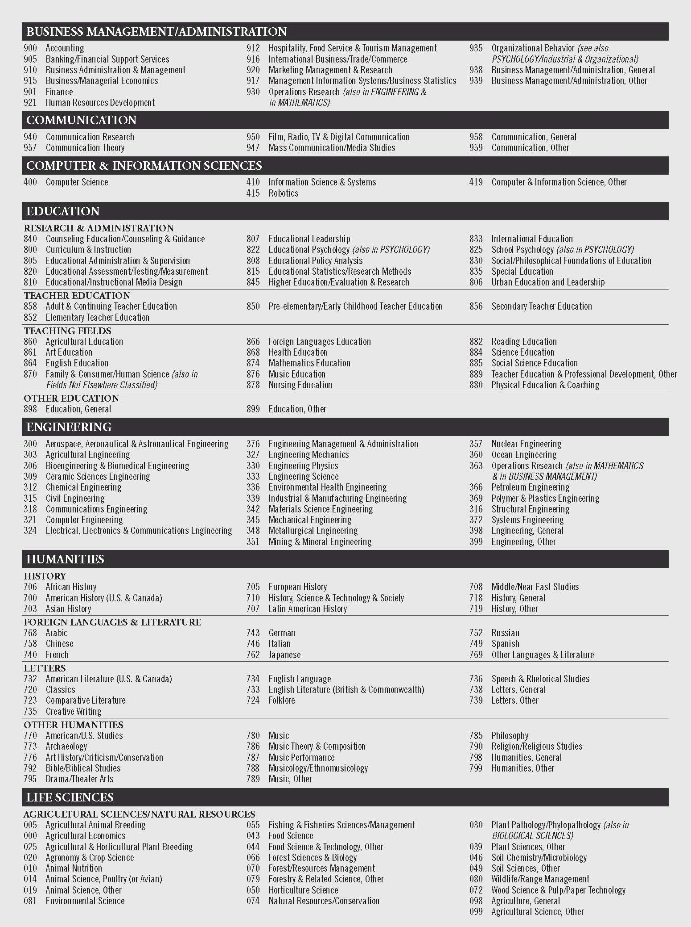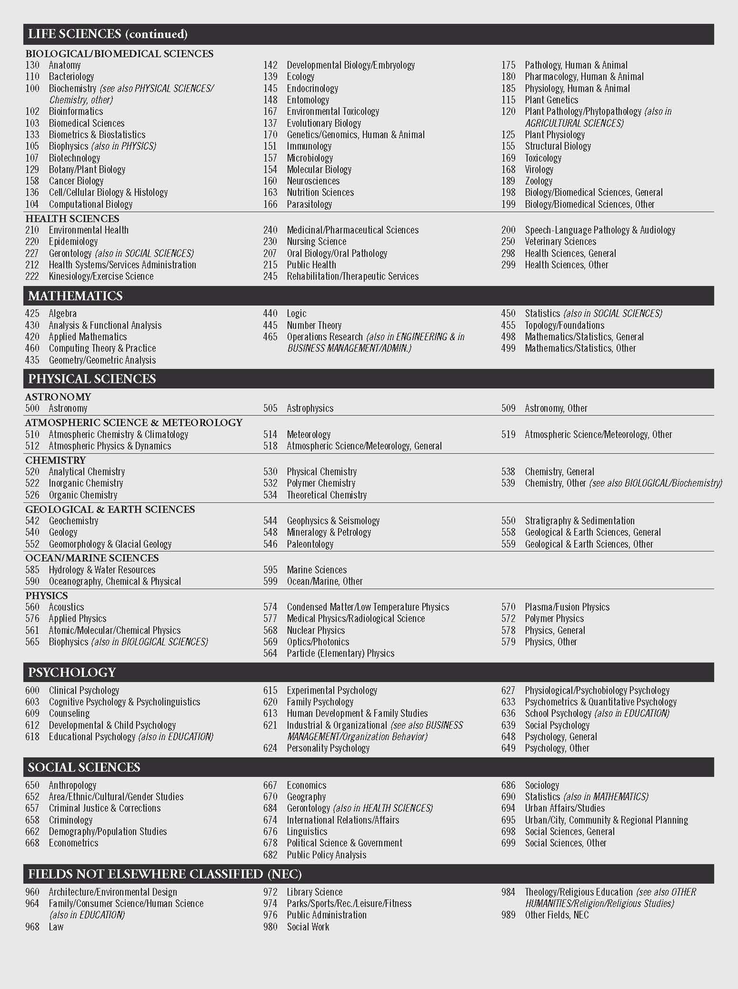
Main Field of Study List
For Fields 26, 30, and 41

