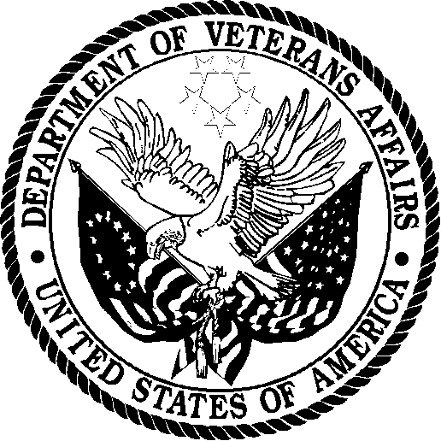 | Department of Veterans Affairs  Veterans Health Administration  Washington DC 20420

Dear Veteran,

The Veterans Health Administration (VHA) wants to make the Department of Veterans Affairs (VA) your first choice for all your health care needs, and we need your help. The VHA has partnered with XXXXXXX, a well-known survey firm, to conduct an important survey. Within two weeks you will be getting a survey about dental care that you received recently at the VA. The answers that you give will help us improve care at the VA.

Your answers will not affect your eligibility for VA benefits. Your survey answers will be anonymous and will only be combined with answers from other veterans in all reports. No participant’s individual survey responses will be identified to their medical facility or to any member of their health care team.

If you have a specific comment about the care provided at your facility, contact the Patient Advocate Office at the facility that you are receiving care. If that does not resolve your issue, contact the Medical Center Director who has a process to help with your concerns.

If you have questions about VA benefits or claims please call 1-800-827-1000.

We look forward to hearing from you and thank you for helping us to understand your opinion.

Sincerely,

VHA Office of Dentistry Quality Committee

