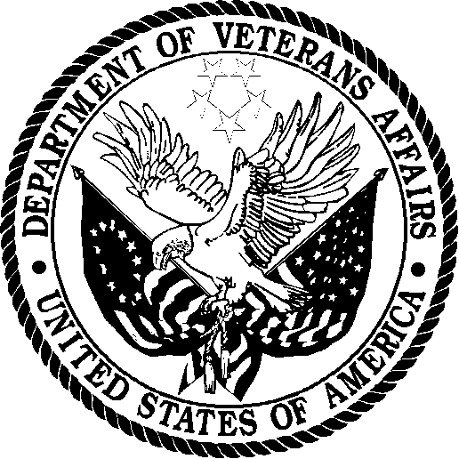 | Department of Veterans Affairs  Veterans Health Administration  Washington DC 20420

Dear Veteran,

Approximately three weeks ago VA sent you a survey regarding your dental care. If you have already returned this survey to us, please accept our thanks and disregard this letter. However, if you have not participated, please take a few minutes to complete the survey questionnaire.

The Veterans Health Administration wants to give you the best healthcare possible, but we need your help. Only you can tell us how we are serving you and in what ways we can serve you better. The VHA has partnered with XXXXXX, a well-known survey firm, to conduct this important survey.

Your answers to the survey will not affect your eligibility for VA benefits. Your survey answers will be anonymous and will only be combined with answers from other veterans in all reports. No participant’s individual survey responses will be identified to their medical facility or to any member of their health care team.

If you have specific comments about the care you receive at your facility, please contact the facility’s Patient Care Advocate. If this does not resolve your issue, contact the Medical Center Director who has a process to help with your concerns.

If you have questions about VA benefits or claims please call 1-800-827-1000.

Please return only the survey in the return envelope provided. Any other correspondence included in the envelope will be forwarded to the Office of the Medical Center Director at your facility.

We look forward to hearing from you and thank you for helping us to understand your opinion.

Sincerely,

VHA Office of Dentistry Quality Committee

