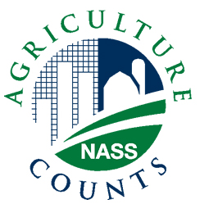**NEWS RELEASE**



United States Department of Agriculture

**NATIONAL AGRICULTURAL STATISTICS SERVICE**

**[STATE NAME] FIELD OFFICE**

**[ADDRESS]**

|  |  |
| --- | --- |
| FOR IMMEDIATE RELEASE | Contact: [Firstname] [Lastname] |
| [Month ##], [Year] | (XXX) XXX-XXXX |

**USDA TO GATHER FARM LABOR STATISTICS IN OCTOBER**

[CITY, STATE] – During the second half of October, U.S. Department of Agriculture’s National Agricultural Statistics Service (NASS) will conduct its biannual Agricultural Labor Survey to collect information about hired labor on (State) farms. More than (sample size) of (State) farmers and ranchers will receive this survey.

“Farm labor information is very important when it comes to budgets and workload planning for upcoming growing seasons,” said (First Name Last Name), Director of the NASS (State) Field Office. “The data that farm operators provide through NASS’s Agricultural Labor Survey will help guide them in their seasonal planning and will inform policy makers in (State) who may take up legislation impacting this industry.”

USDA and the Department of Labor will use the statistics obtained from the Agricultural Labor Survey to help establish minimum wage rates for agricultural workers, administer farm labor recruitment and placement service programs, and assist legislators in determining labor policies.

The survey asks participants to provide input about farm labor on their operations, including total number of hired farm workers, hours worked, and wage rates paid for the weeks of July 8-14 and October 7-13. For their convenience, survey participants will have the option to respond online.

“This is the farmers’ chance to help guide farm labor policies, which is why I hope every farmer will take the opportunity and respond to this important survey,” said (Director’s Last Name).

NASS will compile, analyze and publish survey results in the *Farm Labor* report, to be released on November 15. This and all other NASS reports are available online at [*http://bit.ly/FarmLabor*](https://bitly.com/) . For more information on NASS surveys and reports, call the NASS (State) Field Office at (Toll-free Number).

###