Attachment A2
Changes to 2014 NAMCS-1 Electronic Health Record (EHR) Questions
Please note that the questions below were taken from our 2013 paper NAMCS induction form (used as an FR handout-not data actual collection). The 2013 questions can be used as a starting point to show the order and format of the 2014 computerized instrument. Also, the numbers used indicate skip patterns and are not present on the computerized instrument. The proposed changes are indicated in RED.

2013 NAMCS Electronic Health Record (EHR) Questions
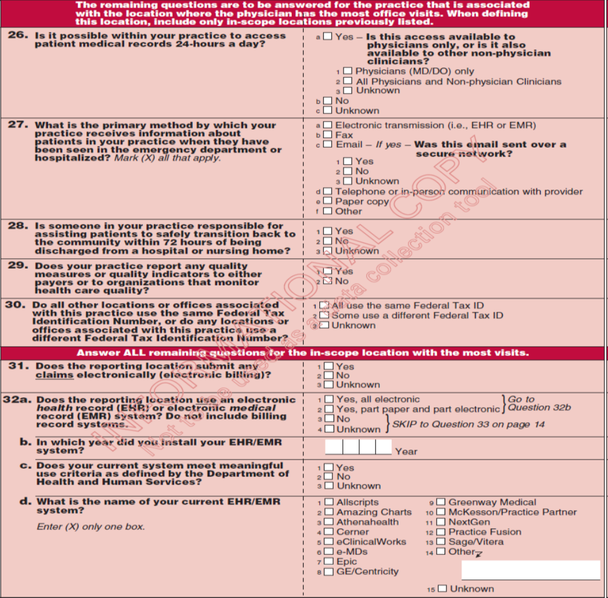
One question was added after 32d-see 15d on page 5
Slight text modification to 34a & 34b-see 17 & 17a on page 5

Delete 35q
Delete 37

Slight re-working of 40b-see 21a on page 7 questions
Delete 40c
Delete 39c
Delete 39b
Delete 38c
Delete 38b

Please note that the questions below were taken from the prototype of the paper EHR mail survey; however, the wording is exactly the same as what is proposed for the computerized 2014 NAMCS instrument. The numbers used indicate skip patterns and are not present on the 2014 NAMCS computerized instrument. The proposed changes are indicated in RED.

2014 Proposed NAMCS Electronic Health Record Questions
New
New references: Stage1 & Stage 2
Responses Modified Slightly
New
New
New

Re-worded
New
New
New
New
New
New

New
New

