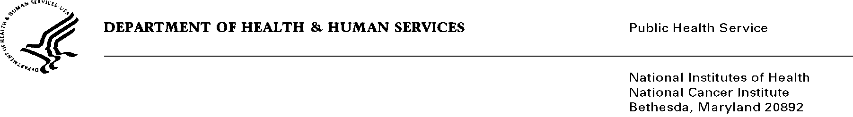

Date: August 19, 2013

TO: Office of Management and Budget (OMB)

Through: Keith Tucker, Reports Clearance Officer, HHS
Seleda Perryman, Report Clearance Officer, NIH
Vivian Horovitch-Kelley, PRA OMB Clearance Liaison, NCI

FROM: Sarah Kobrin (Division of Cancer Control and Population Sciences/Process of Care Research Branch)
National Cancer Institute (NCI)/NIH

SUBJECT: Awareness and Beliefs about Cancer (ABC) Survey

This is a request for OMB to approve the new collection titled, Awareness and Beliefs about Cancer (ABC) Survey”

This computer assisted telephone interview (CATI), of a nationwide representative sample of adults (ages 50 and older) is intended to provide information on beliefs and awareness of cancer to assist in determining whether individuals recognize signs and symptoms of cancer and would plan to report such signs and symptoms to their health care providers. The survey will inform patient/public education efforts, further research to improve early detection of cancer by encouraging doctor-patient communication about cancer signs and symptoms.

The one-time random digit dial (RDD) survey will involve 2,000 adults aged 50 years or older across the United States and will include proportionate numbers of all racial, ethnic, socio-economic backgrounds and levels. Data collection will be conducted over a period of 2 to 3 months and will be followed by an analysis of findings.

A mission of the Division of Cancer Control and Population Sciences at the NCI is to reduce the risk, incidence and death from cancer. The ABC Survey will support that mission by revealing key influences on individuals’ care-seeking decisions. Such decisions effect timing of diagnoses and treatment, which contribute to mortality rates.

