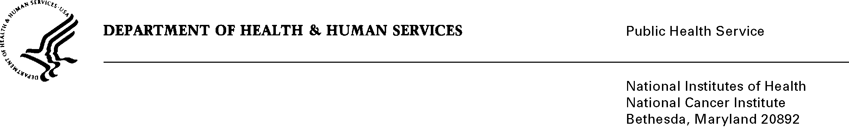
Date: September 9, 2013

TO: Office of Management and Budget (OMB)

Through: Keith Tucker, Reports Clearance Officer, HHS
Seleda Perryman, Report Clearance Officer, NIH
Vivian Horovitch-Kelley, PRA OMB Clearance Liaison, NCI

FROM: Linda Nebeling, Ph.D., MPH, RD, FADA
Health Behaviors Research Branch, Division of Cancer Control & Population Sciences, National Cancer Institute (NCI)/NIH

SUBJECT: New Submission of “Family Life, Activity, Sun, Health, and Eating (FLASHE) Study ”

This is a request for OMB to approve the new information collection titled, “Family Life, Activity, Sun, Health, and Eating (FLASHE) Study” for two years. The supporting statements and various attachments accompany this memorandum.

The FLASHE Study takes a dyadic approach to examine psychosocial, generational (parent-adolescent), and environmental correlates of cancer preventive behaviors. FLASHE will examine the science of cancer and obesity prevention by examining correlates of cancer preventive behaviors, mainly diet, activity, and sedentary behaviors (but also examining other behaviors such as sleep, sun-safety, and tobacco) in new ways not previously addressed comprehensively on other surveys in samples of parents and their adolescent children. The survey’s goal is to advance understanding of the dynamic relationship between the environment, psychosocial factors, and cancer preventive behaviors from a dyadic perspective. Data collected will ultimately be a public use dataset and resource to the research community. FLASHE will be collecting data from parents and their adolescent children using a web survey format with a final estimated sample size of 2,500 dyads, with motion sensing data collected in a subsample of 900 adolescents.

The mission of the Health Behaviors Research Branch is to support research on cancer prevention behaviors and outcomes, which includes diet, physical activity, sedentary behavior, energy balance, obesity, skin cancer prevention (e.g., sun safety), genetic influences on behaviors and virus exposure. It provides leadership in these areas by focusing research on effective cancer prevention influences and approaches at multiple levels including individual, relational, environmental, and community-based. One important strategy to support the mission is to develop publically available datasets that allow the research community to examine correlates of cancer preventive behaviors and the role of the social and environmental context on these behaviors, such as diet and physical activity. The FLASHE Study will provide the data for a publically available dataset that will allow the research community to investigate the correlates of cancer preventive behaviors.

