TRIBAL ANNUAL REPORT

Guide For CCDF
Tribal Lead Agencies
(ACF-700)

Revised March 2008

This reporting guide is a technical assistance product of the Child Care Bureau, Office of Family Assistance, Administration for Children and Families, US Department of Health and Human Services. The guide is for distribution according to department policy. It was revised by General Dynamics Information Technology under contract GS-35F-4357D.



Table of Contents
I. Introduction 1
II. Overview of the Required Tribal Reports 2
III. Preparing the CCDF Tribal Grantee Supplemental Narrative Report 4
IV. Preparing the ACF-700 Report 5
IV. 1 Manual Preparation of the ACF-700 Report: 5
IV. 2 Computer Preparation of the ACF-700 Report: 6
V. Report Preparation – General Instructions 9
VI. Instructions for Manual Calculations (includes definitions) 14
VII. Submitting the Annual Report 38
VII. 1 Internet Submission of the ACF-700 Report 38
VII. 2 Alternate Electronic Submission of the ACF-700 Form and Supplemental Narrative 46
VII.3 Hard Copy Paper Submissions 46
VIII. Resources 47
Appendix A – Glossary of Commonly Used Child Care Terms 48
Appendix B – Internet Submission Registration Form 51

I. Introduction

On an annual basis, Tribal Lead Agencies for the Child Care and Development Fund (CCDF) grantees are required to submit aggregate information on services provided. The Tribal CCDF Annual Report consists of two parts:

- The ACF-700 Form reports data on children and families that received CCDF-funded child care services, and on services that were provided.

- The Supplemental Narrative describes general child care activities and actions in the Lead Agency’s reservation or Tribal service area.

The data reported on the ACF-700 form should reflect services provided during the Federal fiscal year, regardless of whether the services were paid for with CCDF funds from that year or a previous year, and regardless of whether the funds used were Tribal Mandatory Funds or Discretionary Funds. In addition, if a program uses other funds to further support direct child care services for the children being reported on the ACF-700, Tribes should indicate the use of those funds and identify the funding source in the "Comments" field of the ACF-700 report.

Required reports cover the twelve-month Federal fiscal year period from October 1 through September 30. Tribes should only report services that occurred within the Federal fiscal year for which the report is being calculated.

The CCDF Annual Report is due by DECEMBER 31.

This manual provides guidance for completing both the ACF-700 form and the Supplemental Narrative. The remaining sections of the guide include an overview of the report, guidance for completing the Supplemental Narrative, general instructions for ensuring an accurate and complete ACF-700 report, specific directions for those grantees who are preparing the report manually without the help of automated software, submission options, and resources for additional help.

II. Overview of the Required Tribal Reports

The required CCDF Tribal Report contains two parts: 1) the ACF-700 form, and 2) the Supplemental Narrative. The ACF-700 report contains counts of the families and children who received services and information about the services they received, while the Supplemental Narrative gives grantees the opportunity to detail the results of activities in their Tribal service area. The ACF-700 Report and Narrative together offer the Child Care Bureau (CCB) a glimpse into how CCDF program dollars are being spent. Collectively, the submitted reports help to tell the CCDF Tribal child care “story.” The data help to document the work being done and are essential for demonstrating the accomplishments of Tribal child care programs.

The data submitted on the ACF-700 report and the information from the Supplemental Narrative provide the US Congress with information on Tribal programs and serve to inform both policy and fiscal decisions. In addition, the data gathered for the ACF-700 report are a rich source of information that also can be used for a variety of program needs including informing your Tribal Council about your program and the services you provide, evaluating your program, training staff, resource development, and community education.

The ACF-700 form on the following page was modified in FFY 2008 to include additional selection options for Data Element # 4 – Reason for Receiving Care – and to add a new data element to the report. The additional selection options for Data Element # 4 address circumstances where the grantees may be providing care in response to, or associated with, Federally Declared Emergencies. The new element added to the report is: Data Element # 8 – Number of Children Served by Payment Type which includes grant/contract with provider, certificate or voucher, cash payments to parents, and tribally-operated centers.

Instructions for completing both the ACF-700 form the Supplemental Narrative are discussed in the following sections.

ACF-700 Form
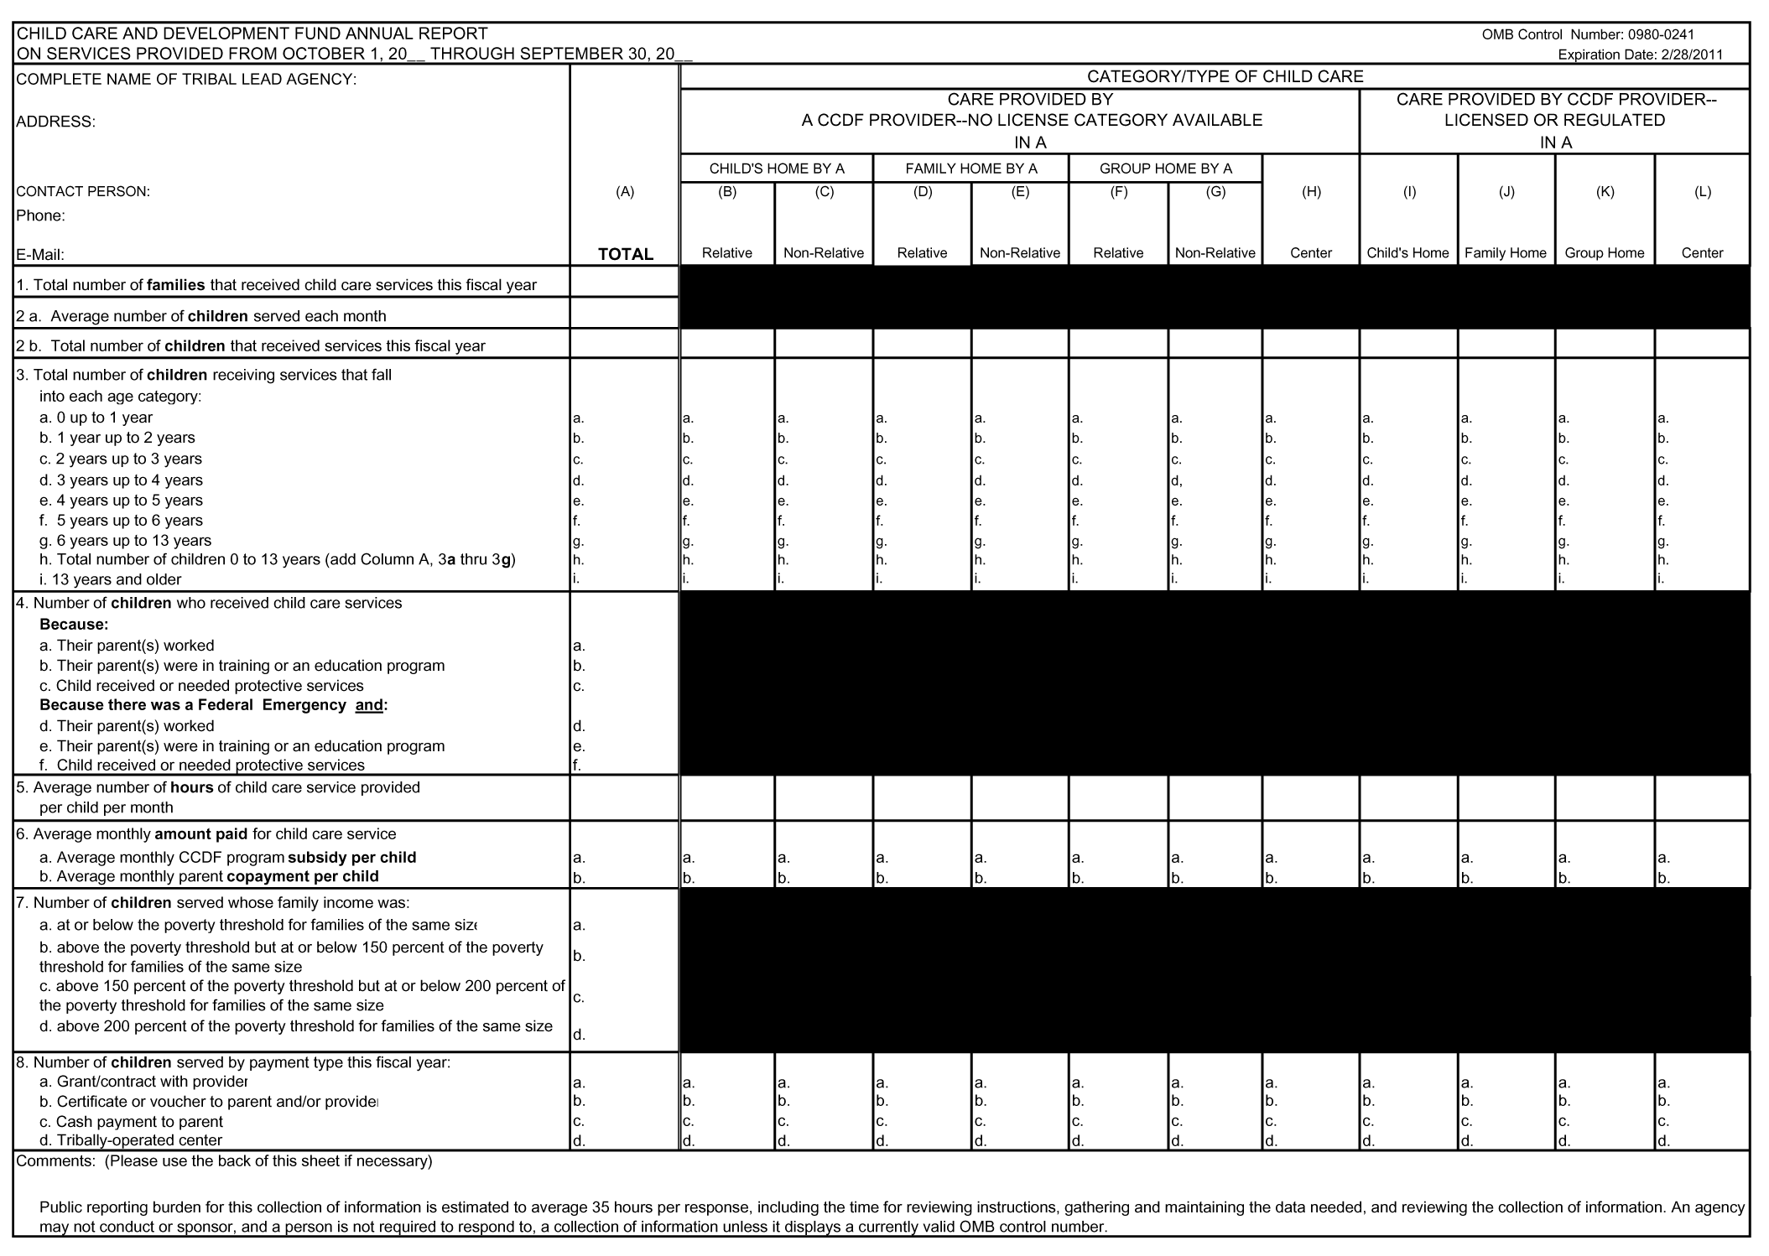
III. Preparing the CCDF Tribal Grantee Supplemental Narrative Report

The Supplemental Narrative Report (to the ACF 700 Form) requests descriptions of the results of specific CCDF-funded activities available on the Tribal Lead Agency’s (TLA) reservation or Tribal service area. This information will be included in the CCDF Report to Congress, as appropriate, and will be shared with other TLAs to inform them of CCDF-funded activities in other Tribal programs. There is no required format for the Supplemental Narrative Report. TLAs are encouraged to include any related materials to accompany the narrative, including brochures, pamphlets or news articles.

The Supplemental Narrative Report requires all TLAs to describe:
1. Any efforts to improve the quality of child care (e.g., early learning and literacy activities, which support school readiness).
2. A description of unmet child care needs, if applicable. For example, a TLA might cite the number of eligible children on a waiting list as of a specific date. A TLA could also cite the unmet need by providing the number of months child care services are not available due to a lack of funds.
3. A description of collaborative activities which promote comprehensive early care and education services, encourage increased quality, business participation, and coordination with State or Tribal agencies responsible for health, education, employment services or workforce development and the State or Tribal agencies responsible for providing Temporary Assistance to Needy Families (TANF).
4. A description of efforts to improve the quality of data collected about families and children served and the types of care provided. If a TLA is using the Child Care Data Tracker, a description of the use of the Tracker must be included.

IV. Preparing the ACF-700 Report

The ACF-700 report can be prepared manually with all of the arithmetic calculations performed by hand, or it can be prepared automatically using computer software. Regardless of the method used to calculate the report, you must keep track of certain information on a regular basis (monthly tracking is recommended). Even though the ACF-700 report and Supplemental Narrative are due at the end of each Federal fiscal year, the information required to prepare the reports must be gathered on an ongoing basis throughout the year.

The ACF-700 should be prepared using information that programs collect during a family’s intake as well as information that is collected on an ongoing basis when services are provided. Generally, during the intake process, a child care program collects demographic information about the families and children they serve. Additionally, as services are provided, programs capture information on the hours of care each child receives, the payment they make on behalf of each child, and each family’s assigned co-pay. All of this information is used to summarize data for the annual ACF-700 report.

You should only include information about children/families whose direct child care services were provided during the Federal fiscal year, regardless of which year’s CCDF funds paid for those services. Note that child care services should be reported whether paid for wholly or in part with CCDF funds. Child care services include those services that you offer directly through your own CCDF program, or services that you pay for with your CCDF grant but are offered by other programs and providers. Child care services include slots purchased through contracts/grants, services purchased through certificates/voucher, and services provided in a tribally-operated facility. See Appendix A for definitions.

IV. 1 Manual Preparation of the ACF-700 Report:

If you choose to complete your ACF-700 manually you will have to be prepared to do the required arithmetic calculations yourself. This can be as simple as counting the number of families and children you served, or as complex as the calculation of monthly averages.

The required information includes the number of families and children receiving services, ages of the children, their reason for care, the number of hours of care for each month for each child, the monthly subsidy amount paid on their behalf, the family’s monthly co-pay, each family’s income, and the type of payment made for each child. For co-payment, subsidy amounts, and hours of service, you also will need to calculate averages for all families and children on a monthly basis for each type of care you provide.

Depending upon the number of clients that a program serves and the number of provider types used, some of the calculations required for the ACF-700 report can be time consuming and preparing the report can be a tedious process. Again, although this is an annual report, many of the calculations have to be completed for each month of the year for each type of care you offer.

If you do prepare your ACF-700 manually, you will find detailed instructions that are required for the accurate reporting of each of the data elements in Section VI of this Guide.

IV. 2 Computer Preparation of the ACF-700 Report:

To facilitate the preparation of the ACF-700 report, some Tribal grantees use automated systems to capture and manage the required information. The Child Care Bureau (CCB) recognized that many Tribal grantees did not have access to information systems that would allow for the capture and management of information for the required ACF-700 report, and developed the Child Care Data Tracker (Tracker) to facilitate the reporting process. The use of this software is optional for the Tribal grantees.

The Tracker is a Microsoft Access-based software tool that is installed and used on any computer that supports Microsoft Access. It is a comprehensive case management tool that can help you to maintain all of your client records and allows you to record a broad range of information about clients including demographics, eligibility reviews, services received, and payments made. The Tracker also can automatically generate a variety of reports, including the required ACF-700 report, based on the required data that you enter. The software is available free of charge to CCDF Tribal Grantees. Over time, several versions of the Tracker have been developed, each of which has made the software more user-friendly and allowed it to function more efficiently.

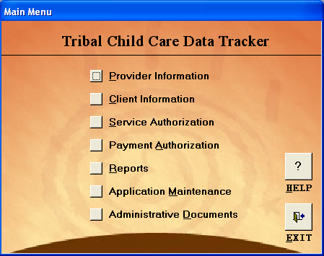

The Tracker functions generally parallel the activities used by child care program staff with the families they serve. There are several data entry modules in the Tracker that allow you to keep track of your children and families, providers, service authorizations and payments. The ACF-700 report is based on the information/data that you enter in these modules. Program information that is required for the ACF-700 report also is required by the software when you use the Tracker. This feature of requiring certain data ensures that you will be able to generate an ACF-700 report at the end of the year.

In addition to generating the ACF-700 report, the report module in the Tracker allows you to generate applicant, provider, service, and payment reports with a variety of sorting options.

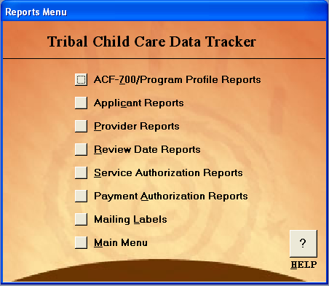

To learn more about the Child Care Data Tracker, see the CCB website at: http://www.acf.hhs.gov/programs/ccb/ta/ccarc/tracker.htm for hardware and software requirements and for a downloadable copy of the User’s Guide.
V. Report Preparation – General Instructions

Regardless of whether you are completing your ACF-700 report manually or using automated software, the following general instructions in Table 1 apply to all of the data elements on the ACF-700 form and can provide guidance as you perform quality assurance checks on your data to ensure they are accurately reflecting your program.

Tables 2 and 3 provide additional information regarding the acceptable use of “Not Applicable” (NA) for any of the ACF-700 report fields, and quality assurance data checks to review prior to submitting your report to CCB.
General Instructions
NOTE: Upper case letters (A, B…L) represent vertical columns on the report. Lower case letters (a, b…f) represent rows going across the report.
Report Period – Federal Fiscal Year | The Federal fiscal year (FFY) begins on October 1 and ends on September 30 of each year. The ACF-700 report should only include information about those activities that occurred during this time frame.
Allowable Values | Generally, the fields should only contain numbers or letters. Do not use decimals, dollar signs, dashes, or other characters.
What to Report –  Counts or Averages | Some data elements require that you provide counts (for example, counts of families or children) while others require that you provide averages.  Counts are required for data elements 1, 2b, 3a-i, 4a-f, 7a-d, and 8a-d.  Averages are required for data elements 2a, 5, 6a, and 6b. To calculate averages, refer to the guidance included in this document for each individual data element.
Counting Children not Families | There is only one data element that requires a family count – Element 1, Column A: Total number of families that received child care services this fiscal year.  All other data elements requesting counts of who received services are counts of children (2b, 3a-i, 4a-f, 7a-d, and 8a-d). Even if you collect information at the family level (for example Element 4, Reason for care), the data should be reported as a count of children within those families.
Unduplicated Counts  (Column A) | In Column A (with the exception of elements 2a, 5, and 6a-6b which ask for averages), you should count each family or child only once regardless of how many times they may have entered and exited service during the Federal fiscal year, or if they received services from more than one provider during the year.
Duplicated Counts  (Columns B-L) | A child should be counted in a column if they received services from that type of provider. The numbers of children reported by provider type (Columns B-L) may be more than the total being reported in Column A; however the number may not be less than Column A. Duplicated counts may be used for data elements 2b, 3a-i, and 8a-d (Columns B-L).
Not-Applicable Fields  (see following table for additional details) | The use of NA is restricted as illustrated in Table 2. If you do not offer a particular type of child care service (for example, in-home care) you can enter NA in that column for each data element. If you do not use a particular type of payment (for example, cash payments), likewise you can enter NA in fields across line #8 c. Use NA only if the service option is not one that you use, or a category of families and children you do not serve. If you do offer a service, but no child utilized it, you should enter zero (0) for your count in that field.
Blank Fields | DO NOT LEAVE ANY BLANK FIELDS. Every field should have either a count (a number) or the letters “NA” (Not Applicable).
Rounding | Please round up or down to the nearest whole number. If the number immediately to the right of the decimal point is 4 or less, round the number down. If it is 5 or more, you should round up. For example, 66.3 hours should be rounded down to 66. A dollar amount of $45.75 should be rounded up to $46.00. In this case you would enter 46 on the ACF-700 form without a dollar sign and without a decimal point.
Data Accuracy Checks | Please see the guidance included with each data element in Section VI to check the accuracy of the numbers you are reporting. Note that some numbers must add up to, and equal, numbers reported in other fields. Likewise, some numbers should be less than numbers reported in other fields. If your numbers do not meet the data accuracy check, there may be an error that you need to fix. See Table 3 below for a summary of the checks.
Comments Field | Use the comments field to explain any unusual or inconsistent data. For example, if the number of families and children you served changed drastically from your prior year’s report, you may want to indicate the reason for the change.  You are not able to attach documents in the comments field of the online submission form. Any documents that you would like to submit to CCARC should be sent via e-mail to: ccarc@childcaredata.org.  You should also use the comments box to provide footnotes explaining when any missing data will be submitted.
Table 1: General Instructions for the ACF-700 Report

Permissible Use of “Not Applicable” (NA)
This table summarizes the appropriate use of “NA” on the ACF-700 report and the submission site (see Section VII). On the submission site, if you enter “NA” for a data element where “NA” is not permitted, you will get an error message.
Element/Columns Where “NA” is Permitted | Circumstances Where “NA” is Permitted
Element 2b - Total Number of Children That Received Services This Fiscal Year, Columns B-L | When a Tribe does not utilize specific types of care
Element 3, Rows a-h - Age Breakdown of Children Receiving Services, Total by Age Category/Types of Care, Columns B-L | When a Tribe does not utilize specific types of care
Element 3i - Age Breakdown of Children Receiving Services, 13 and older, Columns B-L | When a Tribe does not serve children older than 13 years
Element 5 - Average Number of Hours Child Care Service is Provided Per Child Per Month by Type of Care, Columns B-L. | When a Tribe does not utilize specific types of care
Element 6a - Average Monthly CCDF Subsidy, Total and by Type of Care, Columns B-L | When a Tribe does not utilize specific types of care
Element 6b - Average Monthly Parent Co-payment, Total and by Type of Care, Columns B-L | When a Tribe does not utilize specific types of care
Element 8, Rows a-d – Number of Children Served by Payment Type this fiscal year, Columns B-L | When a Tribe does not utilize certain payment types
Table 2: Permissible Use of “NA” on the ACF-700 Annual Report

Data Accuracy Check Summary
You can find more detail on the Data Accuracy Checks for each data element in Section VI. All consistency checks marked with an asterisk (*) indicate checks that are conducted on the ACF-700 Electronic Submission Site. See Section VII for more information).
Element | Consistency Check
Element 1, Column A | Element 1 should be less than or equal to Element 2b.
Element 2a, Column A | Element 2a should be less than or equal to Element 2b.
Element 2b, Column A | Element 2b, Column A, should be greater than or equal to Element 1 and greater than or equal to Element 2a, Column A.
Element 2b, Columns B-L | The total of Element 2b, Columns B-L should be equal to, or greater than Element 2b, Column A.
Element 3a-i, Column A | The total of Element 3a through 3g in Column A should be equal to Element 3h, Column A.*  The total of Element 3h, Column A and Element 3i, Column A should equal Element 2b, Column A.*
Element 3a-i, Columns B-L | For each type of care, the total of Elements 3a to 3g in each column should equal the number in Element 3h for that column.*  For each care type, the total number of children in Element 3h and element 3i for that column should equal Element 2b of that column. *  The total sum across each row (Columns B-L) must be equal to, or greater than the number reported on the same row in Column A.
Element 4a-f, Column A | The total of Elements 4 a-f, Column A should equal Element 2b, Column A.*
Element 5, Column A | Generally, full-time care is about 160 hours per month. If most of your children are receiving full-time care, your reported average monthly hours of service per child would not likely be substantially higher or substantially lower than 160 in Column A or in any one care type (Columns B-L).  If, however, you primarily operate a Before or After School program, your average hours per month may be substantially lower. The average hours should be representative of the program that you operate and the services that you provide.
Element 5, Column B-L

Element | Consistency Check
Element 6a, Column A | In most cases, the subsidy amount (6a) will be larger than the co-payment amount (6b) for both the total column (A) and for each individual care type column (B-L). If your reported co-payment is higher than your reported subsidy, you may have an error in your data.
Element 6a, Column B-L
Element 6b, Column A
Element 6b, Columns B-L
Element 7(a-d), Column A | The sum of 7a, 7b, 7c, and 7d must equal Element 2b, Column A.*
Element 8 a-d, Column A | The sum of 8a, 8b, 8c, and 8d must equal Element 2b, Column A.*
Element 8 a-d, Columns B-L | The sum of 8a, 8b, 8c and 8d must equal Element 2b in the same column. *  The total sum across each row (Columns B-L) must be equal to, or greater than the number reported on the same row in Column A.

Table 3: Summary of Data Accuracy Checks
VI. Instructions for Manual Calculations

Following are detailed instructions for manually calculating the ACF-700 report. These instructions include definitions, guidance on manual calculation, and data accuracy checks for each data element. If you are completing the ACF-700 report with the Tracker software, you may skip this section of the guide because all of the calculations are automatically completed by the Tracker software when you generate your ACF-700 report.

Tribal Lead Agency Contact Information:

Tribal Lead Agency Data Elements
Complete Name of Tribal Lead Agency

Definition: Name of the Tribal Lead Agency for the Child Care and Development Fund
Allowable Values: Text
Address

Definition: Mailing address of the Tribal Lead Agency for the Child Care and Development Fund
Allowable Values: Text, Numbers
Tribal Lead Agency City

Definition: City of the mailing address of the Tribal Lead Agency for the Child Care and Development Fund
Allowable Values: Text

Tribal Lead Agency State

Definition: Two-letter postal State abbreviation of the mailing address of the Tribal Lead Agency for the Child Care and Development Fund
Allowable Values: Valid postal State abbreviations

Guidance: Click below for a list of all valid State and Territorial postal State codes
http://www.usps.com/ncsc/lookups/usps_abbreviations.html
Tribal Lead Agency ZIP Code

Definition: Numerical code assigned by the US Postal Service to designate a local area or entity for the delivery of mail
Allowable Values: Accepts all valid ZIP codes
5 digits required
4 digit extension option (do not include hyphen)

Guidance: You can search for valid ZIP codes at: http://zip4.usps.com/zip4/citytown_zip.jsp
Tribal Lead Agency Contact Information (continued)

Contact Person Information
Contact Person

Definition: Full name of individual whom the Child Care Bureau should contact in regard to this report
Allowable Values: Text
Phone

Definition: Area code and telephone number for the contact person
Allowable Values: Numbers
Guidance: Include area code
E-mail

Definition: Electronic mail address for the contact person
Allowable Values: Text, Numbers
Guidance: Be sure that the entered e-mail address is complete and clearly legible

DATA ELEMENT 1, Column A: Total number of families that received child care services this fiscal year

Element 1, Column A
Total Number of Families That Received Child Care Services This Fiscal Year
Definition: Unduplicated count of families who received CCDF subsidized child care services during the Federal fiscal year.
Child care services include those that you offer directly through your own CCDF program, or services that you pay for with your CCDF grant but are offered by other programs and providers. Child care services include slots purchased through contracts/grants, services purchased through certificates/vouchers, and services provided in a tribally-operated facility. See Appendix A for definitions.
Data Accuracy Check: Element 1, number of families receiving services should be less than or equal to Element 2b, the total number of children receiving services.
Guidance: Each family should be counted once, regardless of the number of days care was provided, and even if the family has exited and re-entered the program.

Example 1: A family leaves the program in March but is reinstated in August. The family is counted one time in Element 1.

Report the number of families for whom you provided services during the reporting period October 1 – September 30 regardless of:
- when the payment for the service was made, or
- which fiscal year's funds paid for the service.

Example 2: A child received care in August only. The Tribal Lead Agency paid for that care in October. Count the family because the service was received during the report period.

When data are applicable but not available, provide a footnote in the comment section explaining when the missing data will be submitted.

DATA ELEMENT 2a, Column A: Average number of children served each month

Element 2a, Column A
Average Number Of Children Served Each Month
Definition: The average number of children served each month. An average is one single number that arithmetically represents a group of numbers. See the Guidance section below for one method of calculating this data element.
Data Accuracy Check: Element 2a, the average number of children served per month should be less than or equal to Element 2b, the total number of children receiving services all year.
Guidance - How to Calculate a Monthly Average Number of Children Served:
Add the number of children you served each month during the Federal fiscal year and divide by the number of months the Tribal child care program provided services (such as full year, 12 months).

Note: This is a monthly average, not a yearly average. The following demonstrates how a monthly average can be calculated.

Month | # Children
Oct | 15
Nov | 12
Dec | 13
Jan | 13
Feb | 12
Mar | 14
Apr | 11
May | 12
Jun | 13
Jul | 15
Aug | 15
Sep | 18
Total count for all months | 163
Divide by the number of months provided service (12) to get a monthly average. | 13.58  (Round to 14)

When data are applicable but not available, provide a footnote in the comment section explaining when the missing data will be submitted.

DATA ELEMENT 2b, Column A: Total number of children that received services this fiscal year

Element 2b, Column A
Total Number of Children That Received Services This Fiscal Year
Definition: An unduplicated count of children who received child care services for the Federal fiscal year regardless of the type of care.
Data Accuracy Checks:

Check 1: Element 2b, Column A, should be greater than or equal to Element 1, Column A, the total number of families receiving services.

Check 2: Element 2b, Column A, should be greater than or equal to Element 2a, Column A, the average number of children receiving care each month.
Guidance: Each child who received services should be counted only once, regardless of the number of days care was provided or if the child exited and re-entered the program.

Example 1: A child leaves the program in March, but is reinstated in August. The child is counted one time in Element 2b, Column A.

Count all children who received child care services during the Federal fiscal year. Child care services are defined as slots purchased through contracts/grants, services purchased through certificates/vouchers, or services provided in a tribally-operated facility funded under CCDF. See Appendix A for definitions.

Example 2: A Tribal Lead Agency provides child care certificates/vouchers to 100 families to receive child care services at a program of their choice. The total unduplicated number of children should be counted in Element 2b, Column A. Enter the number of children receiving child care through certificates/vouchers regardless of their setting type on line 2b, Column A.

Example 3: A Tribal Lead Agency contracts with a center for 50 full-time slots for the Federal fiscal year. The total unduplicated number of children receiving child care through agency contracts with centers should be reported in Element 2b, Column A. If you contracted for 50 slots, the number of children served through these slots will depend on the utilization rate.
(continued)

DATA ELEMENT 2b, Column A (continued)

Do not count children or families who only generally benefited from services such as when your program:

- Receives a grant or contract to establish, expand, or conduct an early childhood school readiness enrichment program (i.e., not specific slots); or

- You initiate an expansion of quality activities funded under the CCDF. Your use of quality dollars to improve the quality of care should be explained in your Supplemental Narrative.

Example 4: A Tribal Lead Agency contracts with a resource and referral agency to provide professional staff development training at a Center serving 78 children. The Tribal Lead Agency does not contract for slots with the center and no children there receive CCDF certificates. Do not count the children because they did not receive direct child care services from the CCDF funds expended.

When data are applicable but not available, provide a footnote in the comment section explaining when the missing data will be submitted.
DATA ELEMENT 2b, Columns B-L: Total number of children that received services this fiscal year by category/type of child care

Element 2b, Columns B-L
Total Number of Children Receiving Child Care Services This Fiscal Year by Category/Type of Child Care
Definition: An unduplicated count of children who received child care services during the Federal fiscal year for each provider type. See the Guidance section below for detailed definitions of care types.

Data Accuracy Check: Add the number of children being served in each care type (Element 2b, Columns B-L). This number should be equal to, or greater than, the total unduplicated number of children reported in Element 2b, Column A. The sum of the children being served in all care types can not be less than the total number of children reported in Column A.

Guidance: A child may be counted in more than one provider type column (Columns B-L) if the child received care from more than one provider type for different portions of the typical day, week, or month. However, the child should NOT be counted more than once within a single provider type column.

Example 1: A child attends a family child care home before school hours and a child care center after school hours. The child would be counted under provider types of both family home and center based child care.

When a child changes the category of provider during the report period, count the child separately in each care type.

Example 2: A child receives care in a family child care home from September to March, uses an in-home provider during April and a center from May through October. The child would be counted under each provider type – family home, child’s home, and center care.

Provider types are broken up into two broad categories of no license category available (legally operating in state or locality) and licensed/regulated. Under each of these categories are four types of providers: child’s home, family home, group home, and centers. Additionally, several no-license category provider types are also broken down into relative and non-relative care.

(Continued)

DATA ELEMENT 2b, Columns B-L (continued):

No License Category Available (legally operating provider) = For reporting purposes, a legally operating, unregulated provider is one which, if not participating in the CCDF program, would not be subject to state or local child care regulations. According to section 98.2 of the CCDF regulations, "Licensing or regulatory requirements means requirements necessary for a provider to legally provide child care services in a state or locality, including registration requirements established under state, local or Tribal law...."

Licensed or regulated provider = Provider legally regulated or licensed by Tribe or State
designated licensing agent.

DEFINITIONS:

Child’s Home  Family Home  Group Home  Center-Based  Relative Care | Care provided by a caregiver in the child’s own home.  Care provided in the family home of the provider (i.e., care provided by an individual in their own private residence). Generally family home care is provided only to a limited number of children at any one time (e.g. 3-5).  Care provided in the family home of the provider with the assistance of at least one additional hired staff member. Group homes can provide services to a larger number of children at any one time (e.g. 6-10).  Care provided in a center-based setting, including programs in schools or churches.  Care by a provider who is a grandparent, great-grandparent, aunt or uncle, or sibling living outside the child’s home.
When data are applicable but not available, provide a footnote in the comment section explaining when the missing data will be submitted.

DATA ELEMENT 3 a-i, Column A: Total number of children receiving services that fall into each age category

Element 3 a-i, Column A
Total Number of Children Receiving Services That Fall Into Each Age Category
Definition: Breakdown by age of children receiving child care services.

Data Accuracy Checks:

Check 1: Add the total number of children in each age bracket for Elements 3a through 3g in Column A. Compare your answer to the number in Element 3h, Column A. If they are not the same, there is an error in the data which should be corrected.

Check 2: Add the total number of children in Element 3h, Column A and the number of children in Element 3i, Column A. Your answer should equal the number in Element 2b, Column A. If not, there is an error in the data which should be corrected.
Guidance: Each child that received services should be counted only once, regardless of the number of days care was provided and even if the child has exited and re-entered the program.
Example 1: A child leaves the program in March, but is reinstated in August. The child is counted one time in Elements 3 a-i, Column A.

The age of the child is reported as of the end of the report period (or the date of exit from the CCDF program).

Example 2: A 2-year-old child received services starting in March. On September 15 she turned 3 years old and continued to receive services through the reporting period. The child should be reported as a 3-year-old on line 3d, Column A.

When data are applicable but not available, provide a footnote in the comment section explaining when the missing data will be submitted.

DATA ELEMENT 3 a-i, Columns B-L: Total number of children receiving services that fall into each age category by category/type of child care
Element 3 a-i, Columns B-L
Total Number of Children Receiving Services That Fall Into Each Age Category by Category/Type of Child Care
Definition: Breakdown by age of children receiving child care services by category/type of care.
Data Accuracy Checks:
Check 1: For each type of care, add the number of children in each age bracket for Elements 3a to 3g in each column. Your number should match the number in Element 3h for that column. If the numbers do not match there is an error that should be corrected.

Check 2: For each type of care, add the number of children in Element 3h and the number of children in Element 3i for that column. Compare your answer to the value entered in Element 2b of that column. If the numbers are not the same, there is an error that should be corrected.

Check 3: The total sum across each row (Columns B-L) must be equal to, or greater than the number reported on the same row in Column A.
Guidance: A child may be counted in more than one provider column (Columns B-L) if the child receives care from more than one provider type during the Federal fiscal year. However, the child should not be counted more than once within a single provider type column.

Example 1: A child attends a child care center in the morning and a family child care home in the afternoon. The child would be counted under both provider types of center-based and family home.

Example 2: If a child only attended a child care center starting in June and switched to a family home starting August 16 and continuing through September 30, count the child once in each category.

Provider types are broken up into the two broad categories of no license category available (legally operating in state or locality) and licensed/regulated. Under each of these categories are four types of providers: child’s home, family home, group home, and centers. Additionally, several no-license category provider types are also broken down into relative and non-relative care.

Refer to definitions provided for Element 2b, Columns B-L.

When data are applicable but not available, provide a footnote in the comment section explaining when the missing data will be submitted.

DATA ELEMENT 4 a-f, Column A: Number of children who received child care services because of each specified reason

Element 4 a - f, Column A
Number of Children Who Received Child Care Services Because of Each Specified Reason
Definition: An unduplicated count of children receiving child care services by reason for care.
This element separates reason for care into six categories:

- Parent working
- Parent in a training or education program
- Child receiving or needing Protective Services
- A Federally declared emergency and parent working*
- A Federally declared emergency and parent in a training or education program*
- A Federally declared emergency and a child receiving or needing Protective Services*

* Effective in FFY 2008, three new categories of Reason for Care were added. These categories relate to special situations during which the reason for receiving subsidized care is related to the existence of a Federally declared emergency, and when other routine eligibility criteria may not necessarily have to apply in the same way. This generally is a temporary category used only for the duration of the emergency.

A Federally declared emergency is an emergency that has resulted in a declaration by the President of the U.S. indicating that Federal assistance is necessary.
Data Accuracy Check: Add the number of children recorded for Elements 4 a-f Column A. This answer and the number in Element 2b, Column A should be the same. If they are not the same, there is an error.
Guidance: This is a count of children, NOT families. Each child may be counted only once.

When a family receives care for more than one reason (e.g., the parent works and is in a training program), count only the activity in which the parent (or child, in the case of Protective Services) spends the most time and is the primary reason for needing subsidized child care – that is, the reason the family is eligible to receive a subsidy.

Element 4, Column A entries should be unduplicated counts.

When a child’s reason for needing care changes during the report period, report the reason as of the end of the report period (or date of exit from the program).
(continued)
DATA ELEMENT 4 a-f, Column A: (continued)

Example 1: A child received care in October because of her parents' employment. From November through September child care was provided because the child was in Protective Services. Count the child in line 4c only – Protective Services.

NOTE: Each Tribal Lead Agency defines the terms "working," "job training and educational program” and “protective services" in Appendix 2 of its Tribal Plan Preprint.

When data are applicable but not available, provide a footnote in the comment section explaining when the missing data will be submitted.

DATA ELEMENT 5, Column A: Average number of hours of child care service provided per child per month
Element 5, Column A
Average Number of Hours of Child Care Service Provided Per Child Per Month
Definition: The average number of hours of child care service provided per child per month.
Data Accuracy Check: Generally, full-time care is about 40 hours per week for 4 weeks (about 160 hours per month). If most of your children are receiving full-time care, your reported average monthly hours of service per child would not likely be substantially higher or substantially lower than 160.

If, however, you primarily operate a Before or After School program, your average hours per month may be substantially lower. The average hours should be representative of the program that you operate and the services that you provide.
Guidance: This is a monthly average, NOT a yearly average. One method to calculate the average number of hours of care per child per month:

- Begin by counting the total number of hours of care for all children for the first month you provided service during the fiscal year (month X, for example October)
- Count the total number of children served during month X
- Divide the total number of hours from step 1 by the total number of children from step 2 to get the average number of hours of care provided per child for month X
- Do steps 1 – 3 for each month services were provided
- Add together each of the monthly average hours to get a sum
- Divide the sum from step 5 by the total number of months services were provided during the year to get the average number of hours of care provided per child per month

Some Tribal Lead Agencies do not pay for (or keep records for) the actual number of hours of service per child. Rather, they reimburse by "full" or "part" days of service (or other increments). Such Tribal Lead Agencies still can calculate the average number of hours of child care per child per month based on the program’s definitions or estimate of the number of hours that “full” or “part” days represent.

For example, a Tribal Lead Agency may define a “part” day as 4 hours or fewer per day (and estimate a “part” day at 4 hours of care). This same grantee may define a “full” day as more than 5 hours (and estimate a “full” day at 8 hours of care). In step #1 of the above calculations, the Tribal Lead Agency would count 4 hours of care for each “part” day and “8” hours for each “full” day they paid for child care services to get the total number of hours of care for all children for month X.

When data are applicable but not available, provide a footnote in the comment section explaining when the missing data will be submitted. Tribal Lead Agencies should also describe in a footnote how they calculated the average number of hours.

DATA ELEMENT 5, Columns B-L: Average number of hours of child care service provided per child per month by category/type of child care
Element 5, Columns B– L
Average Number of Hours of Child Care Service Provided Per Child Per Month by Category/Type of Child Care
Definition: The average number of hours of child care service provided per child per month – by category/type of child care.
Data Accuracy Check: Generally, full-time care is about 40 hours per week for 4 weeks (about 160 hours per month). If most of your children are receiving full-time care, your reported average monthly hours of service per child would not likely be substantially higher or substantially lower than 160.

If, however, you primarily operate a Before or After School program, your average hours per month may be substantially lower. The average hours should be representative of the program that you operate and the services that you provide.
Guidance: This is a monthly average, NOT a yearly average. One method to calculate the average number of hours of care per child per month by category/type of child care:

- Work with one care type at a time and begin by counting the total number of hours of care for the first month you provided service during the fiscal year (month X, for example October) for all of the children in that type of child care
- For that care type, count the total number of children served during month X
- Divide the total number of hours for that type of child care from step 1 by the total number of children from step 2 to get the average number of hours of care provided per child for month X for that type of child care
- Do steps 1-3 for each month services were provided in that care type
- Add together each of the monthly averages for that type of child care to get a sum
- Divide the sum (from step 5) by the total number of months services were provided during the year in that care type to get the average number of hours of care provided per child per month for that category/type of child care
- Repeat steps 1-6 for each type of care

Some Tribal Lead Agencies do not pay for (or keep records by) the actual number of hours of service per child. Rather, they reimburse by "full" or "part" days of service (or other increments). Such Tribal Lead Agencies can still calculate the average number of hours of child care per child per month by type of care based on the programs definition or estimate of the number of hours that “full” or “part” days represent.

For example, a Tribal Lead Agency may define a “part” day as 4 hours or fewer per day (and estimate a “part” day at 4 hours of care). This same grantee may define a “full” day as more than 5 hours (and estimate a “full” day at 8 hours of care). In step #1 of the above calculations, the Tribal Lead Agency would count 4 hours of care for each “part” day and “8” hours for each “full” day they paid for child care services to get the total number of hours of care for all children in that type of child care.

When data are applicable but not available, provide a footnote in the comment section explaining when the missing data will be submitted.
DATA ELEMENT 6a, Column A: Average monthly CCDF program subsidy per child

Element 6a, Column A
Average Monthly CCDF Program Subsidy Per Child
Definition: The average monthly cost that your CCDF program paid for child care services per child. This does not include the parent’s co-payment.
Data Accuracy Check: Except in rare circumstances, Element 6a, Column A, the average monthly subsidy paid per child, will be greater than Element 6b, Column A, the average monthly parent co-payment paid per child.

Guidance: This is a monthly average, NOT a yearly average. Tribal Lead Agencies should use the same method for calculating the average monthly subsidy amount paid in Element 6a, Column A as used to calculate the average number of hours of care for Element 5, Column A.

One method to calculate the average monthly CCDF subsidy paid for child care services per month per child:

- Begin by counting the total amount of CCDF subsidy paid for child care services for all children for the first month you provided service during the fiscal year (month X, for example October)
- Count the total number of children served during month X
- Divide the total amount from step 1 by the total number of children from step 2 to get the average amount of CCDF subsidy paid for child care services for month X
- Do steps 1 – 3 for each month services were provided
- Add together each of the monthly averages to get a sum of averages
- Divide the sum from step 5 by the total number of months services were provided during the year to get the average subsidy amount paid for child care services per child per month

(continued)

DATA ELEMENT 6a, Column A (continued)

Guidance for Tribally-Operated Centers:

Some Tribal Lead Agencies run their own center(s) and do not technically “pay” a provider. Such agencies can still estimate the “average” monthly CCDF subsidy amount paid per child for child care services provided using the record of expenditures that is submitted annually on the required ACF-696T, the Tribal financial report.

Calculation to estimate the average monthly subsidy per child (for programs with a Tribally Operated Center):

1) Add the Tribal Mandatory, Discretionary, and Discretionary Funds Base amount expenditures (not including expenditures for construction and renovation) that your Tribe reported on Line 4 of the ACF-696T – Expenditures for Child Care Services. During the fiscal year, if you expended funds from more than one grant year, you must add the appropriate expenditures from each of the reports submitted regardless of the year that the grant was awarded.

2) Divide the above total by the number of months that you provided services during the year (ranging from 1 to 12 months) to get an overall monthly subsidy amount.

3) Divide the monthly subsidy amount from step 2 by the average number of children served per month (data element 2a) to estimate the average monthly subsidy per child.

When data are applicable but not available, provide a footnote in the comment section explaining when the missing data will be submitted.

DATA ELEMENT 6a, Columns B-L: Average monthly CCDF program subsidy per child by category/type of child care

Element 6a, Columns B-L
Average Monthly CCDF Program Subsidy Per Child by Category/Type of Child Care
Definition: The average monthly cost that your CCDF program paid for child care services per child for each category/type of care.
Data Accuracy Check: Except in rare circumstances, Element 6a, Columns B-L, the average monthly subsidy paid per child will be greater than Element 6b, Columns B-L, the average monthly co-pay paid per child.
Guidance: This is a monthly average, NOT a yearly average.
Tribal Lead Agencies should use the same method for calculating the average monthly CCDF subsidy in Element 6a, Columns B-L as used to calculate the average number of hours of care for Element 5, Columns B-L.

One method to calculate the average monthly CCDF subsidy amount paid for child care services per month for each category/type of child care:

- Work with one care type at a time and begin by calculating the total amount of CCDF subsidy paid for child care services for the first month you provided service during the fiscal year (month X, for example October) for all children in that one type of care
- For that care type, count the total number of children served during month X
- Divide the total amount from step 1 by the total number of children from step 2 to get the average amount of CCDF subsidy paid for child care services for month X for that care type
- Do steps 1 – 3 for each month services were provided by that care type
- Add together each of the monthly subsidy averages for that type of care to get a sum
- Divide the sum from step 5 by the total number of months services were provided during the year in that care type to get the average amount paid for child care services per month for that care type
- Repeat steps 1-6 for each type of care

(continued)

DATA ELEMENT 6a, Columns B-L (continued)

Guidance for Tribally-Operated Centers:

Some Tribal Lead Agencies run their own center(s) and do not technically “pay” a provider. Such agencies can still estimate the “average” monthly CCDF subsidy amount paid per child for child care services provided using the record of expenditures that is submitted annually on the required ACF-696T, the Tribal financial report.

Calculation to estimate the average monthly subsidy per child (for programs with a Tribally Operated Center):

1) Add the Tribal Mandatory, Discretionary, and Discretionary Fund Base amount expenditures (not including expenditures for construction and renovation) that your Tribe reported on Line 4 of the ACF-696T – Expenditures for Child Care Services. During the fiscal year, if you expended funds from more than one grant year, you must add the appropriate expenditures from each of the reports submitted regardless of the year that the grant was awarded.

2) Divide the above total by the number of months that you provided services during the year (ranging from 1 to 12 months) to get an overall monthly subsidy amount.

3) Divide the monthly subsidy amount by the average number of children served per month (data element 2a) to estimate the average monthly subsidy per child.

When data are applicable but not available, provide a footnote in the comment section explaining when the missing data will be submitted.

DATA ELEMENT 6b, Column A: Average monthly parent co-payment amount paid per child for child care service.

Element 6b, Column A
Average Monthly Parent Co-payment Per Child
Definition: The average monthly cost that the family/parent was assessed to pay toward the cost of care per child.
Data Accuracy Check: Generally the parent co-payment is less than the subsidy amount (Element 6a). If your co-payment is larger than the reported subsidy, check to be sure that your numbers are correct.

Guidance: This is a monthly average, NOT a yearly average. Tribal Lead Agencies should use the same method for calculating the average monthly parent co-payment on Element 6b, Column A as used to calculate the average number of hours of care for Element 5, Column A.

One method to calculate the average monthly parent co-payment amount paid for child care services per month per child for each category/type of child care:

- Begin by calculating the total amount of CCDF co-payments paid by all families for child care services for the first month you provided service during the fiscal year (month X, for example October)
- Count the total number of children served during month X
- Divide the total amount from step 1 by the total number of children from step 2 to get the average CCDF co-payment paid per child for child care services for month X
- Do steps 1 – 3 for each month services were provided
- Add together each of the monthly co-payment averages to get a sum
- Divide the sum from step 5 by the total number of months services were provided during the year to get the average parent co-payment amount paid for child care services per month per child

When data are applicable but not available, provide a footnote in the comment section explaining when the missing data will be submitted.

DATA ELEMENT 6b, Column B-L: Average monthly parent co-payment per child by category/type of child care.

Element 6b, Columns B-L
Average Monthly Parent Co-Payment Amount Paid Per Child by Category/Type of Child Care
Definition: The average monthly cost that the family/parent was assessed to pay toward the cost of care per child for each category/type of care.
Data Accuracy Check: Generally the parent co-payment is less than the subsidy amount. If your co-payment is larger than the reported subsidy, check to be sure that your numbers are correct.

Guidance: This is a monthly average, NOT a yearly average. Tribal Lead Agencies should use the same method for calculating the average monthly parent co-payment in Element 6b, Columns B-L as used to calculate the average number of hours of care for Element 5, Columns B-L.

One method to calculate the average monthly parent co-payment amount paid for child care services per month for each category/type of child care:

- Work with one care type at a time and begin by calculating the total amount of CCDF co-payment paid for child care services for the first month you provided service during the fiscal year (month X, for example October) for one type of care
- Count the total number of children served during month X for that care type
- Divide the total amount of co-payments from step 1 by the total number of children from step 2 to get the average parent co-payment paid for child care services for month X for that type of care
- Do steps 1 – 3 for each month services were provided for that type of care
- Add together each of the monthly averages for that care type to get a sum of the averages
- Divide the sum from step 5 by the total number of months that services were provided for that care type during the year to get the average co-payment amount paid for child care services per child per month for that care type
- Repeat steps 1-6 for each type of care

When data are applicable but not available, provide a footnote in the comment section explaining when the missing data will be submitted.

DATA ELEMENT 7 a-d, Column A: Number of children served whose family income was at various levels of poverty

Element 7 a-d, Column A
Number of Children Served Whose Family Income Was at Various Levels of Poverty
Definition: This is an unduplicated count of children receiving child care services whose family’s income was at various levels of poverty.
This element separates income into four categories:
  - at or below the poverty threshold for families of the same size
  - above the poverty threshold but at or below 150 percent of the poverty threshold for families of the same size
  - above 150 percent of the poverty threshold but at or below 200 percent of the poverty threshold for families of the same size
d. above 200 percent of the poverty threshold for families of the same size
Data Accuracy Check: Except in rare circumstances, the sum of rows 7a, 7b, 7c and 7d will equal Element 2b, Column A. If the numbers are not the same, there maybe an error that should be corrected.
Guidance: This is a count of children, NOT families. Each child may be counted only once.

If a family’s income changed during the reporting period, report the children in the appropriate poverty threshold based on the family’s income at the end of the reporting period or when they left the program.

Example: If a family’s income is below the poverty threshold for families of the same size, and they have 3 children receiving subsidized care, Element 7a would include a count of “3” children for that family. The count would be “3” even if the children were receiving care from more than one provider.

Element 7 asks for the number of children served from families at specific poverty thresholds. The current Health and Human Services (HHS) poverty guidelines, as published in the US Department of Health and Human Services Poverty Guidelines, Research, and Measurement site http://aspe.hhs.gov/poverty should be used in completing Element 7.

When data are applicable but not available, provide a footnote in the comment section explaining when the missing data will be submitted.

DATA ELEMENT 8 a-d, Column A: Number of children served by payment type this fiscal year

Element 8 a-d, Column A
Number of Children Served By Payment Type This Fiscal Year
Definition: this is an unduplicated count of children served by various types of payment.

This element separates payment type into four categories:
- Grant/Contract with provider
- Certificate or voucher to parent and/or provider
- Cash payment to parent
- Tribally-Operated Center

See the Guidance section below for definitions of the various payment types.
Data Accuracy Check: The sum of rows 8a, 8b, 8c and 8d, Column A must equal Element 2b, Column A. If they are not the same, there is an error that should be corrected.

Guidance: This is a count of children, NOT families.

Each child should be counted only once. If payment type for services for a child changes during the reporting period, select the last known payment type.

Example: From October through February you paid for a child’s services with cash payments to the applicant. Beginning in March and through the remainder of the fiscal year, the child’s services were paid through a grant or contract. This child should be counted in 8a, Column A (grant or contract with provider) only.

If services for the child were paid for with two types of payment at the same time during the reporting period, select the primary payment type, that is, the type with the most hours.

Example: For the entire Federal fiscal year, a child received services from an in-home provider for 2 hours a day in the early morning, and this provider was paid with cash. At the same time, this child received services for the rest of the day in a center for 8 hours each day, and the center was paid through a contract. You would report this child under 8a, Column A (grant/contract with provider) only.

(Continued)

DATA ELEMENT 8 a-d, Column A (continued)

Definitions:

Grant/Contract with Provider: A legally binding agreement with a child care provider to deliver services, defining the terms and conditions of those services.

Certificate or Voucher to Parent and/or Provider: A certificate (that may be a check or other form) that is issued by a State, Tribal or local government directly to a parent to verify their eligibility for subsidized services.

Cash Payment to Parent: Money paid to parents in the form of cash or checks to cover the cost of child care services. (This does not include two-party checks to parents and providers, or cash to providers). Note that the term “parent” includes any individual operating in loco parentis, as defined in the Tribe’s CCDF plan.

Tribally-Operated Center: A child care center operated by the Tribal Lead Agency. The center is usually located on the Tribal reservation or in the Tribal Lead Agency’s service area. A Tribally-operated center differs from a grant or contract in that a Tribal Lead Agency pays the operational costs of the Center (including teacher salaries).

When data are applicable but not available, provide a footnote in the comment section explaining when the missing data will be submitted.
DATA ELEMENT 8 a-d, Column B-L: Number of children served by payment type this fiscal year by category/type of child care

Element 8 a-d, Column B-L
Number of Children Served by Payment Type This Fiscal Year by Category/Type of Child Care
Definition: Total number of children in each care type whose service was paid for by each payment type.

This element separates payment type into four categories:
a. Grant/Contract with provider
b. Certificate or voucher to parent and/or provider
c. Cash payment to parent
d. Tribally-Operated Center

See the definitions provided in the Guidance section for Data Element #8 a-d, Column A.
Data Accuracy Checks:

Check 1: The sum of rows 8a, 8b, 8c and 8d must equal Element 2b in the same column. If the numbers are not the same, there is an error that should be corrected.

Check 2: Add the reported numbers across each row (Columns B-L). The total sum must be equal to, or greater than, the number reported on the same row in Column A. If the sum is less than the number reported on the same row in Column A, there is an error.

Guidance: This is a count of children, NOT families. For each payment type (row) a child can be counted in more than one provider type column (Columns B-L) if the child receives care from more than one provider type for different portions of the typical day, week, or month.

Example: If a child being served using certificates (8b) receives before school care with a family home provider, and after school care in a center, that child would be counted on row 8b in two care type columns (family home and center).

Definitions:

See the definitions provided in the Guidance section for Data Element #8 a-d, Column A

When data are applicable but not available, provide a footnote in the comment section explaining when the missing data will be submitted.

VII. Submitting the Annual Report

Each Tribal Lead Agency must submit the information requested on the ACF-700 Annual Report and the Supplemental Narrative by December 31 for the preceding Federal fiscal year (FFY), covering the services provided during the period from October 1 through September 30. ACF Regional Offices are responsible for monitoring compliance with timeliness of submissions. Tribal Lead Agencies anticipating problems in complying with the reporting requirement should contact the ACF Regional Office (see contact information in Section VIII). The ACF-700 report may be submitted electronically or in hard copy on paper.

The Child Care Bureau (CCB) encourages grantees to submit both parts of the Tribal Annual Report using electronic means. Electronic submission may be achieved using the ACF-700 Submission site on the CCB web site, or using e-mail or other computer alternatives.

VII. 1 Internet Submission of the ACF-700 Report

Your ACF-700 report can be submitted through the ACF-700 Data Submission Site on the Child Care Bureau website (https://extranet.acf.hhs.gov/acf700/login/login700.jsp ). This page contains a password-protected web-based form that checks the data when it is entered for compliance with some data standards. These built-in edit-checking features make it easier for Tribes to identify and correct errors. Use of this paperless Internet data entry site streamlines submission processing and improves data quality.

The submission web site requires that you log in with an assigned user name and password. Some Tribes have already designated individuals to access the ACF-700 submission site. The user name and password carry over to each new reporting period, so there is no need to register each year to use the submission site.

To register new staff or otherwise modify registration information, submit the ACF-700 Internet Registration form in Appendix B by mail or fax to:

Child Care Automation Resource Center
2600 Tower Oaks Blvd., Suite 600
Rockville, MD 20852

Fax: 301-692-0700

The Child Care Automation Resource Center (CCARC) will contact the staff identified on the form to provide further instructions and guidance. To obtain information about lost user names and passwords, contact the Child Care Automation Resource Center toll-free at
1-877-249-9117 or by e-mail at ccarc@childcaredata.org.

Using the ACF-700 Submission Site

To submit your ACF-700 report (or to access and/or edit previously submitted data) using the CCB electronic submission site (https://extranet.acf.hhs.gov/acf700/login/login700.jsp), you must first access the web page using the Internet.

Once there, enter your username and password (assigned by CCARC) in the “Username” and “Password” fields and click the SUBMIT button.

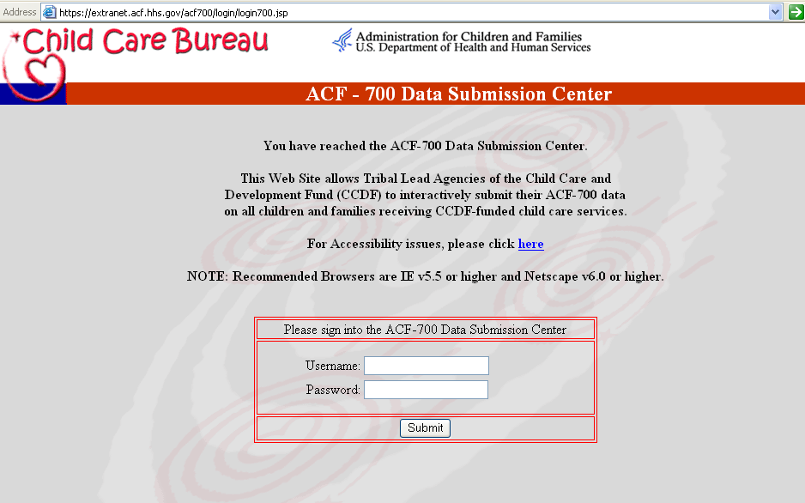

The welcome page will open displaying your name – this indicates that you have successfully entered the submission site.

Select the appropriate fiscal year of the data that you would like to enter from the “Federal Fiscal Year” drop-down list. Next, click on the ACF-700 Form button.

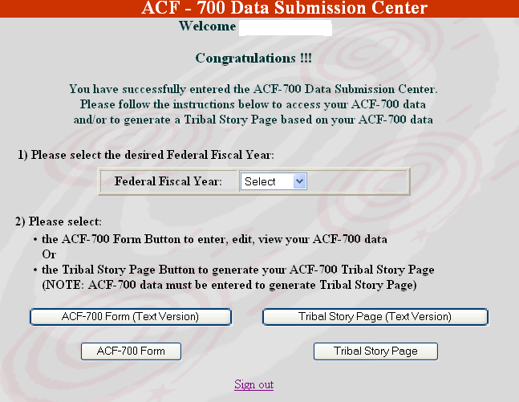

Use This Version
Use This Version

NOTE: DO NOT use the (Text Version) buttons. The (Text Version) buttons for both the ACF-700 Form and the Tribal Story Page are designed for use specifically by persons with visual impairments.

The ACF-700 form will open with your existing Tribal Lead Agency name and address noted. Make any needed corrections to this contact information before you begin entering data.

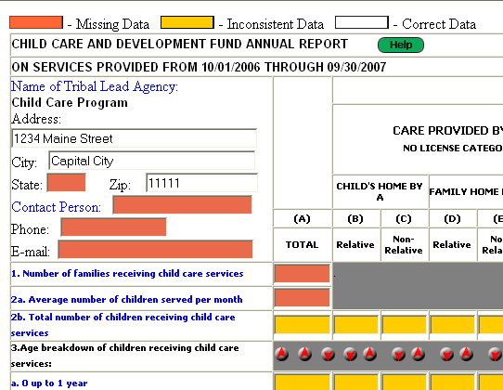

Note that when the form (similar to the one on the next page) is first opened and before any data is entered, all of the fields are white. When you begin to enter information, all of the cells will change to red or yellow and the colors of the fields may continue to change as you enter information. This color coding helps you to identify and correct any potential data problems.

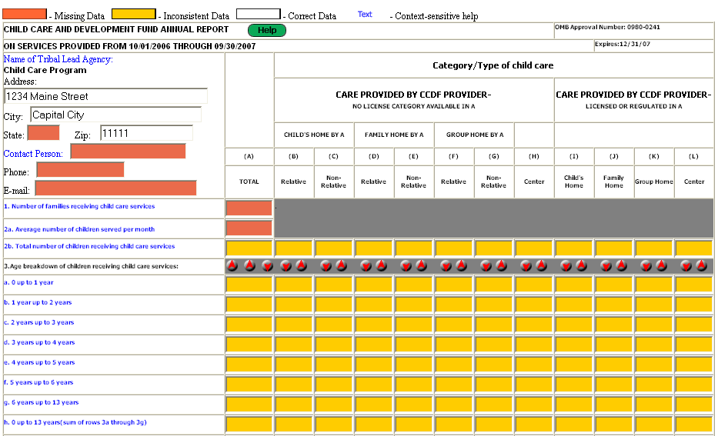
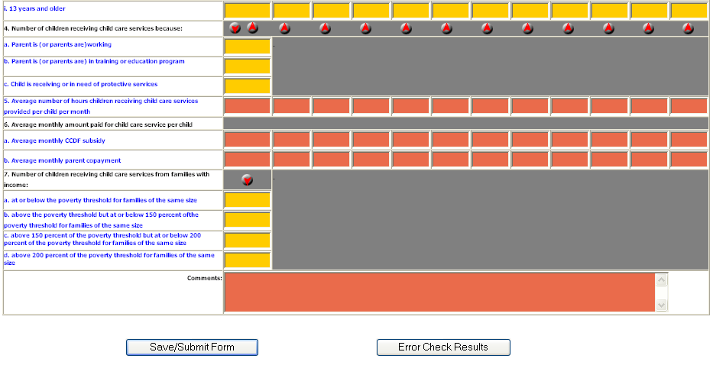

The electronic submission site checks for two types of errors (see Table 3 for additional details):

- If the field has been left blank (red cells), and
- If the data in specific fields are inconsistent (yellow cells) with information in related fields.

Meeting the system quality checks does not guarantee that the information is correct. You still must review your own report carefully to ensure that the data you submit to the CCB accurately reflects the families and children you serve, and the services you provide.

If the system notes a potential error, a red arrow button will be shown by the data element in question. You can click the red arrow to display an explanation of the possible error and use the guidance to make corrections to your report.

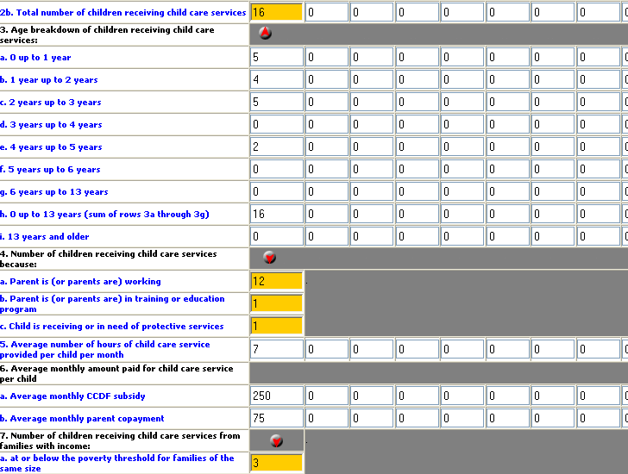

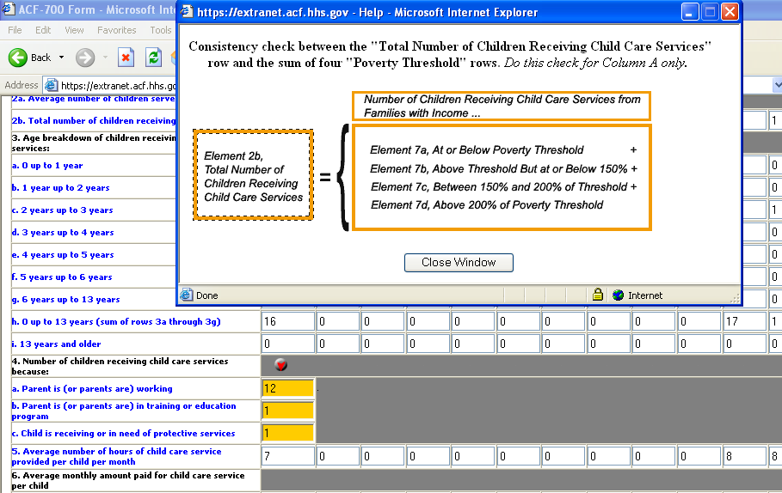

To check your entered data for errors, click the Error Check Results button located at the bottom of the page. A page will open that lists the errors for your submitted data or indicates that no errors were found.

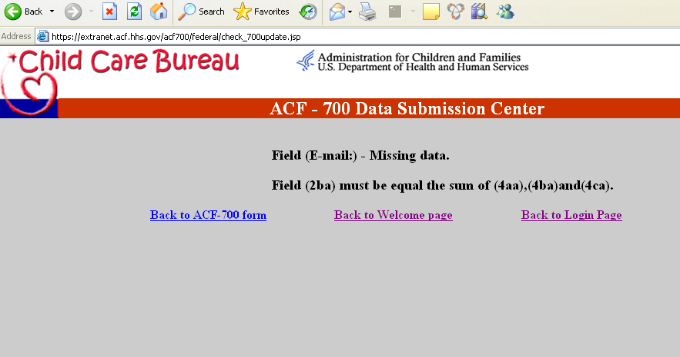

Things to Remember:

You must enter information in each of the cells on the ACF-700 submission site. Do not leave any cells blank. Each cell should have either a number or NA (See Table 2 for the appropriate use of NA - not applicable).

You should use the “Comments” field to enter information that would help clarify any special reporting circumstances or to explain any peculiarities in your data (See Table 1 for further information).

When you have completed entering and checking information, click the Save/Submit Form button at the bottom of the screen to save your information and submit it to the Child Care Bureau (CCB). If you exit the form without saving it, all of the information you entered will be lost.

If you need to stop data entry and finish entering information at another time, you still should click the Save/Submit Form button. Everything that you have entered to that point will be saved and available when you return later to complete the form. It is acceptable to submit a partially completed form as long as you remember to return and complete it in a timely manner. Upon saving your data, the next screen will indicate that you have successfully uploaded the data.

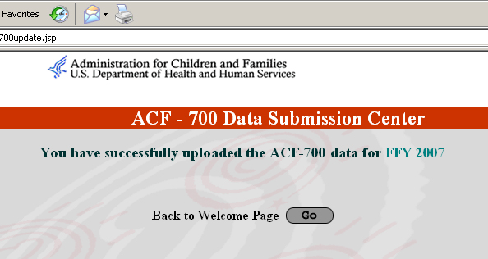

Upon returning to the ACF-700 form (after saving the data), a print button will display on the bottom right hand corner of the screen. To print your report, click the Print this Form button. We recommend that you always keep a hard copy of each year’s report for future reference.

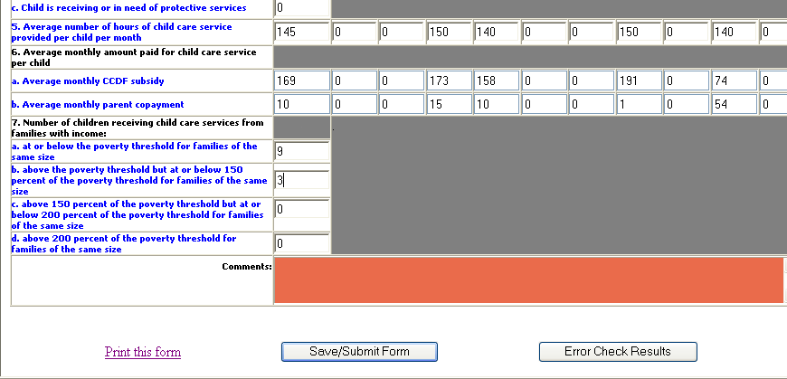

VII. 2 Alternate Electronic Submission of the ACF-700 Form and Supplemental Narrative

Tribal Lead Agencies may submit an electronic copy of the ACF-700 form and the Supplemental Narrative report using compatible electronic media, such as e-mail or a CD. The ACF-700 form is in Excel® 5.0 format and can easily be transmitted as an attachment to an e-mail message. (An electronic version of ACF-700 is available on the Child Care Bureau’s website at http://www.acf.hhs.gov/programs/ccb/report/formhelp/acf700/index.htm). ACF Regional Offices or CCARC can e-mail a blank version of the ACF-700 form, if requested. CD’s also are available from the ACF Regional Offices. Tribes also can submit the Supplemental Narrative report by attaching an electronic Word® or text file to an e-mail.

Both the ACF-700 form and the Supplemental Narrative should be sent to the ACF Regional Office (see Section VIII for contact information) with a copy to CCARC at ccarc@childcaredata.org.

VII.3 Hard Copy Paper Submissions

A Tribal Lead Agency without access to the Internet or e-mail may submit its Annual Report (both the ACF-700 form and the Supplemental Narrative) on paper through the mail. The original should be mailed to the ACF Regional Office (see contact information in Section VIII.) and a copy should be sent to CCARC at the address below.
Faxes are acceptable only if followed by a paper copy sent through the mail. The original of the faxed submission should be mailed to the Tribe’s ACF Regional Office and a copy should be sent to CCARC.

Child Care Automation Resource Center
2600 Tower Oaks Boulevard, Suite 600
Rockville, MD 20852

Fax: 301-692-0700
Attn: CCARC

VIII. Resources

Child Care Automation Resource Center

If you have questions or need additional assistance completing the ACF-700 or using the Child Care Data Tracker software, contact the Child Care Automation Resource Center (CCARC). The CCARC was established by the Child Care Bureau to provide technical assistance related to the grantee reporting requirements. You may contact CCARC by e-mail, phone, fax, or mail. The CCARC staff is available Monday-Friday, 9:00 am to 5:00 pm, prevailing Eastern Time. All voice-mail messages left during or outside of those hours are returned promptly.

Child Care Automation Resource Center
2600 Tower Oaks Blvd., Suite 600
Rockville, MD 20852
Phone: 1-877-249-9117 (toll-free)
Fax: 301-692-0700
E-mail: ccarc@childcaredata.org

Regional Office Contact information

If you have questions regarding policy issues, contact your Regional Office.

List of Regional Office addresses and phone numbers
http://www.acf.hhs.gov/programs/ccb/ta/raaddr/program_managers.htm

Appendix A – Glossary of Commonly Used Child Care Terms

A-B
ACF | The Administration for Children and Families, an agency of the Department of Health and Human Services (HHS). ACF is responsible for Federal programs that promote the economic and social well being of families, children, individuals, and communities.
ACF-696T | The financial report required to be submitted by Tribes receiving Child Care and Development Fund (CCDF) grants.
ACF-700 | An annual data report required to be submitted by Tribal grantees. The report contains data related to families and children receiving assistance through the CCDF.
Applicant | A family or individual who is applying to receive a child care subsidy and who must meet defined eligibility requirements. An applicant may be a member of a family group (usually a parent) or a single child in protective custody.
Average | One single number that arithmetically represents a group of numbers.
C-D
CCB | Child Care Bureau, a Bureau of the Office of Family Assistance in ACF. The CCB is dedicated to enhancing the quality, affordability, and availability of child care for all families. The Bureau administers Federal funds to States, Territories, and Tribes to assist low-income families in accessing quality child care for children when the parents work or participate in education or training. The CCB web site is www.acf.hhs.gov/programs/ccb.
CCARC | Child Care Automation Resource Center. A team of technical assistance specialists who help grantees to meet grant reporting requirements. CCARC’s toll free number is 1-877-249-9117 and the e-mail address is ccarc@childcaredata.org.
CCDF | Child Care and Development Fund. CCDF provides funding for low-income families, families receiving temporary public assistance, and those transitioning from public assistance, to obtain child care so they can work or attend training and/or education activities.
Cash Payment | Money paid to providers or parents in the form of cash or checks to cover the cost of child care services. (This does not include two-party checks to parents and providers, or cash to providers).
Center Care | Service that is provided in a facility other than a private home. Center-based care also would include such providers as churches and schools.
Certificate/Voucher | A certificate (that may be a check or other form) that is issued by a State or local government directly to a parent to verify their eligibility for subsidized services.
Child/Children | Those persons who are receiving subsidized child care services.
Child’s Home Care | Services that are provided in the home of the child receiving services.
Contact Person | The grantee staff person who is familiar with the ACF-700 information and will be able to answer questions and provide clarifications. This may or may not be the Program Director.
Contract/Grant | A legally binding agreement with a child care provider to deliver services, defining the terms and conditions of those services.
Co-payment | The amount of money the applicant/family pays for child care. This represents only the family share of the total amount paid to a child care provider as negotiated and assigned by the Tribal grantee.
E-K
Education | School or work-related information and training activities intended to prepare individuals to obtain and keep a paying job that will allow them to achieve financial independence.
Eligibility Income | The total amount of money a family/applicant receives (earned or unearned) that is included when eligibility for the CCDF program is being determined.
Family | The applicants who apply for, and must qualify for CCDF subsidy assistance. A family may be represented by birth, adopted, or foster parents, and children in need of child care. The ACF-700 requires an annual unduplicated family count.
Family Home Care | Service that is provided by one person in a residence of someone other than the child(ren) receiving care. Usually a family home is the residence of the child care provider.
Grant | See: Contract/Grant
Group Home Care | Service that is provided by more than one person in a residence of someone other than the child(ren) receiving care. A group home typically is able to care for more children at one time than a family home because additional staff are employed to help with child care. Usually a group home is the residence of the primary child care provider.
Hours of Care | The number of hours each day that a child actually attends and participates in child care services.
L-Q
Licensed/Regulated | The provider must apply for, and may only operate after receiving legally defined approval to deliver services as a licensed or regulated provider. The licensing agent usually is the Tribe, Territory, or state.
No License | The provider is not required to obtain a license (as defined above), but still must meet all state or local health, safety, and other child care program regulations to be operating legally.
Non-Relative Provider | A provider who does not meet the description of a relative (see below).
Protective Services | Public program designed to provide safe care for children who are victims of abuse or neglect, or whose parents are otherwise unable to adequately care for them (temporarily or permanently).
Poverty Guideline | A guideline provided by HHS that indicates the minimum income a family with different numbers of family members needs to be able to survive at a most basic level. Families with income at or below this threshold are considered to be living in poverty. Annual poverty guidelines are available on-line at http://aspe.hhs.gov/poverty.
R-S
Regulated | See: Licensed.
Relative Provider | An “adult” who is by marriage, blood relationships, or court decree, a grandparent, great-grandparent, aunt or uncle, or sibling living outside the child’s home.
Subsidy | The amount of money the program/grantee pays for child care. This represents only the program share of the total amount paid to a child care provider. For the ACF-700, the program will report only on subsidies for children that come from CCDF grant funds.
Supplemental Narrative | An annual required written report that describes the program operated and services delivered using the CCDF grant money.
T-Z
TA | Technical assistance. Help that is provided to grantees, Central and Regional ACF staff, and other stakeholders to support program operations and the collection, management, and reporting of high quality CCDF data. TA related to reporting requirements is provided by the CCARC.
Technical Bulletins | Publications, available on the CCB web site at http://www.acf.hhs.gov/programs/ccb/report/formhelp/techbull/index.htm, that provide technical guidance to grantees receiving CCDF funds.
Training | Activities designed to prepare individuals to obtain and keep a paying job that will allow them to achieve financial independence.
Tribal Lead Agency | The organization that applied for, received, and is responsible for administering the Tribal CCDF grant. The lead agency may be different from the organization that directly provides the child care services.
Tribally-Operated Center | A child care center operated by the Tribal Lead Agency. The center is usually located on the Tribal reservation or in the Tribal Lead Agency’s service area. A Tribally-operated center differs from a grant or contract in that a Tribal Lead Agency pays the operational costs of the Center (including teacher salaries).
Un-licensed | See: No License.
Voucher | See: Certificate/Voucher
Work | Paid employment. This employment may include full- time or part- time work. It also may include sporadic, seasonal work.
Appendix B – Internet Submission Registration Form

 | CHILD CARE AND DEVELOPMENT FUND  Tribal Annual Report (ACF-700) Internet Submission  To ensure appropriate authorization for submitting information via the Internet, please provide the following information

Name:

Title:

Agency:

Mailing address:

Phone:
Fax:
E-mail:

Please complete this form for each authorized individual, then fax or mail to:

Child Care Automation Resource Center
2600 Tower Oaks Blvd., Suite 600
Rockville, MD 20852
Fax: 301-692-0700
A Child Care Automation Resource Center Technical Assistance Specialist will contact you to provide additional information and instructions about submitting the ACF-700.
They can be reached at 1-877-249-9117 or via email at CCARC@childcaredata.org.

