

***Thank you for your participation in this important survey!***

*Please write any comments you may have on this survey below.*

**NOTE: PAGE NUMBERS ARE OUT OF SEQUENCE ON THIS REVIEW DRAFT ELECTRONIC FILE SO THAT IT WILL PRINT CORRECTLY DOUBLE-SIDED**

OMB Control No. 2090-XXXX Approval expires XX/XX/20XX

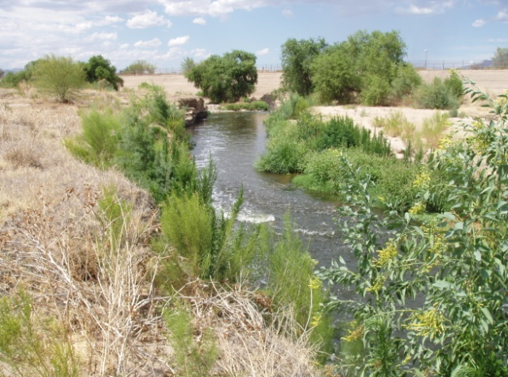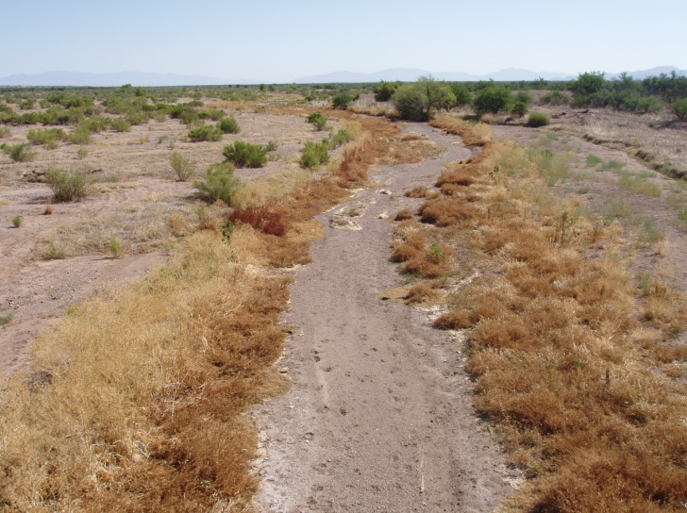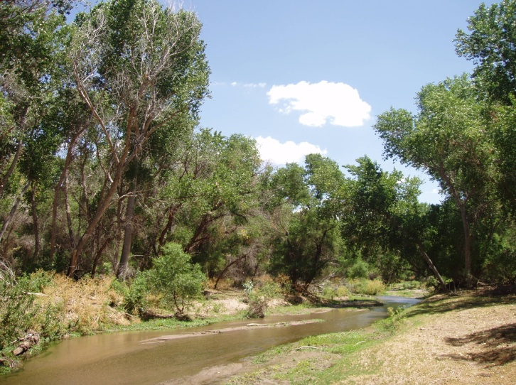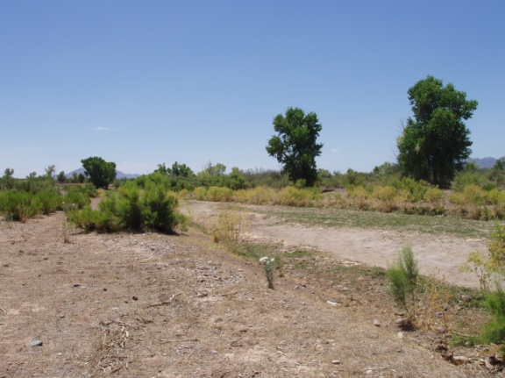

**Paperwork Reduction Act Notice:** The public reporting and recordkeeping burden for this collection of information is estimated to average 30 minutes per response. Send comments on the Agency's need for this information, the accuracy of the provided burden estimates, and any suggested methods for minimizing respondent burden, including through the use of automated collection techniques to the Director, Collection Strategies Division, U.S. Environmental Protection Agency (2822T), 1200 Pennsylvania Ave., NW, Washington, D.C. 20460. Include the OMB control number in any correspondence. Do not send the completed survey to this address.

**FURTHERMORE NOTE THIS IS VERSION 1 OF 9 VERSIONS VARYING Q2-Q5 (see supporting statement Part B)**

*Photos showing the Santa Cruz River where there is flow, and where there is no flow. Open this survey to learn more and to submit your opinion on Santa Cruz River management.*

Survey:

Your Opinion Needed on an

Arizona River Issue

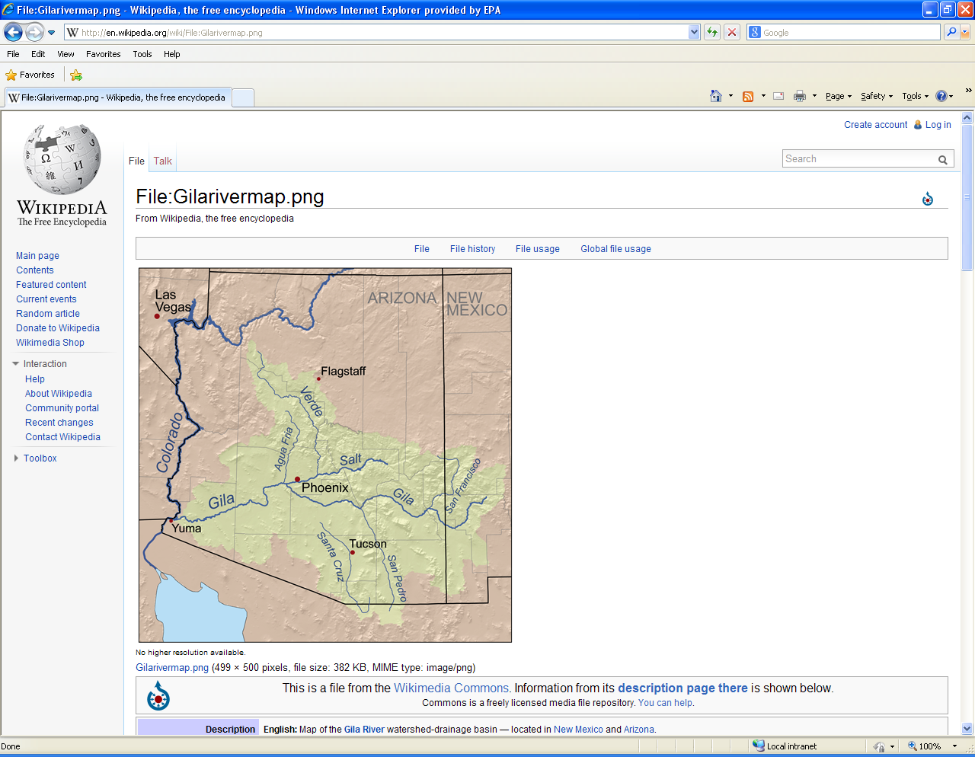

**Question 14:**  What year were you born? 19__ __

**Question 15:**  Are you male or female?O Male O Female

**Question 16:** What is the highest level of education that you have completed?

O Less than high school O One or more years of college

O High school or equivalent O Bachelor’s Degree

O High school + technical school O Graduate Degree

**Question 17:** How many people live in your household? _________

**Question 18:** How many of those people are 18 or older? __________

**Question 19:** Are you and/or your spouse currently employed? O Yes O No

**Question 20:** How many years have you lived in Arizona? _________

**Question 21:** Does anyone in your household belong to an environmental organization *(such as Sierra Club, or National Audubon Society)*?

O Yes O No

**Question 22:** From the following options, do you consider yourself to be:

O American Indian O Latino/Hispanic

O Asian O White

O African American O Other ________________

**Question 23:** What category comes closest to your total household income for 2012?

O Less than $10,000 O $80,000 to $99,999

O $10,000 to $19,999 O $100,000 to $149,999

O $20,000 to $39,999 O $150,000 to $199,999

O $40,000 to $59,999 O $200,000 to $249,999

O $60,000 to $79,999 O $250,000 or more

d

**We need the following questions to ensure votes from all groups have been fairly represented in this survey.**

*This survey asks for your opinion on how to manage the Santa Cruz River. It is important for authorities to hear from all perspectives, so please take the time to read the background and answer the questions. Your responses will help authorities select the best option. This survey is being sent to randomly selected households in southern Arizona.*

The Santa Cruz River is in southern Arizona. It flows north through several communities such as Rio Rico, Tubac, Amado, Green Valley, Sahuarita, Tucson, and Marana. It also flows through Tumacácori National Park near the border with Mexico. The Santa Cruz joins the Gila River south of Phoenix which then joins the Colorado River at Yuma. People have lived in the Santa Cruz valley for thousands of years, and water was found in the Santa Cruz River in some places all-year. Pumping groundwater over the last 80 to 100 years lowered groundwater levels and dried up many of the wet areas along the river.

23

2

**THE SANTA CRUZ RIVER IN SOUTHERN ARIZONA**

**TREATED WASTEWATER IN THE SANTA CRUZ RIVER**

**Question 13:** Rate the importance of different recreational activities for

your household along the Santa Cruz River or along its riverbanks

Since the 1950’s, treated wastewater has been released into the Santa Cruz River in two places, in the North near Tucson, and in the South near the border with Mexico. At first this was just a method of disposing of the treated wastewater. It was then found that the water is helping to provide wet river ecosystems, and associated plants and animals that are scarce in southern Arizona. The treatment is currently being upgraded to provide water of higher quality and to eliminate odor. Having wastewater of higher quality raises new questions about how to best manage the water.

d

|  |  |
| --- | --- |
| **Santa Cruz River Activity** | **Not Somewhat Very**  **Important Important Important** |
| **Walking** | **1 2 3 4 5** |
| **Biking** | **1 2 3 4 5** |
| **Safe Partial Body Contact with Water (wading)** | **1 2 3 4 5** |
| **Safe Full Body Contact with Water (submersion)** | **1 2 3 4 5** |
| **Birdwatching** | **1 2 3 4 5** |
| **Horseback Riding** | **1 2 3 4 5** |
| **Off Road Vehicle Use** | **1 2 3 4 5** |
| **Going to the river to see a large flow or flood** | **1 2 3 4 5** |
| **Boating or Tubing** | **1 2 3 4 5** |
| **Picnicking** | **1 2 3 4 5** |
| **Other_______________________________________** | **1 2 3 4 5** |

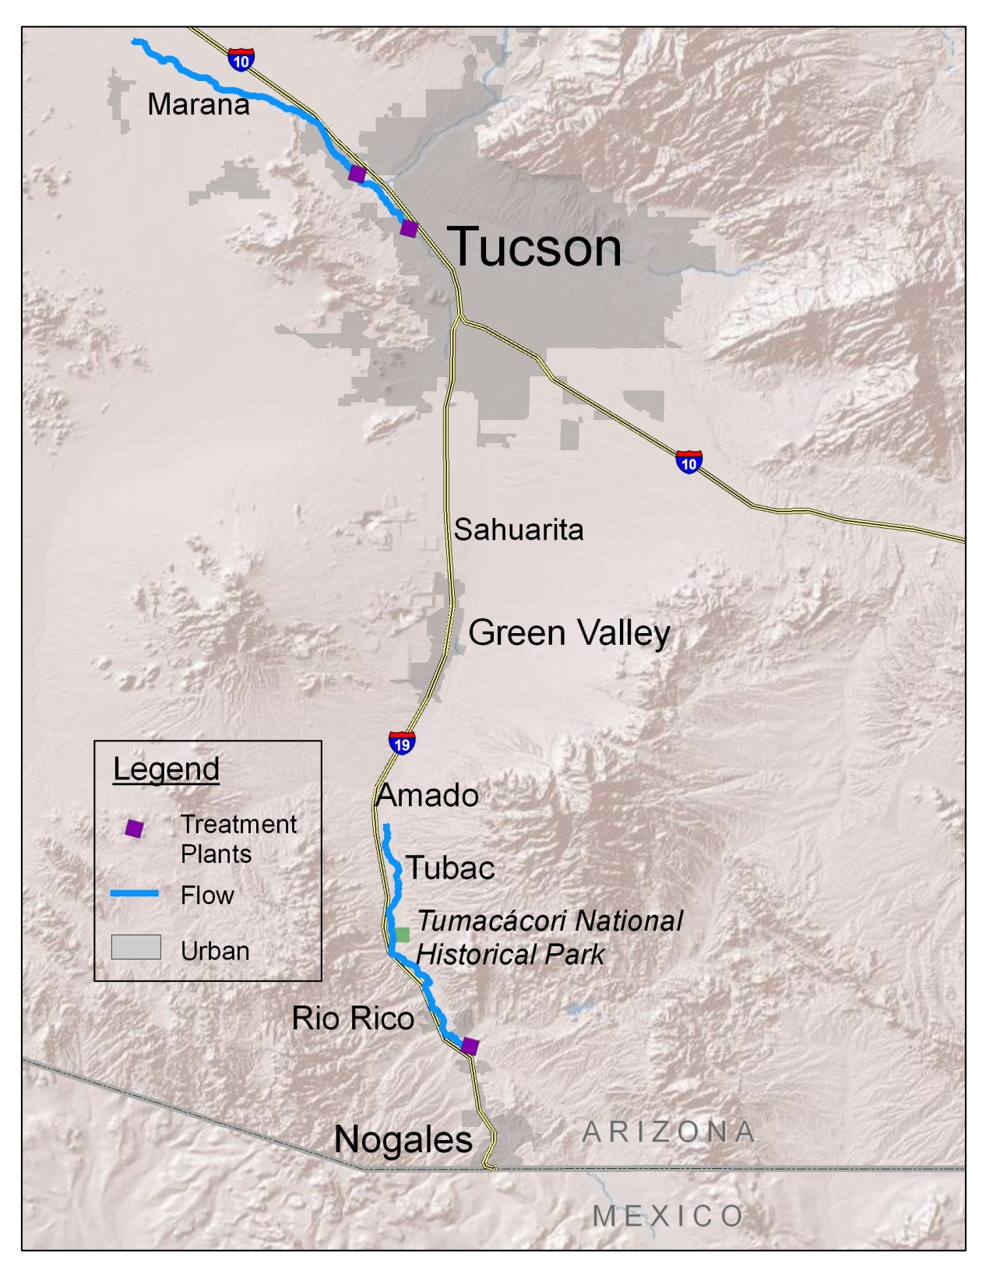

**NORTH**

Treated wastewater now supports about 23 miles of flow, and about 160 acres of forest along the river. The flow starts in NW Tucson near Prince Rd and I-10 and flows past Marana.

22



**SOUTH**

Treated wastewater now supports about 19 miles of flow, and about 490 acres of forest along the river. The flow starts in southern Rio Rico and flows past Tubac.



3

22

**WHAT HAPPENS TO THE WATER?**



**Question 12:**

* In the last 12 months, what is the estimated total number of separate river-related recreational trips members of your household have taken? For example, a trip that combined picknicking and birdwatching activities would count as a single trip.

_____________ total trips in the last 12 months.

* How many of those trips were within a 2 hour drive of your home?

_____________ trips in the last 12 months.

* How many of those trips were within your city or community?

_____________ trips in the last 12 months.

* How many of those trips involved any portion of the Santa Cruz River?

_____________ trips in the last 12 months.

* If there were any trips to the Santa Cruz River, what was the main recreational activity? If this doesn’t apply, just leave this blank.

_______________________________________ was the main activity.

d

* About 10% of the treated wastewater evaporates or is consumed by plants and animals. The remaining 90% is not lost to the watershed, but becomes groundwater.
* Of the 10% consumed, most of it is used by trees. An acre of forest along the river requires about as much water as 44 people per year. An acre is almost the same size as a football field without the endzones.

21

**10%**

**Evaporation, Plant Use, & Animal Use**

4

**To Groundwater**

**90%**

**WHAT DOES THE WATER MEAN FOR THE ENVIRONMENT?**

**Question 11:** In the last 12 months, how often have members of your household engaged in these recreation activities in any river, stream, canal, dry wash, or arroyo, or along its banks?

|  |  |
| --- | --- |
| **River-Related Activity** | **Number of times in the last 12 months** |
| **Walking** | **________ times** |
| **Biking** | **________ times** |
| **Partial Body Contact with Water (wading)** | **________ times** |
| **Full Body Contact with Water (submersion)** | **________ times** |
| **Birdwatching** | **________ times** |
| **Horseback Riding** | **________ times** |
| **Off Road Vehicle Use** | **________ times** |
| **Going to a river to see a large flow or flood** | **________ times** |
| **Boating or Tubing** | **________ times** |
| **Picnicking** | **________ times** |
| **Other_______________________________________** | **________ times** |

* The constant release of treated wastewater supports a wet river ecosystem that used to be more common in southern Arizona.
* If a river does not have water year-round there is still an ecosystem, just not a wet river ecosystem.
* The wet river ecosystem along the Santa Cruz River includes cottonwood and willow trees, tall shade trees dependent on moist soil. This is one of the rarest forest types in southern Arizona.
* In the desert, wet river ecosystems contain a large concentration of plant and animal species. Along the wet areas of the Santa Cruz River, there is a variety of birds and small mammals, and minnow-sized fish have been found.
* The San Pedro River near Sierra Vista and the Gila River near Safford are examples of other wet river ecosystems in southern Arizona. The ecosystems in those locations rely on natural water flow rather than release of treated wastewater.

5

20



**YOU WILL BE ASKED TO VOTE ON THE FOLLOWING OPTIONS**

* **FLOW & FOREST**: People can vote to maintain more miles of river flow and cottonwood and willow forest acres in the North and the South. This is in contrast to the Expected Future which cuts back flows and forest acreage. As stated on pg.3, the current condition is 23 flow miles and 160 forest acres in the North, and 19 flow miles and 490 forest acres in the South. Choosing Flow & Forest more than the Expected Future would mean an increase in taxes as compensation for not selling the water for off-river purposes.

.

* Note that in the South, treated wastewater results in 4 to 5 times more forest per mile of flow. This is because adding treated wastewater in the South allows tree roots to reach the groundwater which is relatively close to the surface there. Trees in the South also tend to grow larger overall.
* Refer to the photos on the next page to compare typical scenes of the North and South. Photos are also shown downstream of where water flows currently end.
* **EXPECTED FUTURE**: Within the next 10 years, the extent of river flow and the wet river ecosystem would be reduced from current condition to 12 flow miles and 45 forest acres in the North, and 10 miles and 250 forest acres in the South. There would still be trees, plants, birds, mammals, and minnow-sized fish in the North and South. This option does not require new taxpayer costs.

.

Within the next 10 years, river flows are predicted to be cut back due to increasing demands for water resources in southern Arizona. This survey will help managers know whether people would be willing to pay to keep various amounts of treated wastewater in the river instead. These funds would be used as compensation for not selling the water. Note that all options, including the no-cost option, maintain at least some wastewater in the river and include the recent wastewater treatment upgrades that increase water quality and eliminate odor. This survey will also help managers know whether people would be willing to pay for additional water quality measures that would allow full body contact recreation in the treated wastewater.

.

19

6

**Question 9:** If you voted for an option with more Flow & Forest than

“Expected Future”, in Q2 to Q5, why?

**CHOOSE ONE ANSWER THAT FITS BEST**

O NEVER CHOSE more Flow & Forest than Expected Future.

O Prefer visible flow in the river

O Prefer more vegetation along the river

O Prefer both more flow and more vegetation along the river

O I was forced to choose Flow & Forest in order to get Full Body Contact

O Other reasons: ____________________________________

**Question 10:** If you voted for an option containing “Full Body Contact” in Q2 to

Q5, why?

**CHOOSE ONE ANSWER THAT FITS BEST**

O NEVER CHOSE an option that included “Full Body Contact”

O My household is interested in recreational contact with the treated water

O I want other people to be able to recreationally contact the treated water

O I was forced to choose Full Body Contact in order to get more Flow & Forest

O Other reasons: ____________________________________



North Downstream of Water Flow

South Downstream of Water Flow

South With Water Flow

North With Water Flow

* Photos show the changes that could happen in the North and South if a part of the river no longer receives treated wastewater.

7

**Question 6**: Before reading this survey were you aware of the location of any part of the Santa Cruz River?

O Yes

O No

**Question 7**: Before reading this survey were you aware that the Santa Cruz River has water all-year in the two places shown on page 3?

**CHOOSE ONE ANSWER THAT FITS BEST**

O Aware of the water in the North

O Aware of the water in the South

O Aware of the water in both the North and the South

O Not aware of the water in the North or the South

**Question 8**: If you ever voted for “Expected Future” in Q2 to Q5, why?

**CHOOSE ONE ANSWER THAT FITS BEST**

O NEVER CHOSE “Expected Future”

O No ability to pay

O Other options were not worth it to my household

O Prefer to make a donation than to increase taxes

O Don’t think the other options are realistic

O Other________________________

**QUESTION 6**

**If you ever chose an option that kept river flow and habitat, why? Choose the reason that is the best match**

O NEVER CHOSE Options B or C

O Prefer visible flow in the river

O Prefer to have more forest

O Prefer higher habitat value

O Other________________________

18

**Question 5.** Given a choice between **Option A,** **Option B**, or **Expected Future** for the Santa Cruz River, how would you vote?

**Summary of North Flow and Forest Possibilities**

**Summary of South Flow and Forest Possibilities**

|  |  |  |  |  |
| --- | --- | --- | --- | --- |
| **Location & Effect** |  | **Option A** | **Option B** | **Expected Future** |
| **North**  **Flow & Forest** |  | 23 flow miles  160 forest acres | 23 flow miles  160 forest acres | 12 flow miles  45 forest acres |
| **North**  **Full Body Contact** |  | No | Yes | No |
|  |  |  |  |  |
| **South**  **Flow & Forest** |  | 10 flow miles  250 forest acres | 17 flow miles  95 forest acres | 10 flow miles  250 forest acres |
| **South**  **Full Body Contact** |  | No | Yes | No |
|  |  |  |  |  |
| **$**  **Cost to your Household per Year** |  | **$30**  Increase in  Annual Taxes | **$60**  Increase in  Annual Taxes | **$0**  Increase in Annual Taxes |
| **HOW WOULD YOU VOTE?**  **(CHOOSE ONE ONLY)** |  |   I vote for  **Option A** |   I vote for  **Option B** |   I prefer  **Expected Future** |

17

8

8

**Question 4.** Given a choice between **Option A,** **Option B**, or **Expected Future** for the Santa Cruz River, how would you vote?

|  |  |  |  |  |
| --- | --- | --- | --- | --- |
| **Location & Effect** |  | **Option A** | **Option B** | **Expected Future** |
| **North**  **Flow & Forest** |  | 12 flow miles  45 forest acres | 17 flow miles  95 forest acres | 12 flow miles  45 forest acres |
| **North**  **Full Body Contact** |  | No | Yes | No |
|  |  |  |  |  |
| **South**  **Flow & Forest** |  | 19 flow miles  490 forest acres | 10 flow miles  250 forest acres | 10 flow miles  250 forest acres |
| **South**  **Full Body Contact** |  | Yes | Yes | No |
|  |  |  |  |  |
| **$**  **Cost to your Household per Year** |  | **$40**  Increase in  Annual Taxes | **$50**  Increase in  Annual Taxes | **$0**  Increase in Annual Taxes |
| **HOW WOULD YOU VOTE? (CHOOSE ONE ONLY)** |  |   I vote for  **Option A** |   I vote for  **Option B** |   I prefer  **Expected Future** |

This concludes the description of the options. Different options for “Flow and

Forest” and “Full Body Contact” are possible for the North and South. You will

have an opportunity to vote on different options, including “Expected Future”.

* **FULL BODY CONTACT**: During stormflows, the water quality is not considered safe for any type of human contact. However, during low-flow times the water in the North and South is currently considered safe for wading. Water quality could be improved to be considered safe for full body contact such as submersion during low-flow times. This would require further measures to control bacteria, which would mean an increase in taxes to pay for these measures.

16

9

|  |  |  |  |  |
| --- | --- | --- | --- | --- |
| **Location & Effect** |  | **Option A** | **Option B** | **Expected Future** |
| **North**  **Flow & Forest** |  | 17 flow miles  95 forest acres | 12 flow miles  45 forest acres | 12 flow miles  45 forest acres |
| **North**  **Full Body Contact** |  | Yes | No | No |
|  |  |  |  |  |
| **South**  **Flow & Forest** |  | 15 flow miles  385 forest acres | 10 flow miles  250 forest acres | 10 flow miles  250 forest acres |
| **South**  **Full Body Contact** |  | Yes | Yes | No |
|  |  |  |  |  |
| **$**  **Cost to your Household per Year** |  | **$40**  Increase in  Annual Taxes | **$20**  Increase in  Annual Taxes | **$0**  Increase in Annual Taxes |
| **HOW WOULD YOU VOTE?**  **(CHOOSE ONE ONLY)** |  |   I vote for  **Option A** |   I vote for  **Option B** |   I prefer  **Expected Future** |

|  |  |  |  |  |
| --- | --- | --- | --- | --- |
| **Location & Effect** |  | **Option A** | **Option B** | **Expected Future** |
| **North**  **Flow & Forest** |  | 23 flow miles  160 forest acres | 12 flow miles  45 forest acres | 12 flow miles  45 forest acres |
| **North**  **Full Body Contact** |  | Yes | No | No |
|  |  |  |  |  |
| **South**  **Flow & Forest** |  | 19 flow miles  490 forest acres | 19 flow miles  490 forest acres | 10 flow miles  250 forest acres |
| **South**  **Full Body Contact** |  | Yes | No | No |
|  |  |  |  |  |
| **$**  **Cost to your Household per Year** |  | **$60**  Increase in  Annual Taxes | **$40**  Increase in  Annual Taxes | **$0**  Increase in Annual Taxes |
| **HOW WOULD YOU VOTE?**  **(CHOOSE ONE ONLY)** |  |   I vote for  **Option A** |   I vote for  **Option B** |   I prefer  **Expected Future** |

**EXAMPLE VOTE *questions will look like the sample below***

**If you prefer**

**Option A,**

**check here**

**If you prefer**

**Option B,**

**check here**

**If you prefer**

**Expected Future,**

**check here**

15

**Question 3.** Given a choice between **Option A,** **Option B**, or **Expected Future** for the Santa Cruz River, how would you vote?

10

**THIS SURVEY IS SIMILAR TO A PUBLIC VOTE**

**Question 2.** Given a choice between **Option A,** **Option B**, or **Expected Future** for the Santa Cruz River, how would you vote?

11

14

The questions starting on the next page ask you how you would vote for different options for the Santa Cruz River.

Effects of each Option will be described with the following information:

|  |  |  |  |  |
| --- | --- | --- | --- | --- |
| **Location & Effect** |  | **Option A** | **Option B** | **Expected Future** |
| **North**  **Flow & Forest** |  | 23 flow miles  160 forest acres | 12 flow miles  45 forest acres | 12 flow miles  45 forest acres |
| **North**  **Full Body Contact** |  | Yes | No | No |
|  |  |  |  |  |
| **South**  **Flow & Forest** |  | 19 flow miles  490 forest acres | 19 flow miles  490 forest acres | 10 flow miles  250 forest acres |
| **South**  **Full Body Contact** |  | Yes | No | No |
|  |  |  |  |  |
| **$**  **Cost to your Household per Year** |  | **$60**  Increase in  Annual Taxes | **$40**  Increase in  Annual Taxes | **$0**  Increase in Annual Taxes |
| **HOW WOULD YOU VOTE?**  **(CHOOSE ONE ONLY)** |  |   I vote for  **Option A** |   I vote for  **Option B** |   I prefer  **Expected Future** |

|  |  |  |
| --- | --- | --- |
| **Location & Effect** |  | **Description** |
| **North**  **Flow & Forest** |  | Approximate Miles of year-round flow; &  Approximate Acres of cottonwood/willow forest along the river, tall shade trees dependent on wet soils. |
| **North**  **Full Body Contact** |  | Yes it is safe for full body contact at low-flow times, or No, it is only safe for wading at low-flow times. |
|  |  |  |
| **South**  **Flow & Forest** |  | Approximate Miles of year-round flow; &  Approximate Acres of cottonwood/willow forest along the river, tall shade trees dependent on wet soils. |
| **South**  **Full Body Contact** |  | Yes it is safe for full body contact at low-flow times, or No, it is only safe for wading at low-flow times. |
|  |  |  |
| **$**  **Cost to your Household per Year** |  | How much the option will cost your household in unavoidable taxes per year. These taxes would not increase or decrease over time. |

|  |  |
| --- | --- |
| **Location & Effect** | **Not Somewhat Very**  **Important Important Important** |
| **North**  **Flow & Forest** | **1 2 3 4 5** |
| **North**  **Full Body Contact** | **1 2 3 4 5** |
| **South**  **Flow & Forest** | **1 2 3 4 5** |
| **South**  **Full Body Contact** | **1 2 3 4 5** |
| **$**  **Cost to your Household per Year** | **1 2 3 4 5** |

**Question 1.**  Rate each of the following in terms of their importance to your household. For each, use “1” for the least important, and “5” for the most important.

**HOW WOULD YOU RATE THE IMPORTANCE OF THESE EFFECTS?**

**AS YOU VOTE, REMEMBER THESE IMPORTANT DETAILS**

* There are 4 voting questions, each on a different page.
* Each question describes alternative choices to help us better understand your household’s opinion.
* Review each question carefully. Your votes are important and will help determine the best option for the Santa Cruz River.
* Costs to your household will range from $0 to $60 per year, depending on the option. All funds are legally guaranteed to be used for the designated purpose.
* The “Expected Future” option shows the expected future at no added cost. Choose this if other options are not worth it to your household.

13

12