Appendix 5: Mailing Contacts
Part I: Survey Prenotice

UNITED STATES ENVIRONMENTAL PROTECTION AGENCY
OFFICE OF RESEARCH AND DEVELOPMENT

WESTERN ECOLOGY DIVISION
200 S.W. 35TH STREET, CORVALLIS, OR. 97333

February XX, 2014

[Resident name & address]

Dear Resident:

In a few days you will receive an important survey from the US Environmental Protection Agency, in collaboration with the University of Arizona, and Arizona State University. The goal of the study is to better understand public opinion on river management in southern Arizona. The focus of the survey is the Santa Cruz River. A map of the river location and additional background will be provided with the survey in the next mailing you receive.

Households like yours were chosen at random to receive the survey since we want to have responses from all kinds of people. When the survey arrives, please quickly fill it out and return it to help keep government costs down for the study. We need a large number of survey responses to have valid results and need to send reminder notices until we get them. The survey is voluntary and your responses will be confidential. A postage-paid return envelope will be included with the survey.

I am writing to you in advance because I want to stress the importance of your participation regardless of your opinion or prior knowledge of river management. I also understand that many people like to know beforehand that they will be sent a survey, and the reason for the survey study.

If you have any questions about this research project now or after you receive your survey, please feel free to call me toll free at XXXXXXX, or by email at weber.matthew@epa.gov.

It’s only with the generous help of people like you that our research can be successful. Thank you in advance for your time and consideration.

Sincerely,

Matt Weber (Project Manager)
[toll free number]
desk: (541) 754-4315
email: weber.matthew@epa.gov

Part II: First Survey Mailing – Cover letter

UNITED STATES ENVIRONMENTAL PROTECTION AGENCY
OFFICE OF RESEARCH AND DEVELOPMENT
WESTERN ECOLOGY DIVISION
200 S.W. 35TH STREET, CORVALLIS, OR. 97333

February XX, 2014

[Resident name & address]

Dear Resident:

Recently, you should have received a notice about an upcoming survey on river management being conducted by the US Environmental Protection Agency, in collaboration with the University of Arizona, and Arizona State University. I am now writing to ask that you complete the survey in order to help the study be successful.

The goal of the study is to better understand public opinion on Santa Cruz River management. Some options would cost taxpayer dollars and one option is free. It is crucial that your opinion be known to help river managers know what is in the best public interest. The survey has three main parts:

  - The first part is background on the Santa Cruz River and the management options.
  - In the second part you choose what you would vote if this were an actual public vote.
  - The third part helps us understand why you chose as you did, and helps us learn a little bit more about you.

We need your opinion. All opinions are needed for this study, it doesn’t matter if you are familiar with this river or rivers in general. Households were contacted randomly so that all types of opinions would be included.

Your responses will be kept confidential and your participation is voluntary. If you have any questions about this project, please feel free to call me toll free at XXXXXXX. Please return the survey within the next 7 days, using the postage paid envelope provided, and thank you very much for your help with this important study.

Sincerely,

Matt Weber (Project Manager)
[toll free number]
desk: (541) 754-4315
email: weber.matthew@epa.gov

Part III: REMINDER POSTCARD
(Back)
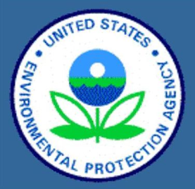

ADDRESS BLOCK

If you have already completed it, please accept our sincere thanks.

If you have not received the survey or have misplaced it, please contact me and I will get another one in the mail to you today.

Matt Weber (Project Manager)
[toll free number]
weber.matthew@epa.gov

Last week a public opinion survey on river management was mailed to you.

(Front)
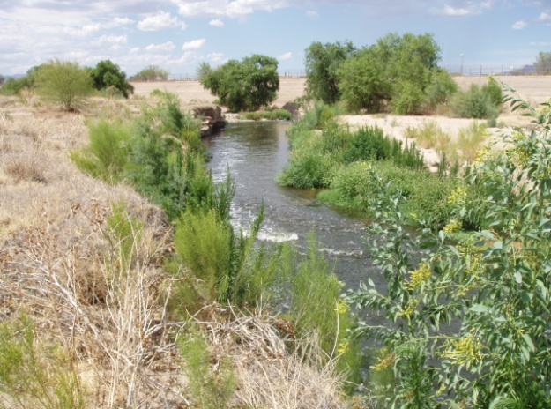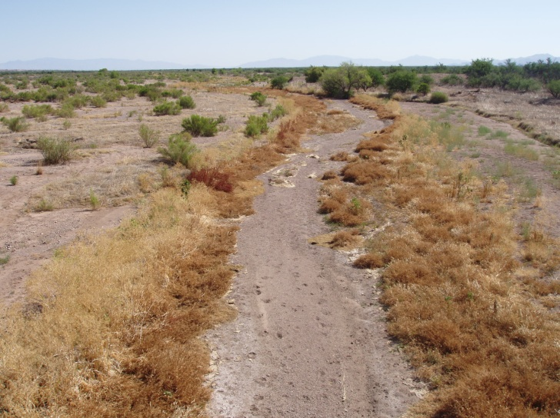
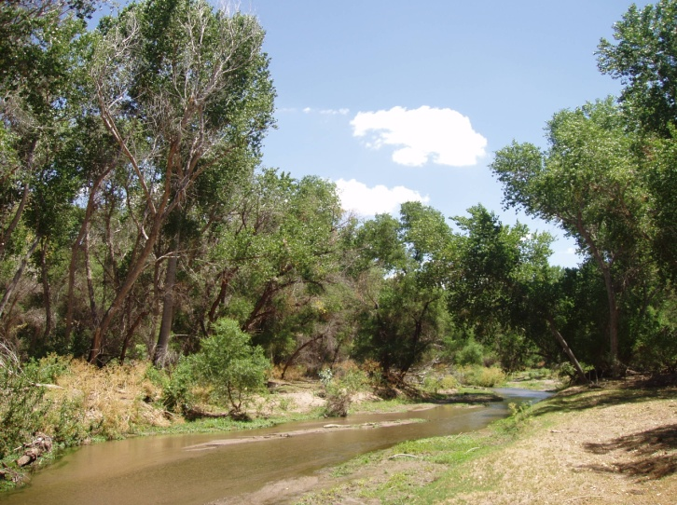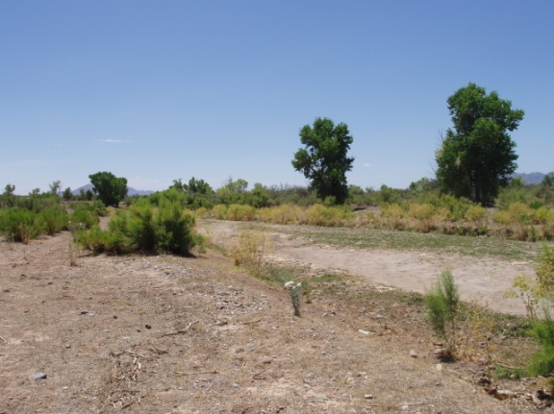

Part IV: Second Survey Mailing – Cover letter

UNITED STATES ENVIRONMENTAL PROTECTION AGENCY
OFFICE OF RESEARCH AND DEVELOPMENT
WESTERN ECOLOGY DIVISION
200 S.W. 35TH STREET, CORVALLIS, OR. 97333

February XX, 2014

[Resident name & address]

Dear Resident:

A survey recently sent to you has not yet been returned. A replacement is being provided to you now along with this letter. The survey is needed to collect public opinion on river management. The study is being conducted by the US Environmental Protection Agency, in collaboration with the University of Arizona, and Arizona State University. Please complete the survey as soon as possible.

Your household was one of the few selected to receive a survey. More responses are needed for the study to be successful. Please respond regardless of your opinion, there are no right or wrong answers.

The goal of the study is to better understand public opinion on Santa Cruz River management. Some options would cost taxpayer dollars and one option is free. It is crucial that your opinion be known to help river managers know what is in the best public interest. The survey has three main parts:

  - The first part is background on the Santa Cruz River and the management options.
  - In the second part you choose what you would vote if this were an actual public vote.
  - The third part helps us understand why you chose as you did, and helps us learn a little bit more about you.

We need your opinion. All opinions are needed for this study, it doesn’t matter if you are familiar with this river or rivers in general.

Your responses will be kept confidential and your participation is voluntary. If you have any questions about this project, please feel free to call me toll free at XXXXXXX. Again, please return the survey as soon as possible. A postage paid return envelope is provided. Thank you very much for your help with this important study.

Sincerely,

Matt Weber (Project Manager)
[toll free number]
desk: (541) 754-4315
email: weber.matthew@epa.gov

Part V: Final Reminder Letter

UNITED STATES ENVIRONMENTAL PROTECTION AGENCY
OFFICE OF RESEARCH AND DEVELOPMENT
WESTERN ECOLOGY DIVISION
200 S.W. 35TH STREET, CORVALLIS, OR. 97333

March XX, 2014

[Resident name & address]

Dear Resident:

Within the past month or two you should have received a survey on river management being conducted by the US Environmental Protection Agency, in collaboration with the University of Arizona and Arizona State University. This is a follow-up letter to ask that you complete the survey as soon as possible.

Your household was one of the few selected to receive a survey. More responses are needed for the study to be successful. Please respond regardless of your opinion, there are no right or wrong answers.

The goal of the study is to better understand public opinion on Santa Cruz River management. Some options would cost taxpayer dollars and some would be free. It is crucial that your opinion be known to help river managers know what is in the best public interest. The survey has three main parts:

  - The first part is background on the Santa Cruz River and the management options.
  - In the second part you choose what you would vote if this were an actual public vote.
  - The third part helps us understand why you chose as you did, and helps us learn a little bit more about you.

We need your opinion. All opinions are needed for this study, it doesn’t matter if you are familiar with this river or rivers in general.

Your responses will be kept confidential and your participation is voluntary. If you have any questions about this project, please feel free to call me toll free at XXXXXXX. Please return the survey as soon as possible, using the postage paid envelope previously sent. If you have misplaced the survey, please contact me by either phone or email so I can send you a new one. Thank you very much for your help with this important study.

Sincerely,

Matt Weber (Project Manager)
[toll free number]
desk: (541) 754-4315
email: weber.matthew@epa.gov

