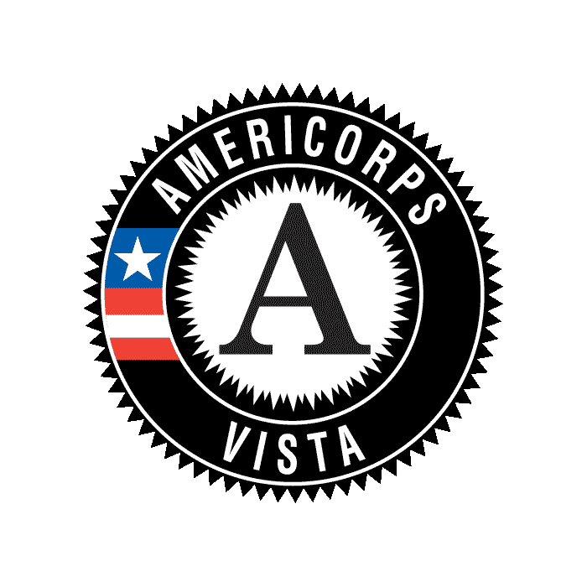

**AmeriCorps VISTA Project Report Supplement**

**BACKGROUND & PURPOSE**

The Corporation for National and Community Service provides the VISTA Progress Report Supplement (VPRS) as an addendum to the regular quarterly progress report required of organizations approved to sponsor a VISTA project. The VPRS is submitted on an annual basis and is intended to cover activities over a single fiscal year, regardless of the individual program year. The VPRS is the vehicle through which projects submit specific data elements needed by the Corporation to report on performance. Corporation personnel will use the reports to track Corporation and VISTA specific performance measures on an annual basis.

**COMPLETION AND SUBMISSION GUIDELINES**

All VISTA projects are required to submit the VPRS once per year.

The project supervisor should complete the VPRS.

AmeriCorps VISTA members should be allowed to review the completed reports, but should not be required to complete the report.

**REPORTING PERIOD**

All VPRS submissions are due upon completion of the fiscal year.

Reporting period covers October 1 through September 30. The due date is October 31.

**TERMS AND DEFINITIONS**

See the Performance Measures Guidance for AmeriCorps VISTA for terms and definitions. The terms have very specific definitions and by reporting against any of them, you are indicating that you are in compliance with those definitions.

**PERFORMANCE MEASURES – CAPACITY BUILDING**

*Please enter a whole number in those measures applicable to your AmeriCorps VISTA project. You must provide data for at least one measure.*

* Dollar value of cash resources leveraged by CNCS-supported organizations or national service participants
* Dollar value of in-kind resources leveraged by CNCS-supported organizations or national service participants
* Number of community volunteers recruited by CNCS-supported organizations or national service participants
* Hours of service contributed by community volunteers who were recruited by CNCS-supported organizations or national service participants
* Number of community volunteers managed by CNCS-supported organizations or national service participants
* Hours of service contributed by community volunteers who were managed by CNCS-supported organizations or national service participants
* Number of veterans and military family members engaged in providing services through CNCS-supported programs
* Number of staff and community volunteers that received training (of one or more types) as a result of capacity-building services provided by CNCS-supported organizations or national service participants
* Number of organizations that received capacity-building services from CNCS-supported organizations or national service participants
* Number of organizations that completed a community assessment identifying goals and recommendations with the assistance of CNCS-supported organizations or national service participants
* Number of organizations implementing three or more effective volunteer management practices as a result of capacity-building services provided by CNCS-supported organizations or national service participants
* Number of organizations reporting that capacity-building activities provided by CNCS-supported organizations or national service participants have helped to make the organization more efficient
* Number of organizations reporting that capacity-building activities provided by CNCS-supported organizations or national service participants have helped to make the organization more effective
* Number of new systems and business processes (technology, performance management, training, etc.) or enhancements to existing systems and business processes put in place as a result of capacity-building services provided by CNCS-supported organizations or national service participants
* Number of organizations that have experienced an increase in requests for their programs and services as a result of capacity-building services provided by CNCS-supported organizations or national service participants
* Number of additional activities completed and/or program outputs produced by the program as a result of capacity-building services provided by CNCS-supported organizations or national service participants in:

1. Disaster Services
2. Economic Opportunity
3. Education
4. Environmental Stewardship
5. Healthy Futures
6. Veterans and Military Families

* Number of additional types of services offered by organizations as a result of capacity-building services provided by CNCS-supported organizations or national service participants in:

1. Disaster Services
2. Economic Opportunity
3. Education
4. Environmental Stewardship
5. Healthy Futures
6. Veterans and Military Families

**PERFORMANCE MEASURES – BENEFICIARIES**

*Please enter a whole number for any measure(s) that apply to your project. Please review the Guidance. Not all projects will have data for these measures.*

* Number of disadvantaged youth receiving services provided by CNCS-supported organizations or national service participants in:

1. Disaster Services
2. Economic Opportunity
3. Education
4. Environmental Stewardship
5. Healthy Futures
6. Veterans and Military Families

* Number of veterans that received CNCS-supported assistance
* Number of veterans’ family members that received CNCS-supported assistance
* Number of family members of active-duty military that received CNCS-supported assistance
* Number of military service members that received CNCS-supported assistance

**Public Burden Statement:** Public reporting burden for this collection of information is estimated to average 8 hours per submission, including reviewing instructions, gathering and maintaining the data needed, and completing the form. Comments on the burden or content of this instrument may be sent to the Corporation for National and Community Service, Attn: Amy Borgstrom, 1201 New York Avenue, NW, Washington, D.C. 20525. CNCS informs people who may respond to this collection of information that they are not required to respond to the collection of information unless the OMB control number and expiration date displayed on page one are current and valid. (See 5 C.F.R. 1320.5(b)(2)(i).)

**Privacy Act Notice:** The Privacy Act of 1974 (5 U.S.C § 552a) requires that the following notice be provided to you: The information requested in the VISTA Progress Report Supplement is collected pursuant 42 U.S.C. 4953 of the Domestic Volunteer Service Act of 1973 as amended. Purposes and Uses - The information requested is collected to assure that AmeriCorps VISTA sponsors address and fulfill program purposes, meet agency program management and grant requirements, and assess progress toward project plan goals. Routine Uses - Routine uses may include disclosure of the information to federal, state, or local agencies pursuant to lawfully authorized requests. In some programs, the information may also be provided to federal, state, and local law enforcement agencies to determine the existence of any prior criminal convictions. The information may also be provided to appropriate federal agencies and Department contractors that have a need to know the information for the purpose of assisting the Department’s efforts to respond to a suspected or confirmed breach of the security or confidentiality or information maintained in this system of records, and the information disclosed is relevant and unnecessary for the assistance. The information will not otherwise be disclosed to entities outside of AmeriCorps VISTA and CNCS without prior written permission. Effects of Nondisclosure - The information requested is mandatory in order to receive benefits.

OMB Control Number: 3045-0038 Expiration Date: TBD