Form NMB-5 OMB No. 3140-0005 (Expiration Date 08/31/2009)

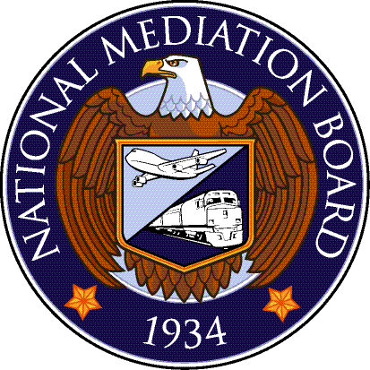

Request for Public Law (PL) Board Member

TO: THE NATIONAL MEDIATION BOARD
Washington, D. C. 20572.

The following request is made by:

Name: |  | Title:
Name of Carrier or  Employee Representative: |  | Address:
Contact: |  | City, State, Zip Code:
Telephone Number: |  | Fax Number:
E-mail: |  | Mobile No:

Pursuant to the provisions of Public Law 89-456 and the National Mediation Board’s Rules pursuant thereto; this REQUEST is for – Check (One Only):

- A Partisan Member pursuant to the National Mediation Board’s Rule 1207.1 (a)
- A Neutral Member pursuant to the National Mediation Board’s Rule 1207.1 (b)
- A Neutral Member pursuant to the National Mediation Board’s Rule 1207.1 (c)

PARTIES TO DISPUTE

Carrier:
Employee Representative:

OUTLINE OF SPECIFIC ISSUES AND/OR DISPUTES TO BE HEARD

Data supporting this request should be appended hereto and made part of this application. Such data should include the agreement establishing the PL Board (if such an agreement in fact exists); the date upon which the request for the establishment of the PL Board was made, and/or the date upon which refusal or failure to agree upon the establishment of the PL Board was made (if such be the case); or the date upon which the parties failed to agree concerning the proposed disputed issues and/or claims or upon a neutral to decide such issues and/or claims.

Requested by (signature): | Date:
Title:

PARTISAN MEMBER REQUESTED

Name: |  | Address:
Title: |  | City and State:
Telephone: |  | E-mail:

