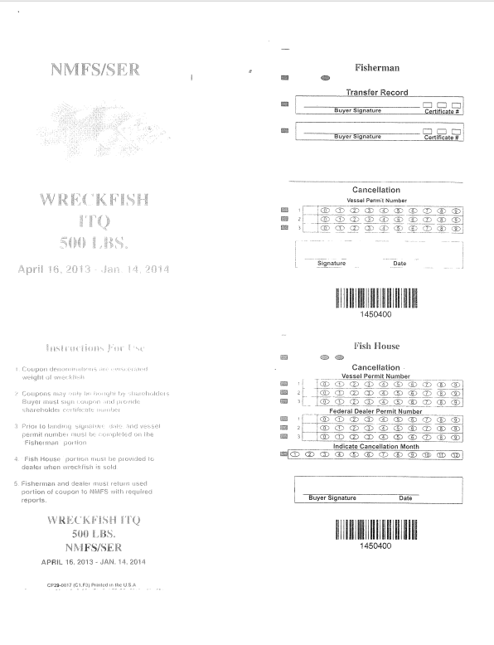
Vessel id number
____________________________
Add additional row (4) for Federal Dealer Permit Number
Vessel id number
____________________________
April 16, 2014 – Jan. 14, 2015

April 16, 2014 – Jan. 14, 2015

