Attachment 4b
Screen Shots of Web-Based Portal for MDE File Submission and Validation

- Login Screen
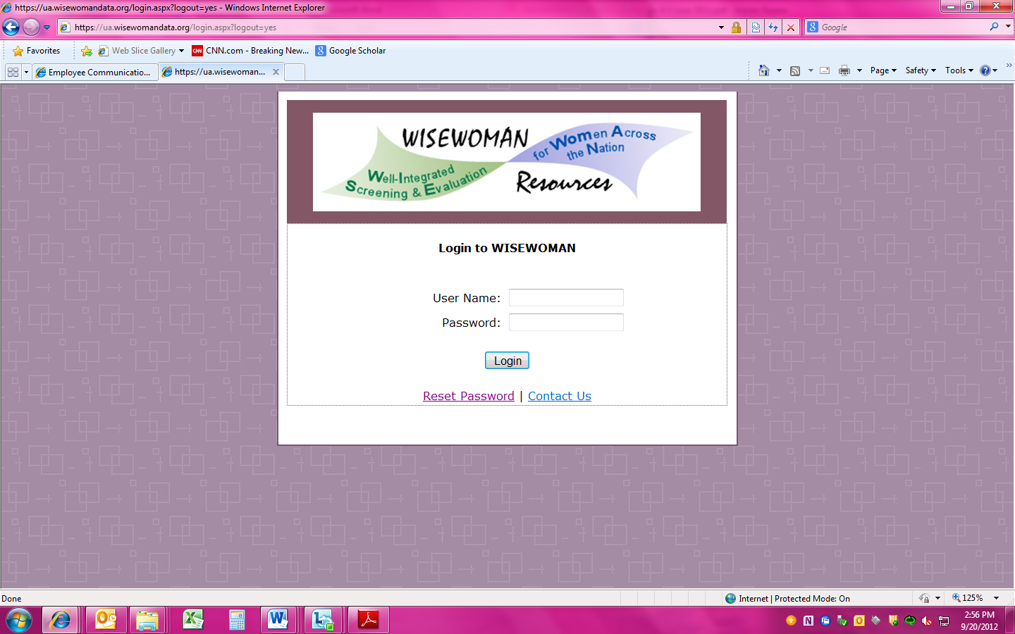

- Home Page

- MDE File Submission Page


- MDE File Validation Page

