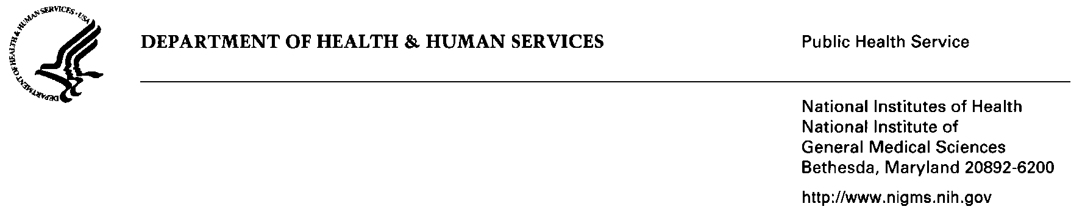
September 3, 2013

TO: Office of Management and Budget (OMB)
Through: Reports Clearance Officer, DHHS
Project Clearance Chief, NIH
Project Clearance Liaison, NIGMS

FROM: Pamela A. Marino, Ph.D., PRAT Program Co-Director
Richard T. Okita, Ph.D., PRAT Program Co-Director

SUBJECT: Request for OMB Clearance for “Application for the Postdoctoral Research Associate Program” (OMB No. 0925-0378)

The OMB approval for the project, “Application for the Postdoctoral Research Associate (PRAT) Program,” OMB No. 0925-0378, has expired on September 30, 2013. We are seeking approval for a reinstatement without change of this currently approved information collection for another three years.

The National Institute of General medical Sciences (NIGMS) established the PRAT Program in 1965. Initially the PRAT program addressed a national need for well-trained leaders in the pharmacological sciences. In keeping with a focus on training leaders in research areas of national need, the program at the request of the NAGMS Council will focus on training leaders in NIGMS designated emerging areas of research. This program offers opportunities for training and experience in laboratory or clinical investigation to individuals with a Ph.D. degree in an NIGMS designated emerging area of research or a related science, M.D., or other professional degree through appointments as PRAT Fellows at the National Institutes of Health or the Food and Drug Administration. With the goal of developing leaders in designated emerging areas of research for key positions in academic, industrial, and federal research laboratories. The program enables those who have committed themselves to training in the biomedical sciences, and for those with backgrounds in clinical medicine or basic science, to obtain specialized experience in selected emerging fields of research.

During their tenure, PRAT Fellows devote most of their time to laboratory research in the biomedical sciences, which further fulfills NIGMS’s mission of supporting research and research training, forming the foundation needed to make advances in understanding disease. With a highly competitive selection process, and appointments based on knowledge, training, and/or research experience, the application and evaluation forms are directly relevant to the continued success of the PRAT Program.

Pamela A. Marino, Ph.D. Richard T. Okita, Ph.D.

Attachments

