# | Page # / Section | FORM CMS-QIMS-0001 (05/11v)  (Original Part B) | FORM CMS-ESRD-0223 (01.14.2013)  Updated Form - ESRD Application Access Form (Previously knows as Part B of the QualityNet Identity Management System (QIMS) Account Form) | Description of Change
1 | All - Header |  |  | Adding ESRD QIP Application to the form. Adding OMB Form Number. Updating CMS logo.
2 | 1 | 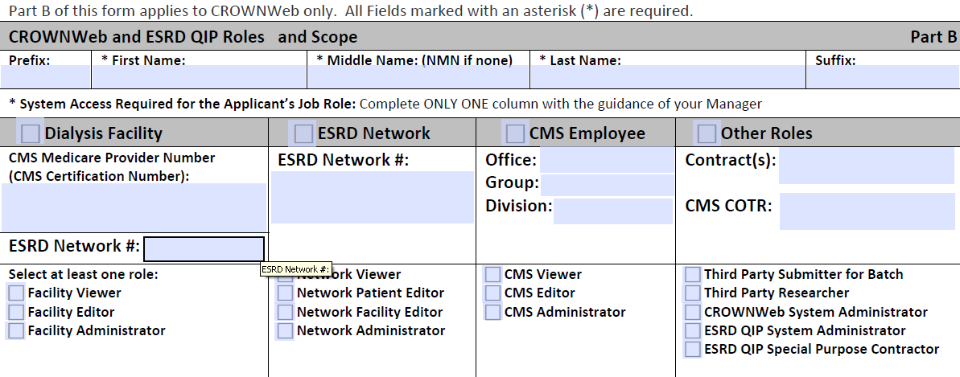 | 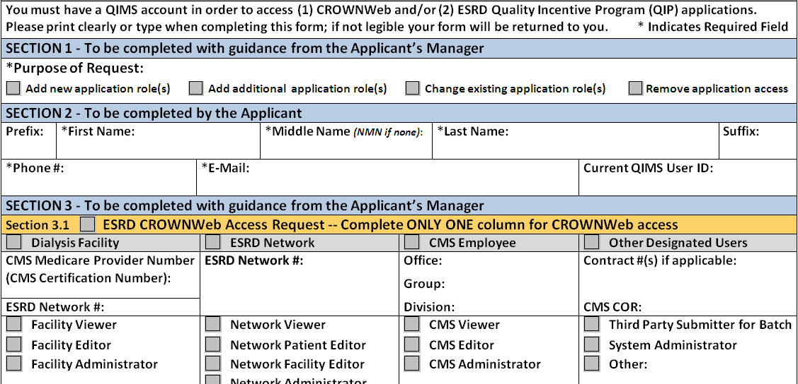 | Added purpose of request text. Added section headers 1, 2, 3 and 3.1. Modified CMS COTR to CMS COR. Removed Third Party Researcher, ESRD QIP System Administrator, ESRD QIP Special Purpose Contractor. Modified CROWNWeb System Administrator to System Administrator.
3 | 1 | 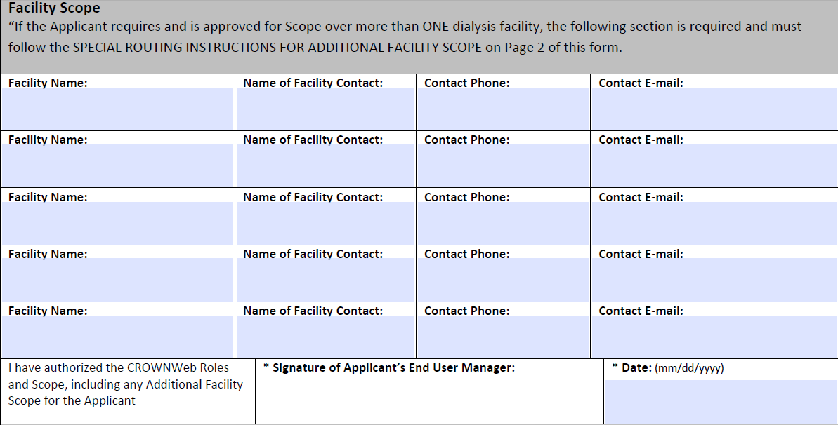 | 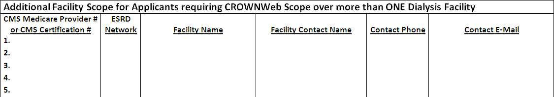 | Added a column for CMS Medicare Provider # or CMS Certification #. Added column for ESRD Network. Modified Name of Facility Contact to Facility Contact Name.
4 | 1 | N/A | 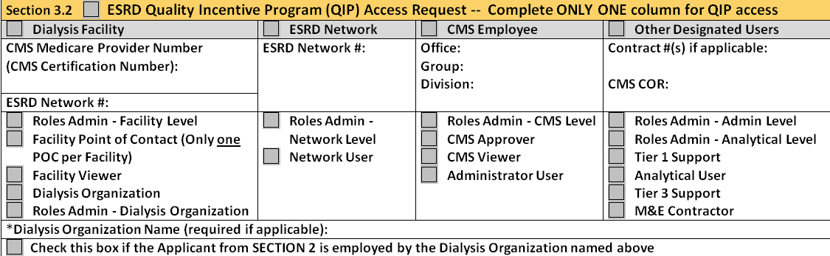 | Added Section 3.2 ESRD Quality Incentive Program (QIP) Access Request. Added Organization Types. Added ESRD QIP user roles.
5 | 1 – Security Official information | 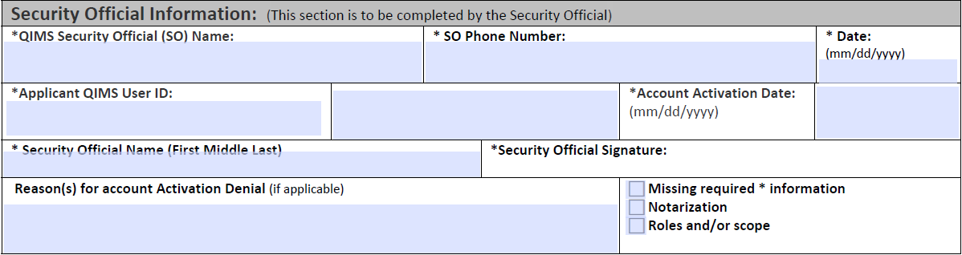 | 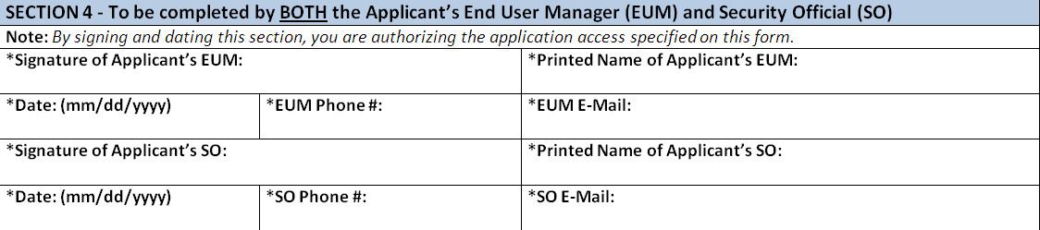 | Combined Security Official and End User Manager signature box. Removed Applicant QIMS User ID, Account Activation Date, Security Official Name (First, Middle, Last), Reason(s) for account activation denial (if applicable), Missing required information checkbox, Notarization checkbox, and Roles and/or Scope checkbox. Added Signature of Applicant’s EUM, Printed Name of Applicant’s EUM, Date (MM/DD/YYYY), EUM Phone Number, EUM E-MAIL, and SO E-MAIL.
6 | All – Footer | Form CMS-QIMS-0001 (05/11v) | FORM CMS-ESRD-0223 (01.14.2013) | Updated CMS Form Number
7 | 1 – Footer | Page 1 of 3 | Page 1 of 4 | Updated page numbers.
8 | 2 | Removed (Instructions and Form Routing for Part A and Part B) | Replaced with Page 3 of Form CMS-QIMS 0001 (05/11v) | No changes to text of QualityNet Data Submission Statement, Privacy Act Statement, or Security Requirements for Users of CMS Computer Systems.
9 | 3, 4 | N/A | Instructions and Form Routing (Sections 1-4) | Replaced page 2 of CMS-QIMS 0001 (05/11v). Provides detailed instructions for completing and submitting the form.

