BSIR Submission Funding Module – Recipients Tab – First Screen

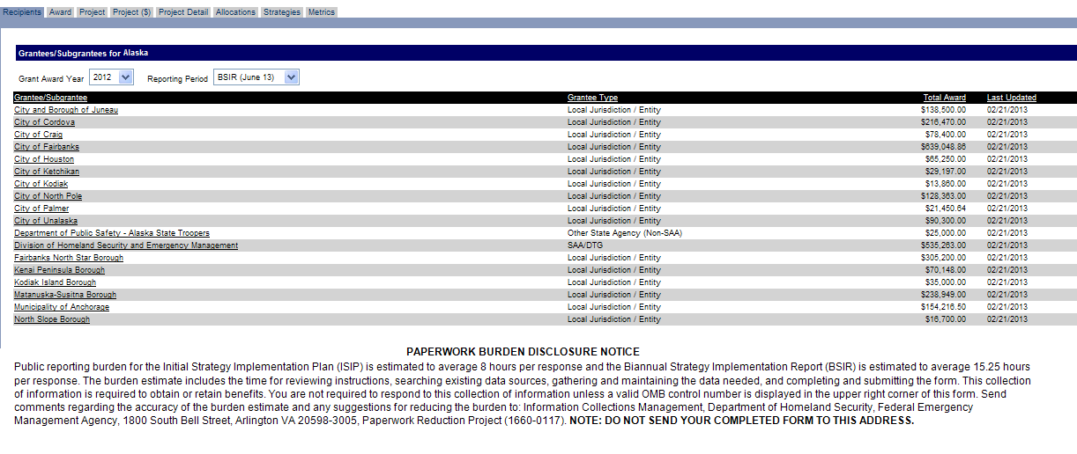
Funding Module – Award Tab – Second Screen
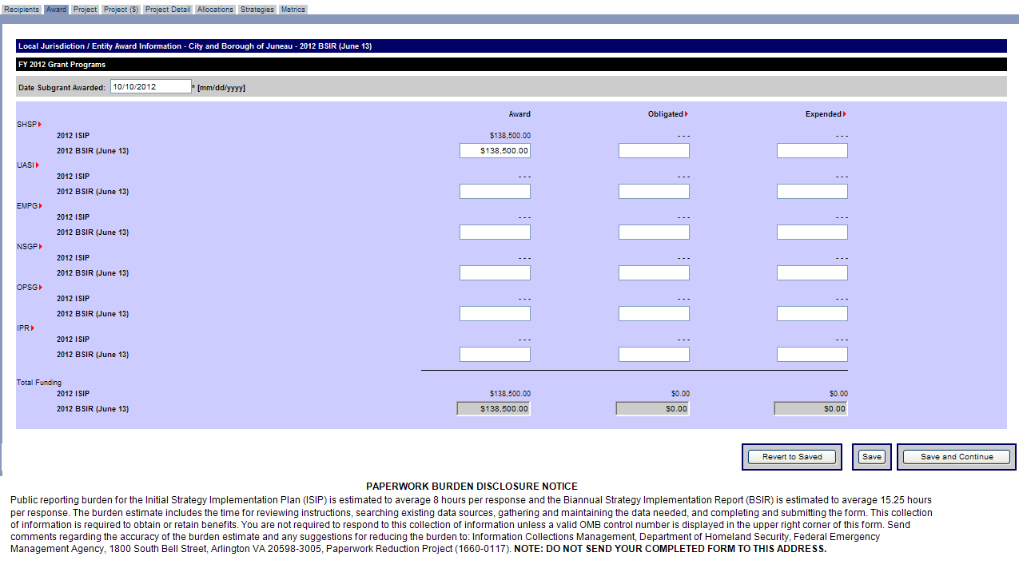
Funding Module – Project Tab – Create Project – Third Screen
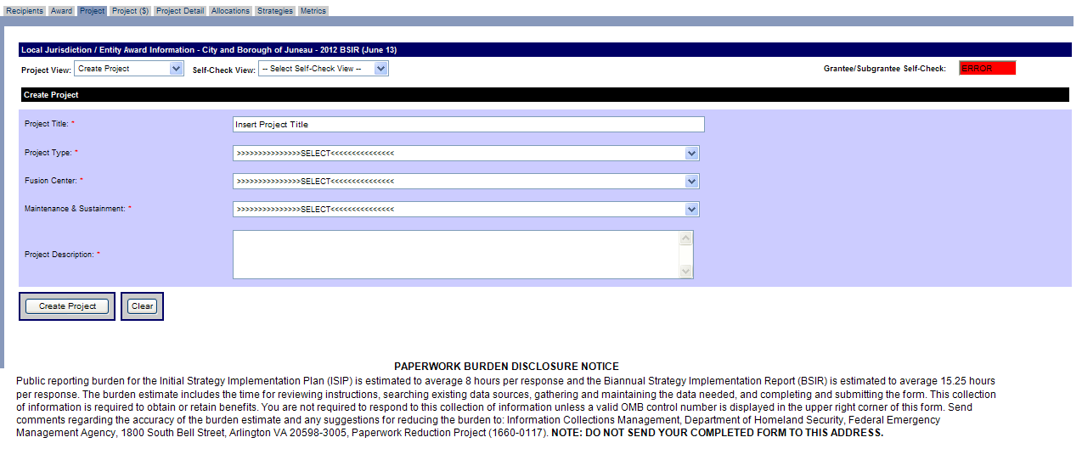
Funding Module – Project Tab – Project History – Fourth Screen
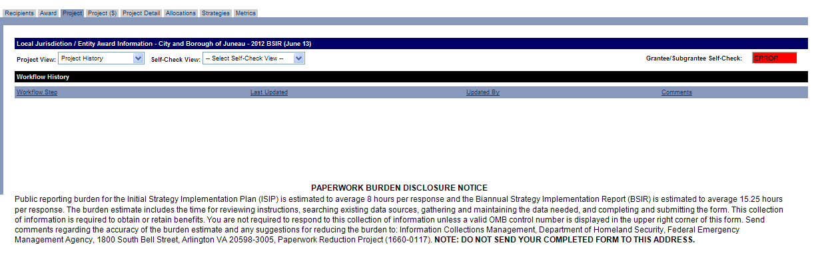
Funding Module – Project Tab – Project List – Fifth Screen
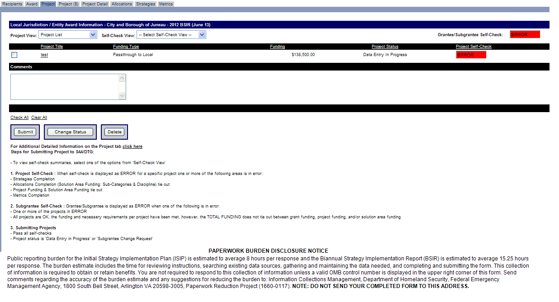
Funding Module – Project ($) Tab – Sixth Screen

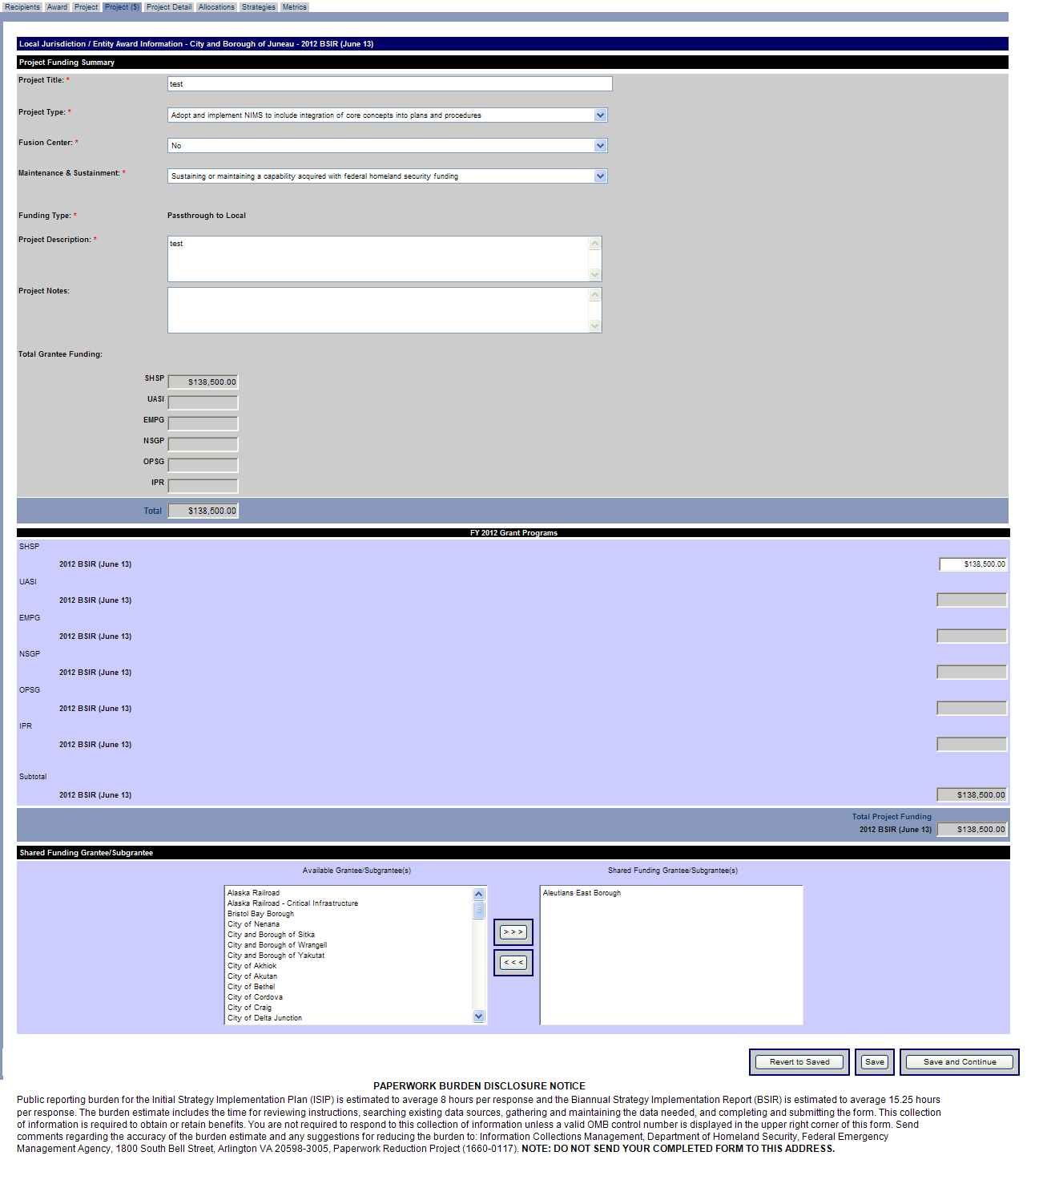

Funding Module – Project Detail Tab – Seventh Screen
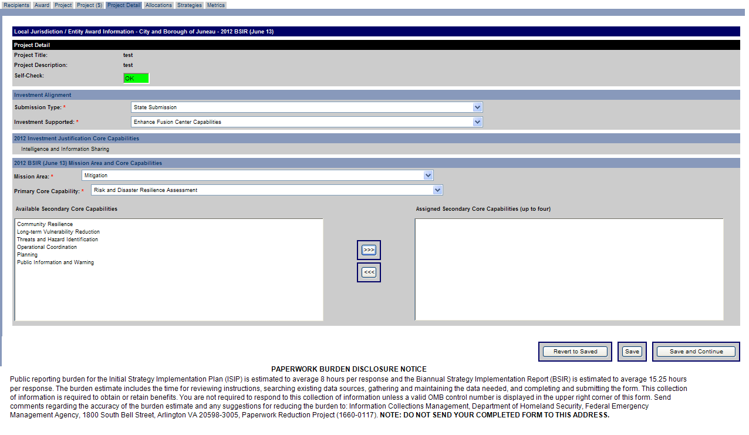
Funding Module – Allocations Tab (Overview) – Eighth Screen
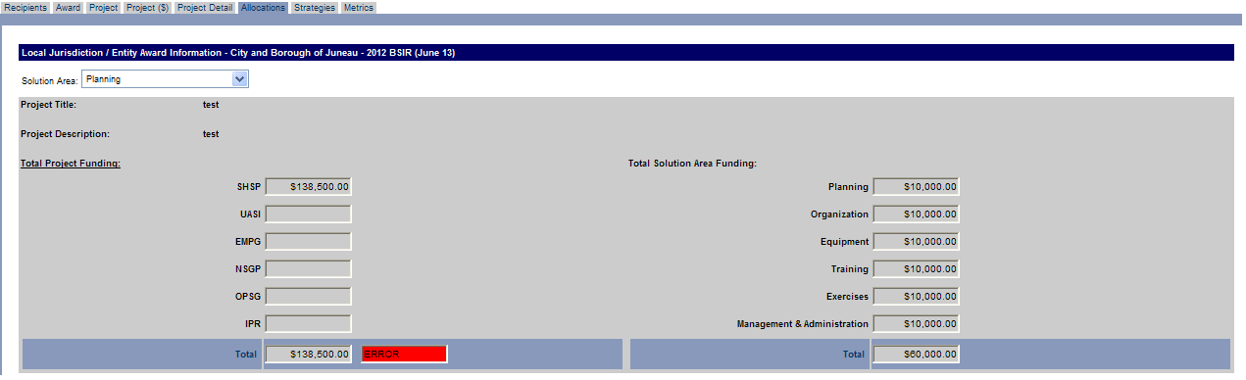
Funding Module – Allocations Tab (Subcategories) – Eighth Screen cont’d
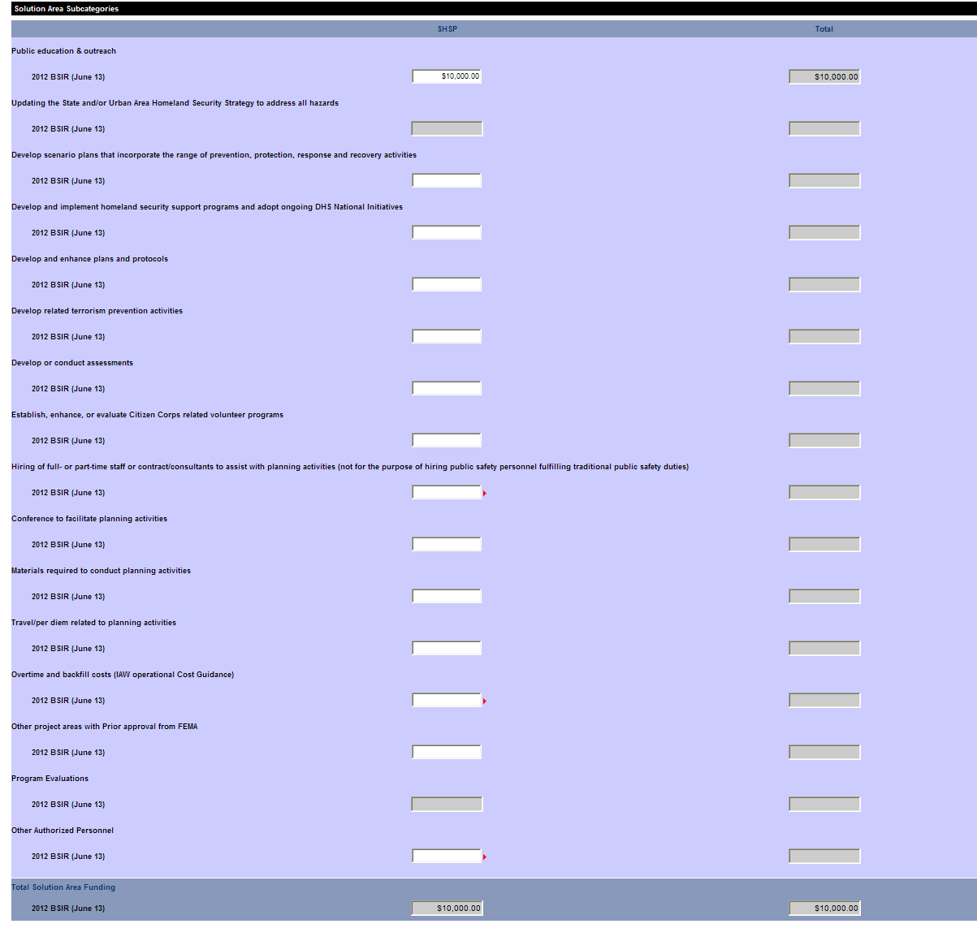
Funding Module – Allocations Tab (Disciplines) – Eighth Screen cont’d

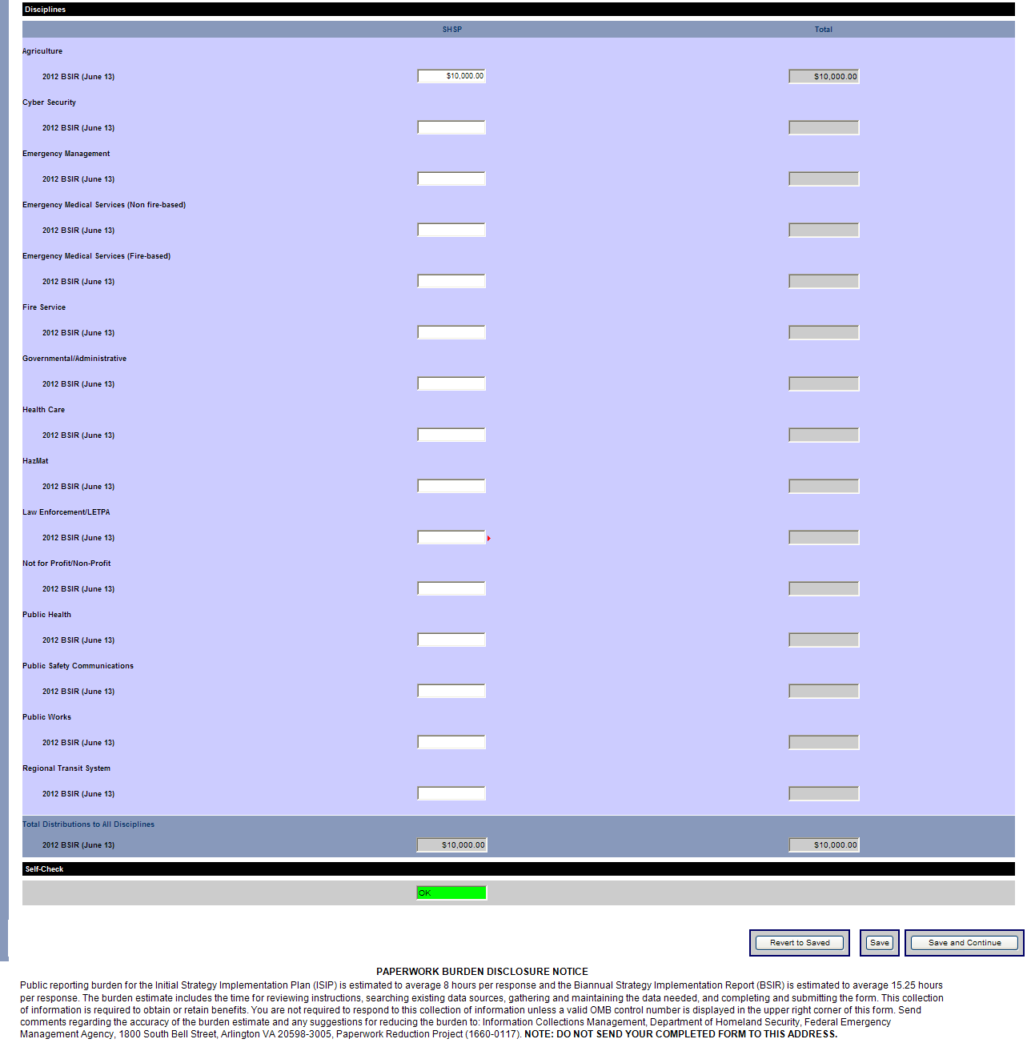
Funding Module – Strategies Tab – Ninth Screen
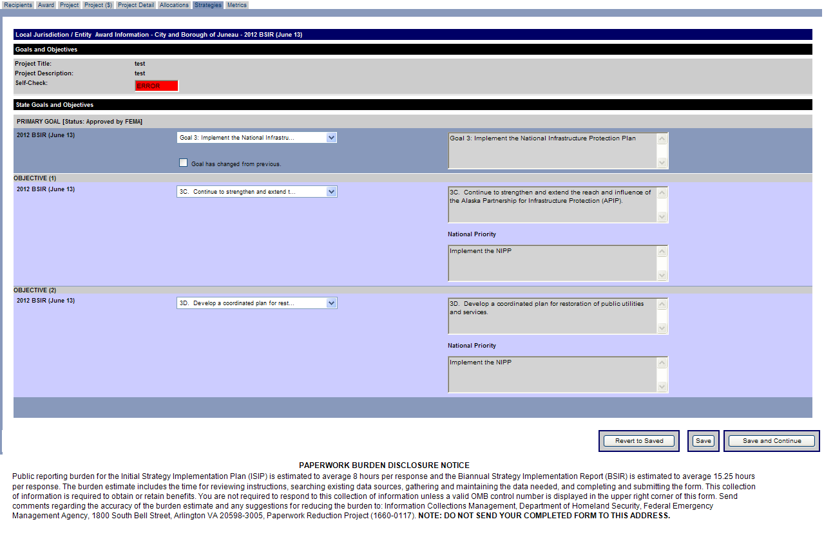
Funding Module – Metrics Tab – Tenth Screen
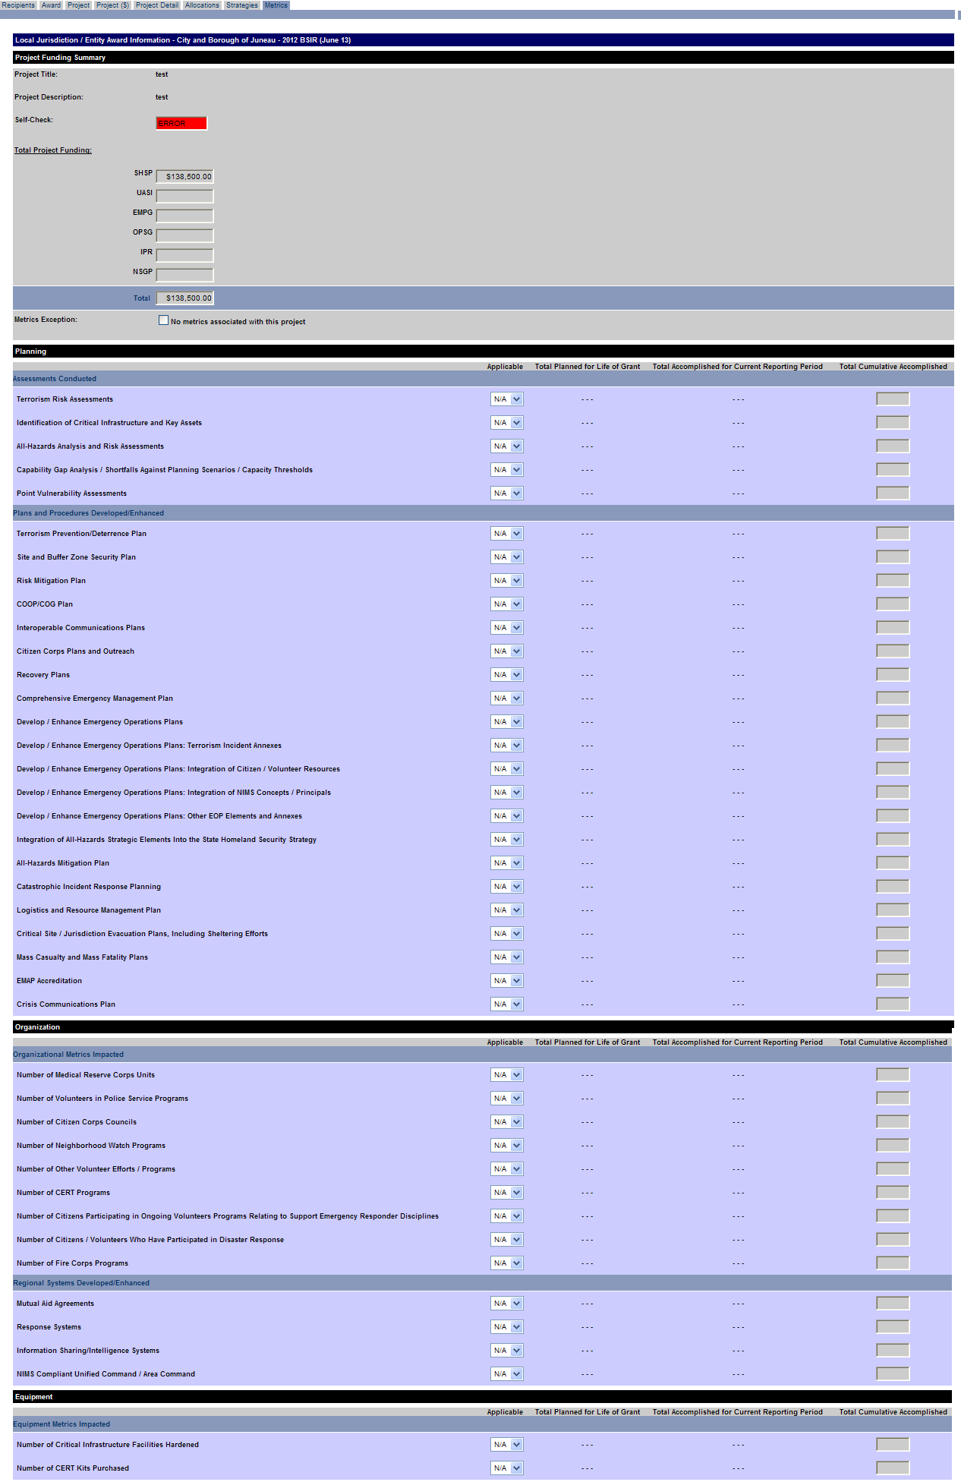
Funding Module – Metrics Tab – Tenth Screen cont’d
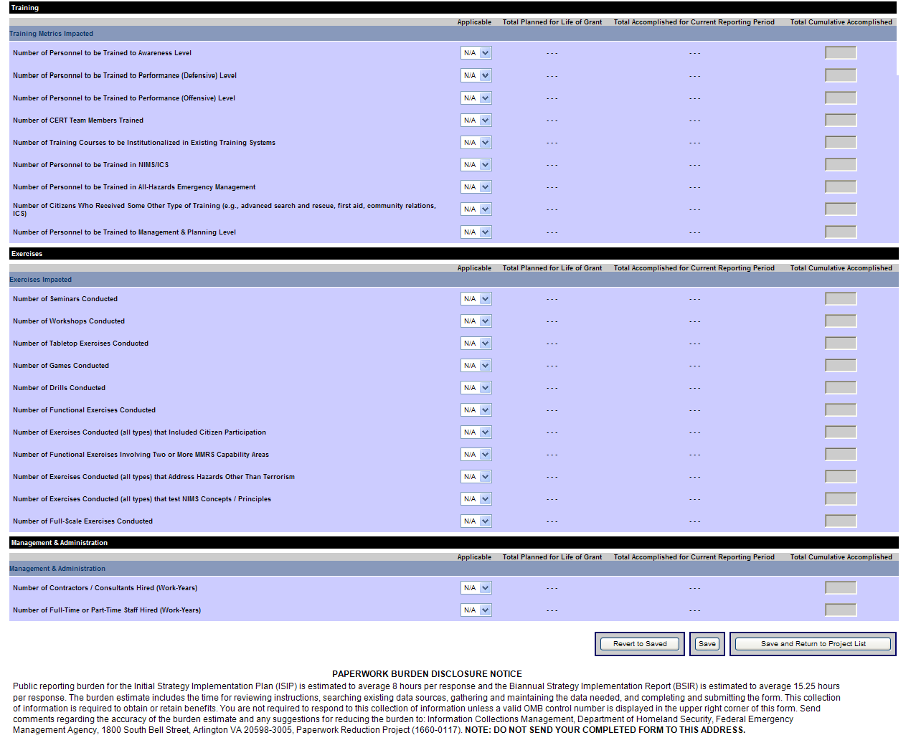
Approval Module – Organization Approval Tab – Eleventh Screen
