ISIP Submission Funding Module – Recipients Tab – First Screen
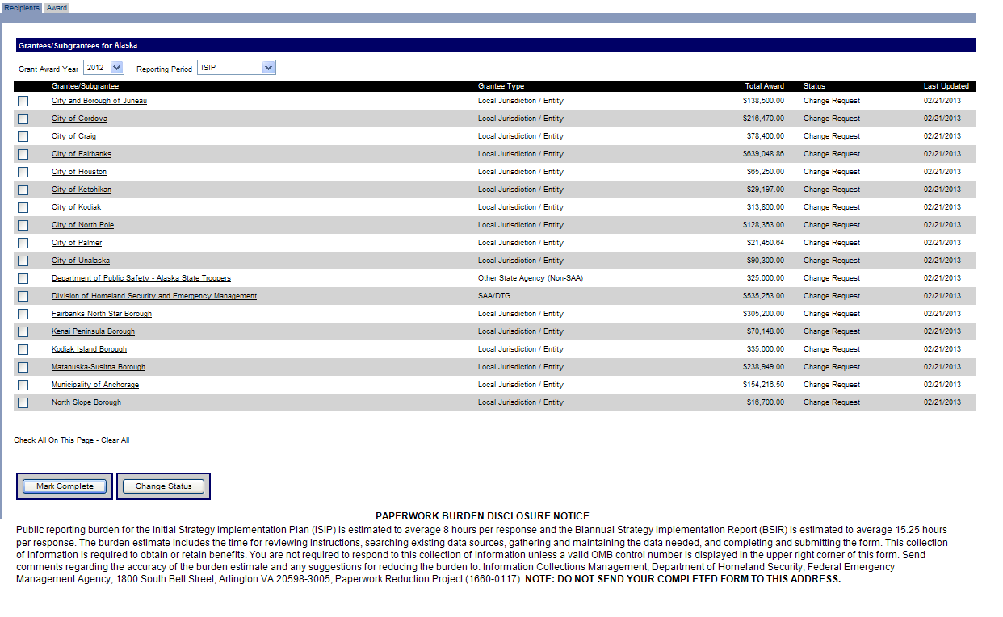
Funding Module – Award Tab – Second Screen
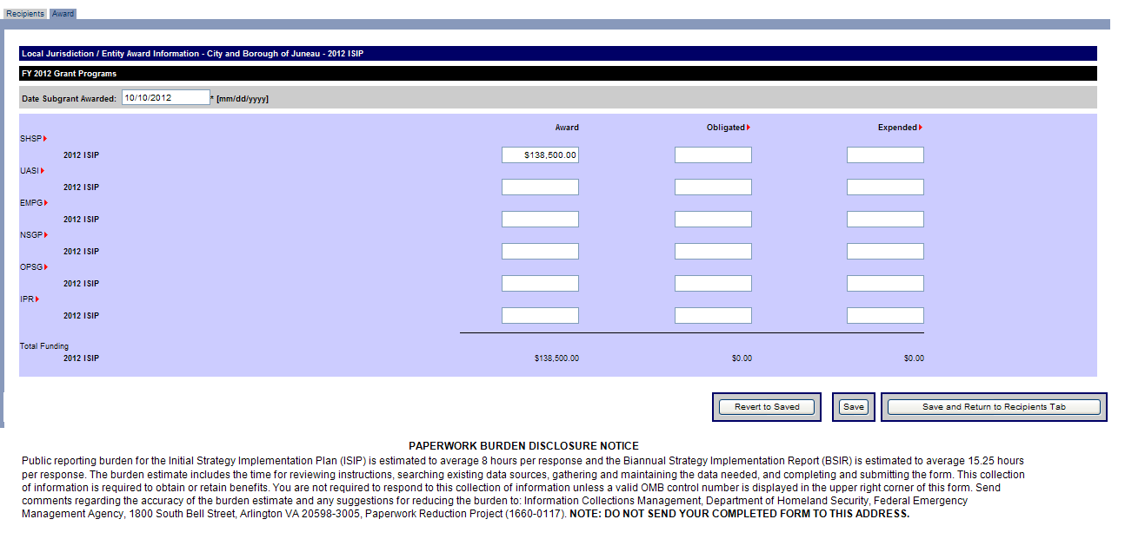

Investment Module – State Overview – Third Screen
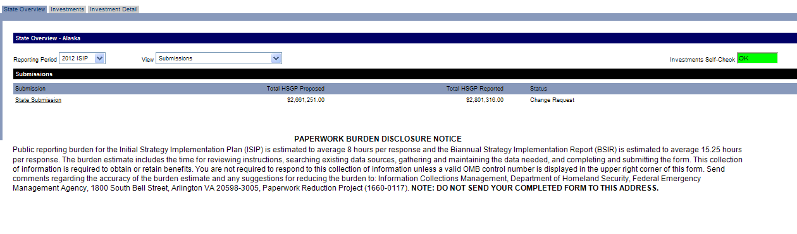
Investment Module – Investments – Fourth Screen
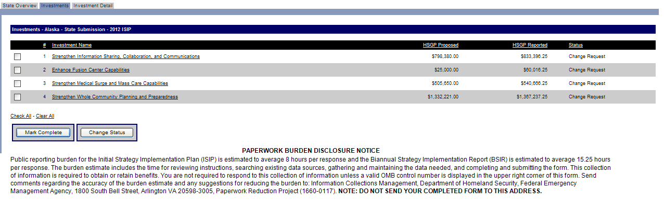
Investment Module – Investment Detail – Fifth Screen
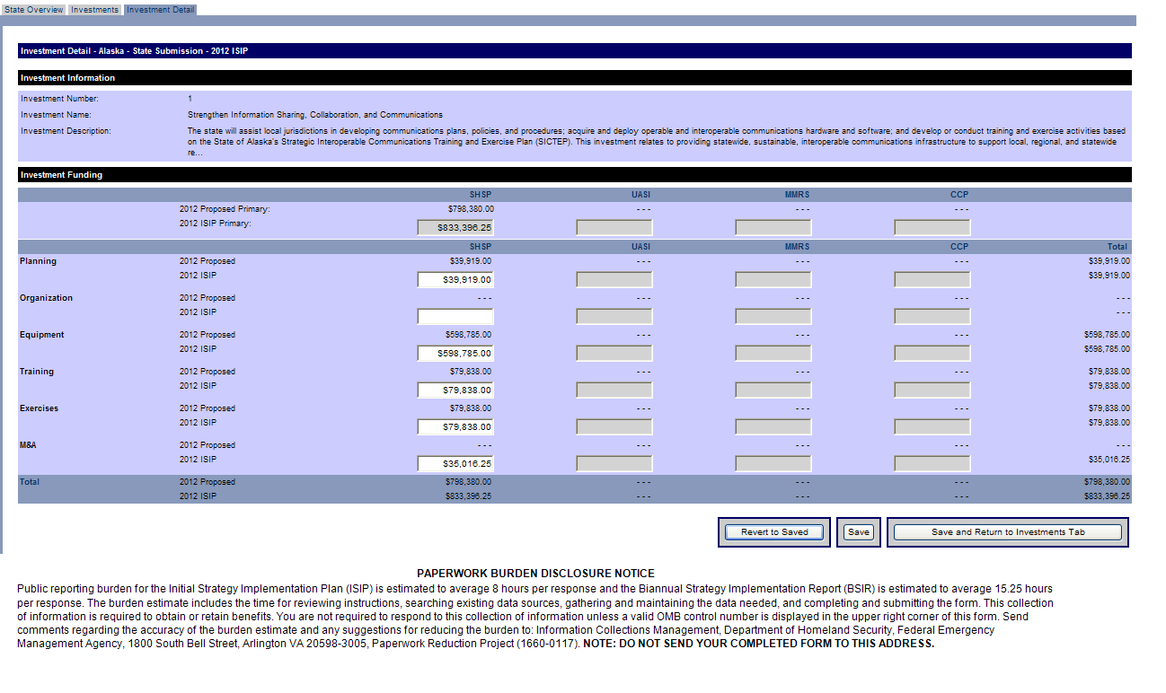
Approval Module – Organization Approval Tab – Sixth Screen
