January 16, 2013
Revised: April 10, 2013
Revised: May 2, 2013

High School Longitudinal Study of 2009 (HSLS:09)
2013 Update and Transcript Main Study (2013)

Data Collection Communication Materials
Appendix 1

Request for OMB Review
OMB# 1850-0852 v.11

Submitted by

National Center for Education Statistics
U.S. Department of Education

TABLE OF CONTENTS
Parent/Student Brochure 1
Parent/Student 2013 Update Brochure 1
Parent Communications 6
Address Update Paper Form 4
Parent: Subsequent Contact Letter A 8
Postcard Reminder 15
Parent: Reminder Flyer 16
Parent: Subsequent Flyer 17
Student Communications 18
Student: Initial Contact Letter 18
Student: Subsequent Contact Letter A 20
Student: Postcard Reminder 27
Student: Reminder Flyer 28
Student: Subsequent Flyer 29
Main StudyTranscript Collection Materials 30
Transcript Request Letter Base Year Schools 30
Transcript Request Letter - Transfer Schools 32
Transcript Request Cover Memo To Transcript Coordinator or Registrar 34
Value and Uses of Transcript Data 35
Transcript Instructions 37
Family Educational Rights and Privacy Act Regulations 39
Student Transcript Fax Test Page 46
Transcript Transmittal Fax 48
Transmittal Sheet Catalog 49
Disclosure Notice 50
Items Contained on the School Information Page 51
Transcript Explicit Permission Letter 56
Transcript Consent Reminder Postcard 61
Post Consent Request Letter – Explicit 62
Post Consent Request Letter – Implied 63
Additional Student Transcript Request Letter 65
Transcript Request Reminder E-mail 66
Transcript Reminder Letter 67
Second Follow-up Field Test Panel Maintenance Materials 68
Panel Maintenance Letter 68
Panel Maintenance E-mail 69
Address Update Web Form 70
Address Update Paper Form 72
Second Follow-up Main Study Panel Maintenance Materials 74
Panel Maintenance Letter 74
Panel Maintenance E-mail 75
Address Update Web Form 76
Address Update Paper Form 78

Parent/Student Brochure



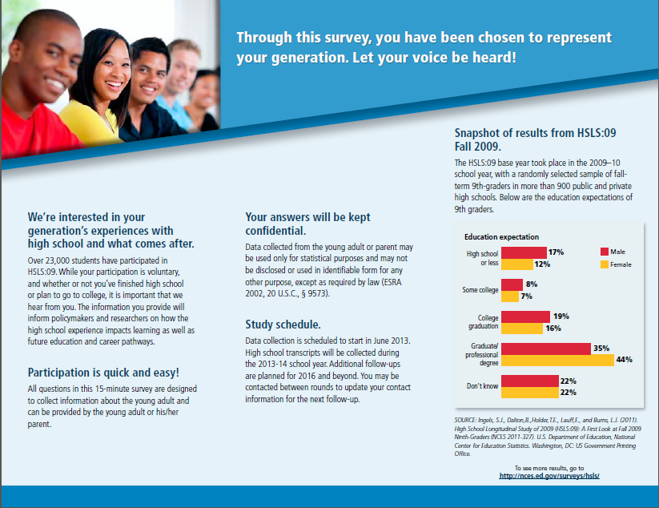

Parent Communications

Panel Maintenance Card
This panel maintenance update is planned to be sent in the spring of 2013, prior to the 2013 Update. We plan to send a greeting card-type mailing and enclose a hard copy update option. A business reply envelope will accompany the hard copy form to facilitate returns.

Card text:
Thank you for your past participation in the High School Longitudinal Study of 2009 (HSLS:09). The next data collection update begins in June 2013. We look forward to speaking with you then!
To confirm or update your contact information, please log in to our secure website:
https://surveys.nces.ed.gov/hsls
Study ID = «userid»
Password = «password»<PW_ind>
Or you may return the enclosed form with your updated contact information.
Thank you!

RTI is collecting data as part of this study by the National Center for Education Statistics (NCES) of the U.S. Department of Education’s Institute for Education Sciences.

Address Update Paper Form
High School Longitudinal Study of 2009 (HSLS:09)

Address Update Information
Thank you very much for your participation in the High School Longitudinal Study of 2009 (HSLS:09). Please take a moment to confirm or update [your/StudentName’s] contact information. We are also requesting that you confirm or update contact information for [your parent/yourself] and provide contact information for one additional person. By updating our records, we will be better able to notify [you/him/her] when it is time for the next round of HSLS:09. Please be assured that both NCES and RTI follow strict confidentiality procedures to protect the privacy of study participants. If you would like more information about the HSLS study, please visit http://surveys.nces.ed.gov/hsls/.

After you complete this form, please mail it back to RTI International using the enclosed Business Reply Envelope.

This update may also be completed on our secure website at [Website_Fil] by entering your study id: [ID_Fill] and password: [PW_Fill]. You may go online to indicate that the information provided in the form below is correct.

We greatly appreciate your help to make HSLS:09 a continued success!

1. [STUDENTS ONLY] May we send you a text message reminder when data collection begins?
- Yes Please enter your cell provider here: ___________________
- No

- If [your/StudentName’s] current contact information is not correct below, please provide the updated contacting information on the right. If the contact information is correct, please check the box.

 | [Your/StudentName’s] contacting information |  |  | Corrections and additions
 | Name: | [StudentName]
 | Address: | [StudentAddress]
 | City | [StudentCity]
 | State | [StudentState]
 | ZIP | [StudentZIP]
 | Home phone: | [StudentHome]
 | Work phone: | [StudentWork]
 | Cell phone: | [StudentCell]
 | Primary e-mail address: | [Studentemail1]
 | Alternate e-mail address: | [Studentemail2]
- Check here if all information is correct

- Please also provide the contact information for the parent most knowledgeable about [your/StudentName’s] education or career. Please also provide contact information for an additional person who will always know how to get in touch with [you/StudentName].

 | Parent information |  |  | Corrections and additions
 | Name: | [ParentName]
 | Address: | [ParentAddress]
 | City: | [ParentCity]
 | State: | [ParentState]
 | ZIP: | [ParentZIP]
 | Home phone: | [Parenthome]
 | Work phone: | [ParentWork]
 | Cell phone: | [ParentCell]
 | Primary e-mail address: | [Parentemail1]
 | Alternate e-mail address: | [Parentemail2]
- Check here if all information is correct

Other contact information
Name:
Address:
City:
State:
ZIP:
Home phone:
Work phone:
Cell phone:
Primary e-mail address:
Alternate e-mail address:

4. [Are you/Is StudentName] currently enrolled in a college, trade school, or other higher education institution?
- Yes Please continue with question 5
- No You are finished with the address update. Thank you.

5. Please provide the name and address of the college, trade school, or other higher education institution that [you/StudentName] attend. Please do not use abbreviated school names (e.g. use Arizona State University, rather than ASU).

School Name:

Thank you in advance for making HSLS:09 a success!

Parent Communications

Parent: Initial Contact Letter
[DATE]

<PARENT NAME> Web Address: https://surveys.nces.ed.gov/hsls
<ADDR1> Study ID: <XXXXXXX>
<ADDR2> Password: <XXXXXXXX><PW_ind>
<CITY STATE ZIP>
Dear <Parent or Guardian Name>:
The High School Longitudinal Study of 2009 (HSLS:09) appreciates your family’s past participation in the study in <2009/2012/2009 and 2012>. A follow-up is now being conducted to learn about <teenagername>’s plans for after high school. This 15-minute questionnaire asks about <teenagername>’s high school completion status, plans after high school including college, work, or joining the military, and the status of any college applications that <teenager> may have submitted. To complete the online survey, please log in using the web address, study ID, and password provided at the top right of this page.
<If incentive: You will receive a $<inc_amt> check as a token of our appreciation after you finish the survey.> Whether or not your <son/daughter> finished high school or plans to go to college, your input is critically important to help us understand all paths that young adults take and the decisions they make about the future.
HSLS:09 is conducted by the National Center for Education Statistics (NCES) of the U.S. Department of Education and will inform policymakers on how the high school experience impacts learning as well as future educational and career pathways. This component of the study should help fill an important gap in educators’ knowledge of students’ and parents’ decisionmaking at this critical transition point after high school. <Teenagername>’s and your participation is voluntary, but incredibly important. <Teenagername> was selected to represent <his/her> generation, and this is your family’s opportunity to describe the role that high school experiences play in shaping <teenager>’s choices for the future.
All questionnaire items can be completed by either <teenager> or a parent < If student over 18: and a letter was also sent to <teenager> with <his/her> login information>. <<If student under 18: If <teenagername> prefers to complete the questionnaire, please give <him/her> the enclosed letter with information about how to access the questionnaire. By giving <him/her> this letter, you are giving your permission for <him/her> to participate.>
HSLS:09 data collection is being carried out by RTI International under contract with NCES. Data collected are used only for statistical purposes and may not be disclosed or used, in identifiable form for any other purpose except as required by law (ESRA 2002, 20 U.S.C., § 9573). The enclosed brochure provides more information about HSLS:09. In addition, results from the first round of the study are available on the HSLS:09 website mentioned above. If you have questions about the study or prefer to complete the interview over the telephone, please call Randy Ottem toll-free at 1-855-500-1440 or the NCES Project Officer of HSLS:09, Dr. Elise Christopher, at 202-502-7899. If you have questions about your rights as a study participant, you may call RTI’s Office for Research Protection toll-free at 1-866-214-2043.
We thank you in advance for your cooperation in this important research.
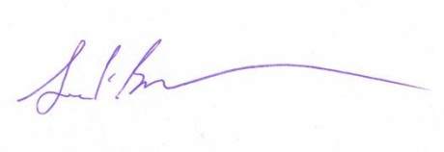
Sincerely,

Jack Buckley, Commissioner
National Center for Education Statistics
Institute of Education Sciences
U.S. Department of Education

Enclosure: HSLS:09 Brochure
<<If student under 18: Young adult Letter>>

NCES is authorized to conduct HSLS:09 under the Education Sciences Reform Act of 2002 (ESRA 2002, 20 U.S.C., § 9543). According to the Paperwork Reduction Act of 1995, no persons are required to respond to a collection of information unless it displays a valid OMB control number. The valid OMB control number of this voluntary information collection is 1850-0852. The time required to complete this information collection is estimated to average 15 minutes for the questionnaire including the time to review instructions and complete and review the information collection. If you have any comments concerning the accuracy of the time estimate or suggestions for improving the interview, please write to: High School Longitudinal Study of 2009 (HSLS:09), National Center for Education Statistics, 1990 K Street NW, Washington, DC 20006.

Parent: Subsequent Contact Letter A
[Date]

<PARENT NAME> Web Address: https://surveys.nces.ed.gov/hsls
<ADDR1> Study ID: <XXXXXXX>
<ADDR2> Password: <XXXXXXXX><PW_ind>
<CITY STATE ZIP>

Dear «fname» «lname»:
We are writing to ask that you or <teenagername> complete a 15-minute questionnaire for the High School Longitudinal Study of 2009 (HSLS:09). The purpose of the study is to understand the impact of the high school experience on young adults’ learning, their education and career choices, and their transitions from high school to college, the workforce, and adulthood. It is important that we hear from everyone who was selected for the study, whether or not <teenagername> has graduated from high school or plans to go to college.
Either you or your young adult can complete the questionnaire. << If incentivized: We will send you a check for $<<INCENT>> after you complete the questionnaire, as a token of our appreciation. >>
Please log in to the survey using the web address, study ID and password provided above. To complete the interview with one of our professional telephone interviewers, call toll-free at 1-855-500-1440. <<If student under 18: If <teenagername> prefers to complete the questionnaire, please give <teenagername> the enclosed letter to indicate that you have given your permission for <him/her> to participate. The letter explains the study and provides log-in information so <teenagername> can complete the questionnaire.>><<If student over 18: Since either you or your young adult may complete the questionnaire, a letter has also been sent to <teenagername> with <his/her> log-in information.>>
If you have questions about the study, please call Randy Ottem toll-free at 1-855-500-1440 or the NCES Project Officer of HSLS:09, Dr. Elise Christopher, at 202-502-7899.
Thank you in advance for making HSLS:09 a success!
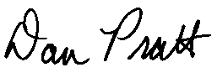
Dan Pratt
HSLS:09 Project Director
RTI International

<<If student under 18: Enclosure: Young adult Letter>>

NCES is authorized to conduct HSLS:09 under the Education Sciences Reform Act of 2002 (ESRA 2002, 20 U.S.C., § 9543). According to the Paperwork Reduction Act of 1995, no persons are required to respond to a collection of information unless it displays a valid OMB control number. The valid OMB control number of this voluntary information collection is 1850-0852. The time required to complete this information collection is estimated to average 15 minutes for the questionnaire including the time to review instructions and complete and review the information collection. If you have any comments concerning the accuracy of the time estimate or suggestions for improving the interview, please write to: High School Longitudinal Study of 2009 (HSLS:09), National Center for Education Statistics, 1990 K Street NW, Washington, DC 20006.
Parent: Subsequent Contact Letter B
[DATE]

<PARENT NAME> Web Address: https://surveys.nces.ed.gov/hsls
<ADDR1> Study ID: <XXXXXXX>
<ADDR2> Password: <XXXXXXXX><PW_ind>
<CITY STATE ZIP>

Dear «fname» «lname»:
By participating in the High School Longitudinal Study of 2009 (HSLS:09), your family will help inform educators, researchers, and policymakers about the choices young adults make and the paths young adults take throughout high school and beyond. Please take about 15 minutes to complete a questionnaire for HSLS:09. <<IF INCENTIVIZED: After you finish the questionnaire, we will send you a check for $<<incent>>, as a token of our appreciation.>> Your assistance is very much appreciated!
You can complete the questionnaire online using the log in information above or call toll-free 1-855-500-1440 to complete the questionnaire over the phone. Either you or <teenagername> may complete the questionnaire. <<If student under 18: If <teenagername> prefers to complete the questionnaire, please give <him/her> the enclosed letter to indicate that you have given your permission for <him/her> to participate. The letter provides <his/her> log in information.>><<If student over 18: We also sent a letter to <teenagername> with <his/her> log in information.>>
If you have questions about the study, please call Randy Ottem toll-free at 1-855-500-1440 or the NCES Project Officer of HSLS:09, Dr. Elise Christopher, at 202-502-7899.
Thank you in advance for making HSLS:09 a success!
Dan Pratt
HSLS:09 Project Director
RTI International
<<If student under 18: Enclosure: Young adult Letter>>

NCES is authorized to conduct HSLS:09 under the Education Sciences Reform Act of 2002 (ESRA 2002, 20 U.S.C., § 9543). According to the Paperwork Reduction Act of 1995, no persons are required to respond to a collection of information unless it displays a valid OMB control number. The valid OMB control number of this voluntary information collection is 1850-0852. The time required to complete this information collection is estimated to average 15 minutes for the questionnaire including the time to review instructions and complete and review the information collection. If you have any comments concerning the accuracy of the time estimate or suggestions for improving the interview, please write to: High School Longitudinal Study of 2009 (HSLS:09), National Center for Education Statistics, 1990 K Street NW, Washington, DC 20006.
Parent: Subsequent Contact Letter C
[Date]

<PARENT NAME> Web Address: https://surveys.nces.ed.gov/hsls
<ADDR1> Study ID: <XXXXXXX>
<ADDR2> Password: <XXXXXXXX><PW_ind>
<CITY STATE ZIP>

Dear «fname» «lname»:
You have an opportunity to help policymakers understand how the high school experience impacts learning and future educational and career pathways by your continued participation in the High School Longitudinal Study of 2009 (HSLS:09). The questionnaire should take approximately 15 minutes to complete.
<If Prepaid: A $<pre-paid-inc-amt> check has been sent to <Teenagername> as a token of our appreciation for your continued participation.> <If both prepaid and promised incentive: In addition,> <If incentive: You/you will receive a $<inc_amt> check after you finish the survey.>
To make participation as easy as possible, the questionnaire is designed so that it can be completed by either <teenager name> or <his/her> parent/guardian.
This update will help fill an important gap in educators’ knowledge of students’ and parents’ decisionmaking at this critical transition point after high school. Whether or not <Teenagername> finished high school or plans to go to college, your input is critically important to help us understand all paths that young adults take and the decisions they make about the future.
To complete the questionnaire online, please log in using the web address, study ID, and password provided at the top of this page. If you would prefer to participate over the telephone, you may call 1-855-500-1440. Data collected are used only for statistical purposes and may not be disclosed or used, in identifiable form for any other purpose except as required by law (ESRA 2002, 20 U.S.C., § 9573).
HSLS:09 is conducted by the National Center for Education Statistics (NCES) of the U.S. Department of Education and data are being collected by RTI. The enclosed brochure provides more information about HSLS:09 and this update. In addition, results from the first round of the study are available on the HSLS:09 website mentioned above. If you have questions about the study, please call Randy Ottem at RTI toll-free at 1-855-500-1440 or the NCES Project Officer, Dr. Elise Christopher, at 202-502-7899. If you have questions about your rights as a study participant, you may call RTI’s Office for Research Protection toll-free at 1-866-214-2043.
Thank you in advance for your continued participation in HSLS:09!
Dan Pratt
HSLS:09 Project Director
RTI International

Enclosure: Brochure
<<If student under 18: Young adult Letter>>

NCES is authorized to conduct HSLS:09 under the Education Sciences Reform Act of 2002 (ESRA 2002, 20 U.S.C., § 9543). According to the Paperwork Reduction Act of 1995, no persons are required to respond to a collection of information unless it displays a valid OMB control number. The valid OMB control number of this voluntary information collection is 1850-0852. The time required to complete this information collection is estimated to average 15 minutes for the questionnaire including the time to review instructions and complete and review the information collection. If you have any comments concerning the accuracy of the time estimate or suggestions for improving the interview, please write to: High School Longitudinal Study of 2009 (HSLS:09), National Center for Education Statistics, 1990 K Street NW, Washington, DC 20006.
Parent: Subsequent Contact Letter D
[Date]
«fname» «mname» «lname» «suffix»
«addr1»«addr2»
«citystatezip»

Dear «fname» «lname»:
Please complete the questionnaire for the High School Longitudinal Study of 2009 (HSLS:09). We value your input! <<If incentivized: and we will send you a check for $<INCENT> in appreciation for your participation>>.
We are interested to know what educational or career plans <teenagername> has for this fall and beyond. The data collected by HSLS:09 will help educators, policymakers, and researchers understand the different paths that young adults take through high school and into higher education, the workforce, or the military.
The survey takes about 15 minutes to complete and either you or <teenagername> can complete the questionnaire. You can complete the questionnaire online using the log-in information below or call toll-free at 1-855-500-1440 if you prefer to complete the questionnaire over the phone.
Website: https://surveys.nces.ed.gov/hsls/
Study ID: «caseid»
Password: «password»<<PW_ind>>
<<If student under 18: If <teenagername> prefers to complete the questionnaire, please give <him/her> the enclosed letter to indicate that you have given your permission for <him/her> to participate. The letter provides <his/her> log-in information.>><<If student over 18: We also sent a letter to <teenagername> with <his/her> log-in information since either you or <teenagername> may complete the questionnaire.>>
If you have questions about the study, please call Randy Ottem at RTI toll-free at 1-855-500-1440 or Dr. Elise Christopher, NCES Project Officer, at 202-502-7899. Thank you in advance for your continued participation in HSLS:09!
Dan Pratt
HSLS:09 Project Director
RTI International
<<If student under 18: Enclosure: Young adult Letter>>
NCES is authorized to conduct HSLS:09 under the Education Sciences Reform Act of 2002 (ESRA 2002, 20 U.S.C., § 9543). According to the Paperwork Reduction Act of 1995, no persons are required to respond to a collection of information unless it displays a valid OMB control number. The valid OMB control number of this voluntary information collection is 1850-0852. The time required to complete this information collection is estimated to average 15 minutes for the questionnaire including the time to review instructions and complete and review the information collection. If you have any comments concerning the accuracy of the time estimate or suggestions for improving the interview, please write to: High School Longitudinal Study of 2009 (HSLS:09), National Center for Education Statistics, 1990 K Street NW, Washington, DC 20006.
Parent: Subsequent Contact Letter E
[Date]
<PARENT NAME> Web Address: https://surveys.nces.ed.gov/hsls
<ADDR1> Study ID: <XXXXXXX>
<ADDR2> Password: <XXXXXXXX><PW_ind>
<CITY STATE ZIP>

Dear «fname» «lname»:
We still need your participation in the High School Longitudinal Study:09 (HSLS:09). <<If incentivized: We understand that your time is valuable – that’s why we’re <if incentive is increasing: now> offering $<incamt> to thank you for completing the HSLS:09 Survey!>>
Please complete the questionnaire before <DATE> or ask <teenagername> to do so. By completing this 15-minute questionnaire, you or <teenagername> will be contributing to a study that will influence how educators, researchers, and policymakers improve education in the US. HSLS:09 is interested in learning how <teenagername>’s high school experience influenced what <he/she> plans to do after high school. Use the log-in information above to complete the questionnaire online or call toll-free at 1-855-500-1440 to complete the questionnaire over the phone.
<<If student under 18: If <teenagername> prefers to complete the questionnaire, please give <him/her> the enclosed letter to indicate that you have given your permission for <him/her> to participate.>><<If student over 18: We also sent a letter to <teenagername> with <his/her> log-in information since either you or <teenagername> may complete the questionnaire.>>
If you have questions about the study, please call Randy Ottem toll-free at 1-855-500-1440 or the NCES Project Officer of HSLS:09, Dr. Elise Christopher, at 202-502-7899. Thank you in advance for making HSLS:09 a success!
Dan Pratt
HSLS:09 Project Director
RTI International
<<If student under 18: Enclosure: Young adult Letter>>
NCES is authorized to conduct HSLS:09 under the Education Sciences Reform Act of 2002 (ESRA 2002, 20 U.S.C., § 9543). According to the Paperwork Reduction Act of 1995, no persons are required to respond to a collection of information unless it displays a valid OMB control number. The valid OMB control number of this voluntary information collection is 1850-0852. The time required to complete this information collection is estimated to average 15 minutes for the questionnaire including the time to review instructions and complete and review the information collection. If you have any comments concerning the accuracy of the time estimate or suggestions for improving the interview, please write to: High School Longitudinal Study of 2009 (HSLS:09), National Center for Education Statistics, 1990 K Street NW, Washington, DC 20006.
Parent: Subsequent Contact Letter F
<date>

<PARENT NAME> Web Address: https://surveys.nces.ed.gov/hsls
<ADDR1> Study ID: <XXXXXXX>
<ADDR2> Password: <XXXXXXXX><PW_ind>
<CITY STATE ZIP>

Dear «fname» «lname»:
We know your time is valuable. We are now offering an abbreviated survey for the High School Longitudinal Study of 2009 (HSLS:09) that will take only about 5 minutes to complete.
<If incentive: You/you will receive a $<inc_amt> check after you finish the survey.>
Please act quickly because the study ends October 31st.
HSLS:09 collects information on the experiences of young adults during and after high school including work experiences, college experiences, and family life. It is vitally important we obtain updated information on all sample members each time that data are collected for the data to be accurate and remain nationally representative of all high school freshmen in the original study sample. Also, your response to our survey is extremely valuable because you will be acting on behalf of all those young adults like you who were not chosen to participate.
Information for completing the questionnaire online is provided above. To complete the interview by telephone with a professional interviewer, call the Help Desk toll-free at 1-855-500-1440.
Your responses may be used only for statistical purposes and may not be disclosed, or used, in identifiable form for any other purpose except as required by law (20 U.S.C. § 9573).
Thank you in advance for your participation in this important study. The information you provide is extremely important, and your cooperation is greatly appreciated.
Sincerely,
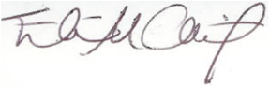
Elise Christopher, Ph.D.
NCES Project Officer
National Center for Education Statistics
U.S. Department of Education

Postcard Reminder
GREETINGS FROM HSLS:09!!

This is a friendly reminder to please complete your HSLS:09 questionnaire. It will take just 15 minutes for you or <teenname> to provide valuable information about <teenname>’s plans for the future. Whether or not your <son/daughter> finished high school or plans to go to college, your input is critically important to help us understand all paths that young adults take and the decisions they make about their future.

Either you or <teenname> can complete the questionnaire. To complete the questionnaire online, please log in to our secure website, using the information below:
https://surveys.nces.ed.gov/hsls
Study ID = «userid»
Password = «password»<PW_ind>
<if incentive: You will receive $<inc_amt> once you complete the questionnaire as a token of our appreciation.>
If you have any questions or problems completing your questionnaire online, or to complete the interview by telephone, please contact the HSLS:09 help desk at 1-855-500-1440. RTI is collecting data for this study for the National Center for Education Statistics (NCES) of the U.S. Department of Education.
Thank you!

Parent: Reminder Flyer
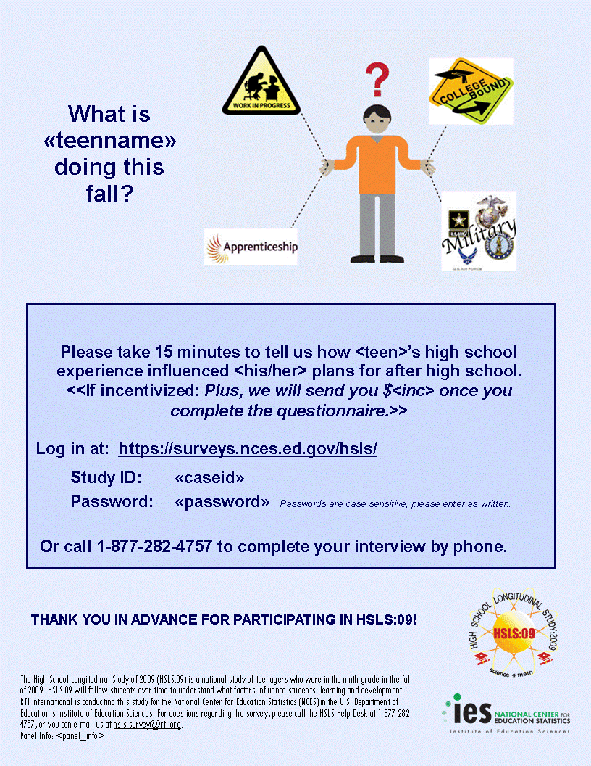

1-855-500-1440
1-855-500-1440

Parent: Subsequent Flyer
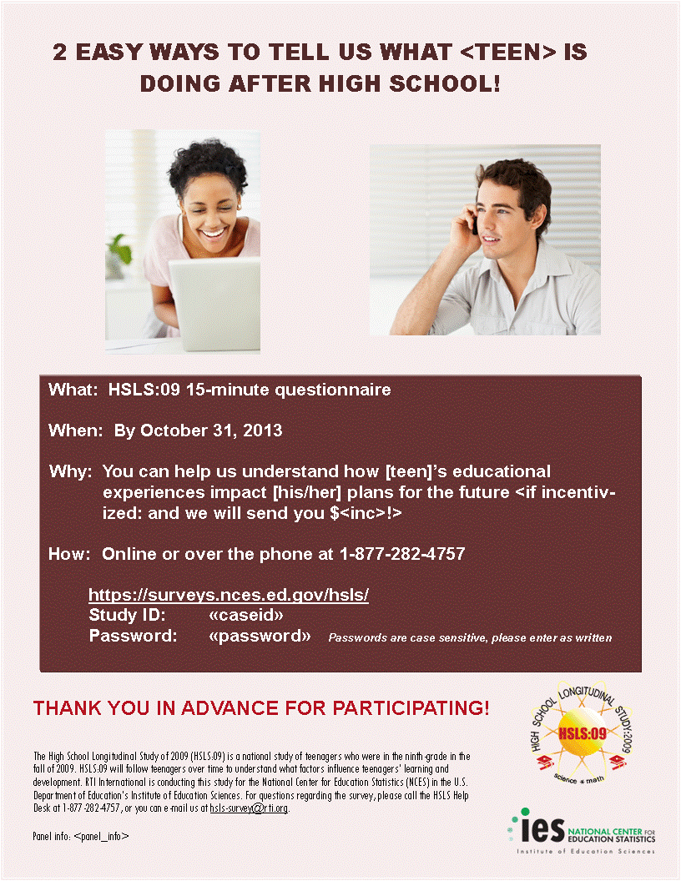
1-855-500-1440
1-855-500-1440

Student Communications

Student: Initial Contact Letter
[DATE]

<TEENAGER NAME> Web Address: surveys.nces.ed.gov/hsls
<ADDR1> Study ID: <XXXXXXX>
<ADDR2> Password: <XXXXXXXX><PW_ind>
<CITY STATE ZIP>
Dear <Teenager Name>:
The High School Longitudinal Study of 2009 (HSLS:09) appreciates your past participation in the study in <2009/2012/2009 and 2012>. A brief follow-up is being conducted to learn about your plans for after high school. This 15-minute questionnaire asks about your high school completion status, plans after high school including college, entering the workforce, or joining the military, and the status of any college applications that you may have submitted. To complete the online survey, please log in using the web address, study ID, and password provided at the top right of this page.
<If incentive: You will receive a $<inc_amt> check as a token of our appreciation after you finish the survey.> Whether or not you finished high school or plan to go to college, your input is critically important to help us understand all paths that young adults take and the decisions you make about your future.
HSLS:09 is conducted by the National Center for Education Statistics (NCES) of the U.S. Department of Education and will inform policymakers on how the high school experience impacts learning as well as future educational and career pathways. This component of the study will help fill an important gap in educators’ knowledge of students’ and parents’ decisionmaking at this critical transition point after high school. Your participation is voluntary, but incredibly important. You were selected to represent your generation, and this is your opportunity to describe the role that high school experiences play in shaping young adults’ choices for the future.
<<If young adult over 18: A letter was also sent to <<parent_name>> with their login information since either you or your parent/guardian can complete the questionnaire. If you would prefer that we not contact your parent, please call us toll-free at 1-855-500-1440.>>
HSLS:09 data are being collected by RTI International under contract with NCES. Data collected are used only for statistical purposes and may not be disclosed or used, in identifiable form for any other purpose except as required by law (ESRA 2002, 20 U.S.C., § 9573). The enclosed brochure provides more information about HSLS:09. In addition, results from the first round of the study are available on the HSLS:09 website mentioned above. If you have questions about the study or prefer to complete the interview over the telephone, please call Randy Ottem toll-free at 1-855-500-1440 or the NCES Project Officer of HSLS:09, Dr. Elise Christopher, at 202-502-7899. If you have questions about your rights as a study participant, you may call RTI’s Office for Research Protection toll-free at 1-866-214-2043.
We thank you in advance for your cooperation in this important research.
Sincerely,
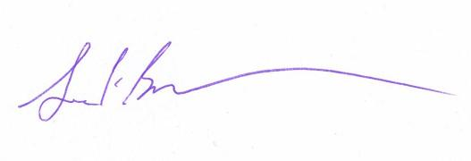
Jack Buckley, Commissioner
National Center for Education Statistics
Institute of Education Sciences
U.S. Department of Education

Enclosure: HSLS:09 Brochure

NCES is authorized to conduct HSLS:09 under the Education Sciences Reform Act of 2002 (ESRA 2002, 20 U.S.C., § 9543). According to the Paperwork Reduction Act of 1995, no persons are required to respond to a collection of information unless it displays a valid OMB control number. The valid OMB control number of this voluntary information collection is 1850-0852. The time required to complete this information collection is estimated to average 15 minutes for the questionnaire including the time to review instructions and complete and review the information collection. If you have any comments concerning the accuracy of the time estimate or suggestions for improving the interview, please write to: High School Longitudinal Study of 2009 (HSLS:09), National Center for Education Statistics, 1990 K Street NW, Washington, DC 20006.

Student: Subsequent Contact Letter A
[Date]

<TEENAGER NAME> Web Address: surveys.nces.ed.gov/hsls
<ADDR1> Study ID: <XXXXXXX>
<ADDR2> Password: <XXXXXXXX><PW_ind>
<CITY STATE ZIP>

Dear «fname» «lname»:
We are writing to ask that you please complete a 15-minute questionnaire for the High School Longitudinal Study of 2009 (HSLS:09). The purpose of the study is to understand the impact of the high school experience on young adults’ learning and their education and career choices. By participating, you have a unique opportunity to help researchers and policymakers understand how young adults make decisions throughout high school and beyond. It is important that we hear from everyone who was selected for the study, whether or not you have graduated high school or plan to go to college.
Either you or your parent may complete the questionnaire. << If incentivized: We will send you a check for $<<INCENT>> after you complete the questionnaire, as a token of our appreciation. >>
Please log in to the survey using the web address, study ID, and password provided above. To complete the interview with one of our professional telephone interviewers or if you have questions, call toll-free at 1-855-500-1440. <<If young adult over 18: Since either you or your parent or guardian can complete the questionnaire, a letter was also sent to <<parent_name>> with their login information. If you would prefer that we not contact your parent, please call us at 1-855-500-1440.>>
Thank you in advance for making HSLS:09 a success!
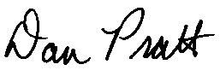
Dan Pratt
HSLS:09 Project Director
RTI International

NCES is authorized to conduct HSLS:09 under the Education Sciences Reform Act of 2002 (ESRA 2002, 20 U.S.C., § 9543). According to the Paperwork Reduction Act of 1995, no persons are required to respond to a collection of information unless it displays a valid OMB control number. The valid OMB control number of this voluntary information collection is 1850-0852. The time required to complete this information collection is estimated to average 15 minutes for the questionnaire including the time to review instructions and complete and review the information collection. If you have any comments concerning the accuracy of the time estimate or suggestions for improving the interview, please write to: High School Longitudinal Study of 2009 (HSLS:09), National Center for Education Statistics, 1990 K Street NW, Washington, DC 20006.
Student: Subsequent Contact Letter B
[Date]

<TEENAGER NAME> Web Address: surveys.nces.ed.gov/hsls
<ADDR1> Study ID: <XXXXXXX>
<ADDR2> Password: <XXXXXXXX><PW_ind>
<CITY STATE ZIP>

Dear «fname» «lname»:

By participating in the High School Longitudinal Study of 2009 (HSLS:09), you will help inform educators, researchers, and policymakers about the choices young adults make and the paths young adults take throughout high school and beyond. Please take about 15 minutes to complete the questionnaire. Your assistance is very much appreciated! <<If incentivized: We will send you a check for $<INCENT> when you complete the questionnaire.>>
You can complete the questionnaire online using the log in information above or call toll-free 1-855-500-1440 to complete the questionnaire over the phone. <<If young adult over 18: A letter was also sent to <<parent_name>> with their login information since either you or your parent/guardian can complete the questionnaire. If you would prefer that we not contact your parent or have other questions about the study, please call us toll-free at 1-855-500-1440.>>
Thank you in advance for making HSLS:09 a success!
Dan Pratt
HSLS:09 Project Director
RTI International

NCES is authorized to conduct HSLS:09 under the Education Sciences Reform Act of 2002 (ESRA 2002, 20 U.S.C., § 9543). According to the Paperwork Reduction Act of 1995, no persons are required to respond to a collection of information unless it displays a valid OMB control number. The valid OMB control number of this voluntary information collection is 1850-0852. The time required to complete this information collection is estimated to average 15 minutes for the questionnaire including the time to review instructions and complete and review the information collection. If you have any comments concerning the accuracy of the time estimate or suggestions for improving the interview, please write to: High School Longitudinal Study of 2009 (HSLS:09), National Center for Education Statistics, 1990 K Street NW, Washington, DC 20006.
Student: Subsequent Contact Letter C
[Date]

<TEENAGER NAME> Web Address: surveys.nces.ed.gov/hsls
<ADDR1> Study ID: <XXXXXXX>
<ADDR2> Password: <XXXXXXXX><PW_ind>
<CITY STATE ZIP>

Dear «fname» «lname»:
You have been selected to represent your generation by participating in the High School Longitudinal Study of 2009 (HSLS:09) and sharing your interests, plans, and choices about your future. The questionnaire should take approximately 15 minutes to complete.
<If prepaid: We have enclosed a $<pre-paid-inc-amt> check as a token of appreciation for your continued participation.> <If both prepaid and promised incentive: In addition,> <If incentive: You/you will receive a $<incent> check after you finish the survey.>
The purpose of the study is to explore the transitions from high school to college, the workforce, and adulthood. This update will help fill an important gap in educators’ knowledge of students’ and parents’ decisionmaking at this critical transition point after high school. Whether or not you finished high school or plan to go to college, your input is critically important to help us understand all paths that young adults take and how decisions are made about the future.
Either you or your parent can complete the questionnaire. To complete the online survey, please log in using the web address, study ID, and password provided at the top right of this page. If you have questions or would prefer to participate on the telephone, please contact one of our professional telephone interviewers at 1-855-500-144. <<If teenager over 18: A letter was also sent to <<parent_name>> with their login information since either you or your parent/guardian can complete the questionnaire. If you would prefer that we not contact your parent, please call us toll-free at 1-855-500-1440.>>
HSLS:09 data are being collected by RTI International under contract with NCES. The enclosed brochure provides detailed information about HSLS:09. Data collected are used only for statistical purposes and may not be disclosed or used in identifiable form for any other purpose except as required by law (ESRA 2002, 20 U.S.C., § 9573). Results from the first round of the study are available on the HSLS:09 website given above.
Thank you in advance for your continued participation in HSLS:09!
Dan Pratt
HSLS:09 Project Director
RTI International

Enclosure: HSLS:09 Brochure
NCES is authorized to conduct HSLS:09 under the Education Sciences Reform Act of 2002 (ESRA 2002, 20 U.S.C., § 9543). According to the Paperwork Reduction Act of 1995, no persons are required to respond to a collection of information unless it displays a valid OMB control number. The valid OMB control number of this voluntary information collection is 1850-0852. The time required to complete this information collection is estimated to average 15 minutes for the questionnaire including the time to review instructions and complete and review the information collection. If you have any comments concerning the accuracy of the time estimate or suggestions for improving the interview, please write to: High School Longitudinal Study of 2009 (HSLS:09), National Center for Education Statistics, 1990 K Street NW, Washington, DC 20006.
Student: Subsequent Contact Letter D
[Date]

«fname» «mname» «lname» «suffix»
«addr1»«addr2»
«city», «state» «zip» «zip4»

Dear «fname» «lname»:
Please complete the questionnaire for the High School Longitudinal Study of 2009 (HSLS:09). We value your input <<If incentivized: and we will send you $<INCENT> in appreciation for your participation>>!.
We’re interested to know what you plan to be doing after high school. The data collected by HSLS:09 will help researchers understand the different paths that young adults take through high school and into higher education, the workforce, or the military.
The survey takes about 15 minutes to complete. You can complete the questionnaire online using the log in information below or call toll-free at 1-855-500-1440 if you prefer to complete the interview over the phone.
Website: https://surveys.nces.ed.gov/hsls/
Study ID: «caseid»
Password: «password»<<PW_ind>>
<<If young adult over 18: Since either you or your parent/guardian can complete the questionnaire, a letter was also sent to <<parent_name>> with their login information. If you would prefer that we not contact your parent, please call us toll-free at 1-855-500-1440.>>
If you have questions about the study, please call Randy Ottem at RTI toll-free at 1-855-500-1440 or Dr. Elise Christopher, NCES Project Officer, at 202-502-7899. Thank you in advance for your continued participation in HSLS:09!
Dan Pratt
HSLS:09 Project Director
RTI International

NCES is authorized to conduct HSLS:09 under the Education Sciences Reform Act of 2002 (ESRA 2002, 20 U.S.C., § 9543). According to the Paperwork Reduction Act of 1995, no persons are required to respond to a collection of information unless it displays a valid OMB control number. The valid OMB control number of this voluntary information collection is 1850-0852. The time required to complete this information collection is estimated to average 15 minutes for the questionnaire including the time to review instructions and complete and review the information collection. If you have any comments concerning the accuracy of the time estimate or suggestions for improving the interview, please write to: High School Longitudinal Study of 2009 (HSLS:09), National Center for Education Statistics, 1990 K Street NW, Washington, DC 20006.
Student: Subsequent Contact Letter E

[Date]
<TEENAGER NAME> Web Address: surveys.nces.ed.gov/hsls
<ADDR1> Study ID: <XXXXXXX>
<ADDR2> Password: <XXXXXXXX><PW_ind>
<CITY STATE ZIP>

Dear «fname» «lname»:
We still need your participation in the High School Longitudinal Study:09 (HSLS:09) <<If incentivized: We understand that your time is valuable – that’s why we’re <if incentive is increasing: now> offering $<incent> to thank you for completing the HSLS:09 survey! >>
Please complete the HSLS:09 questionnaire before <DATE>. If you cannot participate in this important research, your parent can complete the questionnaire. HSLS:09 is interested in knowing what you will be doing after high school. Everyone’s experience is different, so we need participation from as many people as possible to understand the decisions young adults make about their future. By participating, you ensure that your voice and your peers’ voices are heard!
Use the log in information above to complete the questionnaire online or call toll-free at 1-855-500-1440 to complete the interview over the phone. If you have questions about the study, please call Randy Ottem toll-free at 1-855-500-1440 or the NCES Project Officer of HSLS:09, Dr. Elise Christopher, at 202-502-7899.
Thank you in advance for making HSLS:09 a success!
Dan Pratt
HSLS:09 Project Director
RTI International

NCES is authorized to conduct HSLS:09 under the Education Sciences Reform Act of 2002 (ESRA 2002, 20 U.S.C., § 9543). According to the Paperwork Reduction Act of 1995, no persons are required to respond to a collection of information unless it displays a valid OMB control number. The valid OMB control number of this voluntary information collection is 1850-0852. The time required to complete this information collection is estimated to average 15 minutes for the questionnaire including the time to review instructions and complete and review the information collection. If you have any comments concerning the accuracy of the time estimate or suggestions for improving the interview, please write to: High School Longitudinal Study of 2009 (HSLS:09), National Center for Education Statistics, 1990 K Street NW, Washington, DC 20006.
Student: Subsequent Contact Letter F
<date>

<TEENAGER NAME> Web Address: surveys.nces.ed.gov/hsls
<ADDR1> Study ID: <XXXXXXX>
<ADDR2> Password: <XXXXXXXX><PW_ind>
<CITY STATE ZIP>

Dear «fname» «lname»:
We know your time is valuable. We are now offering an abbreviated survey for the High School Longitudinal Study of 2009 (HSLS:09) that will take only about 5 minutes to complete.
<If incentive: You/you will receive a $<incent> check after you finish the survey.> Please act quickly because the study ends October 31st.
HSLS:09 collects information on the experiences of young adults during and after high school including work experiences, college experiences, and family life. It is vitally important we obtain updated information on all sample members each time that data are collected for the data to be accurate and remain nationally representative of all high school freshmen in the original study sample. Also, your response to our survey is extremely valuable because you will be acting on behalf of all those young adults like you who were not chosen to participate.
To complete the interview by telephone with a professional interviewer, call the Help Desk toll-free at 1-855-500-1440.
Your responses may be used only for statistical purposes and may not be disclosed, or used, in identifiable form for any other purpose except as required by law (20 U.S.C. § 9573).
Thank you in advance for your participation in this important study. The information you provide is extremely important, and your cooperation is greatly appreciated.
Sincerely,
Elise Christopher, Ph.D.
NCES Project Officer for HSLS:09
National Center for Education Statistics
U.S. Department of Education

Student: Postcard Reminder
GREETINGS FROM HSLS:09!!
This is a friendly reminder to please complete your HSLS:09 questionnaire. It will take just 15 minutes for you or <teenname> to provide valuable information about <teenname>’s plans for the future. Whether or not you finished high school or plan to go to college, your input is critically important to help us understand all paths that young adults take and the decisions they make about their future.

To complete the questionnaire online, please log in to our secure website, using the information below:
https://surveys.nces.ed.gov/hsls
Study ID = «userid»
Password = «password»<PW_ind>
<if incentive: You will receive $XX once you complete the questionnaire as a token of our appreciation.>
If you have any questions or problems completing your questionnaire online, or to complete the interview by telephone, please contact the HSLS:09 help desk at 1-855-500-1440. RTI is carrying out the data collection for the National Center for Education Statistics (NCES) of the U.S. Department of Education.
Thank you!

Student: Reminder Flyer
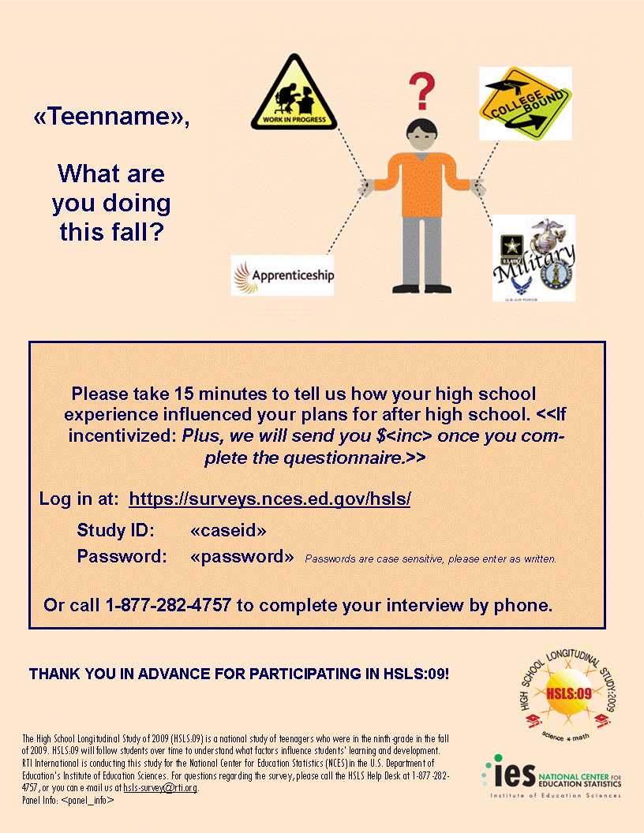
1-855-500-1440

1-855-500-1440

Student: Subsequent Flyer

1-855-500-1440
1-855-500-1440

Main StudyTranscript Collection Materials

Transcript Request Letter Base Year Schools
<Date>
«RecipientName»
«SchoolName»
«Address1»
«Address2»
«City», «State» «Zip»
Dear «RecipientName»:
A sample of students from your school participated in the High School Longitudinal Study of 2009 (HSLS:09). HSLS:09 is conducted by the National Center for Education Statistics (NCES) of the U.S. Department of Education, which has contracted with RTI International (RTI), an independent nonprofit research organization, to collect student transcripts for research purposes. Data will be used to provide information that will be used by Congress, researchers, and policymakers to improve the quality of education in America. Transcript data provide important information about how a student’s courses and grades make a difference in their subsequent work success and college experiences. At this time, we are contacting you to request transcripts for the HSLS:09 sample members from your school. This package includes information about the study and instructions for preparing and transmitting the transcripts.

We have informed parents and students of the transcript collection each time we collected data for HSLS:09 since 2009. All correspondence to parents and students contained a reference to the transcript data collection scheduled for the 2013-2014 academic year. That correspondence includes all of our parent consent forms for study participation, the study brochures and web site, the student instructions during the in-school data collection, the panel maintenance postcards sent out each year, and the telephone interview lead letters.

Collection of transcript information is on behalf of the Secretary of Education under the Family Educational Rights and Privacy Act (FERPA). FERPA allows the release of records to the Secretary of Education or his agents without prior written consent for the evaluation of Federal- and State-supported education programs. We have provided a copy of the relevant text from FERPA in this package.

NCES is authorized by federal law (20 U.S.C., § 9543) to conduct HSLS. Responses and student record information may be used only for statistical purposes and will not be disclosed, or used, in identifiable form for any other purpose, except as required by law (ESRA 2002, 20 U.S.C., § 9573). Data will be combined to produce statistical reports for Congress and others. No individual data (e.g., names or addresses) will be reported.

While federal law permits release of transcripts in this case without obtaining consent, we realize that some schools and districts may sometimes be bound by additional confidentiality regulations of their own. If written or implied consent from parents (if the student is under age 18) or from a student (if 18 years old or over) is required by your school for individual studies, please contact RTI toll-free at 1-XXX-XXX-XXXX so that we can develop consent procedures with you that will fully meet your specific requirements.

Included with this package are instructions for preparing and transmitting transcript data to RTI. A list of students for whom transcripts are requested is posted at the secure study website listed in the box below. To access the site, you will need to log in using the study ID and password printed at the bottom of this letter. Also available at the website are instructions for obtaining reimbursement for the requested transcripts, should your school require it.
We prefer that you send transcripts via an electronic transmission mode, or via fax. We have included a FedEx label for you to use for sending the requested course catalogs, if needed, and you can include transcripts if no other means is possible for your school and if all personally identifiable student information has been removed from the transcripts. Please keep copies of these documents for your records in case we need to contact you about the materials.
We would appreciate receiving the requested transcript data on or before [DUE DATE]. Please do not hesitate to call us if you feel you need to have a later delivery date. If you have any questions about the HSLS:09 transcript collection, please call our Help Desk toll-free at 1-XXX-XXX-XXXX between 8:30 AM and 5 PM Eastern time, Monday through Friday. We can also be reached by e-mail at hsls@rti.org.

A representative from RTI will contact you in a few days to confirm your receipt of this letter, answer any questions you may have, and to identify the person at your school most qualified to provide the requested student transcripts.
Thank you for your cooperation and timely attention to this matter.
Sincerely,
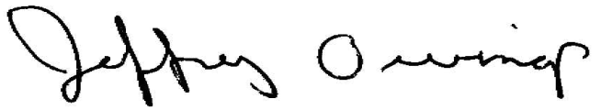
Jeffrey Owings, Ph.D.
Associate Commissioner, Elementary/Secondary & Libraries Studies Division
National Center for Education Statistics
U.S. Department of Education

Please visit the study website for more information:
https://surveys.nces.ed.gov/hsls/

To log in, enter the study ID below
and enter the password below.
Your Study ID: «school_id»
Your password: «password»

Transcript Request Letter - Transfer Schools
<Date>
«RecipientName»
«SchoolName»
«Address1»
«Address2»
«City», «State» «Zip»

Dear «RecipientName»:

We are contacting you to request your help. The National Center for Education Statistics (NCES) of the U.S. Department of Education is conducting the High School Longitudinal Study of 2009 (HSLS:09). This national study of high school students includes the collection of student transcript data. Some of the students in the HSLS:09 study sample attended your school. Your school’s assistance is therefore needed to make the results of this study comprehensive, accurate, and timely. We are collecting transcript information for students who have been selected to participate in HSLS. Collecting transcripts and related information will not involve any school/classroom time for any of your current students.

Transcripts provide an analytically powerful measure of students' high school curricular experience and performance that may be related both to labor market outcomes and to postsecondary educational access and attainment. HSLS:09 data, authorized by federal law (20 U.S.C., § 9543), will be used to provide information that will be used by Congress, researchers, and policymakers to monitor and improve the quality of education. NCES has contracted with RTI International (RTI), an independent nonprofit research organization, to collect the transcript data.

We have informed parents and students of the transcript collection each time we collected data for HSLS:09 since 2009. All correspondence to parents and students contained a reference to the transcript data collection scheduled for the 2013-2014 academic year. That correspondence includes all of our parent consent forms for study participation, the study brochures and web site, the student instructions during the in-school data collection, the panel maintenance postcards sent out each year, and the telephone interview lead letters.

Responses and student record information may be used only for statistical purposes and will not be disclosed, or used, in identifiable form for any other purpose, except as required by law (ESRA 2002, 20 U.S.C., § 9573). Data will be combined to produce statistical reports for Congress and others. No individual data (e.g., names or addresses) will be reported.

The granting of U.S. Department of Education authority for collection of the transcript data has been made pursuant to the provisions of the Family Educational Rights and Privacy Act (FERPA). FERPA permits the release of records to the Secretary of Education or his agents without prior written consent. We have provided a copy of the relevant text from FERPA in this package. However, while federal law permits release of transcripts in this case without obtaining consent, we realize that some schools and districts may sometimes be bound by additional confidentiality regulations of their own. If active or implied consent from parents (if the student is under age 18) or student (if 18 or over) is required by your school, please contact RTI toll-free at 1-XXX-XXX-XXXX so that we can work out consent procedures with you that will fully meet your specific requirements.

Included with this package are instructions for preparing and transmitting transcript data to RTI. A list of students for whom transcripts are requested is posted at the secure study website listed in the box below. To access the site, you will need to log in using the study ID and password printed at the bottom of this letter.

We prefer that you send transcripts via an electronic transmission mode, or send them via fax. We have included a FedEx label for you to use for sending the requested course catalogs, if needed, and you can include transcripts if none of the electronic transmission modes or faxing is possible for your school, and as long as all personally identifiable student information has been removed from the transcripts. Please keep copies of these documents for your records in case we need to contact you about the materials.

We would appreciate receiving the requested transcript data on or before [DUE DATE]. Please do not hesitate to call us if you feel you need to have a later delivery date. If you have any questions about HSLS:09 transcript collection, please call the Help Desk at RTI toll-free at 1-XXX-XXX-XXXX between 8:30 AM and 5 PM Eastern time, Monday through Friday. We can be reached by e-mail at hsls@rti.org.

A representative from RTI will contact you in a few days to confirm your receipt of this letter, answer any questions you may have and to identify the person at your school most qualified to provide the requested student transcripts.

Thank you for your cooperation and timely attention to this matter.

Sincerely,
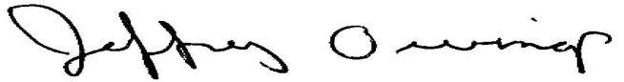
Jeffrey Owings, Ph.D.
Associate Commissioner, Elementary/Secondary & Libraries Studies Division
National Center for Education Statistics
U.S. Department of Education
Please visit the study website for more information:

https://surveys.nces.ed.gov/hsls/

Your Study ID: «school_id»
Your password: «password»

Transcript Request Cover Memo To Transcript Coordinator or Registrar
MEMORANDUM
DATE: <insert>
TO: <HSLS:09 Transcript Contact> or Registrar
FROM: Jeffrey Owings, NCES
SUBJECT: High School Longitudinal Study: Transcript Collection

I am contacting you about the High School Longitudinal Study of 2009 (HSLS:09) that is being conducted by the National Center for Education Statistics (NCES), within the U.S. Department of Education. The data are being collected for NCES by RTI International. We are contacting your school to request high school transcripts for the students from your school who were selected to participate in HSLS:09. This part of the HSLS:09 study is extremely important because student transcripts will provide an objective and reliable source of information about the students’ educational careers and how a student’s courses and grades influence future work success and college experiences.
If you are the most appropriate person to complete this request for transcripts, please review the materials in this packet. If there is someone else you think is more appropriate, please pass this request packet on to him/her at your earliest convenience. We appreciate your help to collect transcript information. Instructions for transmitting transcripts and for obtaining reimbursement for the requested transcripts, should your school require it, can be found on the study website: https://surveys.nces.ed.gov/hsls/.
If there are any questions, please contact RTI toll-free at 1-XXX-XXX-XXXX. We will be calling you soon to see if you have any questions.
Thank you very much for your assistance.
Enclosures
Please visit the study website for more information: https://surveys.nces.ed.gov/hsls/Your Study ID: «entity_id»
Your password: «password»

Value and Uses of Transcript Data
Value and Uses of Transcript Data
The High School Longitudinal Study of 2009 (HSLS:09) transcript study extends the timeline for an invaluable series of high school transcript collections conducted by the U.S. Department of Education’s National Center for Education Statistics (NCES). NCES transcript studies have been conducted both in connection with the National Assessment of Educational Progress (NAEP), and the Center’s high school longitudinal studies dating back to 1982. These transcript studies can be used to understand the coursetaking and grades of graduating seniors from 1982, and, with the addition of HSLS, through 2013, and to support trend comparisons over the last three decades.

High school transcripts provide immense value to researchers and policymakers as objective, reliable measures of students’ educational experiences. In the course of the first major NCES transcript study (in High School and Beyond, 1982), a methodological comparison was made of student self-reports and school records. This comparison (Fetters, Stowe, and Owings, 1984) established that with respect to level of detail, accuracy, and completeness, transcript data are vastly superior to student self-reports of exposure to learning situations and grades received. Transcript components of longitudinal studies such as HS&B, NELS:88, ELS:2002, and HSLS:09 permit the measurement of high school program and course effects on post-high school outcomes in both the labor force and postsecondary education.

The HSLS:09 transcript files will contain a wealth of information about each student’s full high school career. Coursetaking histories include the term, credits earned, and grades received. Additional information is compiled concerning GPA and reason student left the school (graduation, transfer, and so on). Summary variables permit analysts to account for the level or difficulty of coursework in each subject; these “pipeline” measures help to capture the breadth and depth of each student’s coursetaking history. The coupling of transcript data with course offerings data will make it possible to relate students’ coursetaking choices to their opportunities, and to investigate how curriculum structure influences student course choices and how curriculum relates to achievement.

Because HSLS:09 also contains student questionnaire data from grades 9 and 11—as well as reports from teachers, parents, high school counselors and administrators—coursetaking data can be analyzed in context. This contextual information encompasses each student’s home background, various school-level factors, tested achievement, and each student’s plans, attitudes, and expectations. Some examples of findings from past NCES transcript studies may help to clarify the kind of information the transcript studies make available—both in conjunction with each other, as a trend line; and in conjunction with longitudinal outcomes (such as achievement gain, and entry into and completion of postsecondary education).

- One of the strongest predictors of postsecondary completion (e.g., B.A. attainment) is the rigorousness or academic intensity of high school curriculum completed (Adelman, 2006).
- Based on the senior classes of 1982, 1992, and 2004, high school graduates’ completion of mathematics courses increased over time. Graduates came closer to taking 4 full years of academic coursework in mathematics, moving from, on average, 2.7 total credits in mathematics in 1982 to 3.6 total credits in 2004. In addition, graduates shifted from taking lower level mathematics courses to taking more advanced courses (Dalton et al. 2007).
- Based on the same cohorts, the average number of science credits increased from 2.2 science credits in 1982 to 3.3 science credits in 2004 (Dalton et al. 2007).
- For the high school cohort of 2002 sophomores, re-tested in math two years later, the percentage of students with an understanding of simple problem solving skills grew from 53 to 65 percentage points over the last two years of high school. However, 96 percent of students in the sample left high school without proficiency in the most advanced skills, such as solving multistep word problems (Bozick and Ingels, 2008). The greatest gains were made by students who followed the more advanced course sequences and had completed at least precalculus.
- The rate at which students completed advanced-level high school mathematics courses had a direct bearing on whether or not they enrolled in a 4-year college within two years of high school graduation. This relationship was especially evident for students who were the first generation in their families to enroll in higher education (Horn & Nunez, 2000).

Transcript data are subject to the same stringent standards of non-disclosure of respondent identities as are all other components of the NCES data sets. In other words, the data may be used only for statistical purposes and may not be disclosed or used in identifiable form for any other purpose, except as required by law (ESRA 2002, 20 U.S.C., § 9573).

References

Adelman, Clifford. (2006). The Toolbox Revisited: Paths to Degree Completion From High School Through College. Washington, DC: U.S. Department of Education.

Bozick, Robert, and Ingels, Steven J. (2008). Mathematics Coursetaking and Achievement at the End of High School. Washington, DC: National Center for Education Statistics. (NCES 2008-319).

Dalton, Ben, Ingels, Steven J., Downing, Jane, and Bozick, Robert. (2007). Advanced Mathematics and Science Coursetaking in the Spring High School Senior Classes of 1982, 1992, and 2004. Washington, DC: National Center for Education Statistics (NCES 2007-312).

Fetters, William, Stowe, Peter, and Owings, Jeffrey. (1984). Quality of Responses of High School Students to Questionnaire Items. Washington, DC: National Center for Education Statistics. (NCES 84-216)

Horn, Laura, and Nunez, Amy. (2000). Mapping the Road to College: First-Generation Students’ Math Track, Planning Strategies, and Context of Support. Washington, DC: National Center for Education Statistics. (NCES 2000-153)

Transcript Instructions

There are 4 primary steps for providing data. You will need to access the secure study website at https://surveys.nces.ed.gov/hsls. Log in using the study ID and password printed at the bottom of the letter you received from RTI.
NOTE: You will need your study ID and password each time you log in to the website.
1 Complete the School Information page
On this page, you will need to provide or confirm selected information about your school including grading scale and term system. This page is accessible from the Dashboard on the website. If you prefer to provide the information on a paper form, please fill out the one that is enclosed in this packet.
2 Complete the Transcript Data Transmission page
Each student's name and study ID number will be listed on the transcript data transmission page. Please check the box next to each student whose transcript you are sending and select the mode of submission. If you are unable to provide a transcript, please enter the reason in the space provided—for example, "No record of student’s attendance" or "Transcript cannot be located." Please print and retain a copy for your records.
NOTE: You must complete the Transcript Data Transmission webpage prior to sending transcript data, so that we may verify receipt of all transcript data submitted. Once you have sent the transcript data, click Submit. This page is accessible from the Dashboard.
3 Transmit Transcript Data
A number of options are available for transmitting transcript data to RTI. Each is described below.
Uploading to the Secure Study Website: Uploading electronic transcript data directly to the secure website is the preferred method for sending transcript data.
Sending Transcript Data as an Encrypted Attachment by Electronic Mail: If you choose to use electronic mail (e-mail) to submit student transcript data, the attachment containing the data will need to be encrypted, using software such as SecureZIP (select the option Use FIPS 140 Mode), to ensure they are transmitted securely. SecureZIP can be downloaded free of charge from the website: http://www.securezip.com. Detailed instructions for downloading and using SecureZIP can be accessed from the link "E-mail transcript data as an encrypted attachment." If you choose to use encryption software other than SecureZIP, please contact the Help Desk to ensure that the software complies with our security standards.
Once the attachment is encrypted, send to hsls@rti.org and include the file names and descriptions. If you need assistance with this process, please contact the Help Desk toll-free at 866-253-1063 or via e-mail at hsls@rti.org.
Sending Transcript Data by Secure File Transfer Protocol (sFTP): If you choose to submit transcript data using the sFTP site, please contact the Help Desk to obtain the sFTP site location and your username and password. The Help Desk may be reached toll-free at 1-866-253-1063 or via e-mail at hsls@rti.org. Additional instructions on how to perform the data transfer via sFTP may be accessed from the link "Send transcript data by secure File Transfer Protocol (sFTP)." After you have successfully uploaded your files to the sFTP server, please send an e-mail to hsls@rti.org with the names of the files and their structure.
Sending Transcript Data via the SPEEDE Server: If you are a registered user of the SPEEDE server at the University of Texas at Austin and wish to use it to send your transcripts, please select School Code “RTIIES” with School Name “RTI Intl Educ Studies Div” as the transcript recipient.
Faxing Hard Copy Transcripts: If your school is unable to provide the transcript data electronically via any of the methods previously mentioned, you may fax transcripts to one of our secure fax numbers (XXX-XXX-XXXX or XXX-XXX-XXXX). First, fax the Student Transcript Fax Test Page included in your school packet, with your name, telephone number, and fax number, to ensure that the transfer is working correctly. You should receive a printed confirmation page. Please check the fax confirmation page and verify that the fax number matches one of our secure fax numbers. Once you have done this, please fax the completed Student Transcript Fax Transmittal Sheet that you received in your packet and your students’ transcripts to the same number.
Sending Redacted Transcripts via FedEx: If your school is unable to provide the transcript data via any of the other methods, you may send them via FedEx at no cost to you after redacting each student’s personally identifiable information and writing his/her study ID on the transcript. Please refer to the website link “Sending redacted transcripts via FedEx” for instructions.
4 Provide Requested Course Catalogs or Course Descriptions
Once transcript data are received, the individual courses reported in the transcript data will be coded using a common classification system, the National Center for Education Statistics' (NCES) Classification of Secondary School Courses (CSSC). Course catalogs (also referred to as course descriptions) are used as a resource in this process. If we need a course catalog from your school, there will be a Catalog Transmittal Sheet in your packet. It includes a list of the catalogs requested and instructions for sending them to RTI. If you do not find a Catalog Transmittal Sheet in your packet, then no catalogs are needed from your school at this time.

Family Educational Rights and Privacy Act Regulations
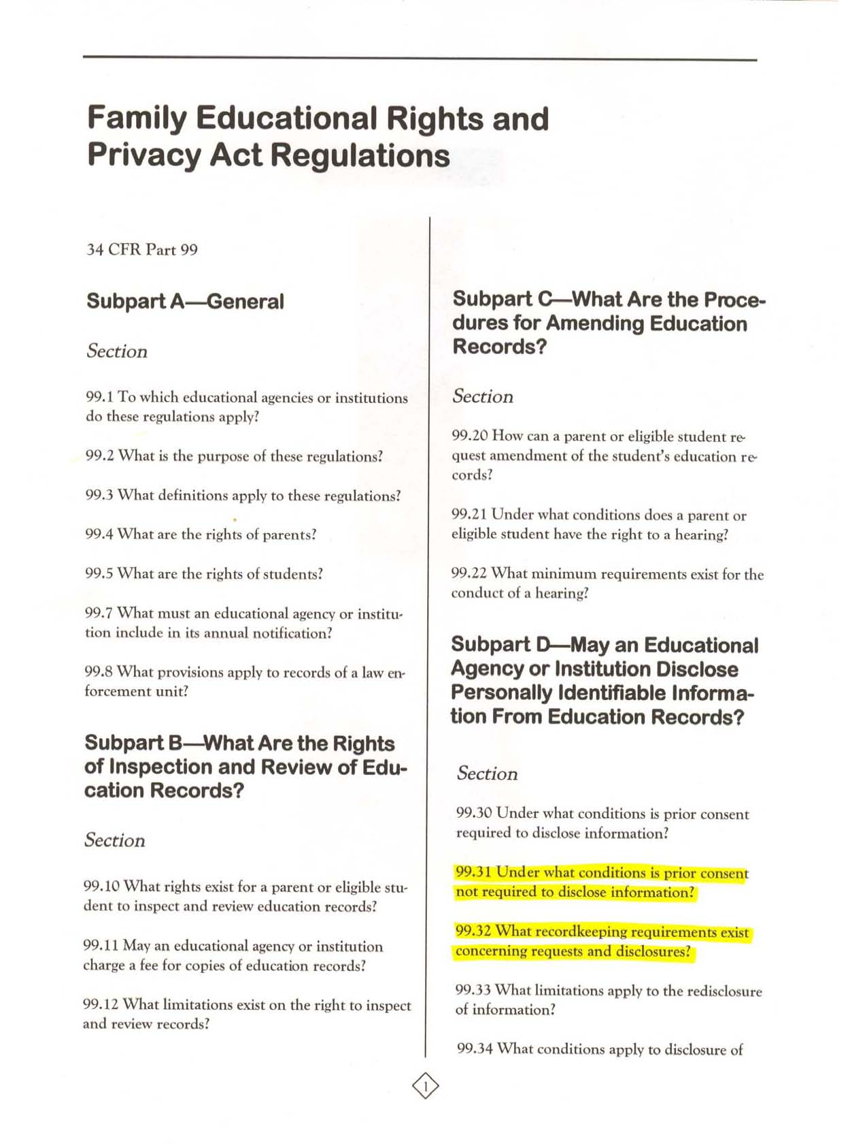
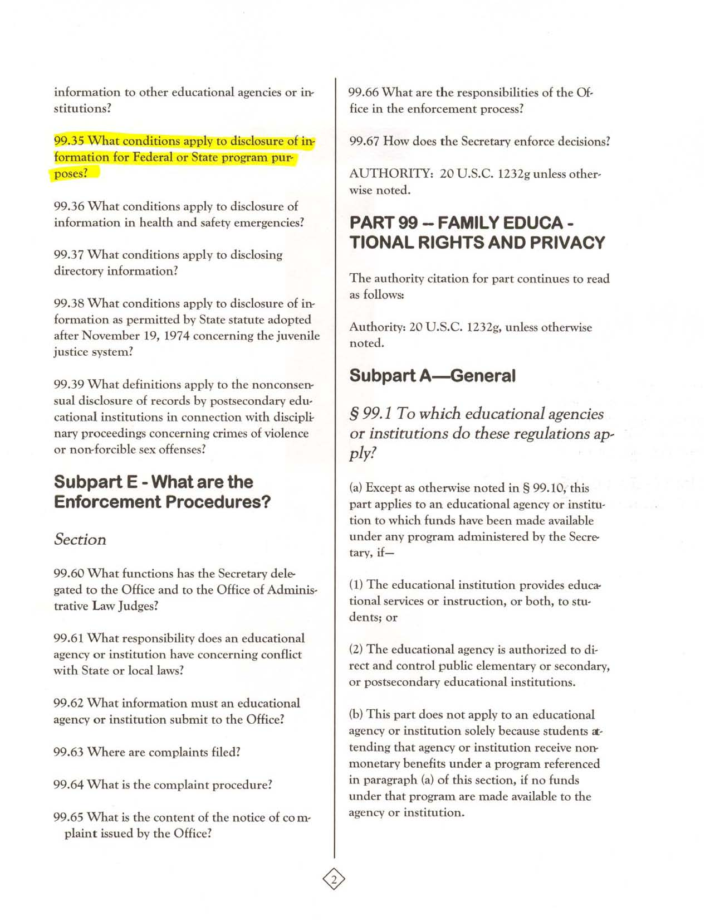
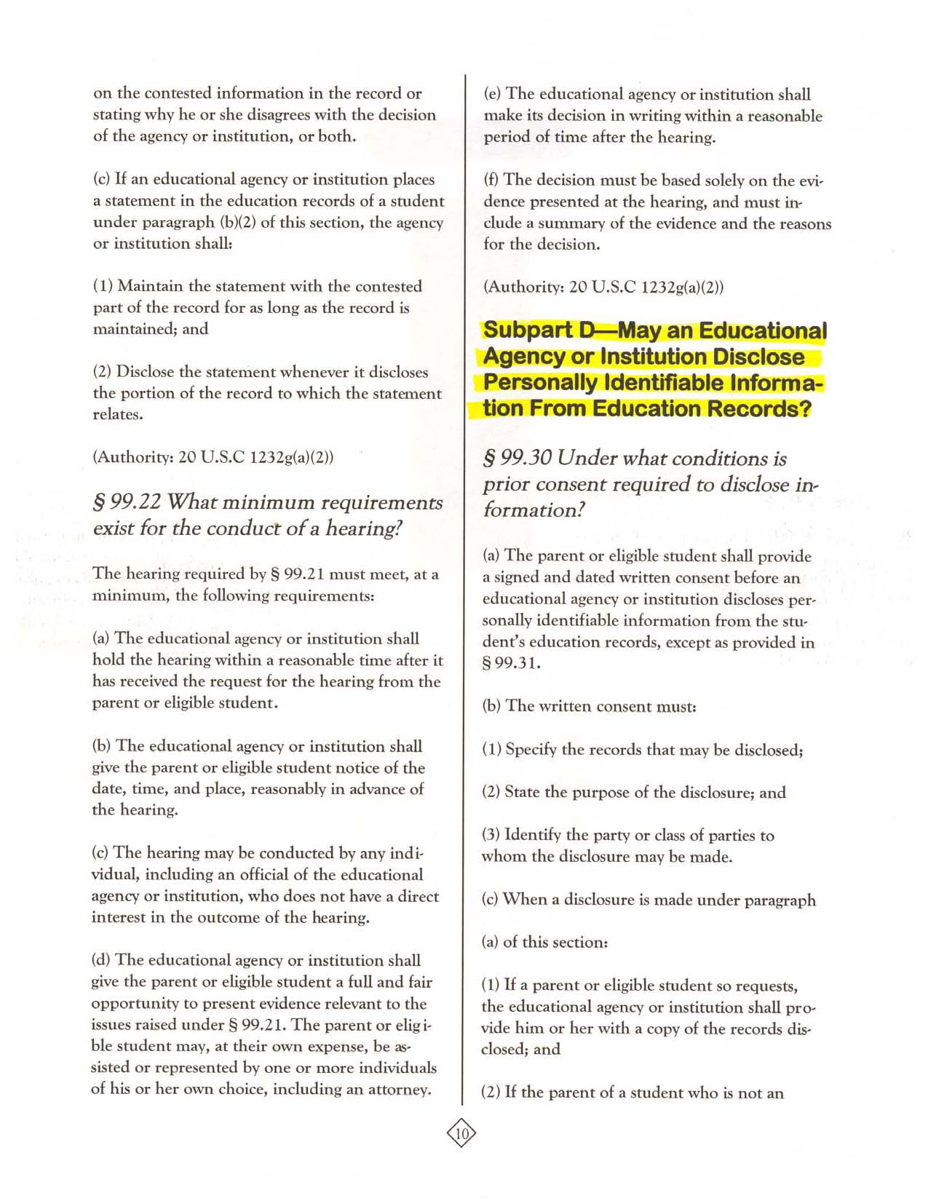
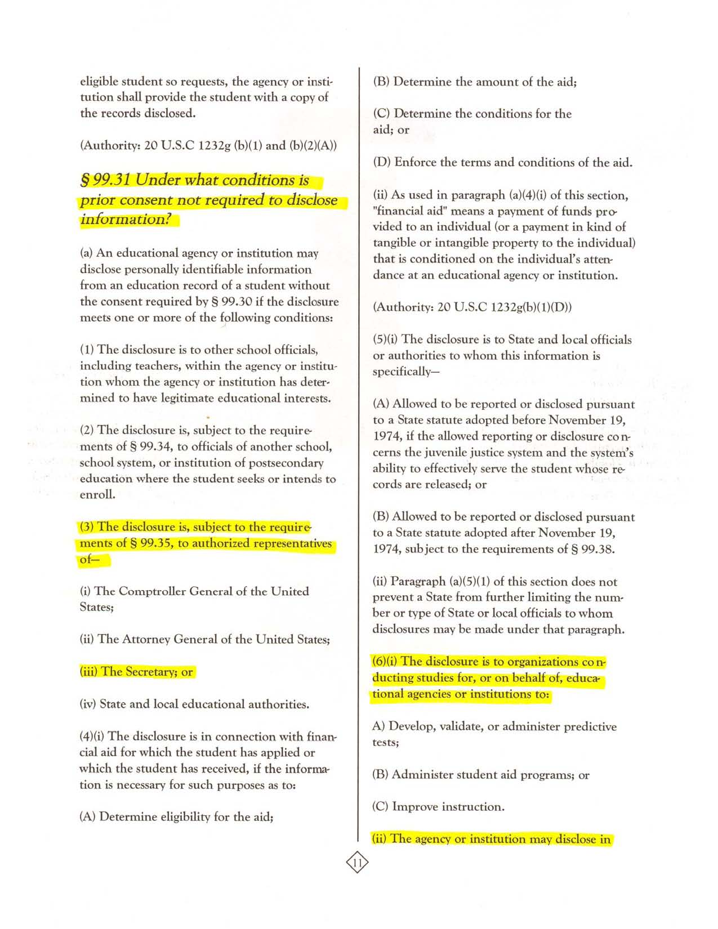
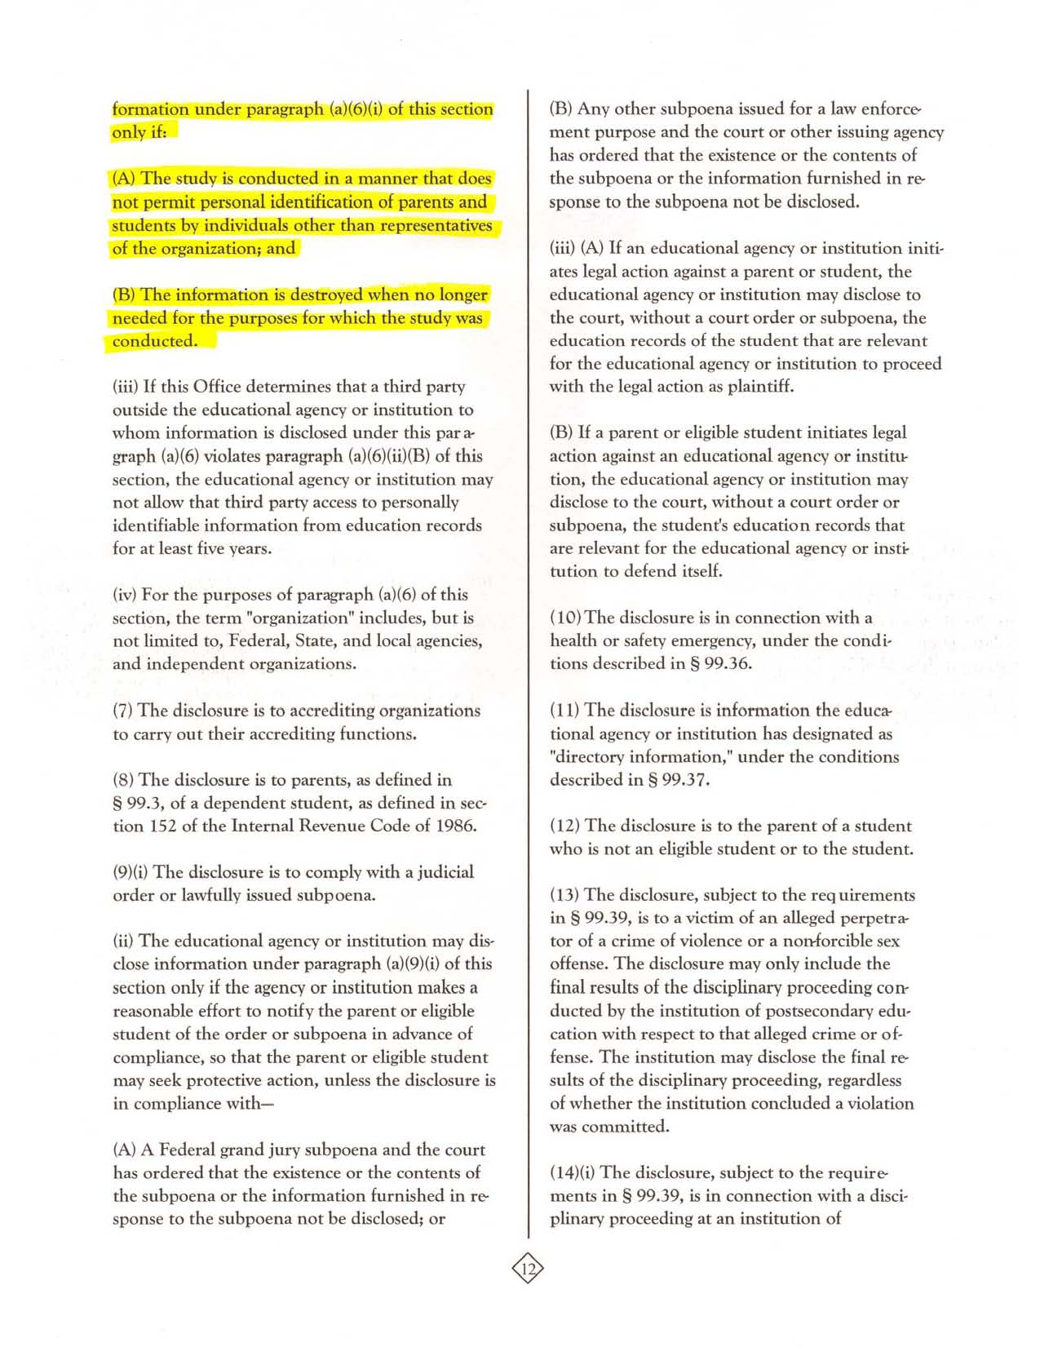
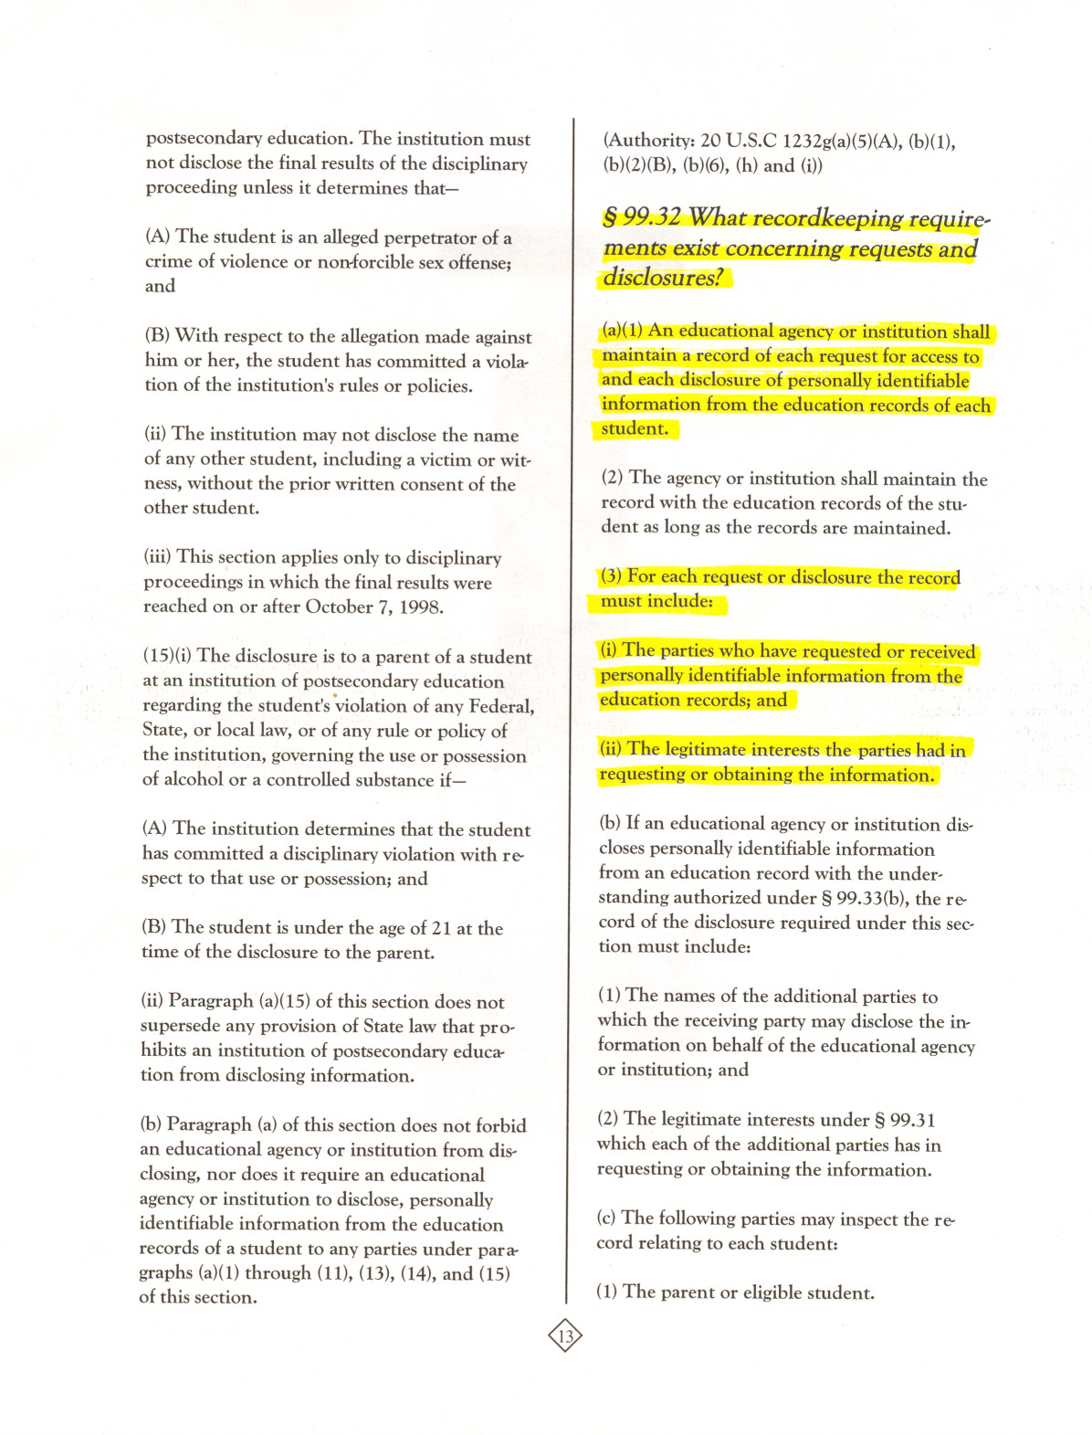
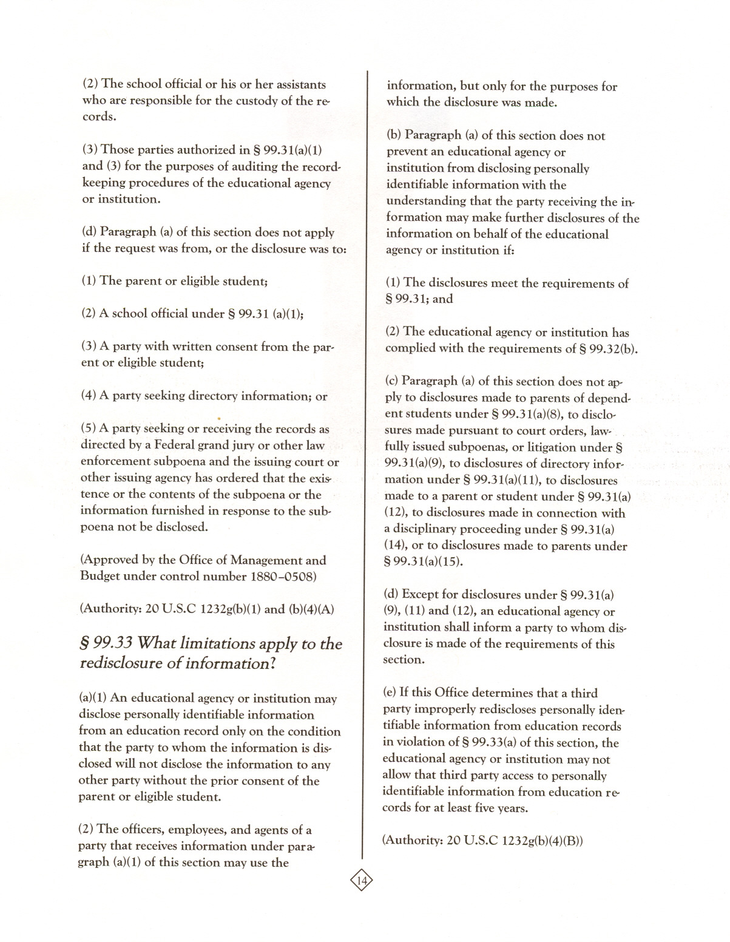

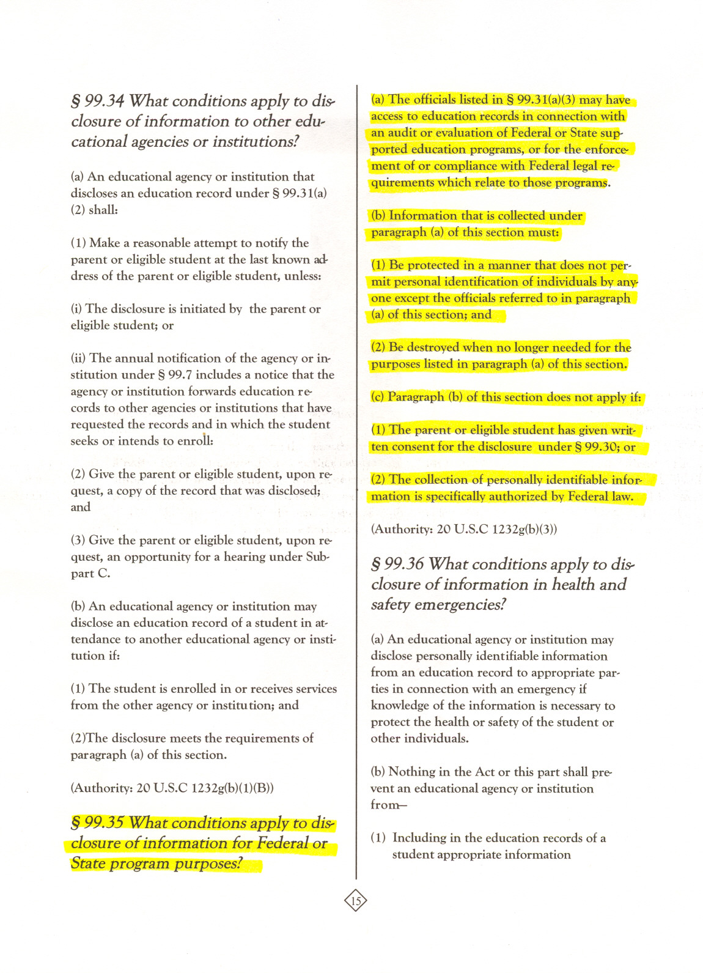
Student Transcript Fax Test Page

Student Transcript Fax Test Page

School ID: «School_ID»
Name of Sender: ____________________________________
Date: ___________________________
Telephone number: __________________________________
Fax number: __________________________________

Instructions:
Please fax this document to XXX-XXX-XXXX or XXX-XXX-XXXX as a test page.
Please check the confirmation page that prints from your fax machine and confirm that the fax was sent to the correct number. Once you’ve confirmed that the page was sent to the correct number, please fax the completed Student Transcript Fax Transmittal Sheet that you received in your packet and your students’ transcripts to the same number.
If you need assistance, please contact our Help Desk at 1-XXX-XXX-XXXX.

Transcript Transmittal Fax

Student Transcript Fax Transmittal Sheet
School ID: «School_ID»
Name of Sender: ____________________________________
Date: ___________________________
Telephone number: __________________________________
Fax number: __________________________________

Number of pages: ________
Number of students whose transcripts you are sending: ________
Number of transcripts you are sending (there could be multiple per student): ________

Instructions:

Be sure that you have faxed the Student Transcript Fax Test Page and been contacted to confirm its receipt before sending this page or the transcripts.

If a student transferred to your school from another high school, please also send copies of any transcripts that you have from other high schools (unless that information is already included on the transcript from your school).

Once you have filled out the top of this document, please fax it and student transcripts to 1-877-254-1952 or 1-877-653-1239.

If you need assistance, please contact our Help Desk at 1-XXX-XXX-XXXX.

Transmittal Sheet Catalog

Course Catalog (Course Description) Transmittal Sheet

School ID: «School_ID»
Name of Sender: ____________________________________
Date: ___________________________
Telephone number: __________________________________

In order to properly code the transcript data we will receive for your students, we need to obtain a copy of your school’s course catalogs, bulletins, or other materials that describe the course offerings for each academic year listed below.

<cat_yr_needed> <level>
<cat_yr_needed> <level>
<cat_yr_needed> <level>
<cat_yr_needed> <level>

Instructions:
If the catalog(s) exist electronically, please send an e-mail to hsls@rti.org and either direct us to the catalog(s) online or send the catalog(s) as an attachment. If you need to send hard copy catalogs, please place check marks in the appropriate columns below to indicate the types of course catalogs you are sending for each year. Please do not send catalogs for which “not needed” appears. Please keep a copy of this completed sheet for your records and send the original to RTI with the catalogs using the FedEx materials provided.

Academic Year | Type of catalog provided (please place checks or comments as appropriate)
Academic Year | General | Other type/program (please specify)
2009-2010
2010-2011
2011-2012
2012-2013

Disclosure Notice
DISCLOSURE NOTICE

Student record data for this student have been provided to RTI International, a nonprofit research organization and agent for the U.S. Department of Education, National Center for Education Statistics (NCES). This disclosure statement fulfills the requirements of 34 CFR 99.32(a) pursuant to the Family Educational Rights and Privacy Act (FERPA) (20 U.S.C. 1232g).

The data were requested for the High School Longitudinal Study of 2009. NCES is authorized by federal law (20 U.S.C., § 9543) to conduct this voluntary study. Responses and student record information may be used only for statistical purposes and will not be disclosed, or used, in identifiable form for any other purpose, except as required by law (ESRA 2002, 20 U.S.C., § 9573). Data from these records will be combined with others into statistical summaries and tables. No individual data (e.g., names or addresses) will be reported.

OMB # 1850-0852
Expiration Date: <insert date>

Items Contained on the School Information Page

High School Longitudinal Study of 2009 (HSLS:09) Transcript Collection
School ID: «School_ID»
Preparer’s name ______________________________________
Preparer’s title ___________________________
Preparer’s e-mail address__________________________________
Preparer’s telephone number ____________________________
Date prepared _____________________

Your answers to the items below will help us analyze the transcripts. We ask that you visit the study website https://surveys.nces.ed.gov/HSLS:09 login with the study ID and password provided on the letter you received with this document, and complete this form online. If you are not able to access the study website, please complete this hardcopy form and fax to RTI at XXX-XXX-XXXX or XXX-XXX-XXXX.

- Please specify below your school’s grade scale (the percentage equivalent of each letter grade). Select Grade Scale 1, Grade Scale 2, or Other Grade Scale and then fill in the percentages your school uses.

Grade Scale 1 |  | Grade Scale 2 |  | Other Grade Scale
A= ____% to ____% |  | A+= ____% to ____%
B= ____% to ____% |  | A = ____% to ____%
C= ____% to ____% |  | A- = ____% to ____%
D= ____% to ____% |  | B+= ____% to ____%
F= ____% to ____% |  | B = ____% to ____%
pass/satisfactory = ____% to ____% |  | B- = ____% to ____%
fail/unsatisfactory= ____% to ____% |  | C+= ____% to ____%
 |  | C = ____% to ____%
 |  | C- = ____% to ____%
 |  | D+= ____% to ____%
 |  | D = ____% to ____%
 |  | D- = ____% to ____%
 |  | F = ____% to ____%
 |  | pass/satisfactory = ____% to ____%
 |  | fail/unsatisfactory= ____% to ____%

2. If your school weights certain courses or programs (such as Advanced Placement or honors), please specify the system you use below.

- Is any of the information below unavailable at your school and consequently not included on or with the transcripts you are providing? Check off each piece of information that is unavailable. Please attempt to retrieve any information not routinely included on transcripts at your school from other sources, such as student records, and provide only the requested information by writing it on each student’s transcript photocopy or printout or by sending copies of additional documents.

Student-level information:
_____ Student address
_____ Participation in specialized programs
_____ Date student left school (graduation date or final withdrawal date)
_____ Reason student left school (graduated, transferred, etc.)
_____ Type of diploma awarded (standard diploma, GED, certificate of
attendance, etc.)
_____Cumulative GPA
_____ Standardized test scores for the PSAT, SAT/ACT, AP, and/or SAT subject tests
_____ Date taken for the PSAT, SAT/ACT, AP, and/or SAT subject tests

Coursetaking histories for grades 9 through 12* including:

_____ Course title
_____ Course number
_____ School name where course was taken
_____ School year course was taken
_____ Grade level course was taken
_____ Term course was taken
_____ Number of credits earned for each course taken
_____ Raw course grade/Standardized letter grade received
_____ Classification of Secondary School Courses (CSSC) code

*If coursetaking histories prior to 9th grade are available, we would be grateful for their inclusion as well. There is keen interest, in particular, in identifying students who have taken algebra or geometry prior to 9th grade.

4. Please specify below how your school calculates Grade Point Average (GPA), including whether all courses are included in the calculation or only academic courses.

5. For 2012-2013, how many credits did a student in this school earn for a course that meets every day for a single class period throughout the school year (or is equivalent to such a course)? _______ credits.
If this changed during the past four years, please also answer the question for each of the school years below:
2009-2010: _______ credits
2010-2011: _______ credits
2011-2012: _______ credits

6. Please specify below what term system your school uses (e.g., year, semesters, quarters, trimesters, etc.).

7. Please send course catalogs, course descriptions, or equivalent documents for the school years listed below. Place a checkmark next to the school year(s) for which you are sending a course catalog. If you are unable to provide a course catalog, please provide a reason (such as “call Jane Doe in district office at (919) 555-1111”). If these catalogs are not available, please send master teaching schedules, a catalog for the 2011-2012 school year, and/or course listings or similar documents. (If there are no catalogs listed below, please skip to item 8.)

«M_0910Catalog»
«M_1011Catalog»
«M_1112Catalog»
«M_1213Catalog»

8. Have there been substantial changes in your course offerings between 2009-2010 and the 2012-2013 school years? Please indicate yes or no, and, if yes, please explain.

9. Please indicate whether or not courses are available to your students in any of the ways listed below. If offered/available, also indicate whether your school’s course catalogs and transcripts include this information:

 |  | If available to your students
 | Available to your students? (Y/N) | Do your course catalogs include information identifying these courses? (Y/N) | Do your transcripts include information identifying these courses?  (Y/N) | Notes/Comments  Are there special symbols or abbreviations used to identify these courses in your course catalogs and on transcripts? If so, please list them below.
Courses taught off-site at career/technical or vocational center
Courses provided at or by a postsecondary institution - for high school credit only
Courses provided at or by a postsecondary institution -
for dual credit
Courses that are part of a tech-prep program
Courses that are part of a career academy
Courses taught on-line or via distance education

If these courses are not included in your school’s standard course catalog, please send us course catalogs or lists (if available) that contain the courses (including the vocational center or other facility’s catalog if it has its own, as applicable). Please record how many of these catalogs (or lists) you are sending: __________.

10. Please place a checkmark next to the types of high school diplomas offered at your school (check all that apply) and indicate the total number of credits required for graduation for the different types. If this information is in the course catalogs, please indicate which page the information is on: page_______.
Diploma Type | Offered? | # of Credits
Standard
Regents (NY State only)
Honors
Certificate of Merit
Vocational
Special Education
Certificate of Attendance
International Baccalaureate
Other (specify)

11. Please provide below (or on additional pages) any information about the transcripts or course catalogs you are providing that would be helpful in processing them, including keys to abbreviations on the transcripts.

Please call RTI toll-free at 1-XXX-XXX-XXXX or e-mail us at hsls@rti.org if you have any questions/concerns. Thank you for your help. We appreciate your cooperation.

Transcript Explicit Permission Letter
«MailingDate»
«studentName» and Parent/Guardian
«Address1» https://surveys.nces.ed.gov/hsls/
«Address2» Study ID: «study_id»
«City», «State» «Zip» «study_password»

Dear «studentName» and Parent/Guardian:

We are contacting you at this time to obtain permission to collect «studentName»’s high school transcript. «studentName» was selected to participate in the High School Longitudinal Study of 2009 (HSLS:09), a study that began with a sample of 9th graders in 2009 and included a follow-up in the spring of 2012. Students, parents, and schools participating in HSLS:09 have all been notified in our previous correspondence that we will be collecting transcripts.

Parents of youth under age 18: If you give permission for your son or daughter’s transcript to be obtained, please write down his or her name and then sign/date the block in option #1. If for any reason you object to your son or daughter’s transcript being obtained, you may simply deny permission by writing down your son or daughter’s name and sign/date the block in option #2.

Youth age 18 or older: If you give permission for your transcript to be obtained, please write down your name and then sign/date the block in option #3. If for any reason you object to your transcript being obtained, you may simply deny permission by writing down your name and sign/date the block in option #4.

HSLS:09 is conducted by the National Center for Education Statistics (NCES) of the U.S. Department of Education. The study focuses on understanding how high school experiences affect students’ learning and their educational and career choices. The study also explores students' transitions from high school to college, the labor force, and adult roles. Of special interest is coursetaking and career preparation in math and science. Transcript data provide important information to researchers and policymakers about how a student’s courses and grades make a difference in subsequent work success and college experiences. The information we will collect from the transcript includes dates of enrollment, grade point average, standardized test scores, and, for each course taken between grades 9 through 12, course number and title, number of credits earned, and grade assigned. We will also collect information about high-school-level courses that were taken prior to 9th grade. Transcripts will be collected under the guidelines of the Family Educational Rights and Privacy Act (FERPA). Please note that if the school charges a fee for obtaining the transcript, HSLS:09 will pay the fee.

Participation is voluntary. Any participant may withdraw from the study at any time. There is no penalty if you or your son or daughter decides not to participate or give permission to release high school transcripts. While there are no risks or direct benefits to taking part in the study, results of this study may help develop policies that benefit all children in the future.

NCES is authorized by federal law (20 U.S.C., § 9543) to conduct HSLS. RTI International, an independent nonprofit research organization based in North Carolina, has been contracted by NCES to collect data for this study. Responses and student record information may be used only for statistical purposes and may not be disclosed, or used, in identifiable form for any other purpose, except as required by law (ESRA 2002, 20 U.S.C., § 9573). Data will be combined to produce statistical reports for Congress and others. No individual data (e.g., names or addresses) will be reported.

If you have any questions about HSLS:09 or participation in the survey or transcript collection, please call Jane Griffin at RTI toll-free at 1-XXX-XXX-XXXX between 8:30 AM and 5 PM Eastern time, Monday through Friday. If you have any questions about your rights as a study participant, you can call RTI's Office of Research Protection at 1-866-214-2043 (a toll-free number). Both can be reached at: Research Triangle Institute, P.O. Box 12194, Research Triangle Park, NC 27709.

We thank you in advance for your cooperation in this important research.

Sincerely,
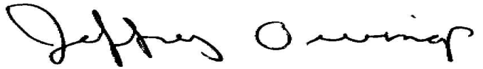
Jeffrey Owings, Ph.D.
Associate Commissioner, Elementary/Secondary & Libraries Studies Division
National Center for Education Statistics

Sample Letter To Be Signed By School Principals And Included In Mailing To Student/Parent With Explicit Permission Form

Dear «studentName» and Parent/Guardian:

RTI International is requesting permission to collect «studentName»’s high school transcript. <If base year school: «School Name» and> «studentName»’s was/were selected to participate in the High School Longitudinal Study of 2009 (HSLS:09), a study that began with a sample of 9th graders in 2009 and included a follow-up in the spring of 2012. We are unable to provide your transcript to RTI without your written permission to do so. As the attached letter from RTI requests, please sign and date the permission form and return to RTI as soon as possible.

I thank you in advance for your cooperation in this important research.

Sincerely,
<<School Principal>>
High School Longitudinal Study of 2009 Permission Form to Obtain Transcript

The information RTI will collect from the transcript includes dates of enrollment, grade point average, standardized test scores, and, for each course taken between grades 9 through 12, course number and title, number of credits earned, and grade assigned. RTI will also collect information about high-school-level courses that were taken prior to 9th grade.
Please sign the form or go to https://surveys.nces.ed.gov/hsls/ and click the radio button beside the line that indicates your decision regarding participation in this phase of the study. Please choose only one option and then review the student’s name, address, and phone number at the bottom of the form and make corrections, if needed.
IF YOU CHOOSE TO GRANT PERMISSION USING THE HARD COPY FORM, PLEASE RETURN IT AS SOON AS POSSIBLE. WE HAVE ENCLOSED AN ENVELOPE ADDRESSED TO RTI.
YOUTH AGE 18 OR OLDER:

Option 1. As a youth age 18 or older, I, _________________________________, give permission to the school to release my high school transcript to RTI as part of the High School Longitudinal Study of 2009.
______________________________________________ _________________________
(Signature of youth age 18 or older) (Date of signature)

Option 2. As a youth age 18 or older, I, _________________________________, do not give permission to the school to release my high school transcript to RTI as part of the High School Longitudinal Study of 2009.
______________________________________________ _________________________
(Signature of youth age 18 or older) (Date of signature)

PARENTS OF A YOUTH PARTICIPANT UNDER AGE 18:

Option 3. As a parent of a youth participant under age 18, I give permission to the school to release the high school transcript of my son/daughter, _____________________________________, to RTI as part of the High School Longitudinal Study of 2009.

______________________________________________ _________________________
(Signature of parent or guardian) (Date of signature)

Option 4. As a parent of a youth participant under age 18, I do not give permission to the school to release the high school transcript of my son/daughter, ______________________________________, to RTI as part of the High School Longitudinal Study of 2009.

______________________________________________ _________________________
(Signature of parent or guardian) (Date of signature)

PLEASE CORRECT THE INFORMATION BELOW, IF NEEDED:

Student name: «studentName»

Address: «Address1» «Address2» «City», «State» «Zip»

Telephone number: «PhoneNumber»

FOR OFFICE USE ONLY:
Student ID: «CaseID»
High School Name: «SchoolName»
School ID: «SchoolID»
Transcript Implied Permission Letter
«MailingDate»
«studentName» and Parent/Guardian
«Address1»
«Address2»
«City», «State» «Zip»

Dear «studentName» and Parent/Guardian:

We are contacting you at this time to obtain permission to collect «studentName»’s high school transcript. «studentName»was selected to participate in the High School Longitudinal Study of 2009 (HSLS:09), a study that began with a sample of 9th graders in 2009 and included a follow-up in the spring of 2012. Students, parents, and schools participating in HSLS:09 have all been notified in our previous correspondence that we will be collecting transcripts

If you will allow RTI to obtain the high school transcript, you do not need to return this form. If for any reason you object to the high school transcript being obtained, you may simply deny permission. If you wish to deny RTI permission to obtain the high school transcript, please fill out the form enclosed with this letter and return it to RTI in the enclosed envelope as soon as possible. We are scheduled to begin transcript collection soon and will include the request for your transcript if we have not received a response from you in 3 weeks.

HSLS:09 is conducted by the National Center for Education Statistics (NCES) of the U.S. Department of Education. The study focuses on understanding how high school experiences affect students’ learning and their educational and career choices and explores students' transitions from high school to college, the labor force, and adult roles. Of special interest is coursetaking and career preparation in math and science. Transcript data provides important information about how a student’s courses and grades make a difference in the work success and college experiences of young people. The information we will collect from the transcript includes dates of enrollment, grade point average, standardized test scores, and, for each course taken between grades 9 through 12, course number and title, number of credits earned, and grade assigned. We will also collect information about high-school-level courses that were taken prior to 9th grade. Transcripts will be collected under the guidelines of the Family Educational Rights and Privacy Act (FERPA). Please note that if the school charges a fee for obtaining the transcript, HSLS:09 will pay the fee.

Participation is voluntary. Any participant may withdraw from the study at any time. There is no penalty if you or your son or daughter decides not to participate or give permission to release high school transcripts. While there are no risks or direct benefits to taking part in the study, results of this study may help to formulate policies that benefit all children in the future.

NCES is authorized by federal law (20 U.S.C., § 9543) to conduct HSLS. RTI International, an independent nonprofit research organization based in North Carolina, has been contracted by NCES to collect data for this study. Responses and student record information may be used only for statistical purposes and will not be disclosed, or used, in identifiable form for any other purpose, except as required by law (ESRA 2002, 20 U.S.C., § 9573). Data will be combined to produce statistical reports for Congress and others. No individual data (e.g., names or addresses) will be reported.

If you have any questions about HSLS:09 or participation in the survey or transcript collection, please call <name> at RTI toll-free at 1-XXX-XXX-XXXX between 8:30AM and 5 PM Eastern time, Monday through Friday. If you have any questions about your rights as a study participant, you can call RTI's Office of Research Protection at 1-866-214-2043 (a toll-free number). Both can be reached at: Research Triangle Institute, P.O. Box 12194, Research Triangle Park, NC 27709.

We thank you in advance for your cooperation in this important research.

Sincerely,
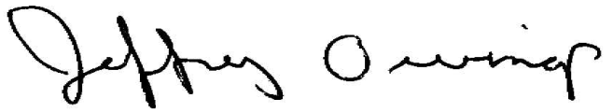
Jeffrey Owings, Ph.D.
Associate Commissioner, Elementary/Secondary & Libraries Studies Division
National Center for Education Statistics

High School Longitudinal Study of 2009 Transcript Permission Denial Form

The information RTI will collect from the transcript includes dates of enrollment, grade point average, standardized test scores, and, for each course taken between grades 9 through 12, course number and title, number of credits earned, and grade assigned. RTI will also collect information about high-school-level courses that were taken prior to 9th grade.
IF YOU GRANT PERMISSION TO THE SCHOOL TO RELEASE THE HIGH SCHOOL TRANSCRIPT TO RTI, YOU DO NOT NEED TO RETURN THIS FORM.
IF YOU DO NOT GRANT PERMISSION TO THE SCHOOL TO RELEASE THE HIGH SCHOOL TRANSCRIPT TO RTI, PLEASE RETURN THIS FORM TO RTI IN THE ENCLOSED ENVELOPE AS SOON AS POSSIBLE.
Please sign only one option and only if you do not give permission. Then, review the student’s name, address, and phone number at the bottom of the form and make corrections, if needed.

Parents of a participating youth under age 18: if you wish to deny permission to the school to release the high school transcript to RTI, you should fill in your son/daughter’s name and sign and date this form beside option #1 below.

Youth age 18 or older: if you wish to deny permission to the school to release the high school transcript to RTI, you should fill in your name and sign and date the form beside option #2 below.

YOUTH AGE 18 OR OLDER:

Option 1. As a youth age 18 or older, I, ______________________________________________, DO NOT GIVE PERMISSION to the school to release my high school transcript to RTI as part of the High School Longitudinal Study.
_________________________________________________ __________________________
(Signature of youth age 18 or older) (Date of signature)

PARENTS OF YOUTH PARTICIPANT UNDER AGE 18:

Option 2. As a parent of a youth participant under age 18, I DO NOT GRANT PERMISSION to the school to release the high school transcript of my son/daughter, _______________________________ _______________, to RTI as part of the High School Longitudinal Study.
_________________________________________________ __________________________
(Signature of parent or guardian) (Date of signature)

PLEASE CORRECT THE INFORMATION BELOW, IF NEEDED:

Student name: «studentName»

Address: «Address1» «Address2» «City», «State» «Zip»

Telephone number: «PhoneNumber»

FOR OFFICE USE ONLY:
Student ID: «CaseID»
High School Name: «SchoolName»
School ID: «SchoolID»

Transcript Consent Reminder Postcard

High School Longitudinal Study of 2009
A couple of weeks ago we mailed you a letter regarding high school transcript collection as part of the High School Longitudinal Study of 2009. If you have already read the letter and sent back the consent form, thank you very much. If you have not yet had the opportunity to read the letter and complete the consent form, please do so as soon as possible and return it in the postage-paid envelope that was included with that letter. If you did not receive the letter, please let us know so we may send you another one. You may contact us by calling our toll-free number 1-XXX-XXX-XXXX, or e-mailing us at hsls@rti.org. Thank you for your assistance on this important education study.

Post Consent Request Letter – Explicit
«MailingDate»
«RecipientName»
«SchoolName»
«Address1»
«Address2»
«City», «State» «Zip»

Dear «RecipientName»:

Recently, we contacted you about the collection of high school transcripts as part of the High School Longitudinal Study of 2009 (HSLS:09). You may recall that HSLS:09 is conducted by the National Center for Education Statistics (NCES) which contracted RTI International (RTI), a not-for-profit research organization, to collect the transcript data. The study focuses on understanding how high school experiences affect students’ learning and their educational and career choices and explores students' transitions from high school to college, the labor force, and adult roles. Of special interest is coursetaking and career preparation in math and science. Transcript data provide important, critically valuable information about how a student’s courses and grades influence subsequent postsecondary success in work or at college. At this time, we are contacting you to request transcripts for the students at your school who were selected to participate as fall 2009 9th graders. Enclosed in this package are instructions for preparing and transmitting the transcripts. You can access the list of sampled students on the secure study website (see below).

At your request, RTI mailed a letter to HSLS:09 sampled students (and their parents/guardians) who attended your school. The letter asked the students/parents to sign and return a permission form regarding the transcript collection. You can access the list of sampled students on the secure study website (see below). It will indicate the names of HSLS:09 sample members who attended your school and have granted permission to RTI for the release of the student transcript. We ask that you provide transcripts for these students electronically or via fax. We will also accept hard copy transcripts if sent via FedEx and as long as personally identifiable information has been redacted.
Collection of transcript information is on behalf of the Secretary of Education under the Family Educational Rights and Privacy Act (FERPA). FERPA allows the release of records to the Secretary of Education or his agents without prior written consent. We have provided a copy of the relevant text from FERPA in this package.

Responses and student record information may be used only for statistical purposes and will not be disclosed, or used, in identifiable form for any other purpose, except as required by law (ESRA 2002, 20 U.S.C., § 9573). Data will be combined to produce statistical reports for Congress and others. No individual data (e.g., names or addresses) will be reported.

If you have any questions about HSLS:09 transcript collection, please call Jane Griffin at RTI toll-free at 1-XXX-XXX-XXXX between 8:30 AM and 5 PM Eastern time, Monday through Friday. We can also be reached via e-mail at hsls@rti.org.
Please visit the study website for more information:

https://surveys.nces.ed.gov/hsls/

To log in, enter the Study ID below and enter the password below.

Your Study ID: «entity_id»
Your password: «password»

Thank you for your cooperation and timely attention to this matter.

Sincerely,
Jeffrey Owings, Ph.D.
Associate Commissioner, Elementary/Secondary & Libraries Studies Division
National Center for Education Statistics
U.S. Department of Education

Post Consent Request Letter – Implied
«MailingDate»
«RecipientName»
«SchoolName»
«Address1»
«Address2»
«City», «State» «Zip»

Dear «RecipientName»:

Recently, we contacted you about the collection of high school transcripts as part of the High School Longitudinal Study of 2009 (HSLS:09). You may recall that HSLS:09 is conducted by the National Center for Education Statistics (NCES) of the U.S. Department of Education, which has contracted with RTI International (RTI), a not-for-profit research organization, to collect the transcript data. The study focuses on understanding how high school experiences affect students’ learning and their educational and career choices and exploring students' transitions from high school to college, the labor force, and adult roles. Of special interest is coursetaking and career preparation in math and science. Transcript data provide important, critically valuable information about how a student’s courses and grades influence postsecondary success in work and at college. At this time, we are contacting you to request transcripts for the students at your school who were selected to participate as fall 2009 9th graders. Enclosed in this package are instructions for preparing and transmitting the transcripts. You can access the list of sampled students on the secure study website (see below).

At your request, RTI mailed a letter to your HSLS:09 sampled students (and their parents/guardians). The letter asked the students/parents to opt out if they do NOT want their transcript data to be released. You can access the list of sampled students on the secure study website (see below). It will indicate the names of HSLS:09 sample members who attended your school and who have not contacted us to opt out of the transcript collection as of the three-week period indicated in our correspondents. We ask that you provide transcripts for these students electronically or via fax. We will also accept hard copy transcripts if sent via FedEx and as long as personally identifiable information has been redacted.

Collection of transcript information is on behalf of the Secretary of Education under the Family Educational Rights and Privacy Act (FERPA). FERPA allows the release of records to the Secretary of Education or his agents without prior written consent. We have provided a copy of the relevant text from FERPA in this package.

Responses and student record information may be used only for statistical purposes and will not be disclosed, or used, in identifiable form for any other purpose, except as required by law (ESRA 2002, 20 U.S.C., § 9573). Data will be combined to produce statistical reports for Congress and others. No individual data (e.g., names or addresses) will be reported.

If you have any questions about HSLS:09 transcript collection, please call Jane Griffin at RTI toll-free at 1-XXX-XXX-XXXX between 8:30 AM and 5 PM Eastern time, Monday through Friday. She can also be reached by mail at: Research Triangle Institute, P.O. Box 12194, Research Triangle Park, NC 27709, or by e-mail at hsls@rt.org.

Thank you for your cooperation and timely attention to this matter.

Sincerely,
Jeffrey Owings, Ph.D.
Associate Commissioner, Elementary/Secondary & Libraries Studies Division
National Center for Education Statistics
U.S. Department of Education
Please visit the study website for more information:

https://surveys.nces.ed.gov/hsls1/

To log in, enter the study ID below and enter the password below.

Your study ID: «entity_id»
Your password: «password»

Additional Student Transcript Request Letter

«MailingDate»
«RecipientName»
«SchoolName»
«Address1»
«Address2»
«City», «State» «Zip»

Dear «RecipientName»:

We contacted you recently to obtain transcripts for students who attended «schoolname» and are sample members in the High School Longitudinal Study of 2009 (HSLS:09) being conducted the National Center for Education Statistics within the U. S. Department of Education. The data are being collected for NCES by RTI International. We want to thank you for your efforts in providing those valuable data. We are contacting you again to seek additional transcripts for sample members we learned attended your school from another school’s transcript. I am requesting transcripts for these {phase2_num} students. [If only 1 student, then we would say: I am requesting the transcript for one student.]

Included with this letter are instructions for preparing and transmitting transcript data to RTI. You can find a list of your students for whom transcripts are requested, with their dates of birth, at the secure study website listed in the box below; to access the site, log in using the username and password printed at the bottom of this letter. Also available at the website are instructions for obtaining reimbursement for preparing the transcripts, should your school require it. I would appreciate your sending us the requested transcript data by «due_date». Please call 1-XXX-XXX-XXXX or e-mail hsls@rti.org if you have any questions.

Thank you again for your assistance with the HSLS:09 transcript collection.

Sincerely,

Please visit the study website for more information:

https://surveys.nces.ed.gov/hsls/

To log in, enter the study ID below and the password below.

Your study ID: «entity_id»
Your password: «password»

Dan Pratt
HSLS:09 Project Director

Transcript Request Reminder E-mail

Dear <administrator_name>,

I am writing to follow up on information that was recently sent to you regarding a request for student transcripts for the High School Longitudinal Study of 2009 (HSLS:09). This Fed Ex package included information about HSLS:09 along with instructions for preparing and transmitting the student transcript(s). HSLS:09 is conducted by the National Center for Education Statistics (NCES) of the U.S. Department of Education, which has contracted with RTI International (RTI), an independent nonprofit research organization, to collect student transcripts for research purposes. Data will be used to provide information that will be used by Congress, researchers, and policymakers to improve the quality of education in America. Transcript data provide important information about how a student’s courses and grades make a difference in their subsequent work success and college experiences.

To access the list of students for whom we need transcripts, please go to our study website at: https://surveys.nces.ed.gov/hsls/. You will need to enter the following information to access the student information.
Study ID: <12345678>
Password: <password>

Once logged into the secure website, you will be instructed to change the password to something you will remember more easily. You can then locate the list of students by clicking the "View List of Sampled Students" button.
Please submit the requested student transcript(s) by [INSERT DATE].
If you did not receive the packet we sent, you may access the full set of instructions by using the study ID and password listed above to access our website: https://surveys.nces.ed.gov/hsls. If you prefer to receive another packet via FedEx, please call us toll-free at 1-XXX-XXX-XXXX, or e-mail us at hsls@rti.org. Thank you for your assistance with this important education study.

Sincerely,

Dan Pratt
HSLS:09 Project Director

CONFIDENTIALITY NOTICE
This electronic mail may contain confidential and/or privileged information that is intended only for the use by person(s) named above. If you are not the intended recipient, you are hereby notified that any review, dissemination, distribution, or duplication of this communication is strictly prohibited. If you are not the intended recipient, please contact the sender by reply e-mail and destroy all copies of the original message.

Transcript Reminder Letter

<Date>
«TranscriptCoordinatorName»
«SchoolName»
«Address1»
«Address2»
«City», «State» «Zip»
Dear «TranscriptCoordinatorName»:

I am writing to encourage participation of <schoolname> in the High School Longitudinal Study of 2009 (HSLS:09). The U.S. Department of Education‘s National Center for Education Statistics (NCES), is collecting the high school transcripts of sample members who are participating in HSLS:09. HSLS:09 follows a cohort of students who were 9th graders in high school in 2009-10 and surveys them later to find out about their education, work, and family experiences. Their transcript data will be linked with interview data and other administrative records to create a rich dataset for researchers in education.

HSLS:09 transcript data are collected in full compliance with the provisions of the Family Educational Rights and Privacy Act (FERPA) that allow the release of student records to the Secretary of Education or his agents without prior written consent from students. Let me assure you that very stringent measures are in place to safeguard the privacy of participants. Information on the many secure options available to you for providing transcript data may be found at the secure HSLS:09 website: https://surveys.nces.ed.gov/hsls/.

NCES has contracted with RTI International (RTI) to collect data for this important study. Your cooperation with RTI is greatly appreciated. For further information or questions, please contact the Help Desk at 1-XXX-XXX-XXXX or hsls@rti.org.

Sincerely,

Please visit the study website for more information:
https://<website>

To log in, enter the study ID below
and enter the password below.

Your study ID: «entity_id»
Your password: «password»

Elise Christopher, Ph.D.
NCES Project Officer of HSLS:09
SLS:09 HSLS:09 Project Officer National Center for Education Statistics

Second Follow-up Field Test Panel Maintenance Materials

Panel Maintenance Letter
<date>
<name> Website: [Website_Fill]
<address> Study ID: [ID_Fill]
<city> <state> <zip>

Dear <name>:
Thank you for your ongoing participation in the High School Longitudinal Study (HSLS). As you may recall, HSLS is conducted by the National Center for Education Statistics (NCES) of the U.S. Department of Education (OMB control # 1850-0852). [Your/StudentName’s] voluntary participation, and the participation of other young adults like [him/her/you], has helped to make HSLS a great success and has provided valuable data about young adults’ experiences in and out of school.
This important research study follows the same set of over 23,000 young adults, as they move from high school to the work force or further schooling, to understand what factors influence their learning and development.
As we prepare for the next phase of HSLS, which will begin in 2015, we are updating our contact information for study participants. Please update [your/StudentName’s] contact information and current educational status. The success of this national longitudinal study depends on having the most up-to-date contact information for all of the young adults involved in HSLS.
Please visit our website and use the study ID provided above to complete this information. If you prefer, you may fill out the enclosed address update form and send it back in the return envelope provided or call us at 1-XXX-XXX-XXXX. The update should take approximately 5 minutes to complete. <If panel maintenance incentive: We will send you $<inc-amt> as a token of appreciation for updating your contact information.>
As in prior rounds of HSLS, we will ask [you/StudentName] to complete a questionnaire, and [your/his/her] ongoing participation in HSLS is critically important to the study’s success. If you have any questions about HSLS or about updating [your/StudentName’s] contact information, please call the HSLS help desk at RTI, toll-free, at 1-XXX-XXX-XXXX.
HSLS is being conducted by the National Center for Education Statistics (NCES) within the U.S. Department of Education, which is authorized by Federal law (20 U.S.C., § 9543) to conduct HSLS. Data are being collected for NCES by RTI International and will be used only for statistical purposes and may not be disclosed or used, in identifiable form for any other purpose except as required by law (ESRA 2002, 20 U.S.C., § 9573). We thank you in advance for your help and greatly appreciate your continued support of this important research!
Sincerely,
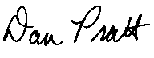
Dan Pratt
Project Director
High School Longitudinal Study

Panel Maintenance E-mail

Dear <NAME>:

In the <IF F1FT RESPONDENT: spring of 2011><and><IF F1FT NONRESPONDENT: fall of 2008>, [you/your son/your daughter] participated in the High School Longitudinal Study (HSLS). HSLS is conducted by the National Center for Education Statistics (NCES) of the U.S. Department of Education (OMB control # 1850-0852). As you know, this important research study follows the same set of over 23,000 young adults as they move from high school to the work force or further schooling to understand what factors influence their learning and development. Your/<StudentName’s> voluntary participation, and the participation of other young adults like [you/him/her], has helped to make HSLS a great success and has provided valuable data about young adults’ experiences in and out of school.
Recently, we sent a letter asking for your help updating contact information for study participants. If you have already completed this update, we thank you! If you have not yet had an opportunity, this is a friendly reminder to please spend about 5 minutes to update this information at your earliest convenience. We sincerely appreciate your help with this important effort!
<If panel maintenance incentive: As a token of our appreciation, we will send you $<inc-amt> for updating your contact information.>
Please visit the website below and use the study ID provided to update [your/<StudentName>’s] contact information. We appreciate your continued support of HSLS. NCES is authorized by Federal law (20 U.S.C., § 9543) to conduct HSLS, for which data are being collected by RTI International. Data will be used only for statistical purposes and may not be disclosed or used, in identifiable form, for any other purpose except as required by law (ESRA 2002, 20 U.S.C., § 9573). If you have any questions, encounter any difficulty on the website, or would prefer to update this information over the telephone, please call the HSLS:09 help desk, toll-free, at XXX-XXX-XXXX.
Go to <Website_Fill>
Enter your study ID: <ID_Fill>

We look forward to hearing from you.

Dan Pratt
Project Director
High School Longitudinal Study

Address Update Web Form
High School Longitudinal Study
Web Address Update Information
Thank you for your participation in the High School Longitudinal Study (HSLS). Please take a moment to update [your/StudentName’s] contact information and [your/StudentName’s] education status. We are also requesting that you provide contacting information for [at least one parent/yourself] and one additional person. By updating our records, we will better be able to notify [you/him/her] when it is time for the next round of HSLS. If the address information we sent you in the mail was correct, please check the appropriate box to indicate it was correct and complete.

Please be assured that both NCES and RTI follow strict confidentiality procedures to protect the privacy of study participants. If you would like more information about the HSLS study, please visit http://surveys.nces.ed.gov/hsls/.

We greatly appreciate your help to make HSLS a continued success!

1. [STUDENTS ONLY] May we send you a text message reminder when data collection begins?
- Yes Please enter your cell provider here: ___________________
- No

- If [your/StudentName’s] current contact information is not correct below, please provide the updated contacting information on the right. Otherwise, check the box at the bottom to indicate the information is correct and complete.

[Your/StudentName’s] contacting information
Name:
Address:
City
State
ZIP
Home phone:
Work phone:
Cell phone:
Primary e-mail address:
Alternate e-mail address:
- Check here if all information is correct

- Please also provide the contacting information for the parent most knowledgeable about [your/StudentName’s] education or career. Please also provide contacting information for an additional person who will always know how to get in touch with [you/StudentName].

Parent contacting information
Name:
Address:
City:
State:
ZIP:
Home phone:
Work phone:
Cell phone:
Primary e-mail address:
Alternate e-mail address:
- Check here if all information on the printed form was correct

One additional person
Name:
Address:
City:
State:
ZIP:
Home phone:
Work phone:
Cell phone:
Primary e-mail address:
Alternate e-mail address:

4. [Are you/Is StudentName] currently enrolled in a college, trade school, or other higher education institution?
- Yes Please continue with question 5
- No You are finished with the address update. Thank you.

5. Please provide the name and address of the college, trade school, or other higher education institution that [you/StudentName] attend. Please do not use abbreviated school names (e.g. use Arizona State University, rather than ASU).

School Name:

Thank you in advance for making HSLS a success!

Address Update Paper Form
High School Longitudinal Study (HSLS)

Address Update Information
Thank you very much for your participation in the High School Longitudinal Study (HSLS). Please take a moment to update [your/StudentName’s] contact information and [your/StudentName’s] education status. We are also requesting that you provide contact information for [at least one parent/yourself] and one additional person. By updating our records, we will be better able to notify [you/him/her] when it is time for the next round of HSLS. Please be assured that both NCES and RTI follow strict confidentiality procedures to protect the privacy of study participants. If you would like more information about the HSLS study, please visit http://surveys.nces.ed.gov/hsls/.

After you complete this form, please mail it back to RTI International using the enclosed Business Reply Envelope.

If you prefer to provide updates or confirm the information below online, please visit the HSLS website at [Website_Fil] and enter your study id: [ID_Fill] and password: [PW_Fill]. You may go online to indicate that the information provided in the form below is correct.

We greatly appreciate your help to make HSLS a continued success!

1. [STUDENTS ONLY] May we send you a text message reminder when data collection begins?
- Yes Please enter your cell provider here: ___________________
- No

- If [your/StudentName’s] current contact information is not correct below, please provide the updated contacting information on the right. If the contact information is correct, please check the box.

 | [Your/StudentName’s] contacting information |  |  | Corrections and additions
 | Name: | [StudentName]
 | Address: | [StudentAddress]
 | City | [StudentCity]
 | State | [StudentState]
 | ZIP | [StudentZIP]
 | Home phone: | [StudentHome]
 | Work phone: | [StudentWork]
 | Cell phone: | [StudentCell]
 | Primary e-mail address: | [Studentemail1]
 | Alternate e-mail address: | [Studentemail2]
- Check here if all information is correct

- Please also provide the contact information for the parent most knowledgeable about [your/StudentName’s] education or career. Please also provide contact information for an additional person who will always know how to get in touch with [you/StudentName].

 | Parent information |  |  | Corrections and additions
 | Name: | [ParentName]
 | Address: | [ParentAddress]
 | City: | [ParentCity]
 | State: | [ParentState]
 | ZIP: | [ParentZIP]
 | Home phone: | [Parenthome]
 | Work phone: | [ParentWork]
 | Cell phone: | [ParentCell]
 | Primary e-mail address: | [Parentemail1]
 | Alternate e-mail address: | [Parentemail2]
- Check here if all information is correct

Other contact information
Name:
Address:
City:
State:
ZIP:
Home phone:
Work phone:
Cell phone:
Primary e-mail address:
Alternate e-mail address:

4. [Are you/Is StudentName] currently enrolled in a college, trade school, or other higher education institution?
- Yes Please continue with question 5
- No You are finished with the address update. Thank you.

5. Please provide the name and address of the college, trade school, or other higher education institution that [you/StudentName] attend. Please do not use abbreviated school names (e.g. use Arizona State University, rather than ASU).

School Name:

Thank you in advance for making HSLS:09 a success!

Second Follow-up Main Study Panel Maintenance Materials
The panel maintenance update prior to the second follow-up is planned to take place about halfway between the 2013 update and the second follow-up collection. If the greeting card style mailing is sucessful prior to the 2013 Update, we may reuse it instead of sending the Panel Maintenance Letter presented below.

Panel Maintenance Letter
<date>
<name> Website: [Website_Fill]
<address> Study ID: [ID_Fill]
<city> <state> <zip> Password: [PW]

Dear <name>:
Thank you for your ongoing participation in the High School Longitudinal Study of 2009 (HSLS:09). As you may recall, HSLS:09 is conducted by the National Center for Education Statistics (NCES) of the U.S. Department of Education (OMB control # 1850-0852). [Your/StudentName’s] voluntary participation, and the participation of other young adults like [him/her/you], has helped to make HSLS:09 a great success and has provided valuable data about young adults’ experiences in and out of school.
This important research study follows the same set of over 23,000 young adults as they move from high school to the work force or further schooling to understand what factors influence their learning and development.
As we prepare for the next phase of HSLS:09, which will begin in 2016, we are updating our contact information for study participants. Please update [your/StudentName’s] contact information and current educational status. The success of this national longitudinal study depends on having the most up-to-date contact information for all of the young adults involved in HSLS:09.
Please visit our website and use the study ID provided above to complete this information. If you prefer, you may fill out the enclosed address update form and send it back in the return envelope provided or call us at 1-XXX-XXX-XXXX. The update should take approximately 5 minutes to complete. <If panel maintenance incentive: We will send you $<inc-amt> as a token of appreciation for updating your contact information.>
As in prior rounds of HSLS:09, we will ask [you/StudentName] to complete a questionnaire, and [your/his/her] ongoing participation in HSLS:09 is critically important to the study’s success. If you have any questions about HSLS:09 or about updating [your/StudentName’s] contact information, please call the HSLS:09 help desk at RTI, toll-free, at 1-XXX-XXX-XXXX.
NCES is authorized by Federal law (20 U.S.C., § 9543) to conduct HSLS:09. Data are being collected for NCES by RTI and will be used only for statistical purposes and may not be disclosed or used, in identifiable form for any other purpose except as required by law (ESRA 2002, 20 U.S.C., § 9573). We thank you in advance for your help and greatly appreciate your continued support of this important research!
Sincerely,
Dan Pratt
Project Director
High School Longitudinal Study of 2009

Panel Maintenance E-mail

Dear <NAME>:

In the <IF F1FS RESPONDENT: spring of 2012><and><IF F1FT NONRESPONDENT: fall of 2009>, [you/your son/your daughter] participated in the High School Longitudinal Study of 2009 (HSLS:09). HSLS:09 is conducted by the National Center for Education Statistics (NCES) of the U.S. Department of Education (OMB control # 1850-0852). As you know, this important research study follows the same set of over 23,000 young adults as they move from high school to the work force or further schooling to understand what factors influence their learning and development. Your/<StudentName’s> voluntary participation, and the participation of other young adults like [you/him/her], has helped to make HSLS:09 a great success and has provided valuable data about young adults’ experiences in and out of school.
Recently, we sent a letter asking for your help updating contact information for study participants. If you have already completed this update, we thank you! If you have not yet had an opportunity, this is a friendly reminder to please spend about 5 minutes to update this information at your earliest convenience. We sincerely appreciate your help with this important effort!
<If panel maintenance incentive: As a token of our appreciation, we will send you $<inc-amt> for updating your contact information.>
Please visit the website below and use the study ID provided to update [your/<StudentName>’s] contact information. We appreciate your continued support of HSLS:09. The U.S. Department of Education is authorized by Federal law (20 U.S.C., § 9543) to conduct HSLS, for which data are being collected by RTI International. Data will be used only for statistical purposes and may not be disclosed or used, in identifiable form for any other purpose except as required by law (ESRA 2002, 20 U.S.C., § 9573). If you have any questions, encounter any difficulty on the website, or would prefer to update this information over the telephone, please call the HSLS:09 help desk, toll-free, at XXX-XXX-XXXX.
Go to <Website_Fill>
Enter your study ID: <ID_Fill>

We look forward to hearing from you.

Dan Pratt
Project Director
High School Longitudinal Study of 2009

Address Update Web Form
High School Longitudinal Study of 2009 (HSLS:09)
Web Address Update Information
Thank you for your participation in the High School Longitudinal Study of 2009 (HSLS:09). Please take a moment to update [your/StudentName’s] contact information and [your/StudentName’s] education status. We are also requesting that you provide contacting information for [at least one parent/yourself] and one additional person. By updating our records, we will better be able to notify [you/him/her] when it is time for the next round of HSLS:09. If the address information we sent you in the mail was correct, please check the appropriate box to indicate it was correct and complete.

Please be assured that both NCES and RTI follow strict confidentiality procedures to protect the privacy of study participants. If you would like more information about the HSLS study, please visit http://surveys.nces.ed.gov/hsls/.

We greatly appreciate your help to make HSLS:09 a continued success!

1. [STUDENTS ONLY] May we send you a text message reminder when data collection begins?
- Yes Please enter your cell provider here: ___________________
- No

- If [your/StudentName’s] current contact information is not correct below, please provide the updated contacting information on the right. Otherwise, check the box at the bottom to indicate the information is correct and complete.

[Your/StudentName’s] contacting information
Name:
Address:
City
State
ZIP
Home phone:
Work phone:
Cell phone:
Primary e-mail address:
Alternate e-mail address:
- Check here if all information is correct

- Please also provide the contacting information for the parent most knowledgeable about [your/StudentName’s] education or career. Please also provide contacting information for an additional person who will always know how to get in touch with [you/StudentName].

Parent contacting information
Name:
Address:
City:
State:
ZIP:
Home phone:
Work phone:
Cell phone:
Primary e-mail address:
Alternate e-mail address:
- Check here if all information on the printed form was correct

One additional person
Name:
Address:
City:
State:
ZIP:
Home phone:
Work phone:
Cell phone:
Primary e-mail address:
Alternate e-mail address:

4. [Are you/Is StudentName] currently enrolled in a college, trade school, or other higher education institution?
- Yes Please continue with question 5
- No You are finished with the address update. Thank you.

5. Please provide the name and address of the college, trade school, or other higher education institution that [you/StudentName] attend. Please do not use abbreviated school names (e.g. use Arizona State University, rather than ASU).

School Name:

Thank you in advance for making HSLS:09 a success!

Address Update Paper Form
High School Longitudinal Study of 2009 (HSLS:09)

Address Update Information
Thank you very much for your participation in the High School Longitudinal Study of 2009 (HSLS:09). Please take a moment to update [your/StudentName’s] contact information and [your/StudentName’s] education status. We are also requesting that you provide contact information for [at least one parent/yourself] and one additional person. By updating our records, we will be better able to notify [you/him/her] when it is time for the next round of HSLS:09. Please be assured that both NCES and RTI follow strict confidentiality procedures to protect the privacy of study participants. If you would like more information about the HSLS study, please visit http://surveys.nces.ed.gov/hsls/.

After you complete this form, please mail it back to RTI International using the enclosed Business Reply Envelope.

If you prefer to provide updates or confirm the information below online, please visit the HSLS:09 website at [Website_Fil] and enter your study id: [ID_Fill] and password: [PW_Fill]. You may go online to indicate that the information provided in the form below is correct.

We greatly appreciate your help to make HSLS:09 a continued success!

1. [STUDENTS ONLY] May we send you a text message reminder when data collection begins?
- Yes Please enter your cell provider here: ___________________
- No

- If [your/StudentName’s] current contact information is not correct below, please provide the updated contacting information on the right. If the contact information is correct, please check the box.

 | [Your/StudentName’s] contacting information |  |  | Corrections and additions
 | Name: | [StudentName]
 | Address: | [StudentAddress]
 | City | [StudentCity]
 | State | [StudentState]
 | ZIP | [StudentZIP]
 | Home phone: | [StudentHome]
 | Work phone: | [StudentWork]
 | Cell phone: | [StudentCell]
 | Primary e-mail address: | [Studentemail1]
 | Alternate e-mail address: | [Studentemail2]
- Check here if all information is correct

- Please also provide the contact information for the parent most knowledgeable about [your/StudentName’s] education or career. Please also provide contact information for an additional person who will always know how to get in touch with [you/StudentName].

 | Parent information |  |  | Corrections and additions
 | Name: | [ParentName]
 | Address: | [ParentAddress]
 | City: | [ParentCity]
 | State: | [ParentState]
 | ZIP: | [ParentZIP]
 | Home phone: | [Parenthome]
 | Work phone: | [ParentWork]
 | Cell phone: | [ParentCell]
 | Primary e-mail address: | [Parentemail1]
 | Alternate e-mail address: | [Parentemail2]
- Check here if all information is correct

Other contact information
Name:
Address:
City:
State:
ZIP:
Home phone:
Work phone:
Cell phone:
Primary e-mail address:
Alternate e-mail address:

4. [Are you/Is StudentName] currently enrolled in a college, trade school, or other higher education institution?
- Yes Please continue with question 5
- No You are finished with the address update. Thank you.

5. Please provide the name and address of the college, trade school, or other higher education institution that [you/StudentName] attend. Please do not use abbreviated school names (e.g. use Arizona State University, rather than ASU).

School Name:

Thank you in advance for making HSLS:09 a success!

Standard text messaging rates apply.
Typically provides career/technical instruction only; students attend part-time and receive their academic instruction at a home high school.
A course taken which enables a student to earn both high school and college credit.
A course that can be taken as part of a program of integrated academic and vocational high school study linked to a related postsecondary program (e.g., 2+2 program).
A course taken as part of a school-within-a school program in which a curriculum that integrates academic and vocational courses is organized around broad career areas (e.g., health, transportation, information technology).
Standard text messaging rates apply.
Standard text messaging rates apply.
Standard text messaging rates apply.
Standard text messaging rates apply.

