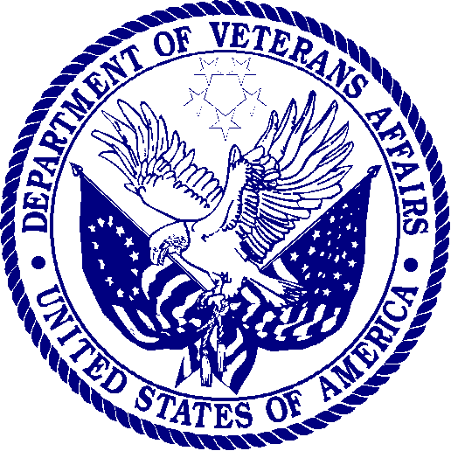 | DEPARTMENT OF VETERANS AFFAIRS  Veterans Health Administration  Washington DC 20420

Date: [INSERT CURRENT DATE]

Dear: [INSERT FIRST AND LAST NAME]:

We would like to invite you to participate in a survey about your knowledge of and/or experiences with the Department of Veterans Affairs (VA) health care system. In the next few weeks, an interviewer from Altarum Institute will call you on the phone to ask about your experiences with and views on the general health care, primary care, and/or women’s specific services you received from the VA health care system.

Our records indicate that your current phone number is [INSERT RESPONDENT NUMBER]. If this is incorrect or you would prefer to be contacted at another number, please contact us by calling [INSERT NUMBER] or by e-mail at [INSERT EMAIL] to provide us with an updated or preferred phone number.

Following is a little more information about the study we are conducting.

Why are we calling?
- The Department of Veterans Affairs wants to have a better understanding of the health care experiences of women Veterans and their interaction with the VA health care system. VA has asked Altarum Institute to gather this information.
- Altarum will interview about 8,400 women Veterans by phone to hear about their experiences and views.
- You received this invitation because you are a woman Veteran who has used, or may be eligible to use, VA health care benefits. Even if you do not currently use VA health care benefits, we would still like your feedback about our system.

Who is Altarum Institute?
- Altarum is a non-profit independent health research organization, and is not part of VA. The VA hired Altarum to gather information about barriers that may keep women from using the VA’s health care system.

How long will the telephone interview take and what will you ask me?
- The interview will take about 45 to 60 minutes.
- We will ask you some questions about your knowledge of, and experience with, the VA health care system. Questions will focus on general health care, primary care, and women’s specific services. We will ask about your satisfaction with the care you have received and about your general health.

Do I have to do this?
- This is your chance to share your experiences with the VA health care system, and we believe this is important. However, you do not have to take part if you do not want to. Even if you agree to participate in the survey, you can skip any specific questions you do not want to answer.
- Your decision about taking part in this interview will not affect any services you receive from VA or your eligibility for services in the future.

Is this confidential?
- YES! Your responses are protected.
- No one will connect your name to any information that you provide.
- We will combine your answers with answers from other participating Veterans and show them only as totals and averages, never as individual responses associated with you.

What will Altarum do with this information?
- Your confidential answers will help VA understand women Veterans’ experiences.
- VA will use this information to improve the quality of care you and other women Veterans receive.
- VA strongly encourages you to participate in this important study.

Who do I contact for more information?
If you have questions about the survey, please contact [SURVEY POC/HELPDESK] by sending an email to [INSERT EMAIL]; by calling [INSERT NUMBER]; or sending a fax to [INSERT NUMBER].

Thank you very much for helping with this important study. The information you provide will help to improve VA services for all women Veterans.

Sincerely,
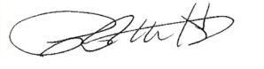
Patricia M. Hayes, PhD
Chief Consultant, Women’s Health Services

