Consumer- File A Report

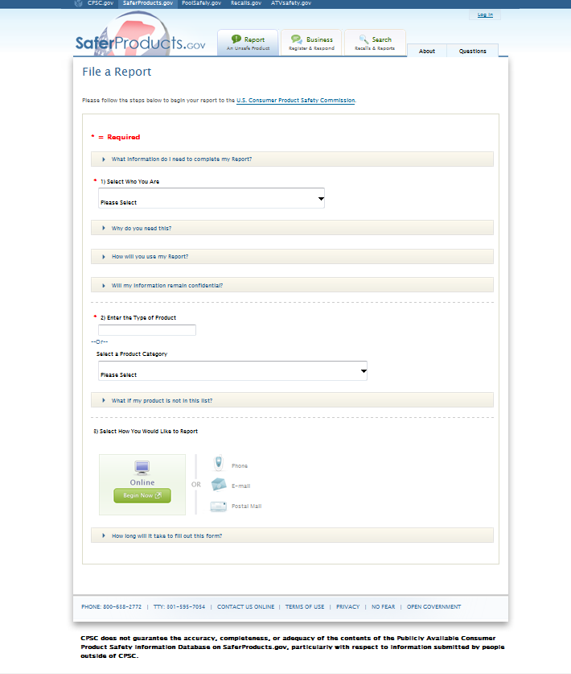

Consumer- Incident Description (Tell Us What Happened)

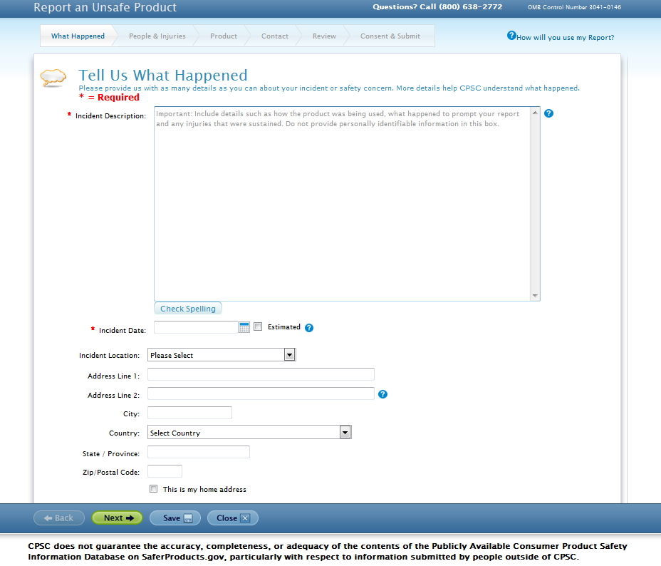

Consumer- People & Injuries

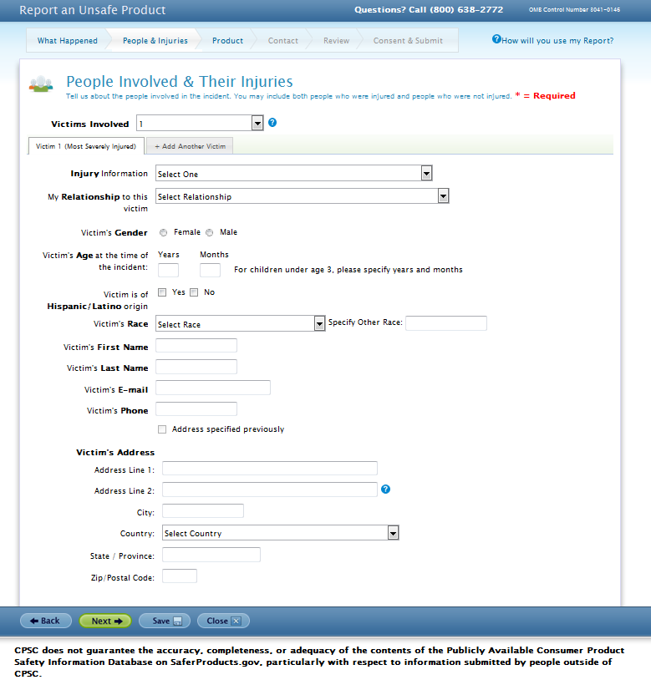

Consumer- Product Details (Tell Us About the Product

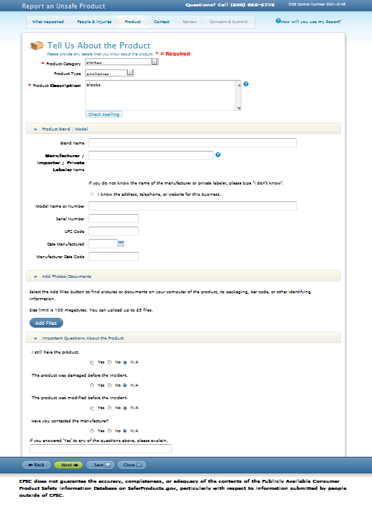

Consumer- Contact Information

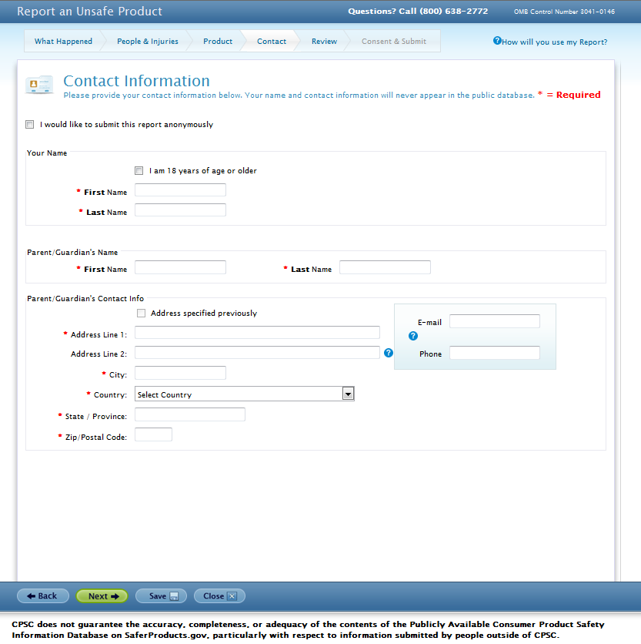

Consumer- Consent & Submit

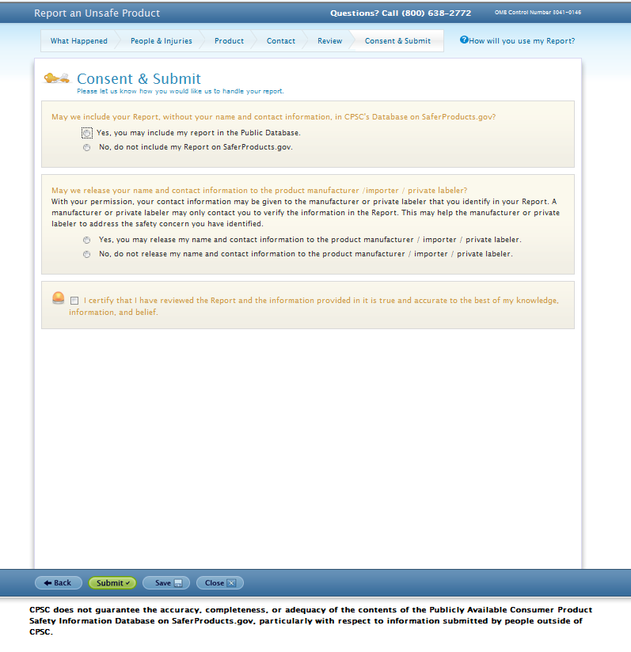

­

Child Care Provider, etc (everyone but Consumer)- Contact Info

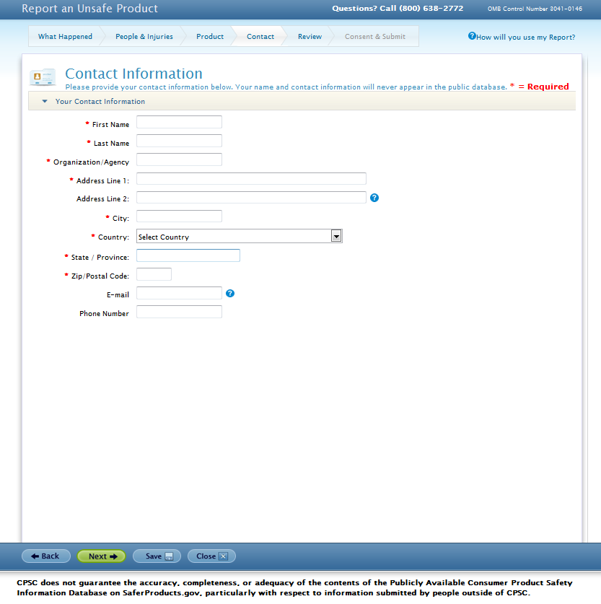

Public Safety Entity/ Government- Case Details

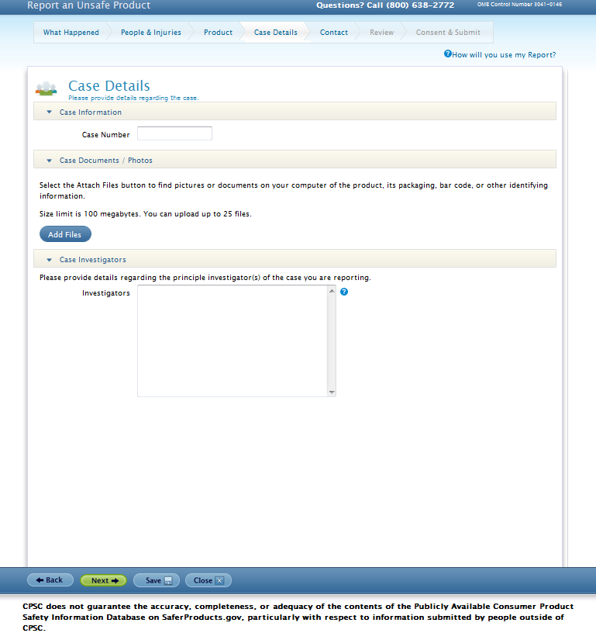

MECAP- People and Injuries

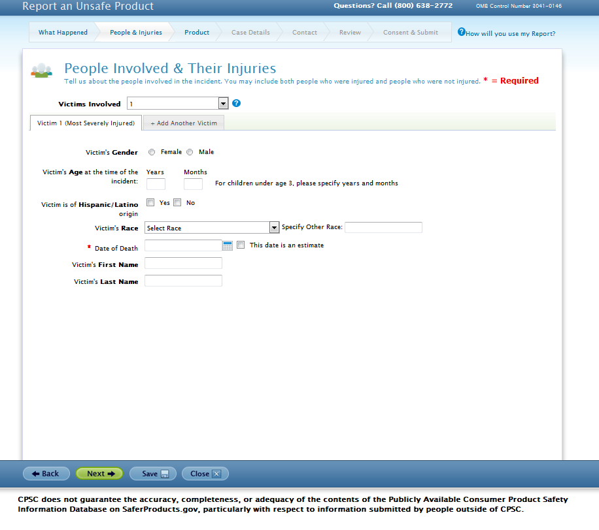



MECAP- Case Details

