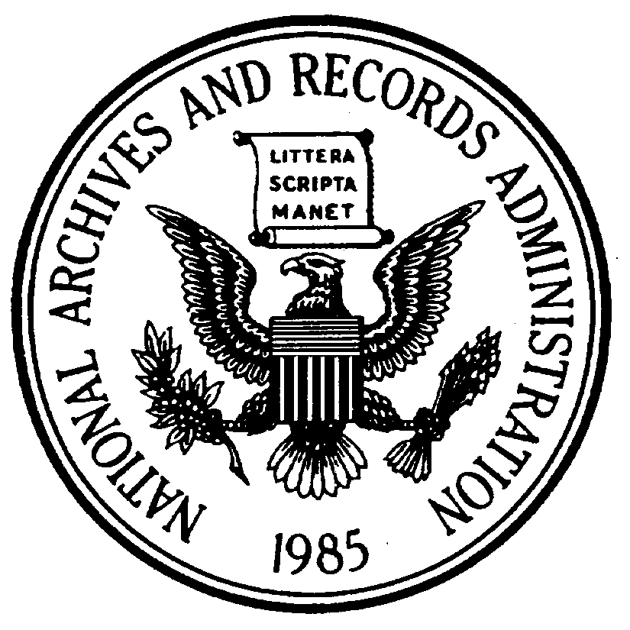
National Archives and Records Administration
700 Pennsylvania Avenue NW, Washington DC 20408-0001

Evaluation

We value your opinion. Please take a few minutes to complete this evaluation. Your comments are invaluable to us in maintaining our services and planning future programs.

Presentation Title: George Washington’s Retirement Activities
Date: June 10, 1790
Speaker/Instructor(s): Martha Washington
Please rate the following items: | Strongly Agree | Agree | Disagree | Strongly Disagree | Not Applicable
The subject is important for my own professional development.
The presentation provided relevant, useful information.
I learned something today that will help me.
Handouts were informative.
Overall, I was satisfied with the presentation.
I would like to see this topic again at the National Archives in the future.
I would like to see this speaker again at the National Archives.

Which of the following categories describes you?
National Archives employee/student/volunteer/docent General public
Researcher Other (please specify): _________________
How did you hear about the presentation?

How could this presentation be improved?

(If more space is needed, continue on other side.)

If you wish to direct additional comments to a supervisor, you may contact Click here to enter text.

PAPERWORK REDUCTION ACT PUBLIC BURDEN STATEMENT: You are not required to provide the information requested on a form that is subject to the Paperwork Reduction Act unless the form displays a valid OMB control number. Public burden reporting for this collection of information is estimated to be less than 5 minutes per response. Send comments regarding the burden estimate or any other aspect of the collection of information, including suggestions for reducing this burden, to National Archives and Records Administration (NHP), 8601 Adelphi Rd, College Park, MD 20740-6001. DO NOT SEND COMPLETED FORMS TO THIS ADDRESS.

OMB Control No. 3095-0023 Expiration date 8/31/2010 NA FORM 2019 (06-06)

