FORM APPROVED BY OMB No. 0581-0125
 | UNITED STATES DEPARTMENT OF AGRICULTURE  Agricultural Marketing Service  Fruit and Vegetable Program |  |  | LOGO USE REQUEST  FOR AUDIT PROGRAMS
FEDERAL AUTHORIZATION: This form is to be completed by authorized personnel in accordance with the specified Specialty Crops Inspection Division audit program(s). All materials which make reference to the audit program(s) design or language are accountable items. Their use is authorized by a contract between the USDA and the participant company. No materials shall bear reference to the audit program(s) design or language without prior written consent of the Specialty Crops Inspection Division.
A. Logo Description
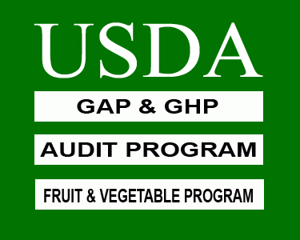 |  | 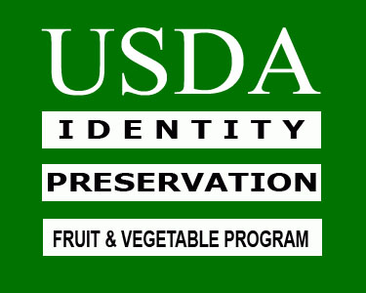 | 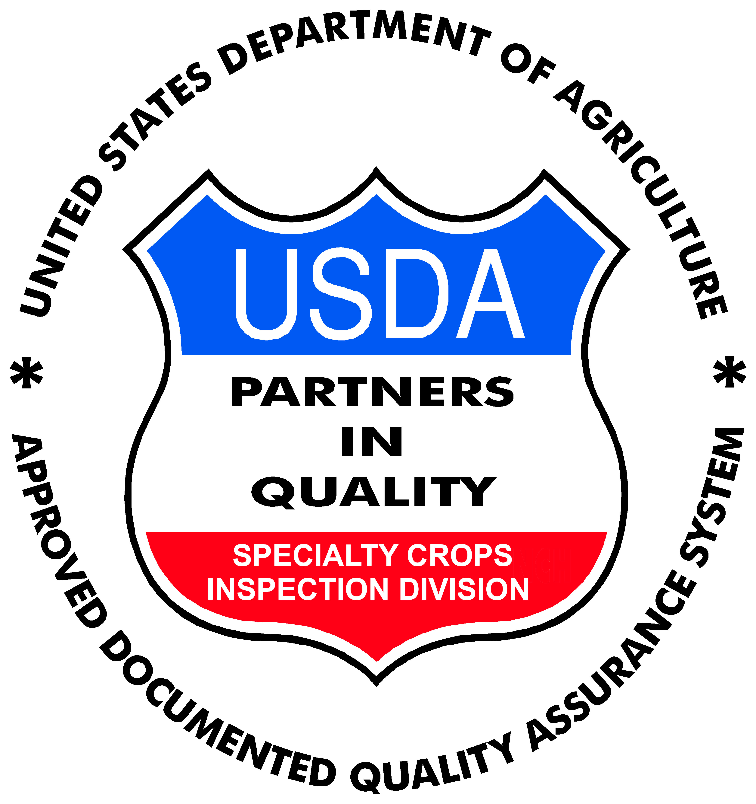 | Type of Logo: □ Black □ Color**  **( GAP&GHP and IP color logos must use Pantone Matching System (PMS) color Green 348. PIQ color logos must use the colors red, white and blue in specified areas. Any other colors used will not be considered an approved audit program logo and will be in violation of the agreement.)
B. Company Information
___________________________________________ _______________________________________________________________
Name of Company Mailing Address of Company
___________________________________________ _________________________ ____________________________________
Name and Title of Person Requesting Logo Use Phone Number Email Address
C. Logo Use
Commodities:_______________________________________________________________________________________________
Select type(s) of use and specify the number of materials that will contain the audit programs logo (Attach Additional Documentation):
□ Containers : __________ □ Publication(s) __________ type(s):___________________________________________
□ Labels/Stickers __________ □ Website(s) __________ web address(es):______________________________________
□ Other : ________________________________________________________________________________________________________________
D. Manufacturer’s Information
___________________________________________ ___________________________________________
Manufacturer’s Name Manufacturer’s Phone Number
_________________________________________________________________________________________
Manufacturer’s Mailing Address
E. Applicant’s Request
As an authorized participant in the Specialty Crops Inspection Division audit program(s), I hereby request that the above materials be approved and produced with the audit program(s) logo. I agree to be responsible for all charges assessed by the manufacturer of the materials for this order. I also acknowledge that all materials containing the audit program(s) logo are in compliance with the audit program(s) logo use requirements and are for the exclusive use as a participant in good standing in the audit program(s) as authorized by the USDA. A copy of the manufacturers’ invoice bearing the exact number of preprinted materials produced with the audit program(s) logo and a signed copy of Section F will be forwarded to the Specialty Crop Inspection Division immediately after the time of receipt.
_________________________________________ _______________
Applicant’s Signature Date
_________________________________________ _______________
Federal Authority Signature Date
F. Applicant’s Receipt
I have received the above listed materials and they are now my responsibility. I certify that only the materials in the above list have been produced and will only be used in accordance with a audit program(s) in good standing.
_________________________________________ _______________
Applicant’s Signature Date
_________________________________________ _______________
Federal Authority Signature Date
According to the Paperwork Reduction Act of 1995, an agency may not conduct or sponsor, and a person is not required to respond to a collection of information unless it displays a valid OMB control number. The valid OMB control number for this information collection is 0581-0125. The time required to complete this information collection is estimated average 0.2 hours per response, including the time for reviewing instructions, searching existing data sources, gathering and maintaining the data needed, and completing and reviewing the collection of information.
The U.S. Department of Agriculture (USDA) prohibits discrimination in all its programs and activities on the basis of race, color, national origin, age, disability, and where applicable, sex, marital status, familial status, parental status, religion, sexual orientation, genetic information, political beliefs, reprisal or because all or part of an individual’s income is derived from any public assistance program. (Not all prohibited bases apply to all programs.) Persons with disabilities who require alternative means for communication of program information (Braille, large print, audiotape, etc.) should contact USDA’s TARGET Center at (202)720-2600 (voice and TDD). To file a complaint of discrimination, write to USDA, Director, Office of Civil Rights, 1400 Independence Avenue, S.W., Washington, D.C. 20250-9410, or call (800)795-3272 (voice) or (202)720-6382 (TDD). USDA is an equal opportunity provider and employer.
FV-652 (11-13)

