**Appendix A1**

**WIC State Agency Web Survey**

**Exhibit 1: Agency Login**

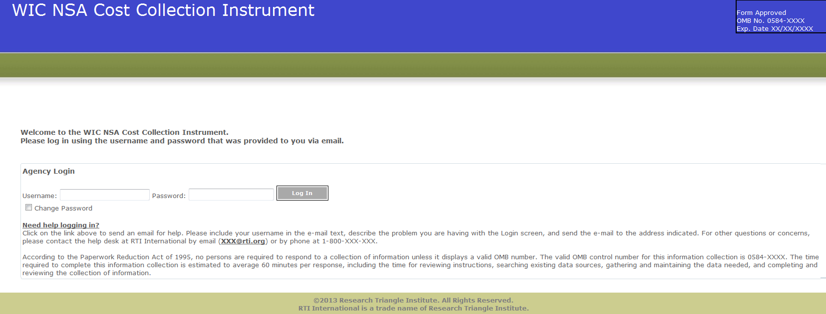

**Exhibit 2: Home Screen**

According to the Paperwork Reduction Act of 1995, no persons are required to respond to a collection of information unless it displays a valid OMB number. The valid OMB control number for this information collection is 0584-XXXX. The time required to complete this information collection is estimated to average 60 minutes per response, including the time for reviewing instructions, searching existing data sources, gathering and maintaining the data needed, and completing and reviewing the collection of information.

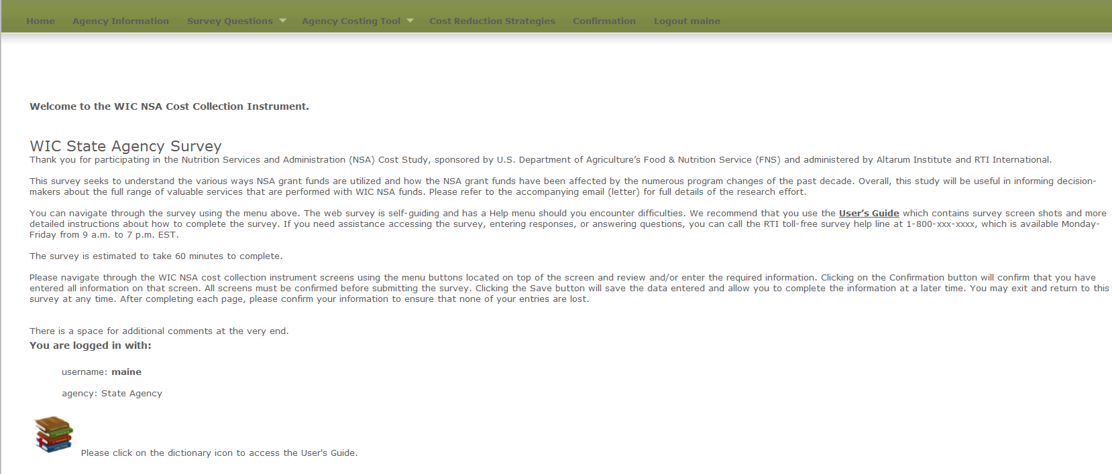

**Exhibit 3: Agency Information Screen**

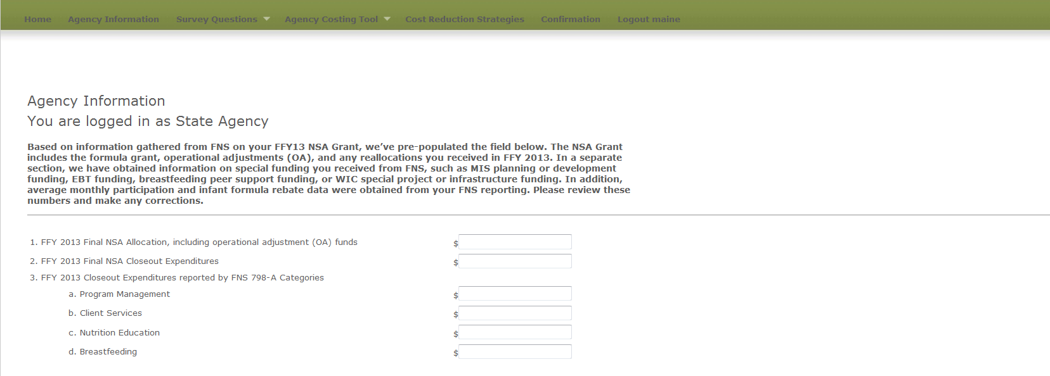

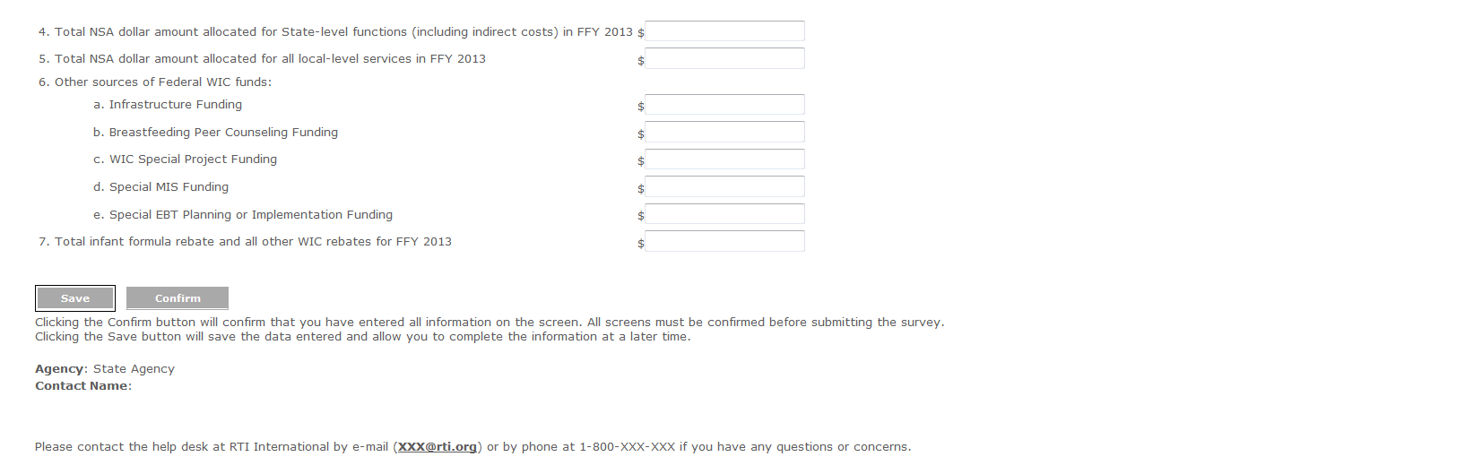

**Survey Questions**

**Exhibit 4: Demographic Questions screen**

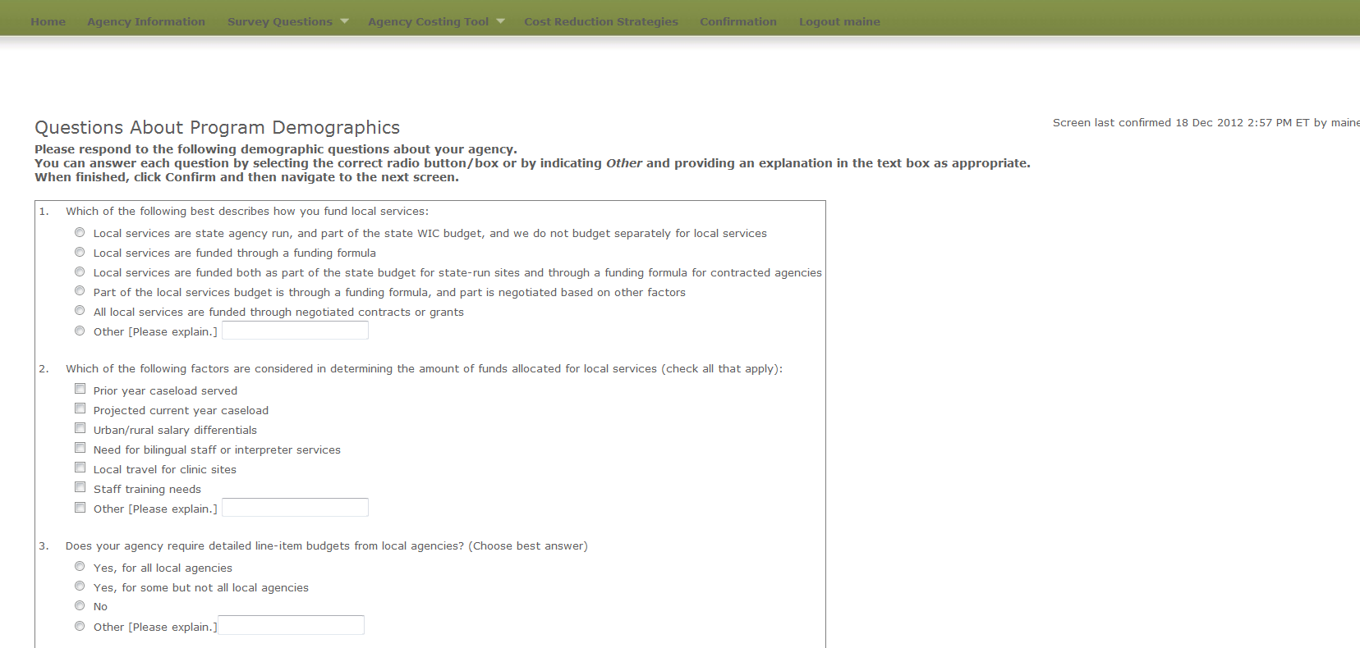

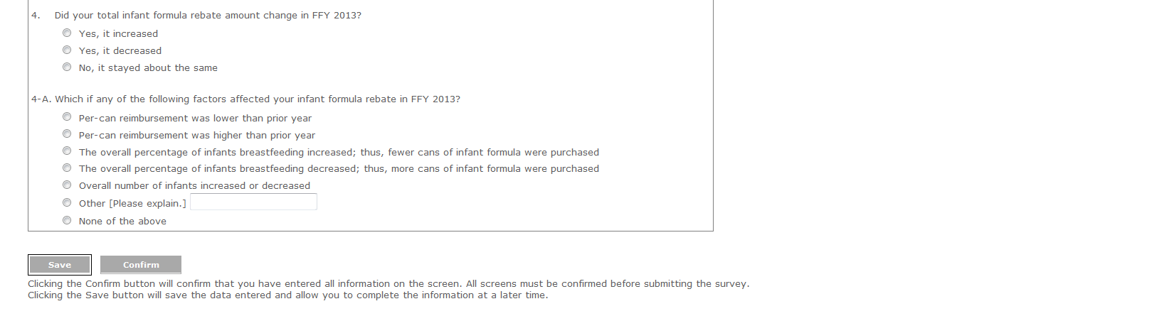

**Exhibit 5: Change in Costs Questions Screen**

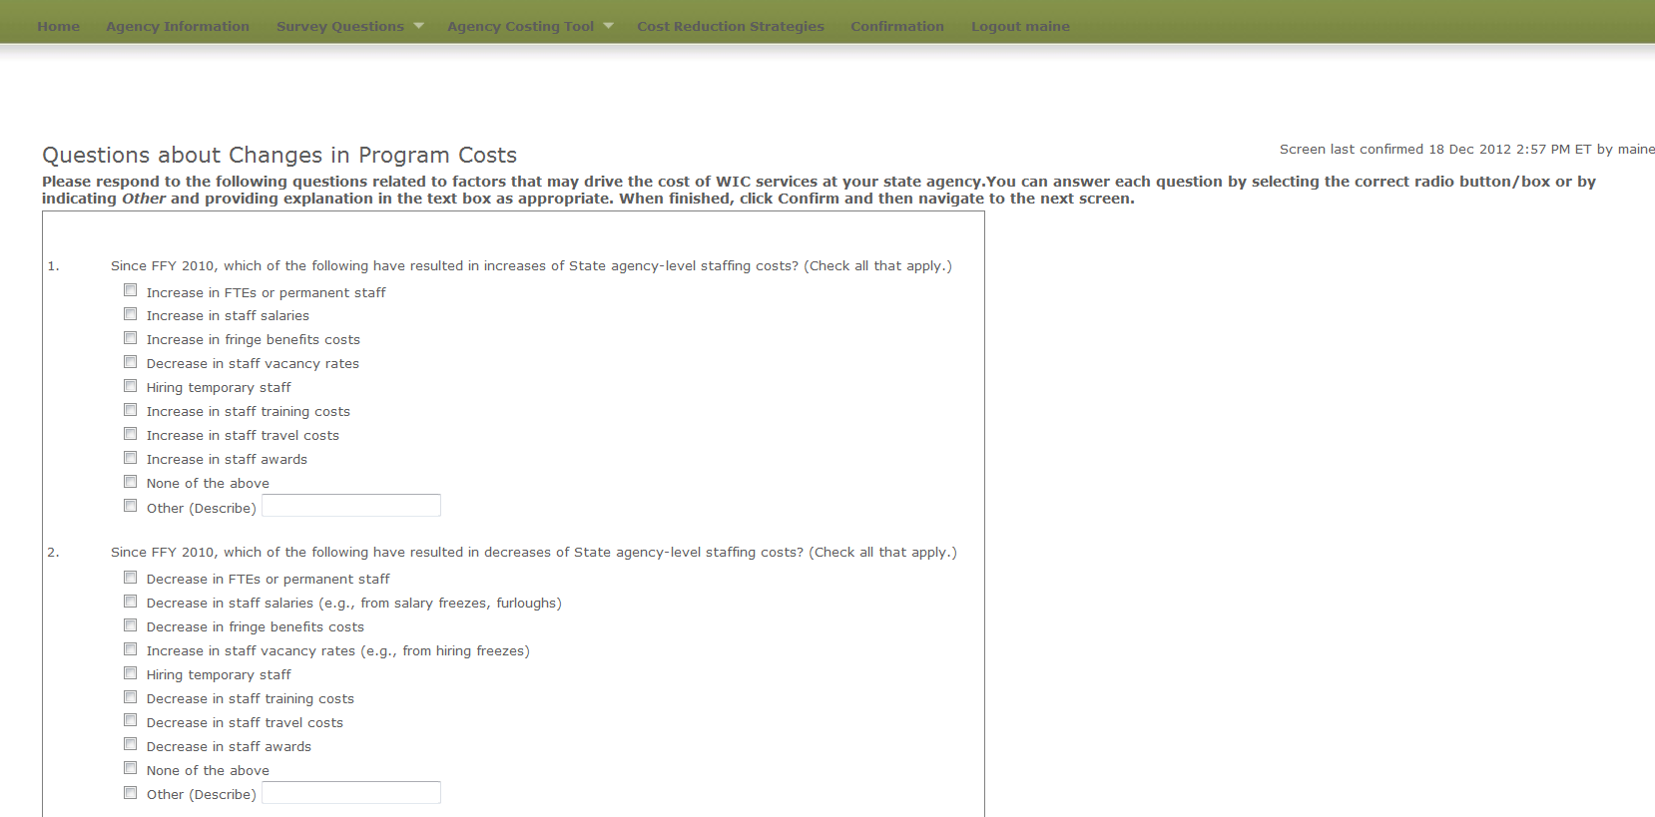

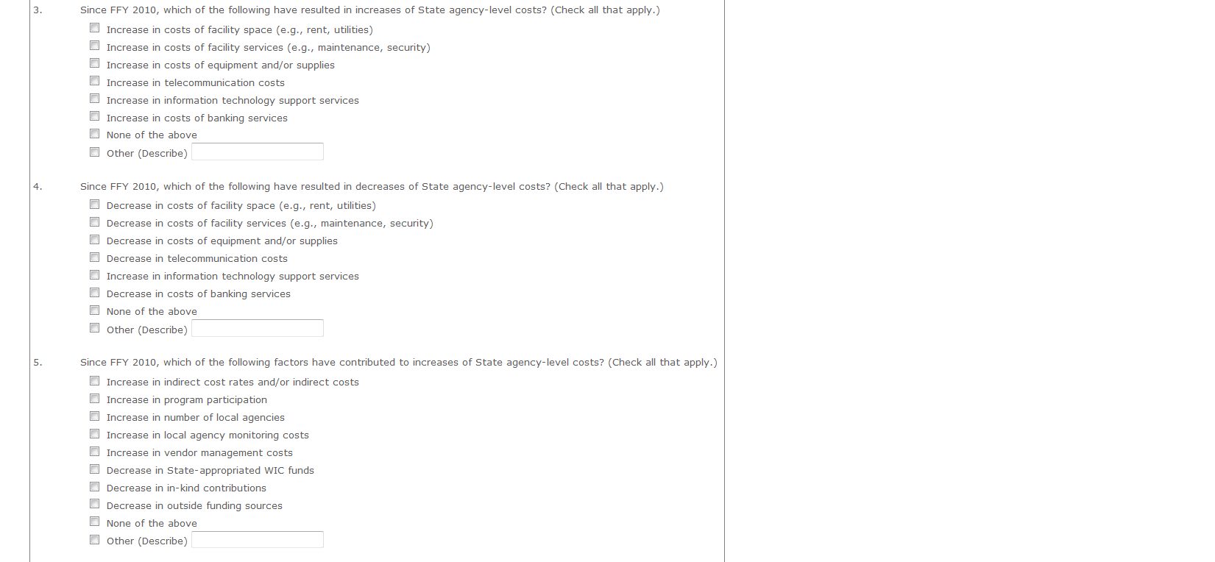

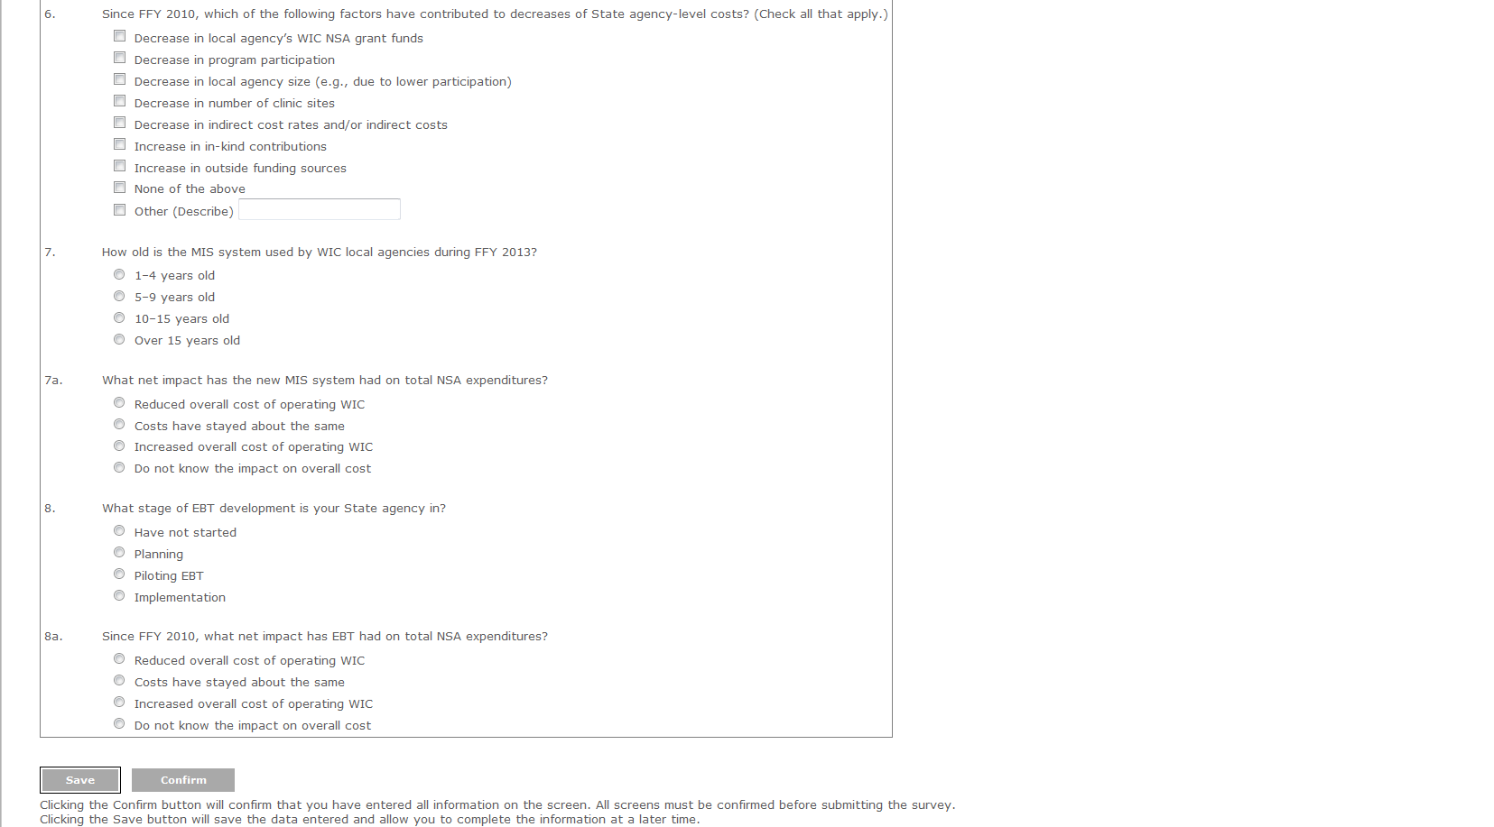

**Exhibit 6: Labor/Personnel Expenditure**

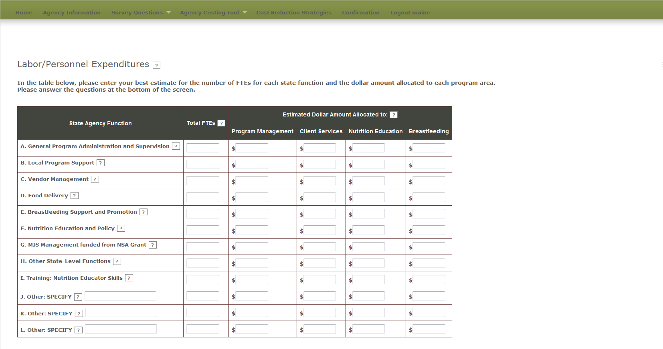

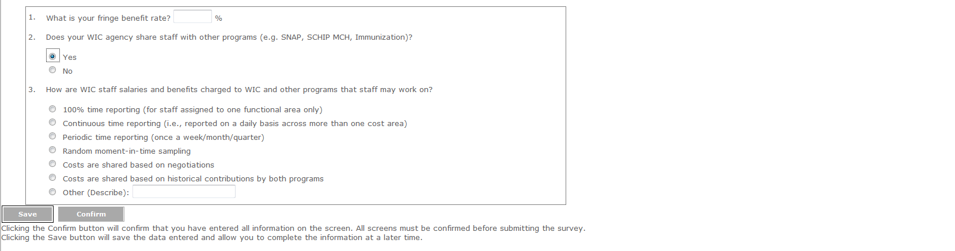

**Exhibit 7: Contracted Services Screen**

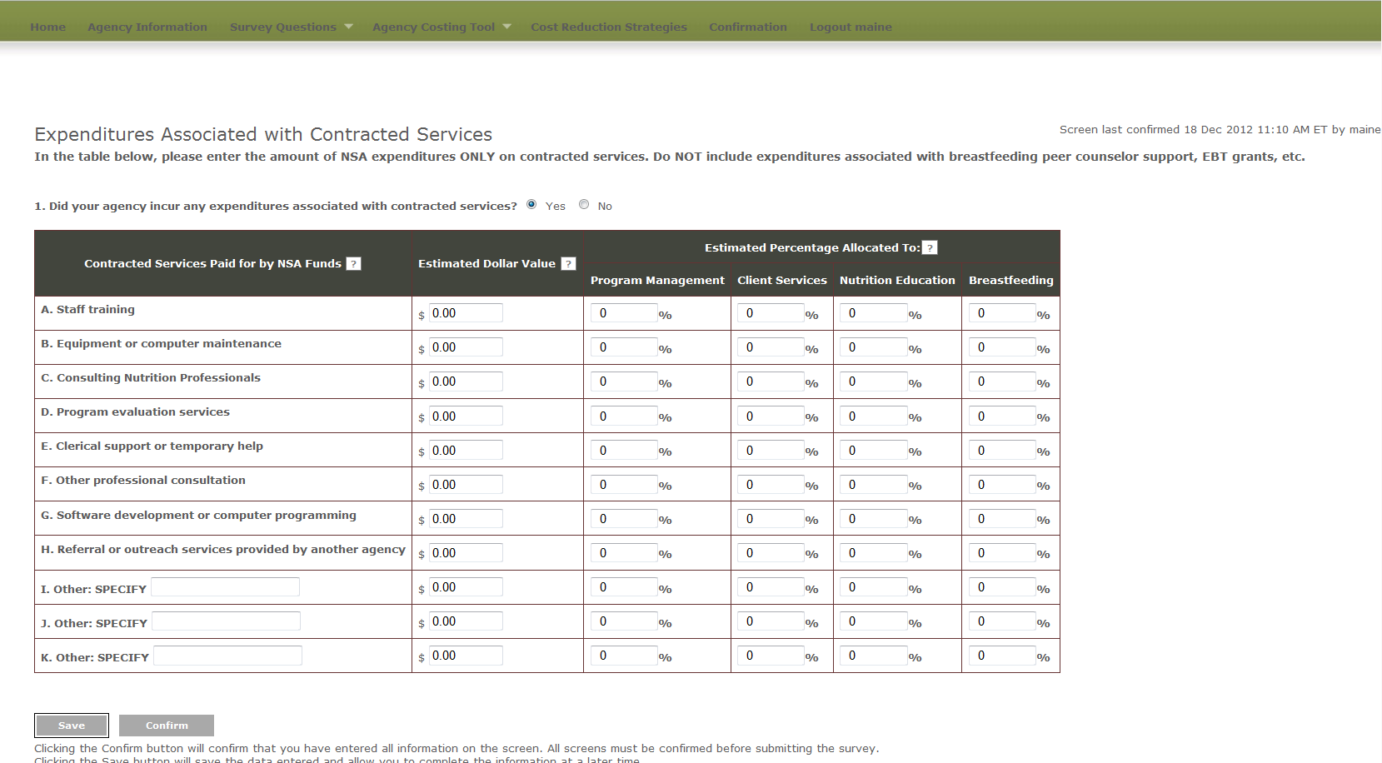

**Exhibit 8: Materials, Services, and Travel Screen**

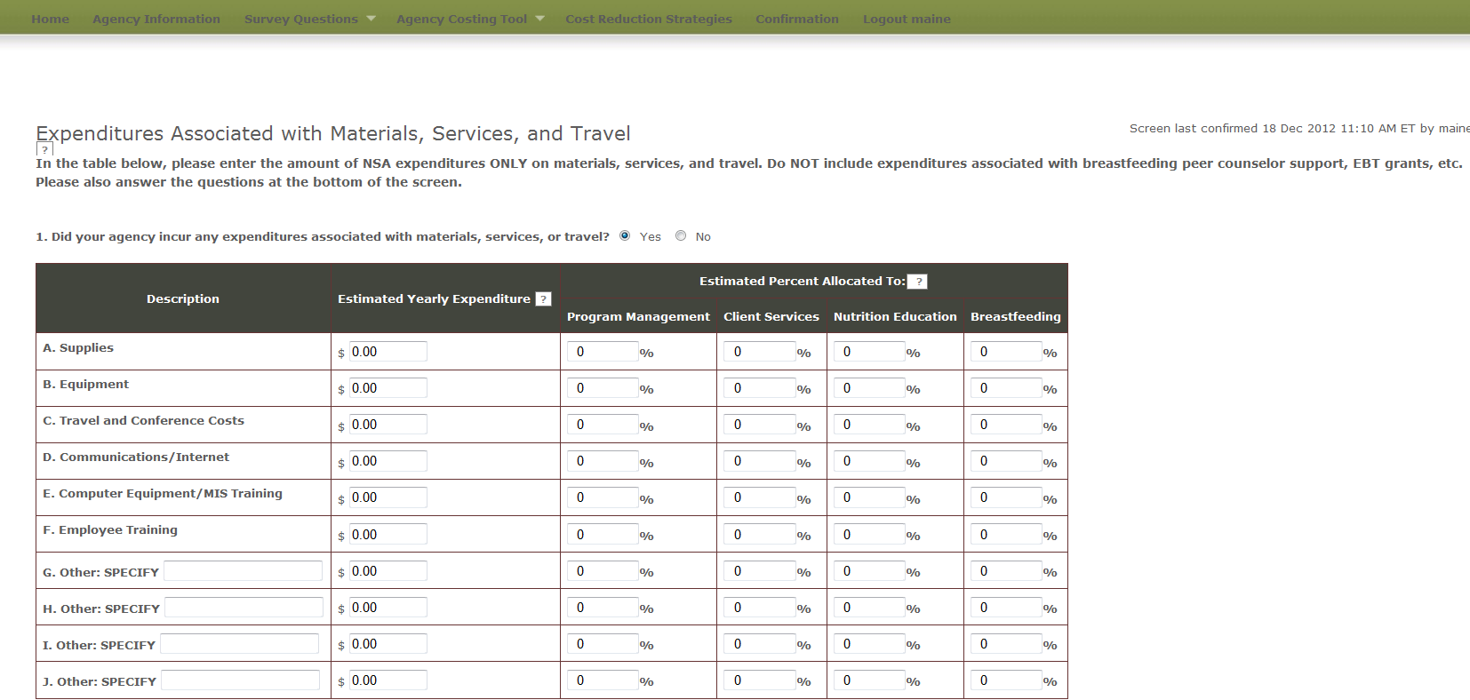

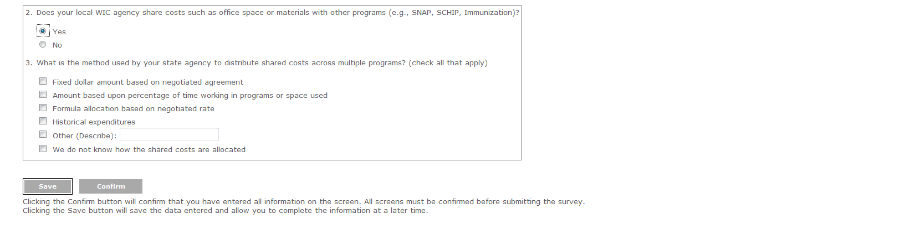

**Exhibit 9: Indirect Costs**

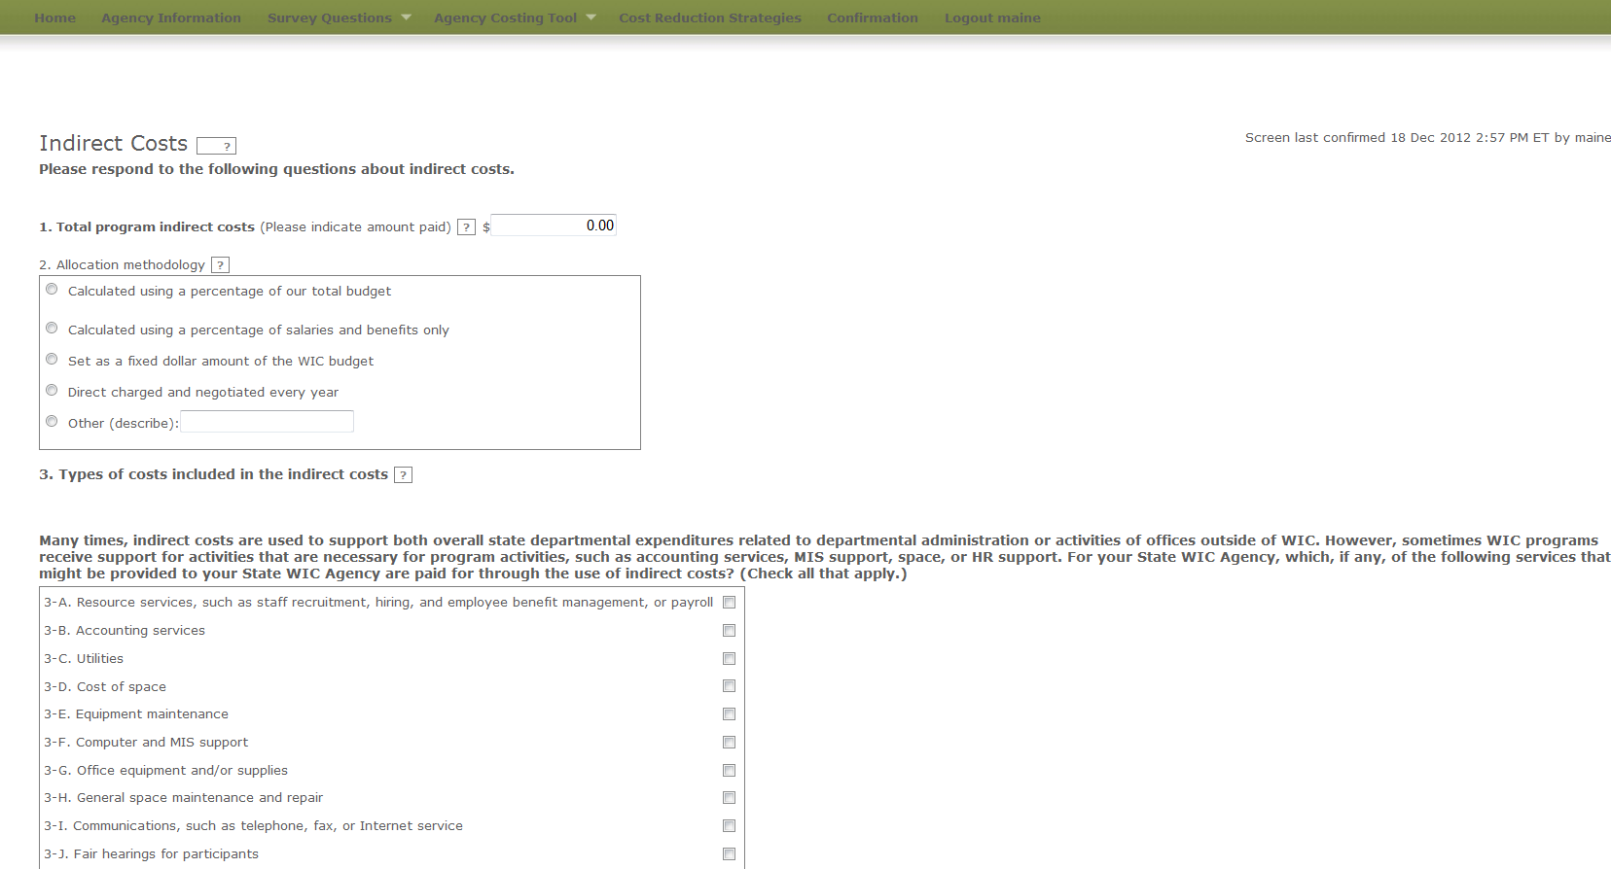



**Exhibit 10: Other Sources of Funds**

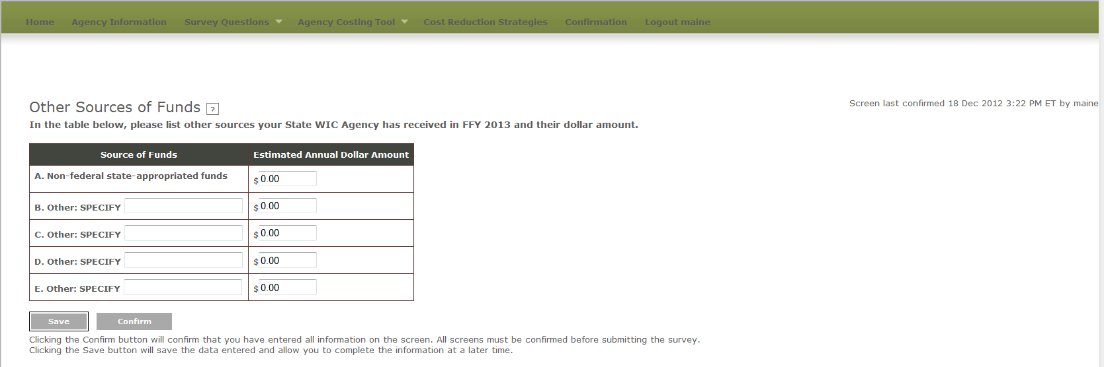

**Exhibit 11: In-kind Contributions**

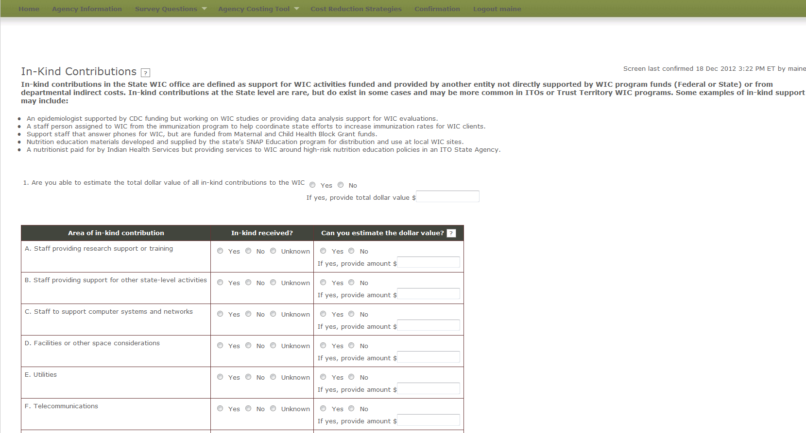

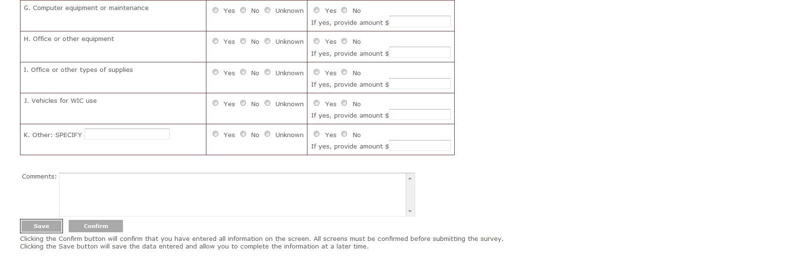

**Exhibit 12: Cost Reduction Strategies**

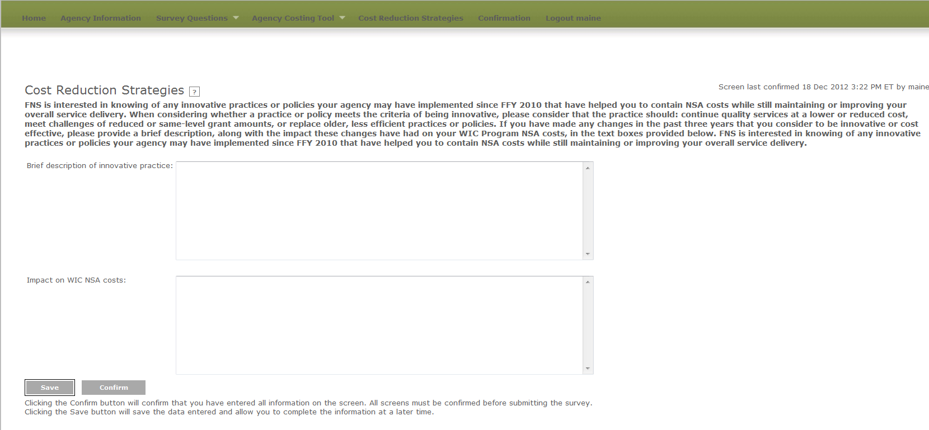

**Exhibit 13: Confirmation Screen**

