**Appendix A3**

**WIC Combination Web Survey**

**Exhibit 1: Agency Login**

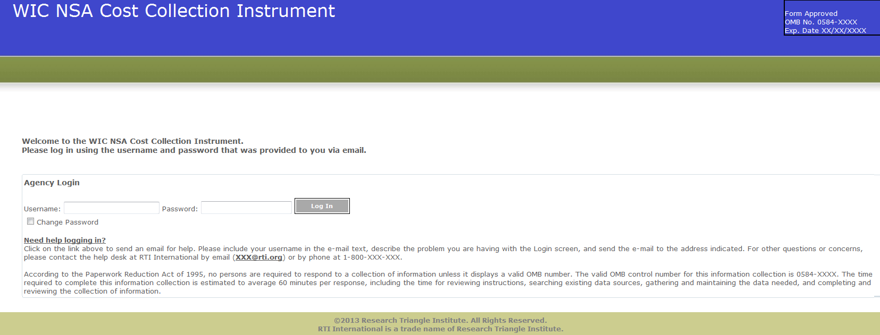

**Exhibit 2: Home Screen**

According to the Paperwork Reduction Act of 1995, no persons are required to respond to a collection of information unless it displays a valid OMB number. The valid OMB control number for this information collection is 0584-XXXX. The time required to complete this information collection is estimated to average 60 minutes per response, including the time for reviewing instructions, searching existing data sources, gathering and maintaining the data needed, and completing and reviewing the collection of information.

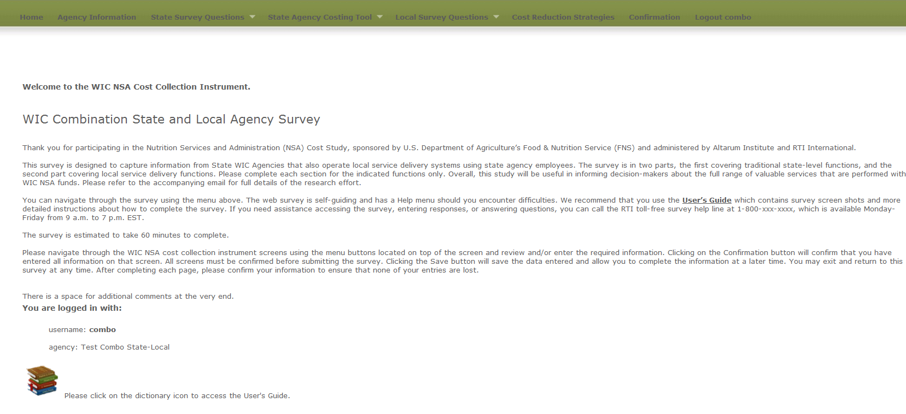

**Exhibit 3: Agency Information Screen**

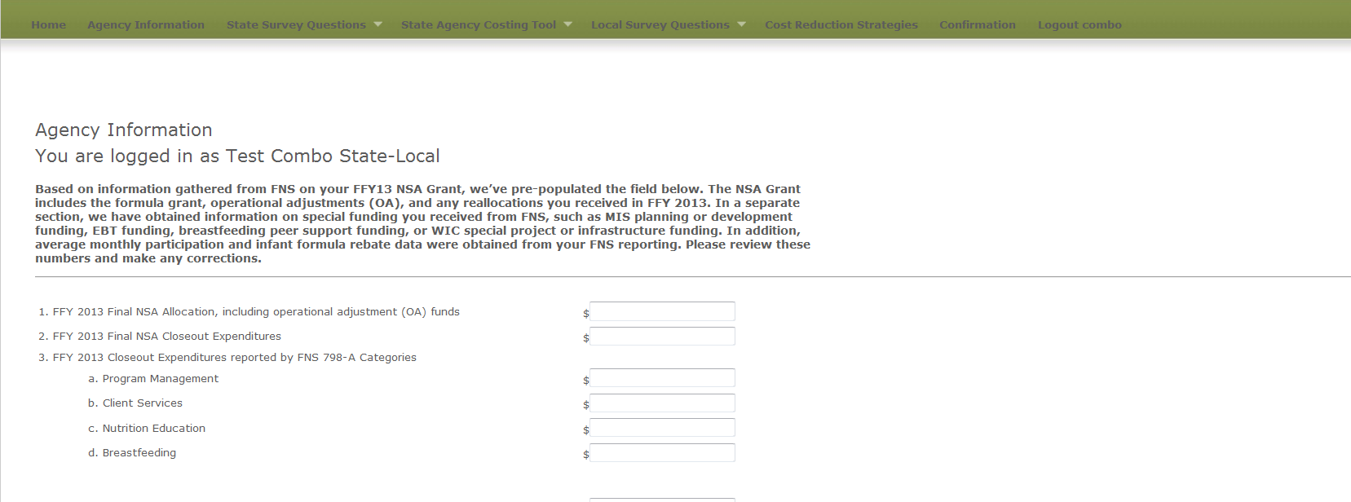

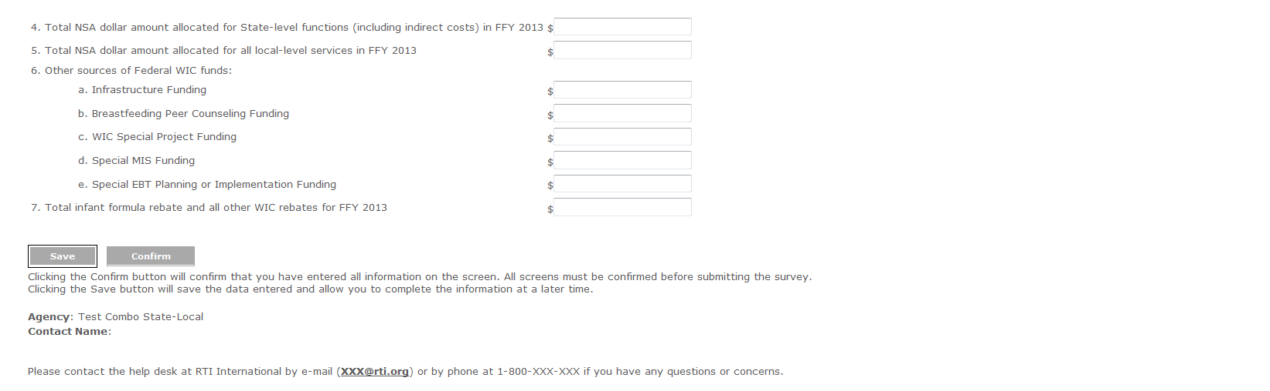

**State Level Survey Questions**

**Exhibit 4: Demographic Questions screen**

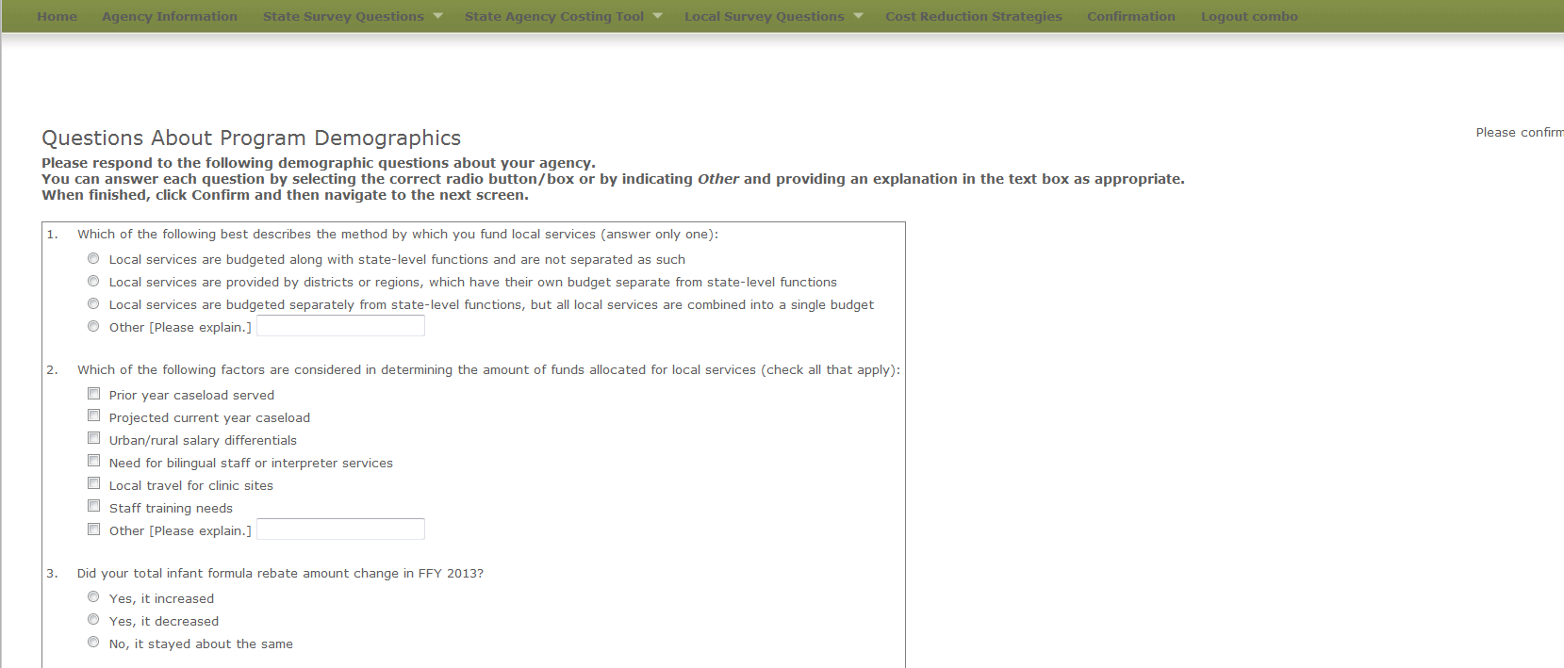

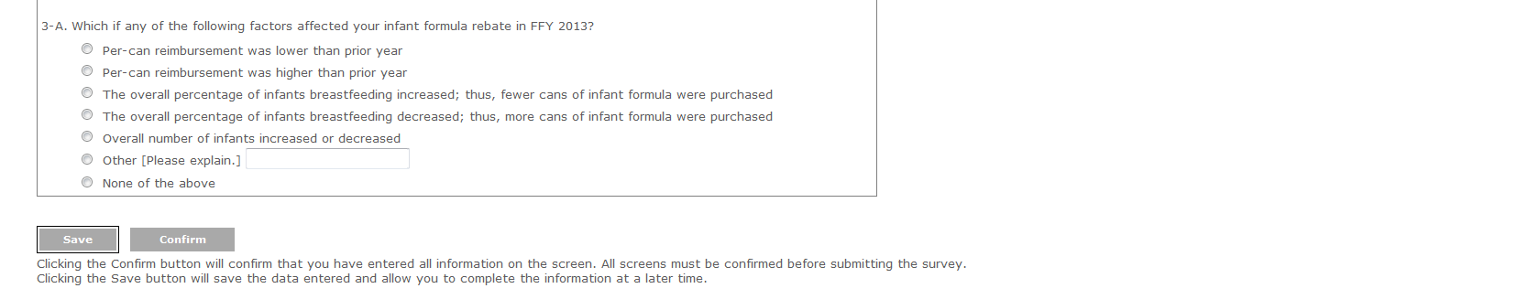

**Exhibit 5: Change in Costs Questions Screen**

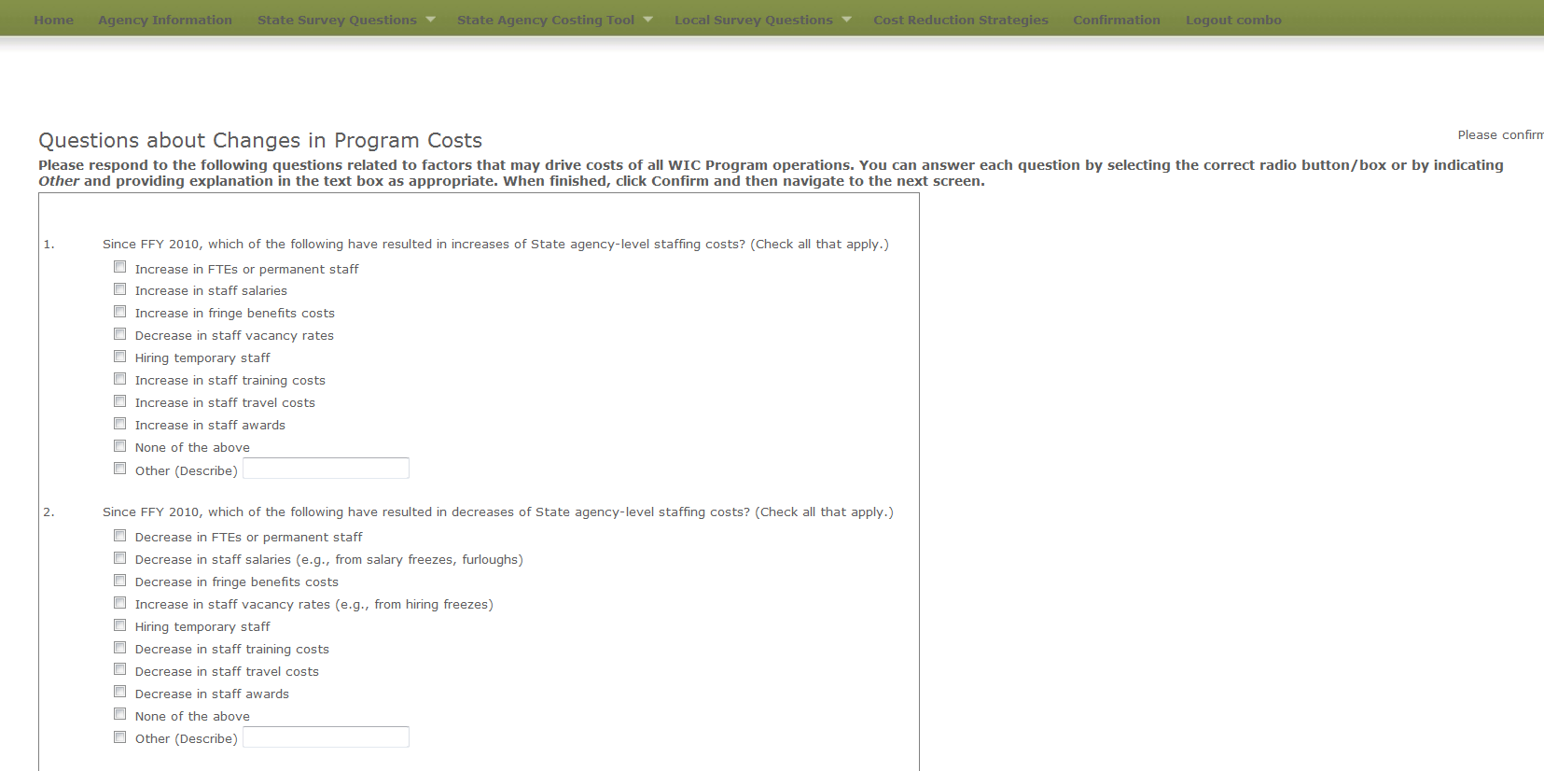

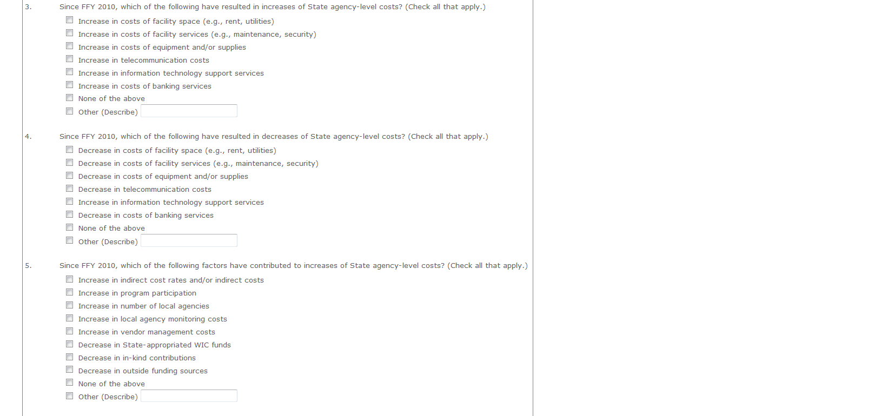

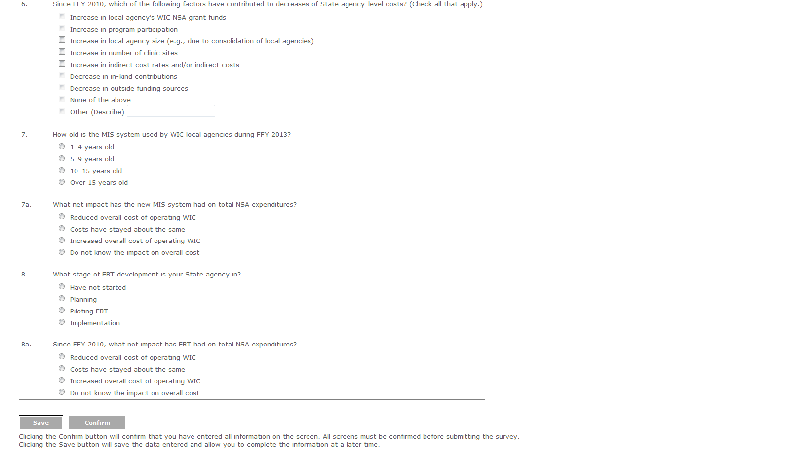

**Agency Costing Tool**

**Exhibit 6: Labor/Personnel Expenditure**

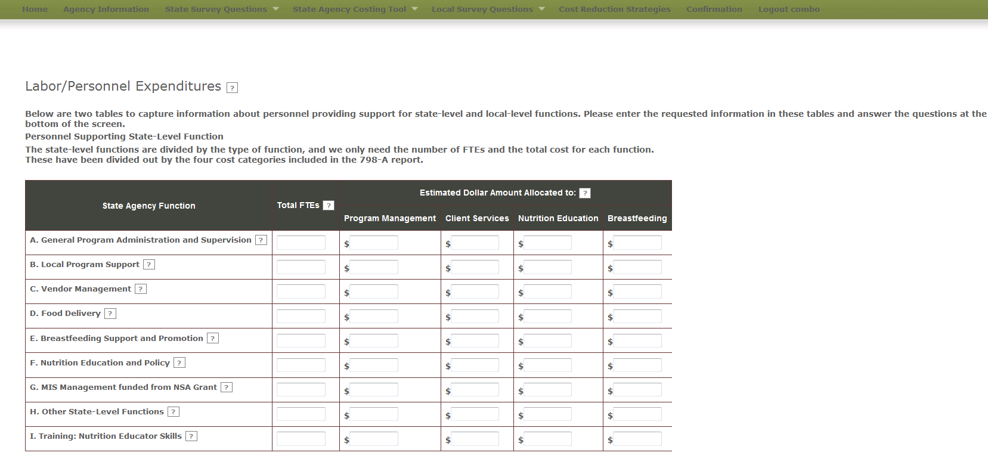

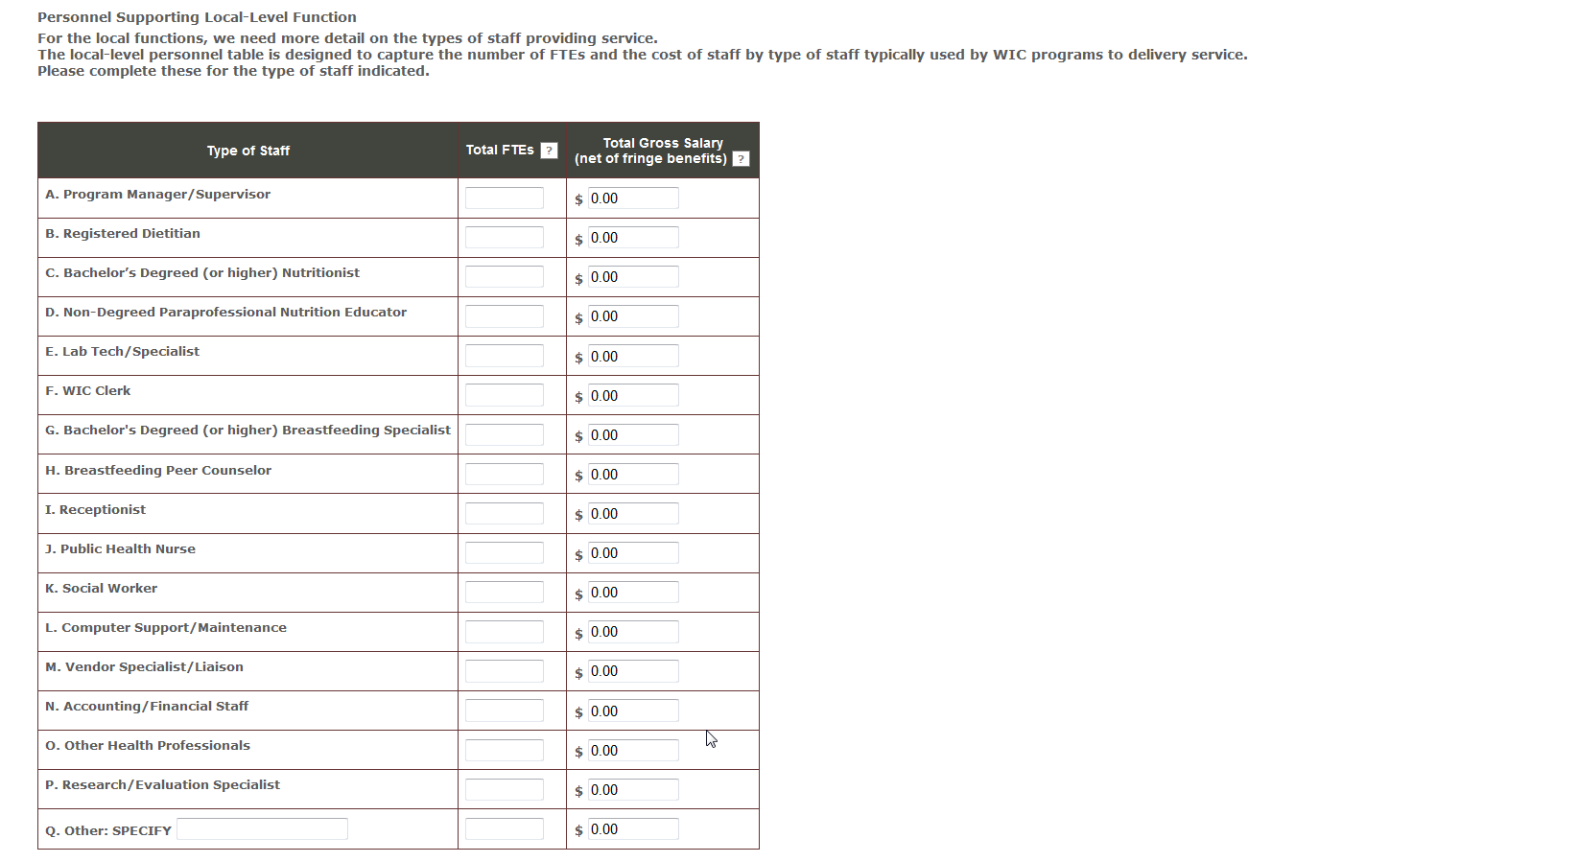

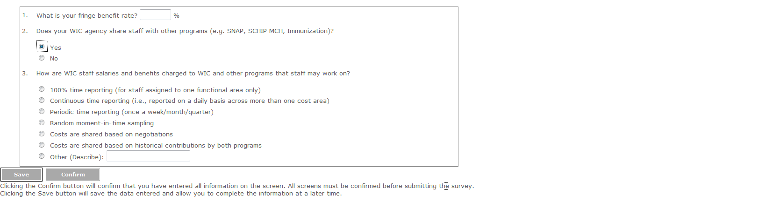

**Exhibit 7: Contracted Services Screen**

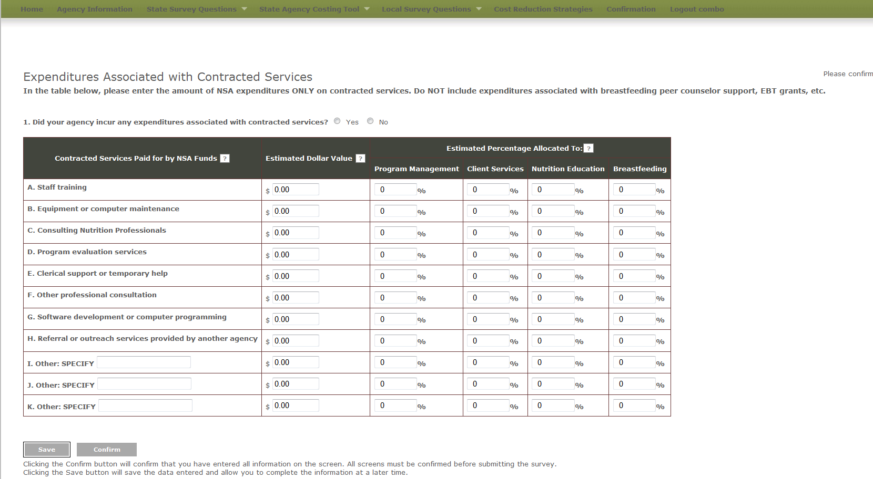

**Exhibit 8: Materials, Services, and Travel Screen**

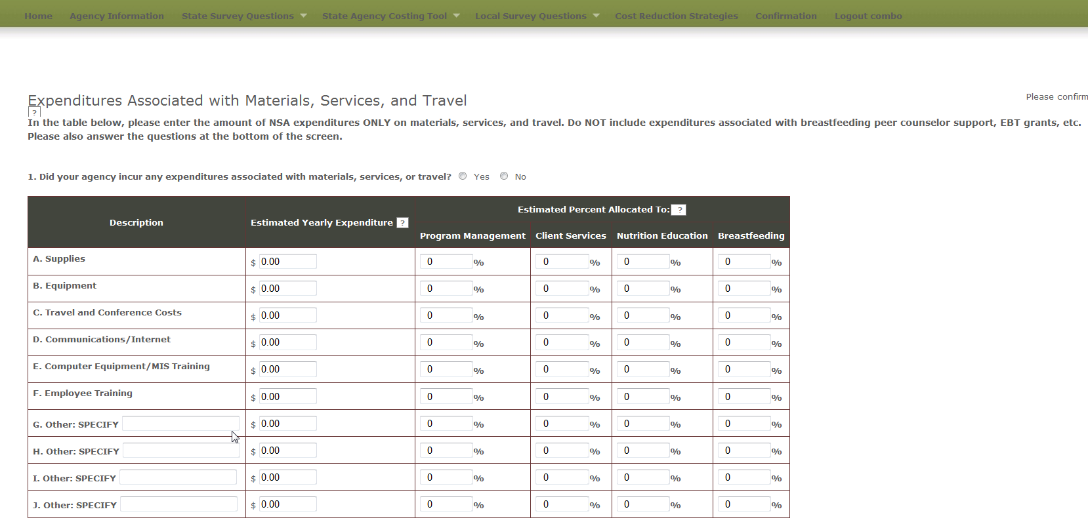

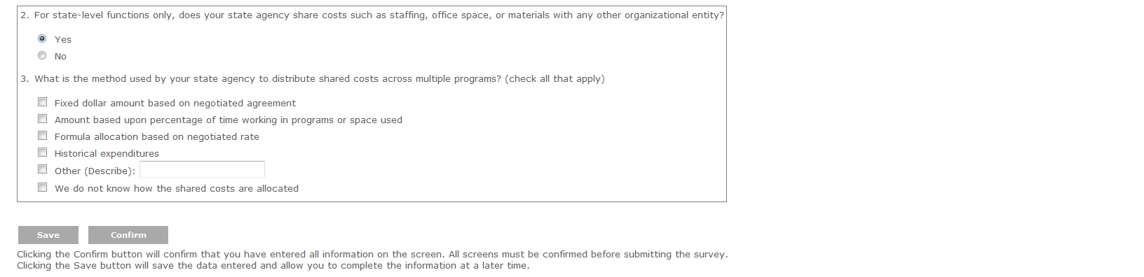

**Exhibit 9: Indirect Costs**

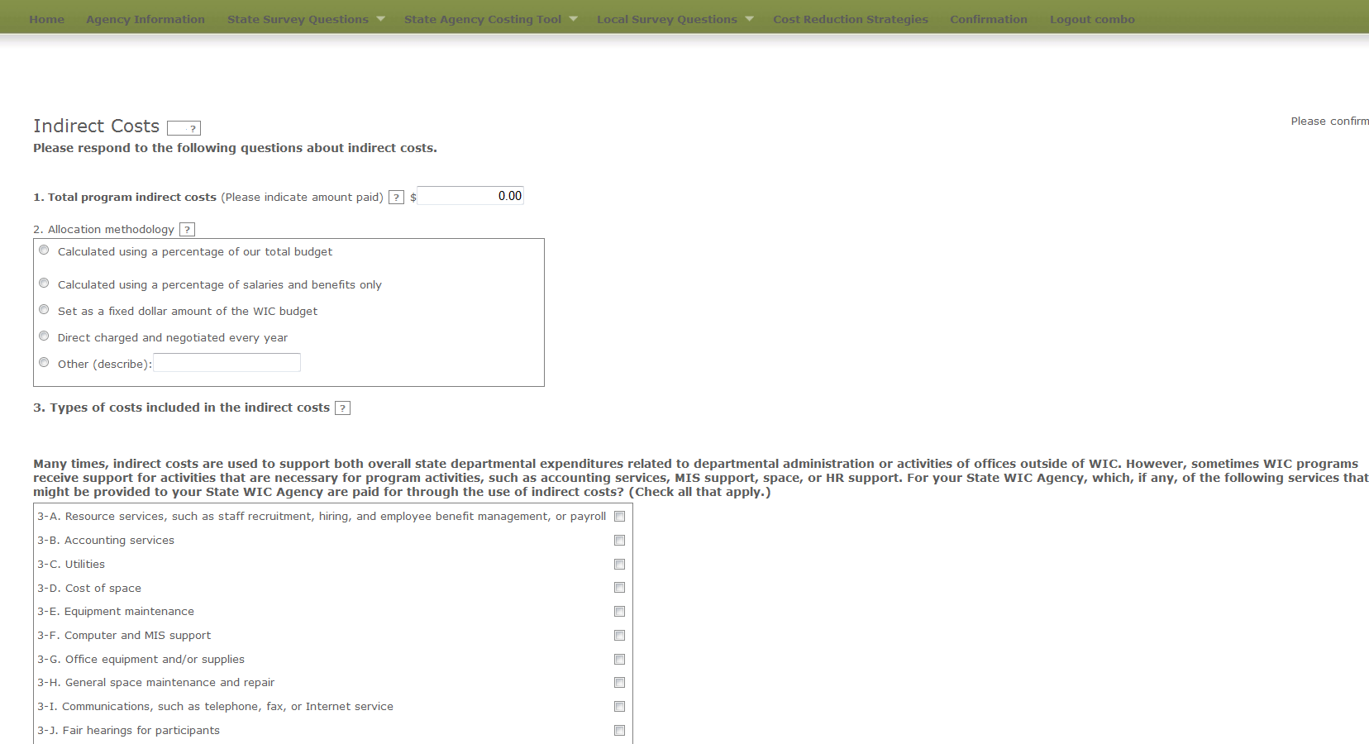

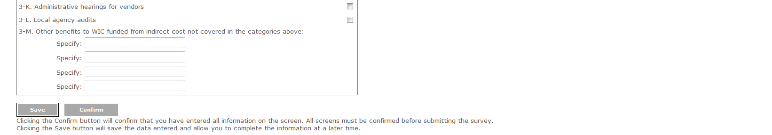

**Exhibit 10: Other Sources of Funds**

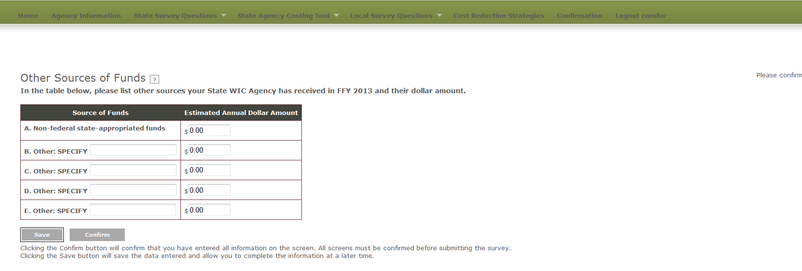

**Exhibit 11: In-kind Contributions**

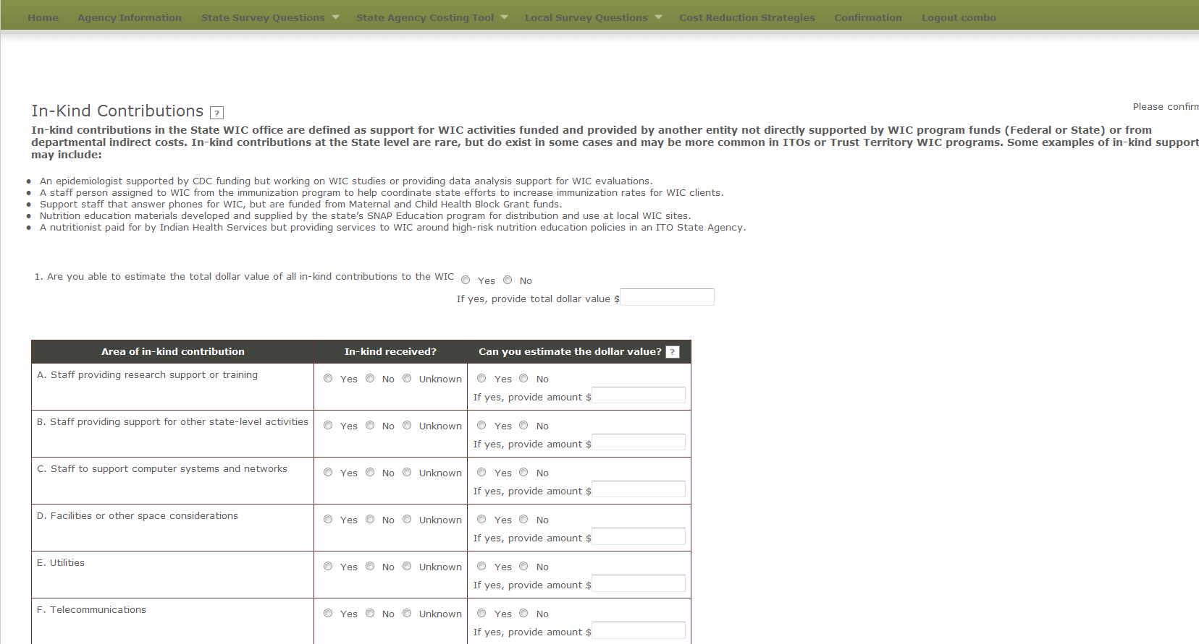

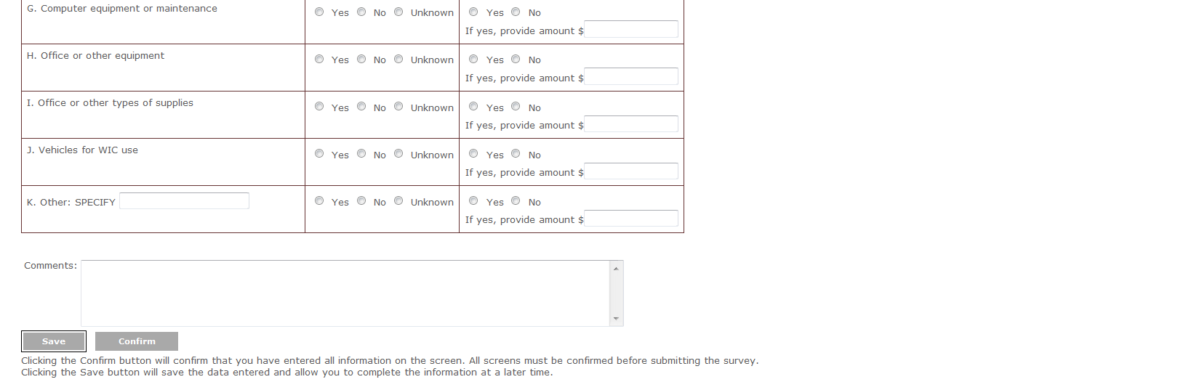

**Local Level Survey Questions**

**Exhibit 12: Demographic Questions Screen**

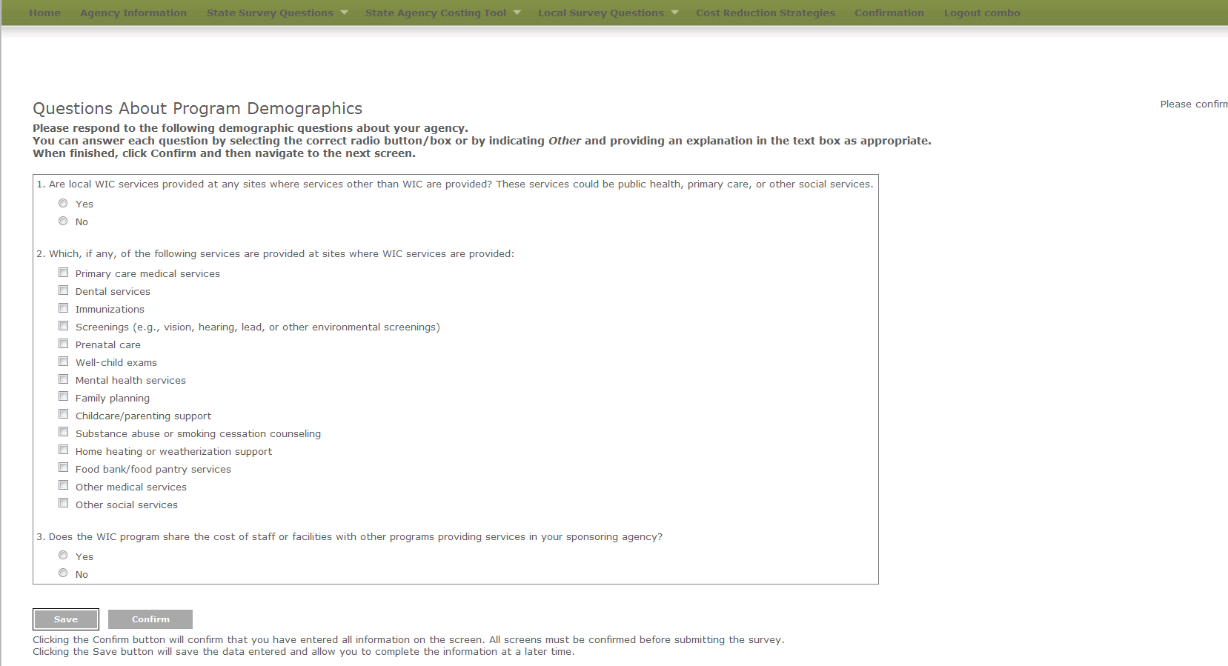

**Exhibit 13: Services Provided Questions Screen**

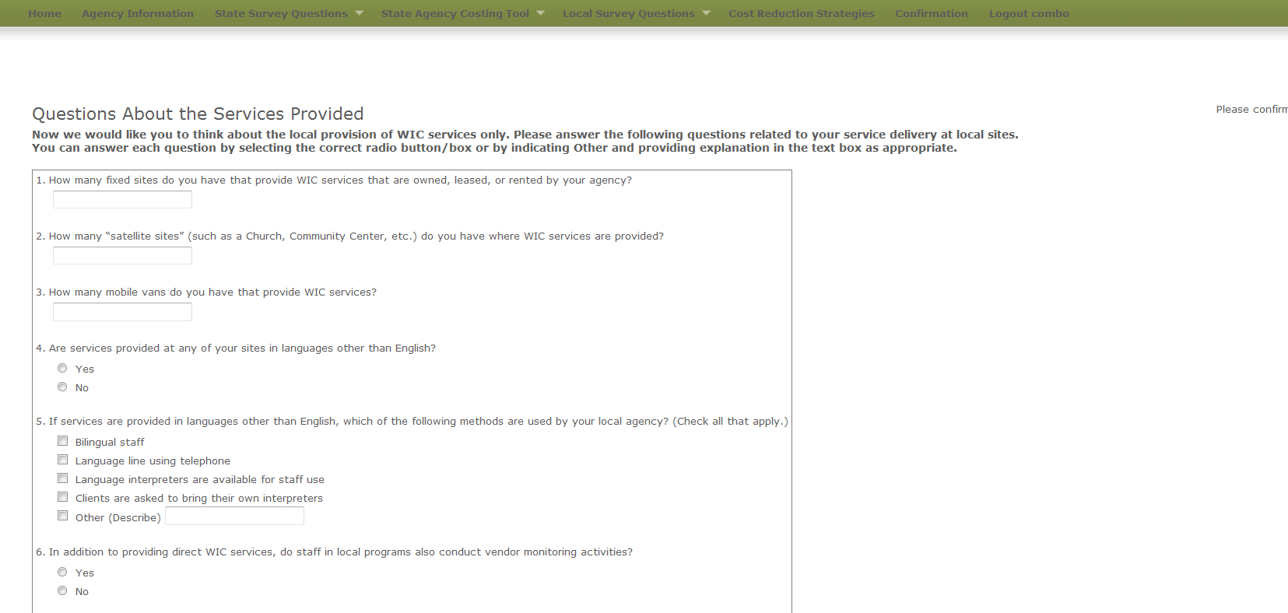

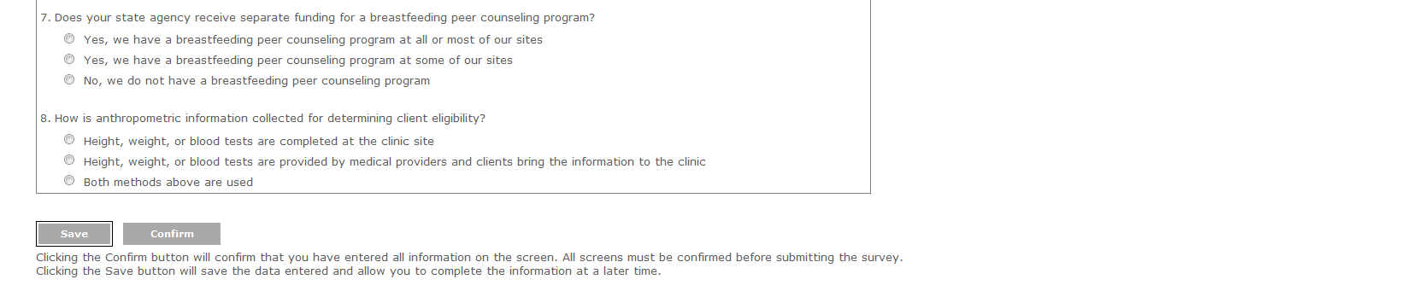

**Exhibit 14: Change in Costs Questions Screen**

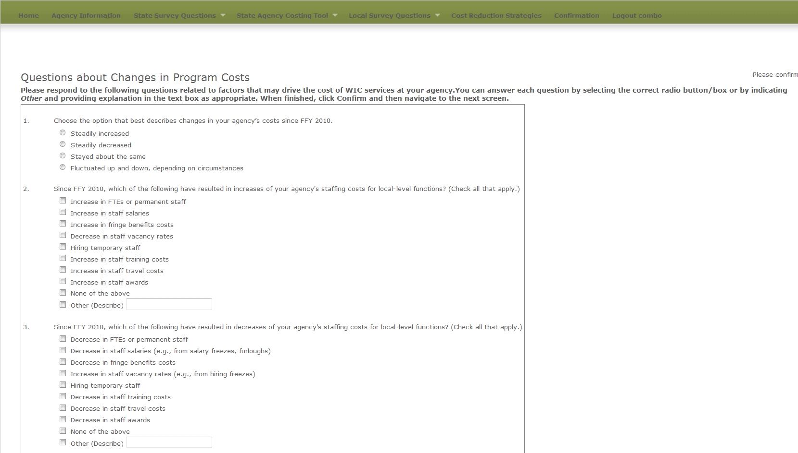

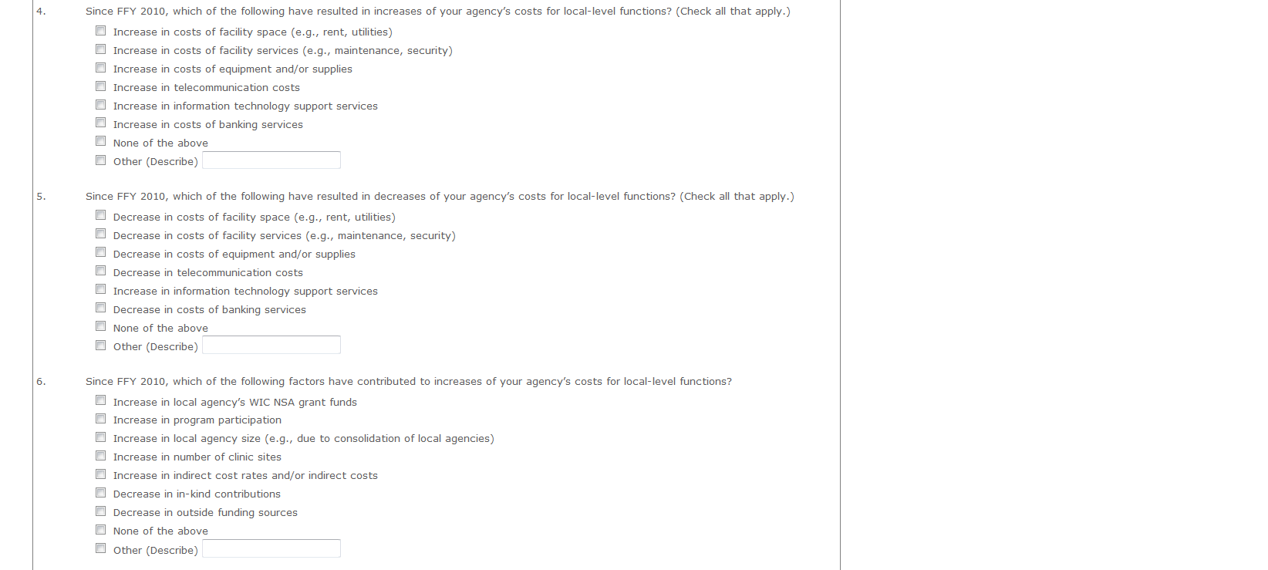

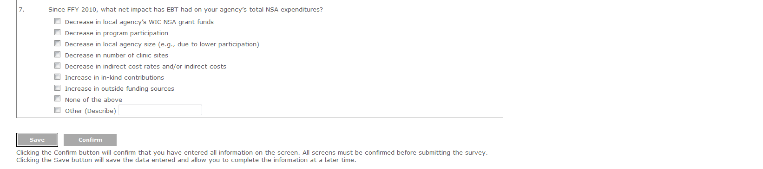

**Exhibit 15: Cost Reduction Strategies**

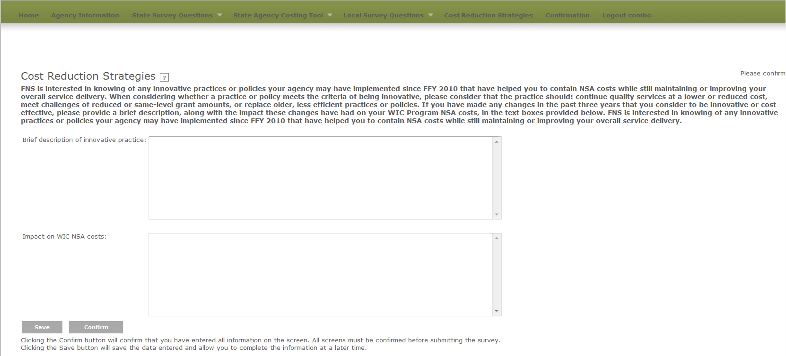

**Exhibit 16 Confirmation Screen**

