
Late 2013 to ► Provide WIC State
Early 2014 Agencies an
overview of data
collection and timeline

Spring 2014 ► Select 14 WIC State Agencies for case studies

► Select 2-3 local agencies in each of the 14 States for case studies

► Select 9 SNAP/TANF state organizations for case studies

Spring 2014 ► Send information to all
State and local agencies about the Web survey that will be used for data collection

► For the agencies selected for case studies, send information about the case study interviews

Spring 2014 to ► Conduct Web survey of all
Summer 2014 state and local agencies

► Conduct interviews for case studies in selected State and local agencies

Fall 2015 ► Submit final report to FNS
Who is conducting this study?
When is the study being conducted?

Under contract with USDA/FNS, Altarum Institute is the coordinating contractor leading the study team, which includes RTI International.



Where do I get more information?

Email questions to NSAcoststudy@altarum.org

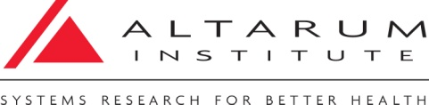

OMB Control Number: 0584-XXXX
Expiration Date: XX/XX/XXXX

WIC plays a critical role in the nutrition and health of over 9 million women, infants
and young children.

To better understand the important role of Nutrition Services and Administration (NSA) costs in providing program services, USDA is conducting a national

WIC NSA
Cost Study

USDA’s Food and Nutrition Service is sponsoring this study to gather information about how NSA funds are used by State and local WIC agencies and to evaluate the impact of recent program changes on NSA costs.

How will the study be conducted?
What is the purpose of the study?

WIC participants receive nutrition education and food benefits, a combination of WIC services that are provided through different funding streams. WIC Nutrition Services and Administration (NSA) funds are used to finance services in four cost categories: 1) program management, 2) client services, 3) nutrition education; and 4) breastfeeding promotion.

The last WIC NSA study of this nature was conducted was in 2000. Since then, numerous WIC program changes have occurred. FNS is interested in understanding the various ways in which NSA grant funds are utilized, the range of operations covered by NSA funds, and the impact of program changes on NSA grant funds.

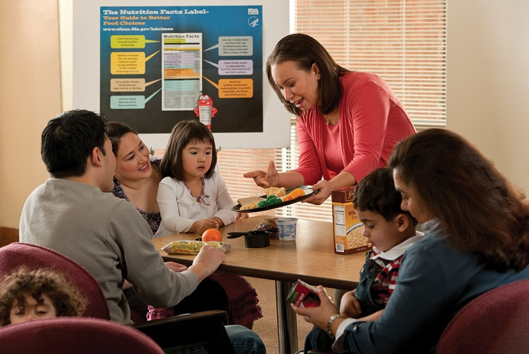

This study will be important for informing decision-makers about the full range of valuable services that are performed with WIC NSA funds. It will also provide insight into how NSA funds are used in each of the diverse WIC settings throughout the nation.

The specific objectives of the study are:

- To gather and analyze data on the NSA grant system in order to better understand NSA costs at the State and local level.
- To understand how State Agencies utilize NSA funds to provide services, how funds are provided to local agencies, and the extent to which expenses are shared with other programs.
- To determine the impact of increased use of technology, particularly MIS and EBT, on NSA costs.
- To identify the effect of economies of scale between larger and smaller WIC programs.
- To compare administrative costs in WIC and other federal programs, such as SNAP and TANF.

All State and local WIC agencies throughout the nation and

US territories are being asked

to participate in this study.

The study team will collect data on NSA costs from a variety of sources, including:

- FNS 798 and 798-A for FFY 2013
- Supporting documentation from local agencies that was used to complete the FNS 798-A for FFY 2013
- A Web survey of all WIC State Agencies and local agencies;
- Interviews from case studies in 14 State Agencies and local agencies within those States; and
- Interviews from case studies in 9 SNAP and TANF organizations.

Consulting with the Advisory Panel
An Advisory Panel of 10 WIC program and research experts has been convened to support the study. The Advisory Panel will provide feedback on the data collection instruments, encourage full participation of their colleagues
at the State and local level, and review the
final report.


