Reviewer Recruitment Module (RRM)

Screen Captures version 1.0

Developed for HRSA

By LCG, Inc

v. 1.0

November 01, 2013

RRM 1.007

cid:image001.png@01CE20BC.CD98D990cid:image001.png@01CE20BC.CD98D990

Contents

RRM Portal Page 3

Account Profile Home 4

Account Creation – Provide Email Address 5

Enter Verification Code – Sent to Email Address 6

Enter Name, Login Name, Password, and Security Question 7

Enter Personal Information 8

Select Expertise Codes and Answer Profile Questions 9

Upload Resume and Type/Paste Details 10

Manage Resume – Download, Add, and Delete 11

Snapshot of Profile Status 12

Manage Account Security 13

Change Email Address 14

Change Password 15

Change Security Question/Answer 16

**Public Burden Statement:** An agency may not conduct or sponsor, and a person is not required to respond to, a collection of information unless it displays a currently valid OMB control number.  The OMB control number for this project is 0915-0295.  Public reporting burden for this collection of information is estimated to average 0.5 hours per response, including the time for reviewing instructions, searching existing data sources, and completing and reviewing the collection of information. Send comments regarding this burden estimate or any other aspect of this collection of information, including suggestions for reducing this burden, to HRSA Reports Clearance Officer, 5600 Fishers Lane, Room 10-29, Rockville, Maryland, 20857.

# RRM Portal Page

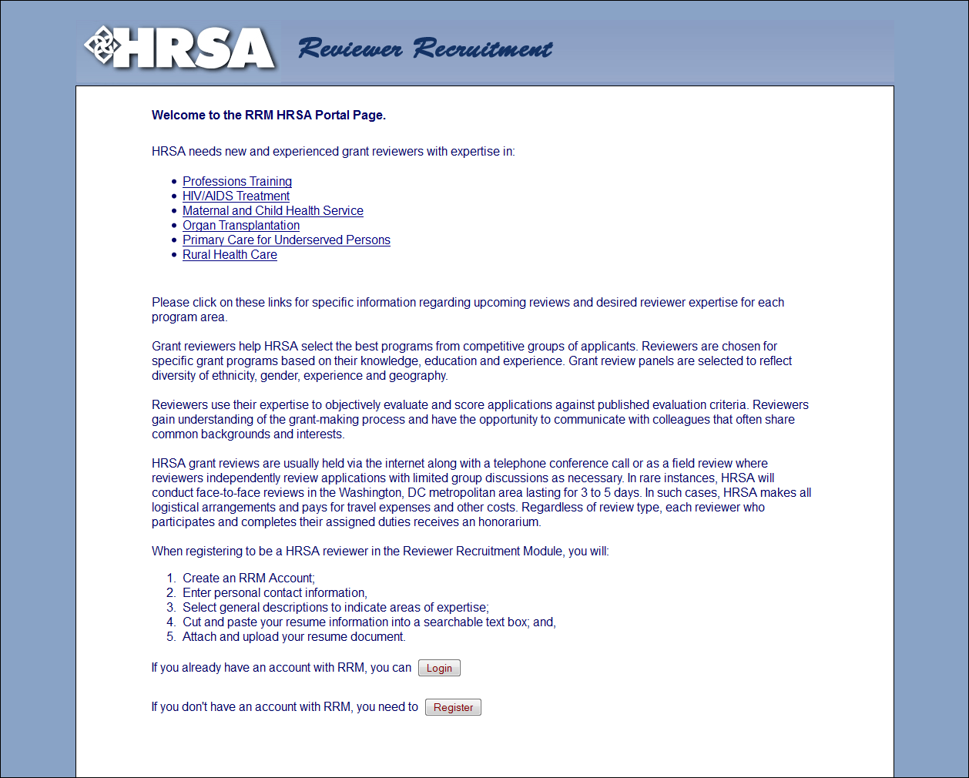

# Account Profile Home

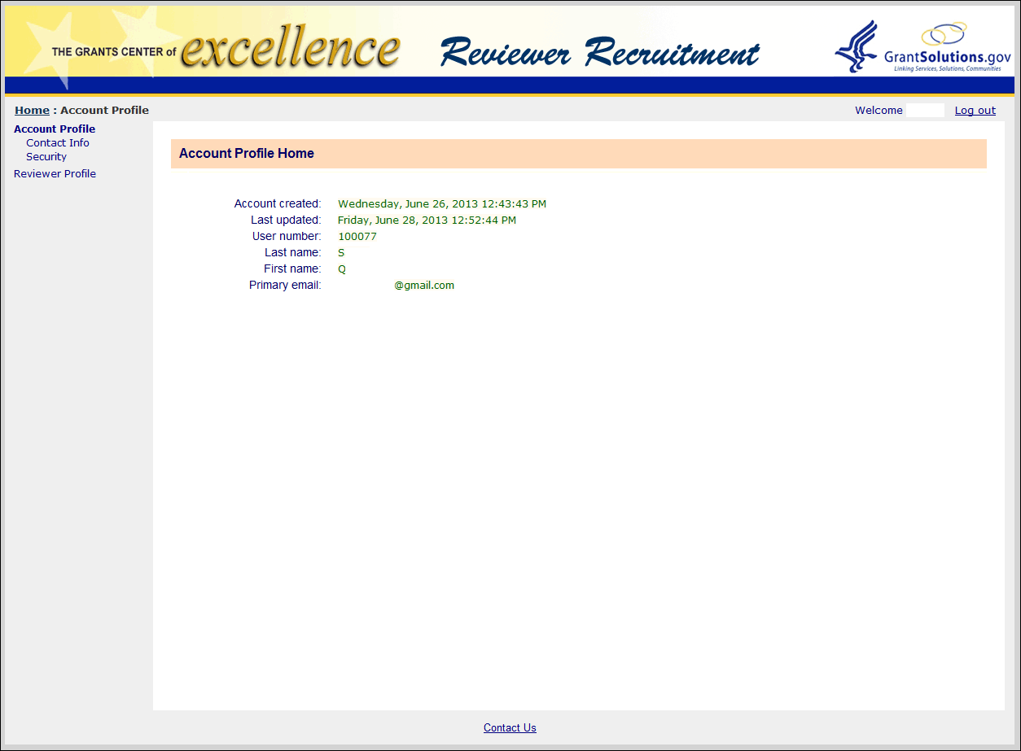

# Account Creation – Provide Email Address

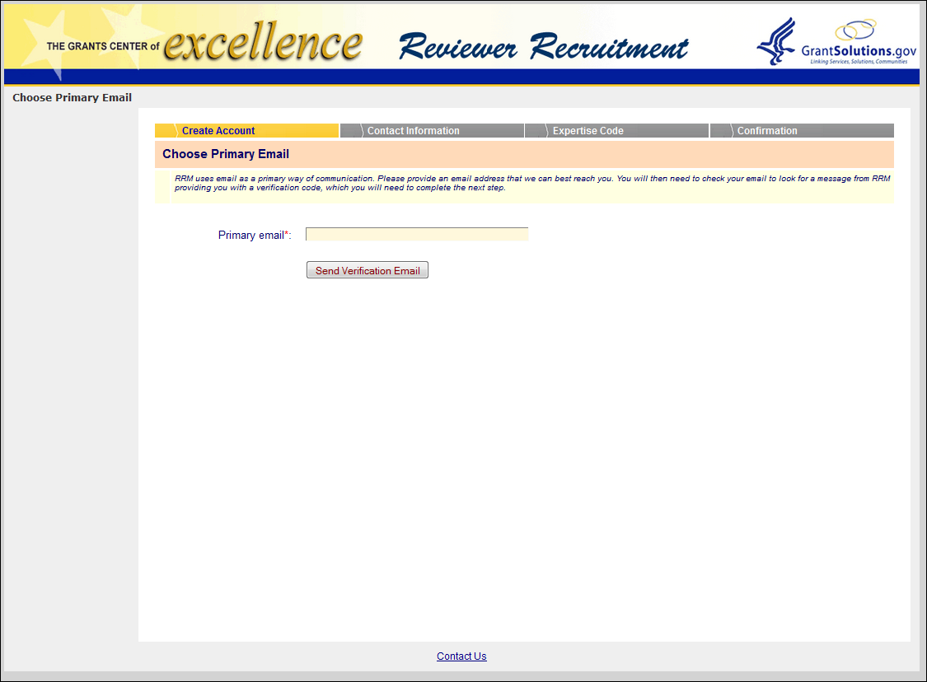

# Enter Verification Code – Sent to Email Address

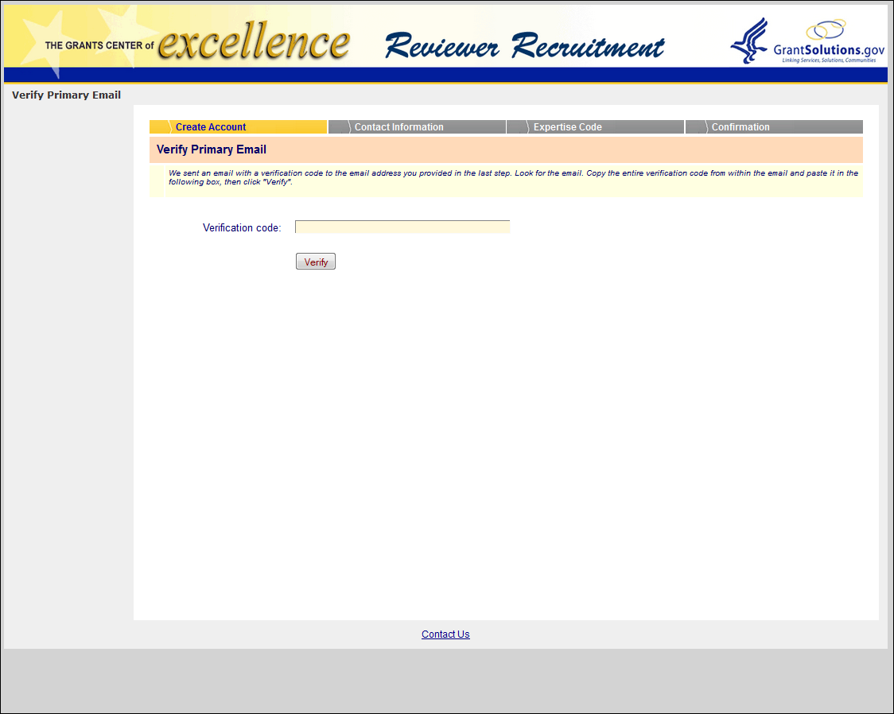

# Enter Name, Login Name, Password, and Security Question

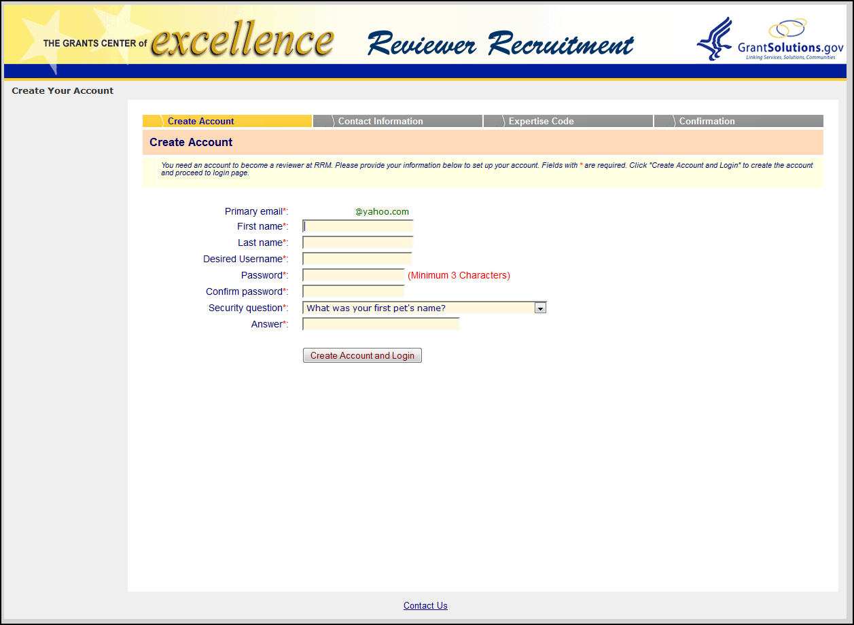

# Enter Personal Information

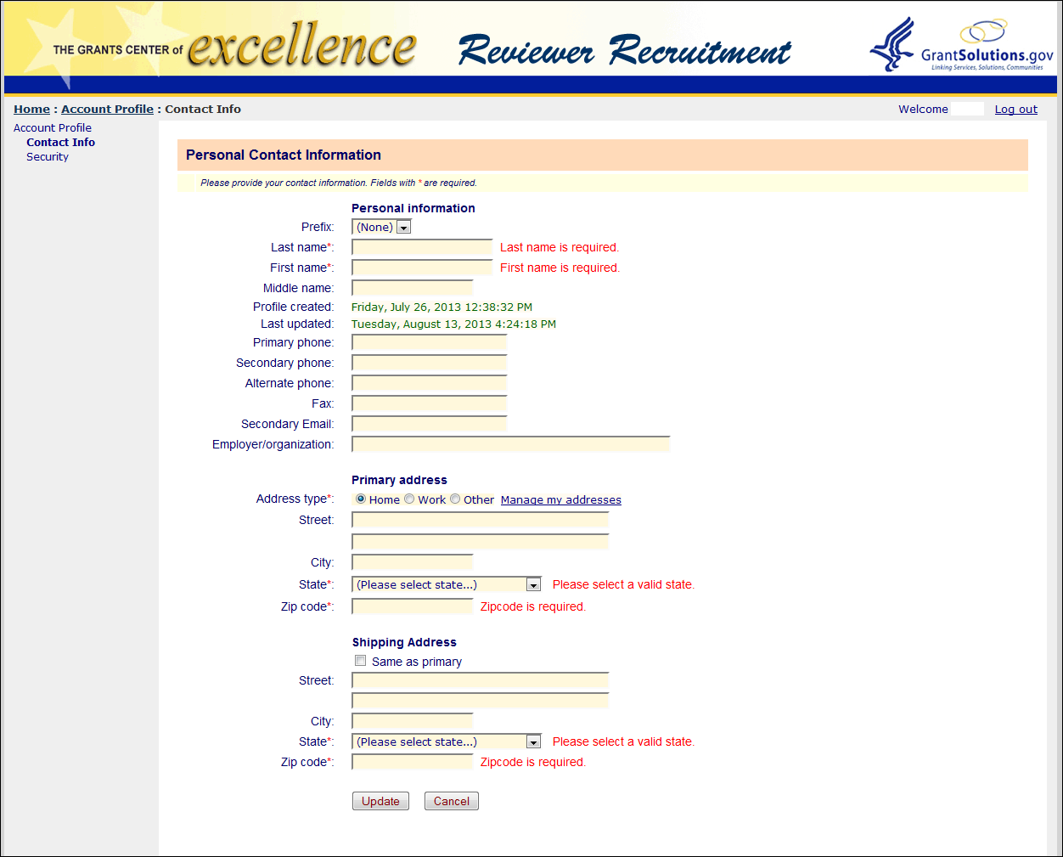

# Select Expertise Codes and Answer Profile Questions

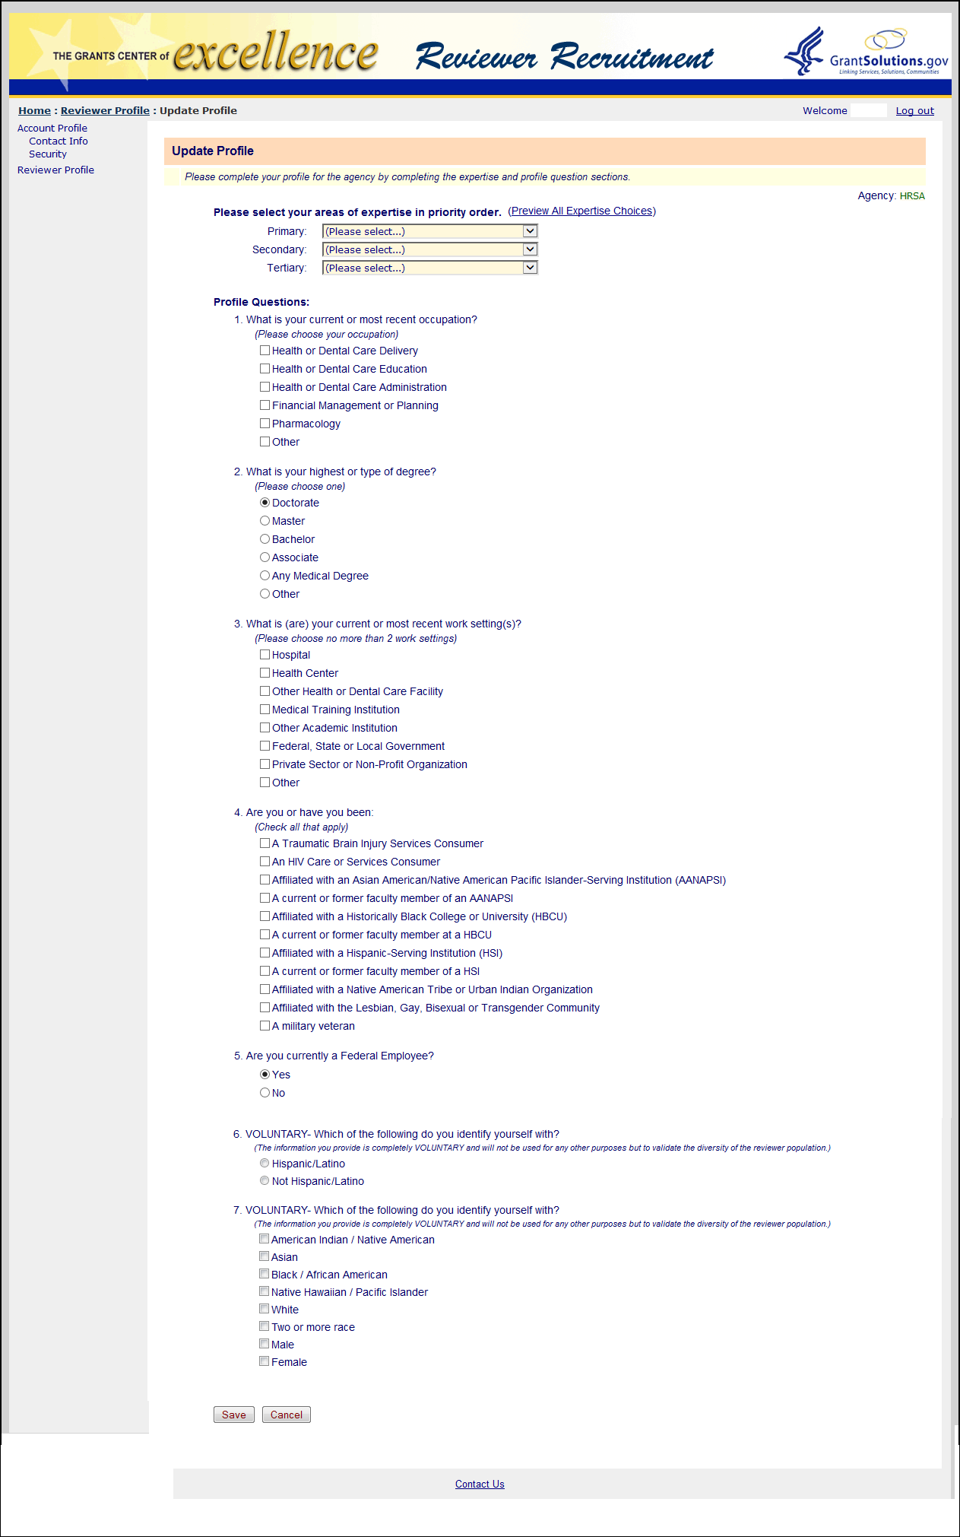

# Upload Resume and Type/Paste Details

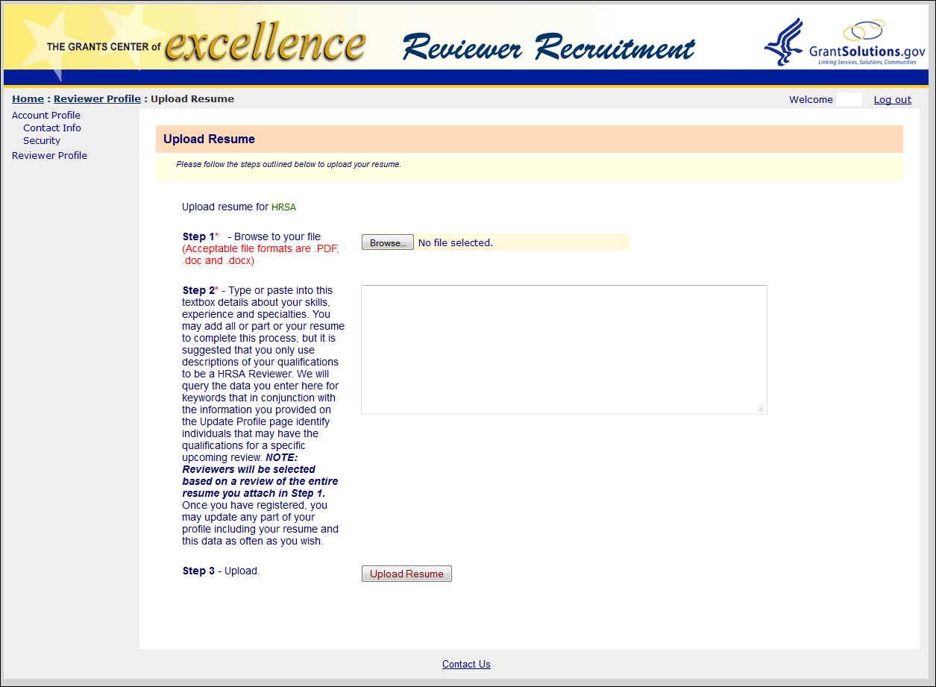

# Manage Resume – Download, Add, and Delete

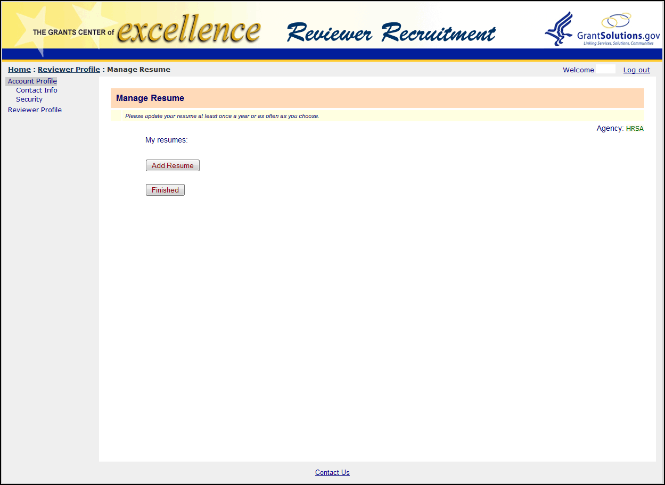

# Snapshot of Profile Status

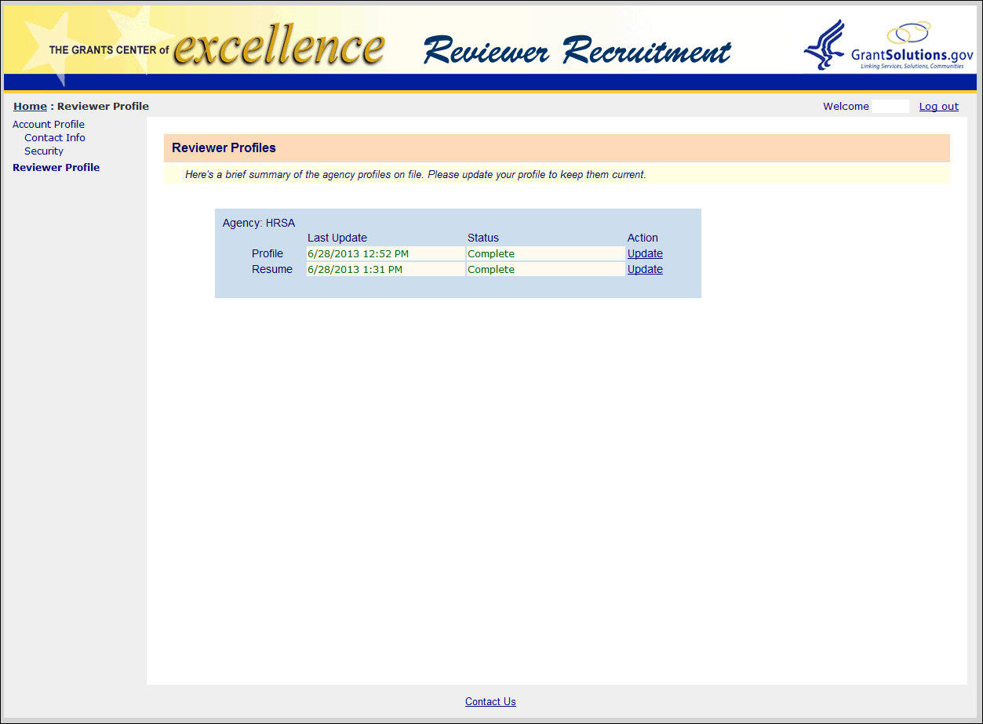

# Manage Account Security

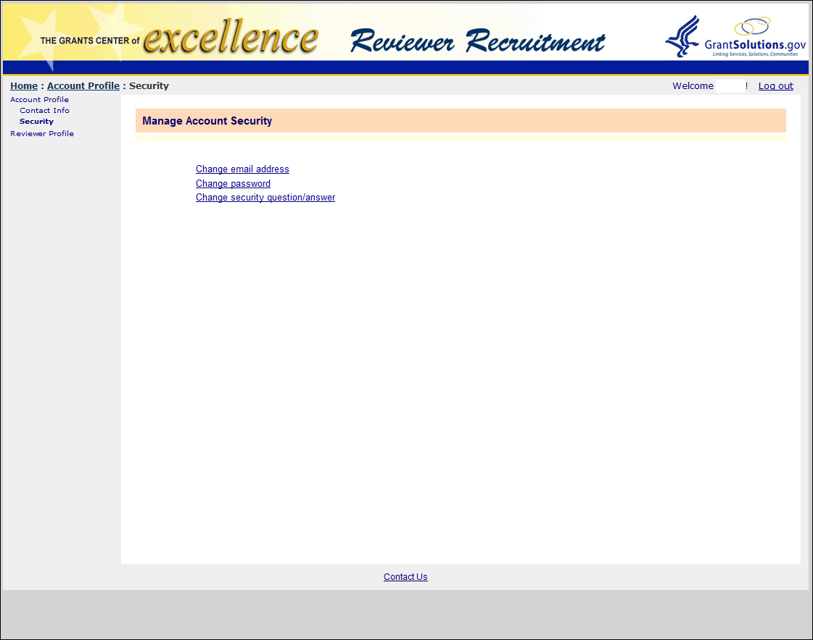

# Change Email Address

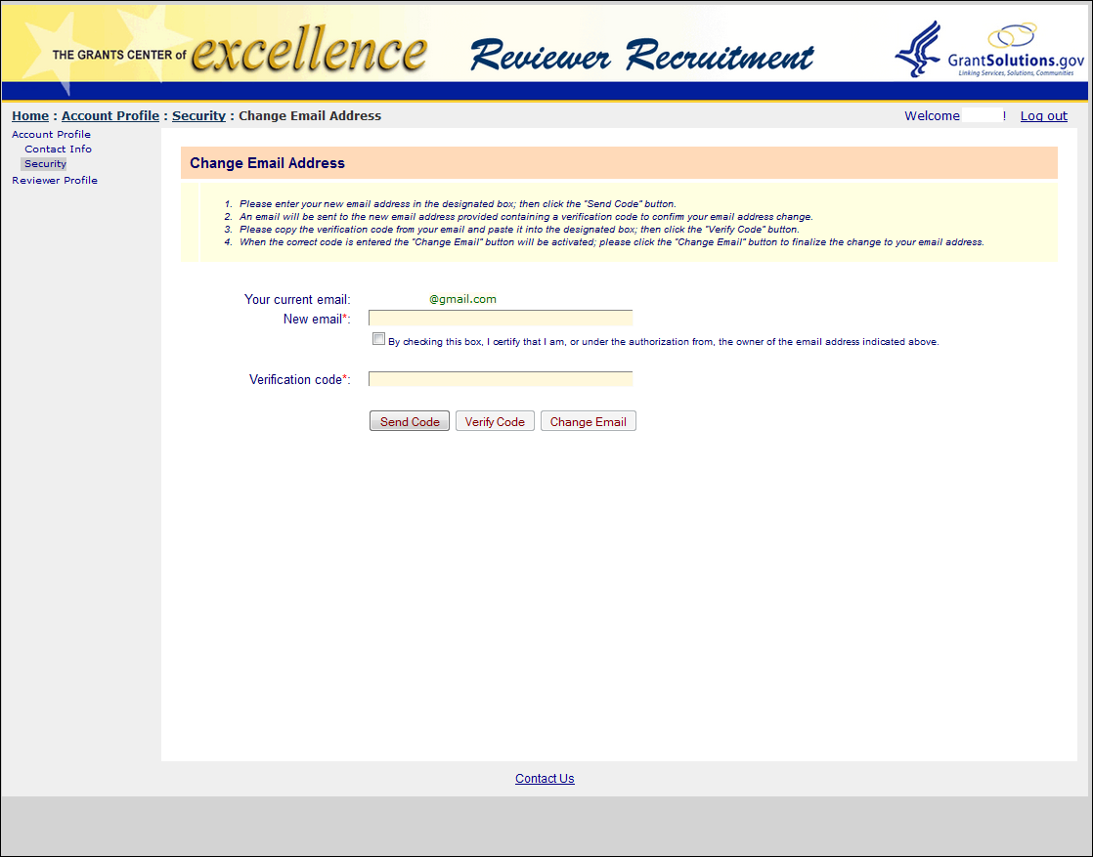

# Change Password

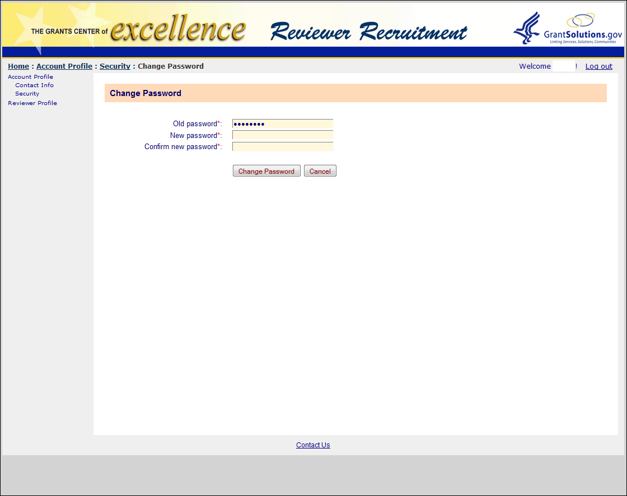

# Change Security Question/Answer

