Online Form for Updating an Existing Record – Screen Shots
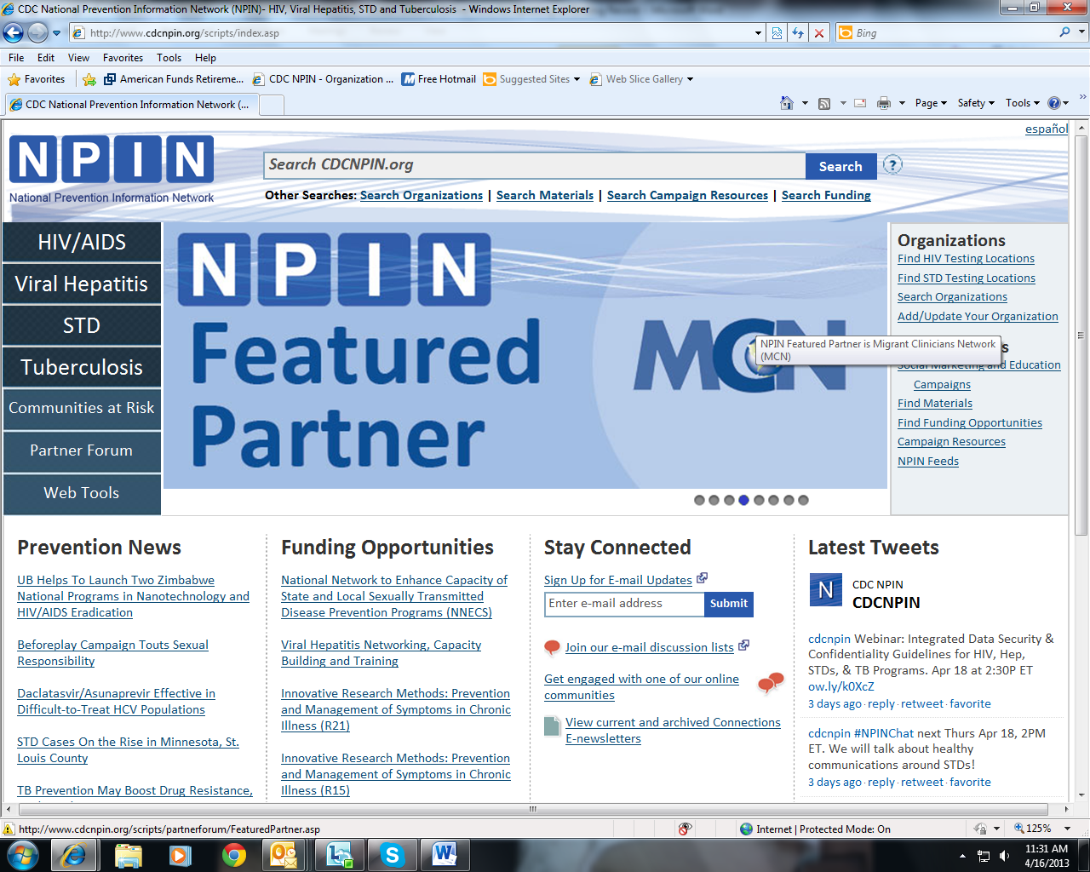
User clicks Search Organizations to search for his organization.
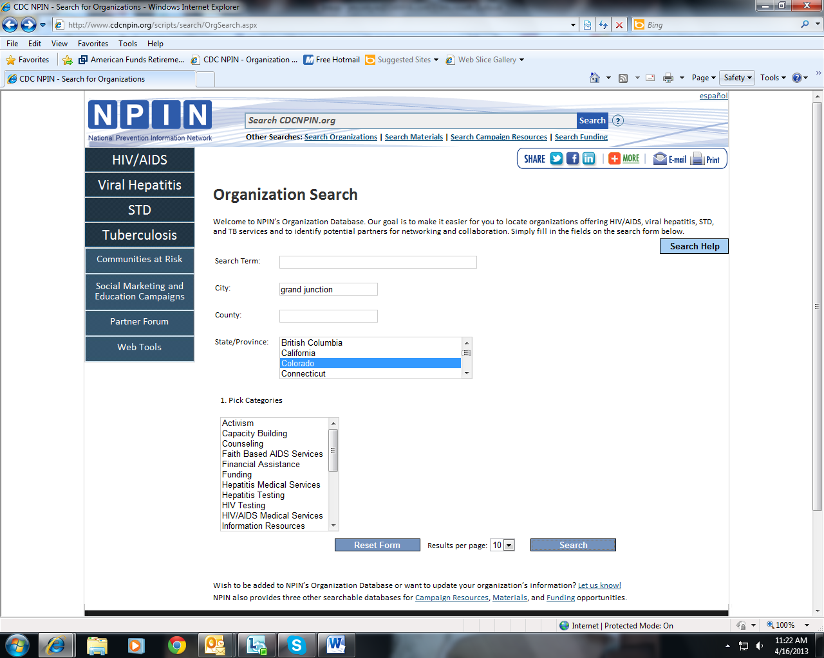
User enters search criteria and clicks Search.

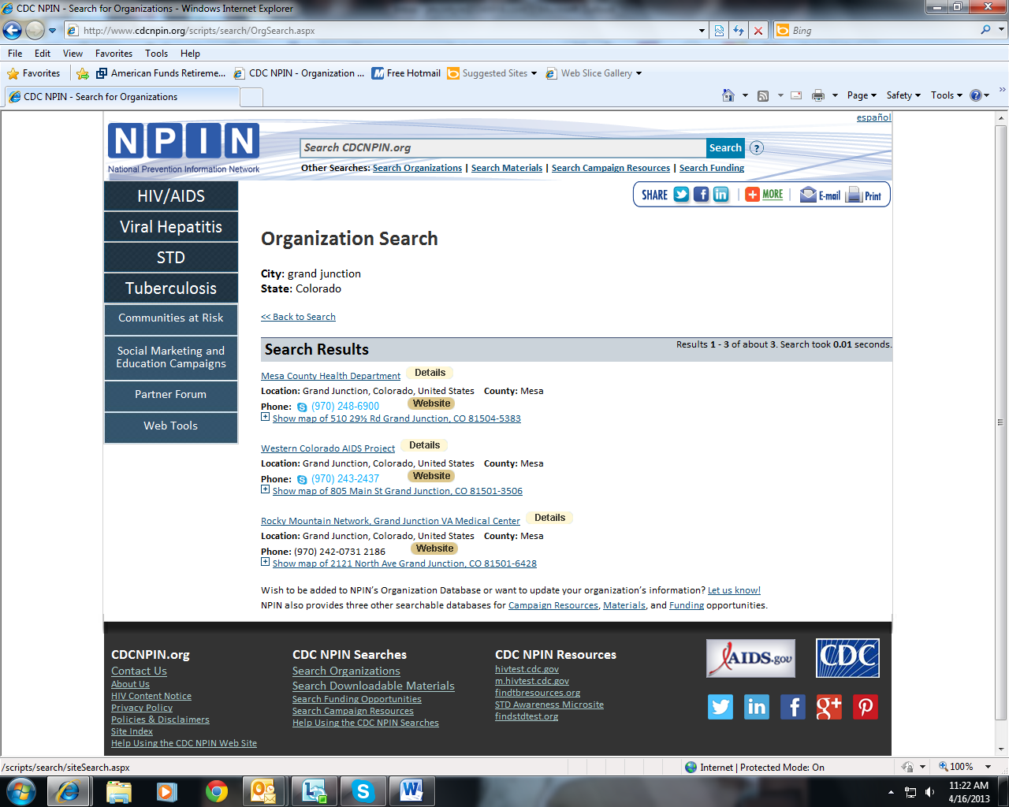
User reviews search results, locates his organization, and clicks on the Details link.
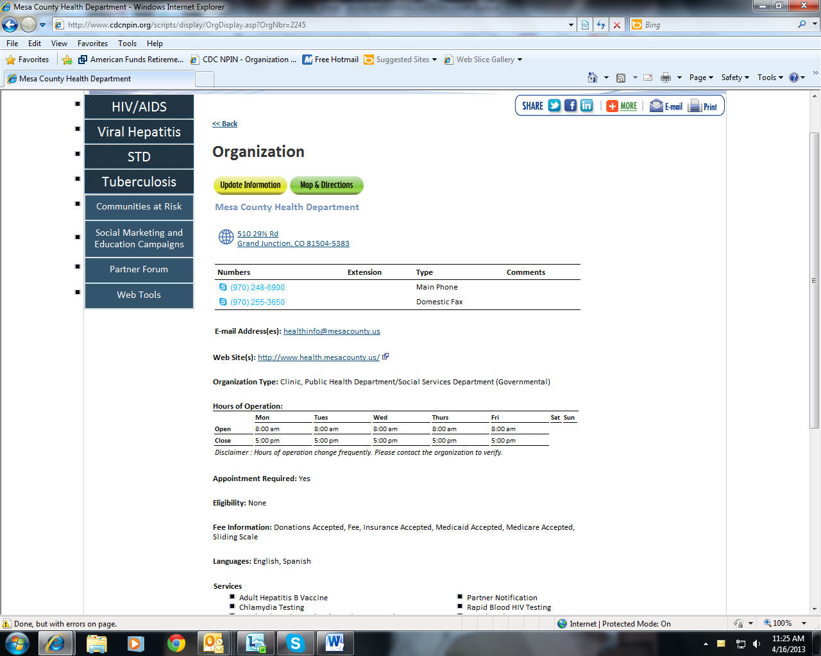
Once a user locates their organization on the search results and clicks on the details page, they will see a yellow “Update Information” button. Clicking this button will load the update form pre-populated with the information currently in the database for this organization.
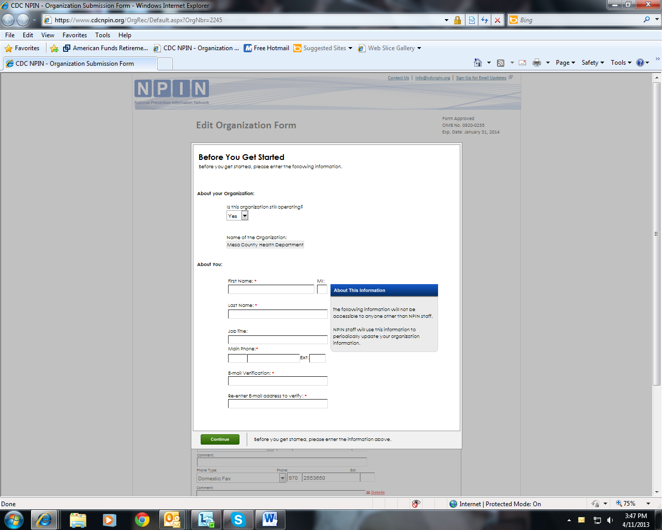
The first screen of the form is for entering contact information for the form submitter and indicating whether the organization is still in operation.
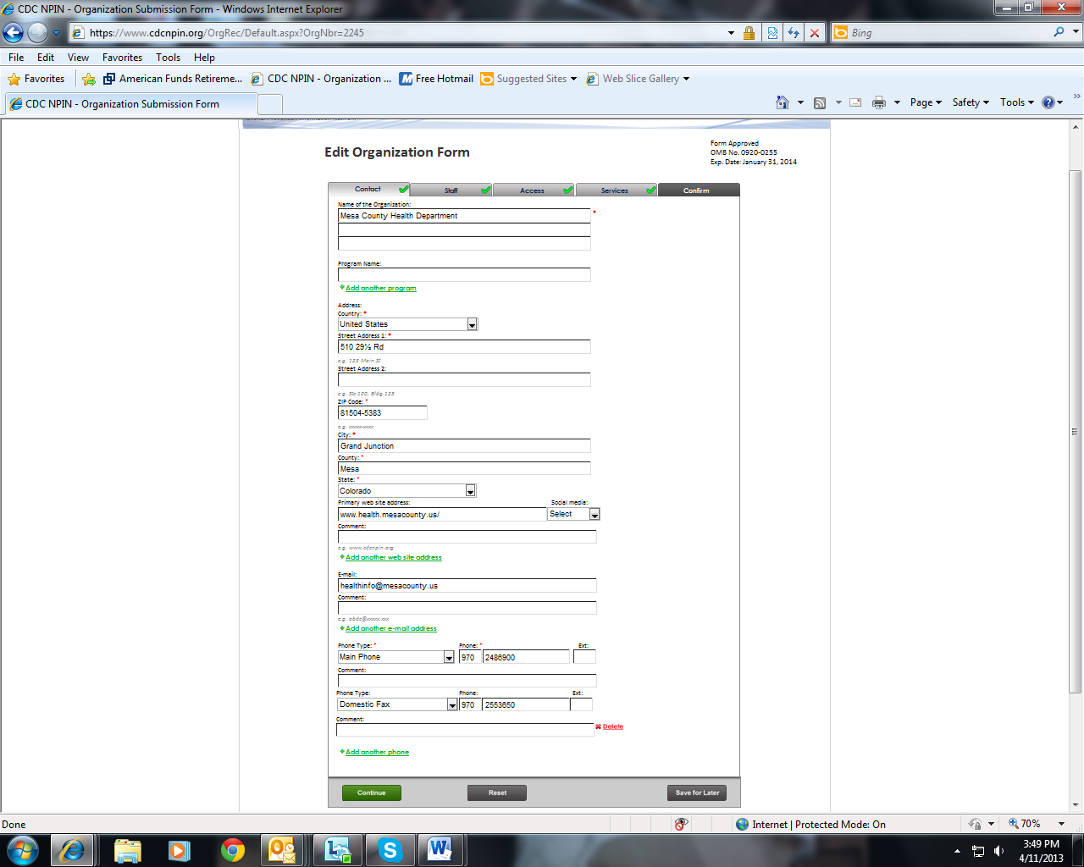
The form is divided into five sections. Check marks on each tab indicate to user that all required information is entered.
Users can edit any information that is incorrect or needs updating.
The first tab, Contact, displays information about contacting the organization.
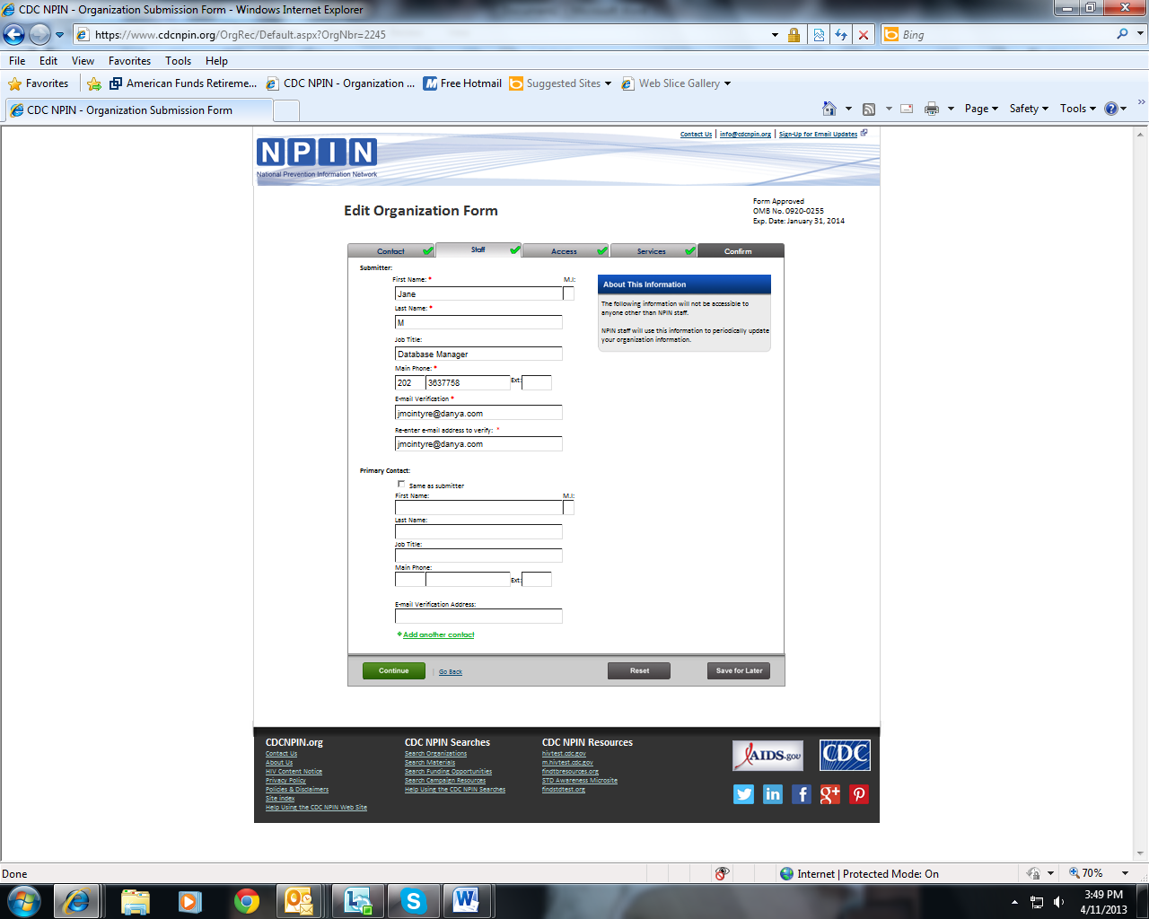
The second tab, Staff, is used to enter information about the form submitter and the person who will be the primary contact for this organization.
Error messaging is provided to assist users in proper completion of the form.
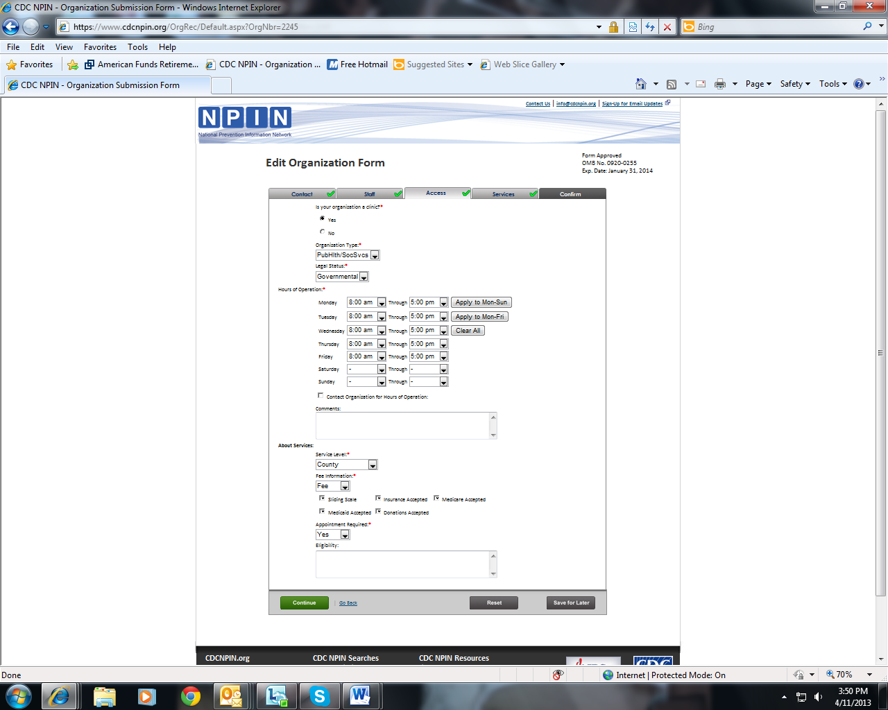
The third tab, Access, contains information about the organization type, hours of operation, and fees.
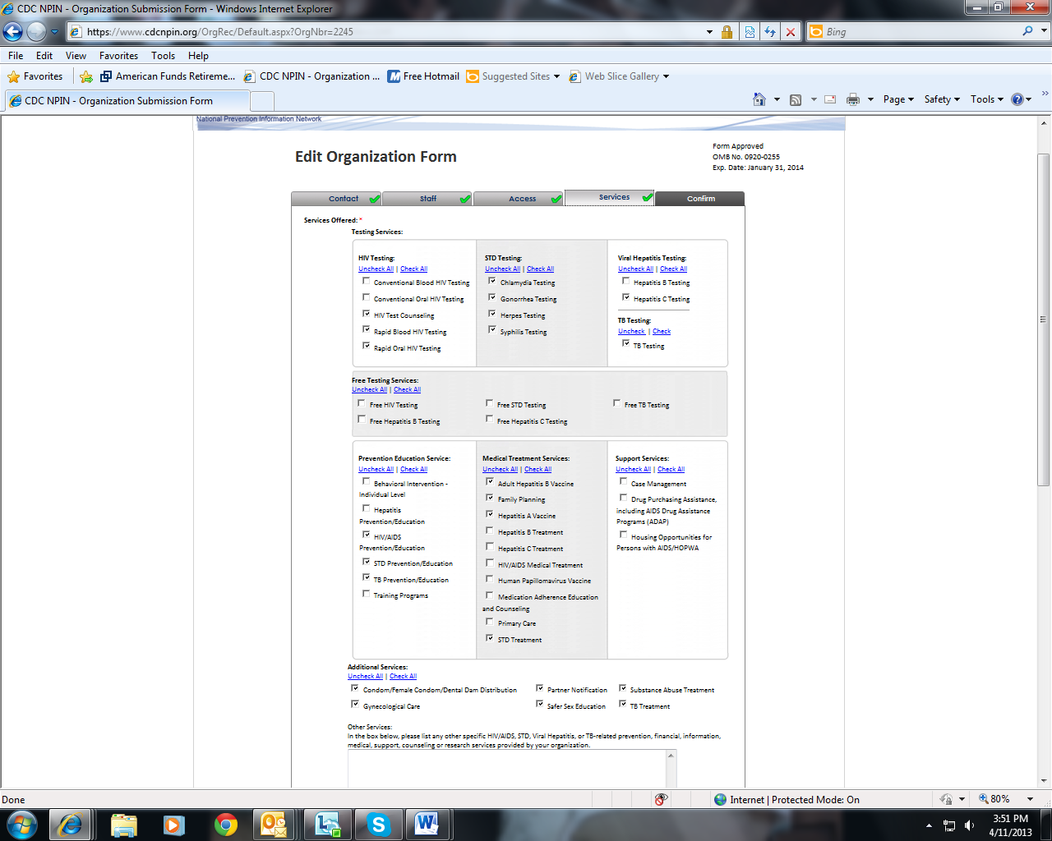
The fourth tab, Services, enables users to indicate the services offered by their organization.
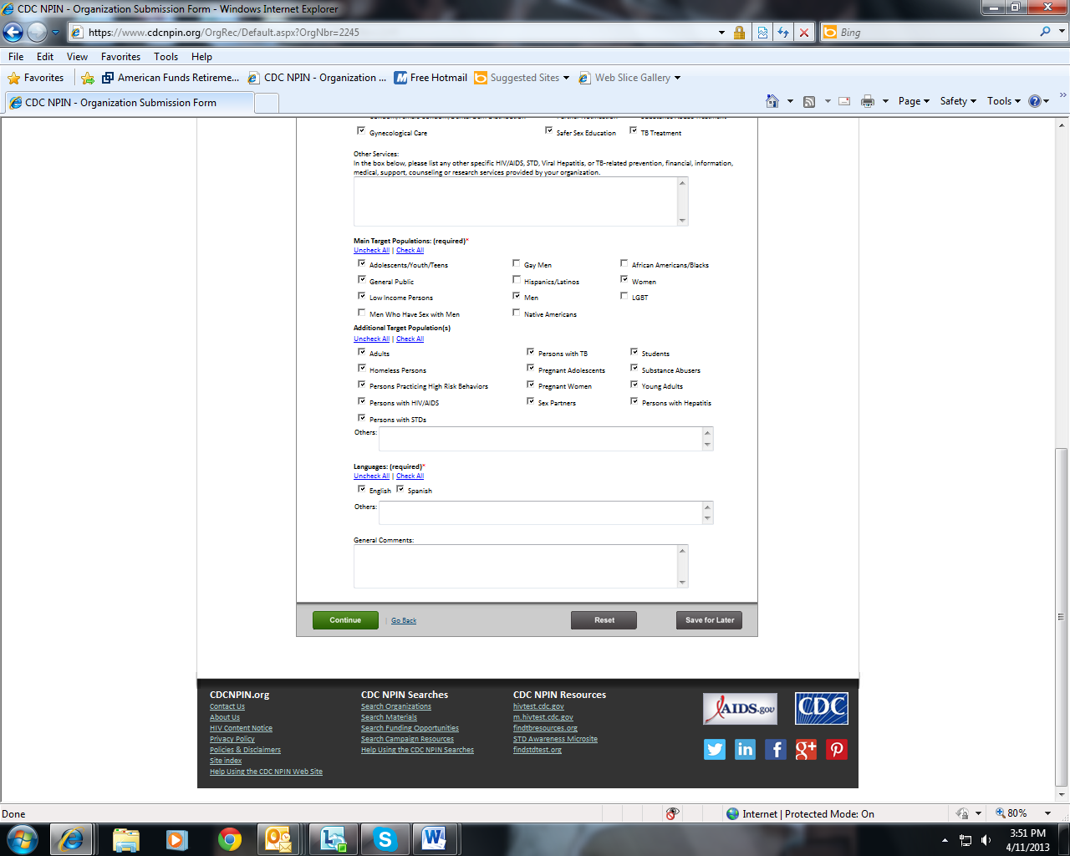
The Services tab also captures information about the audiences served by the organization and the language services that they provide.
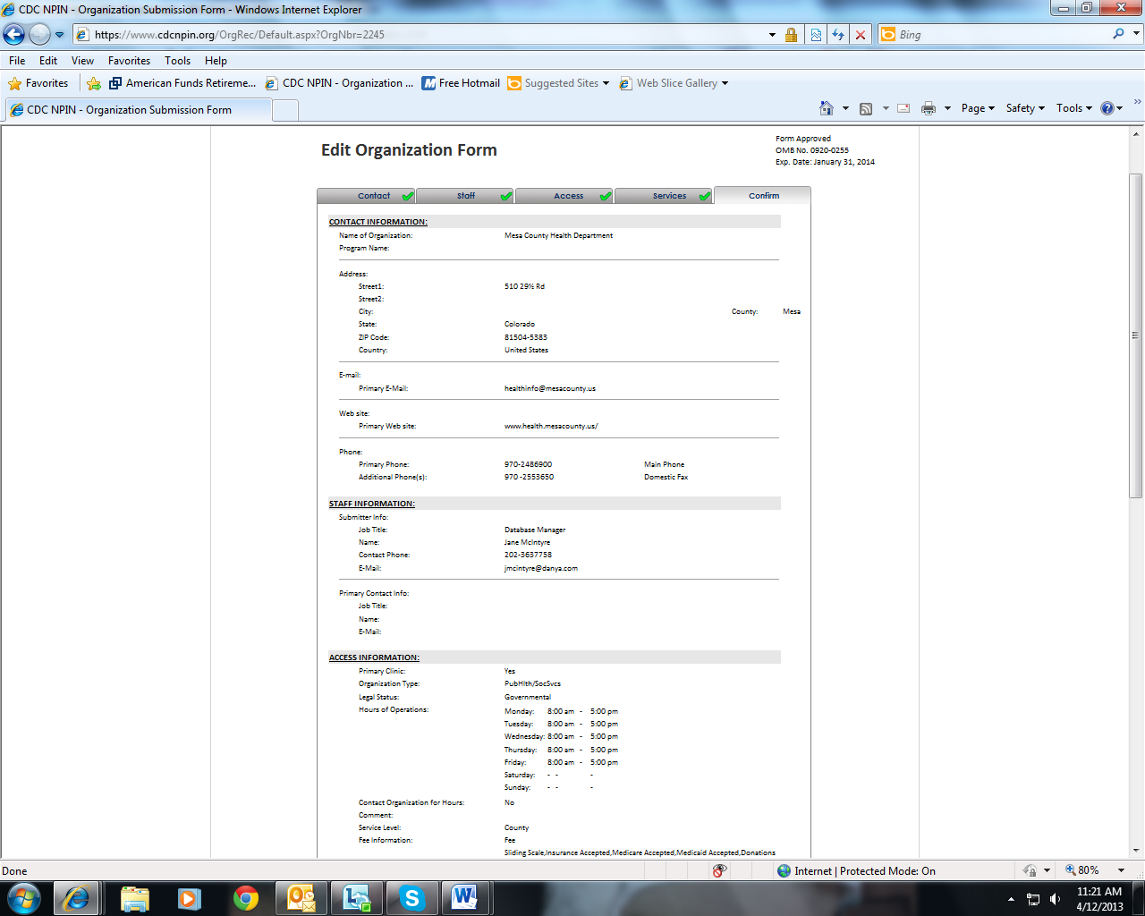
The final tab, Confirm, displays all of the information as entered by the submitter so that it can be reviewed for accuracy.
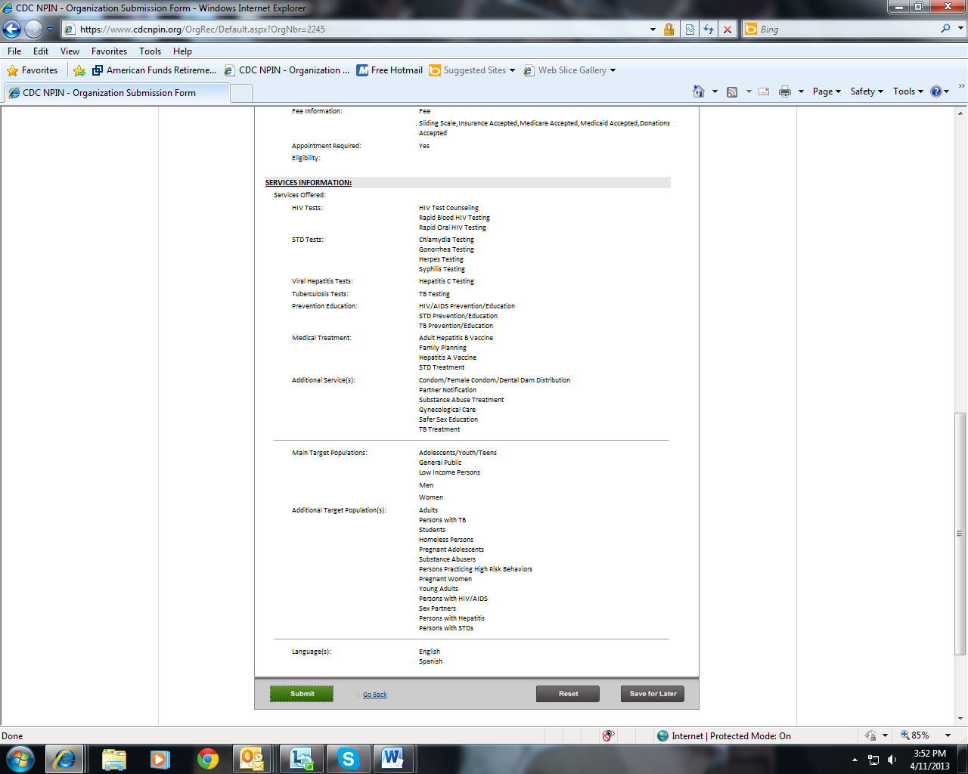
If the user needs to stop before completing the form, they can click the Save for Later button, which saves the information already entered, and go back to the form at their convenience.
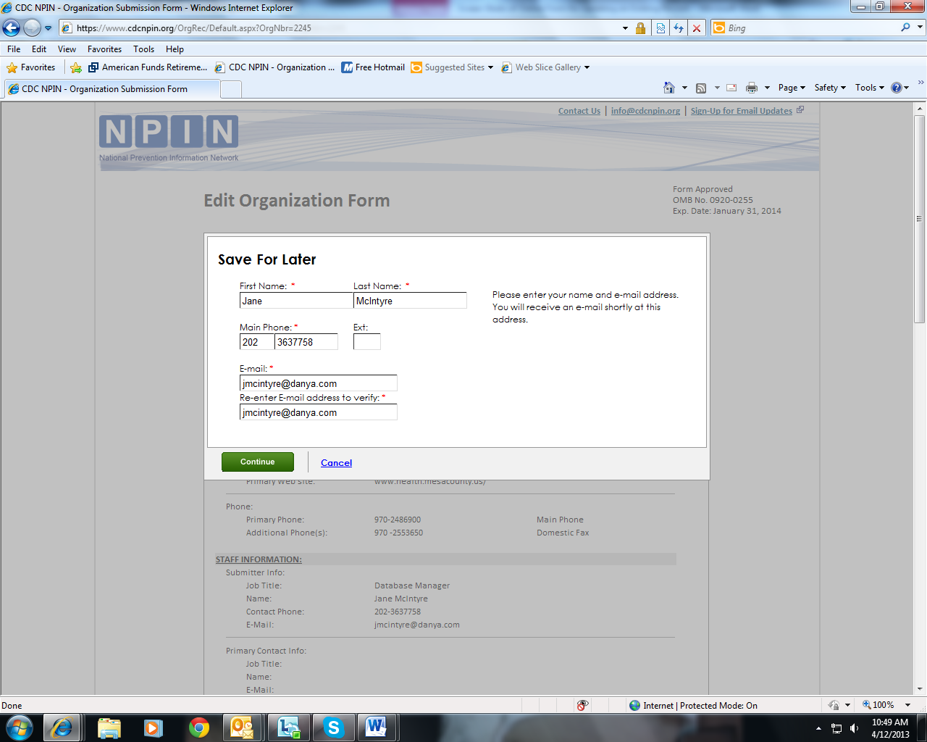
If Save for Later is clicked, the user will be prompted to enter their contact information. If this information has already been entered, it will be pre-populated here.
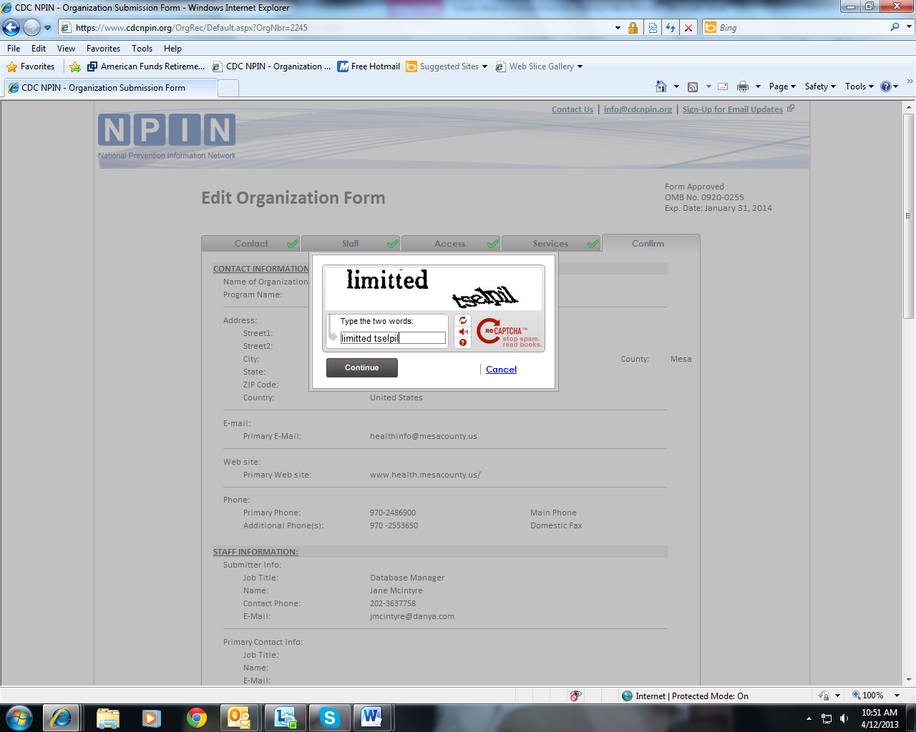
Recaptcha is used as a security precaution. Users must enter the displayed terms.
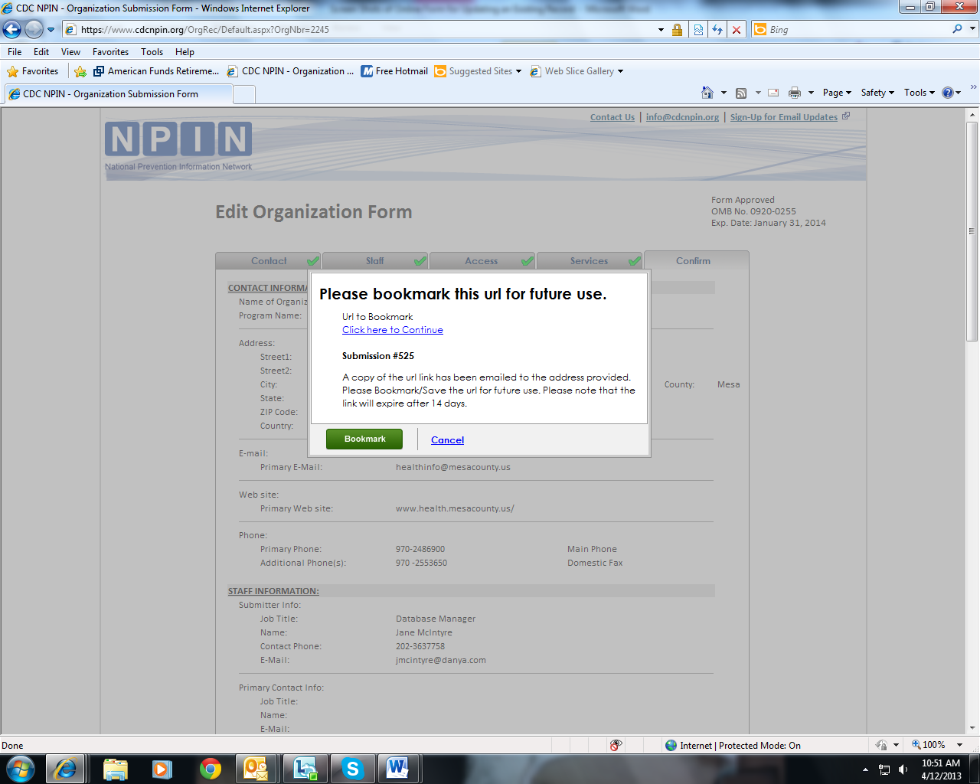
When a submission is Saved for Later, users receive a url to bookmark. This url will take them back to their incomplete form. They have 14 days to finish the submission form.
Once all information is correct, the user then clicks the Submit button to send the form to NPIN.
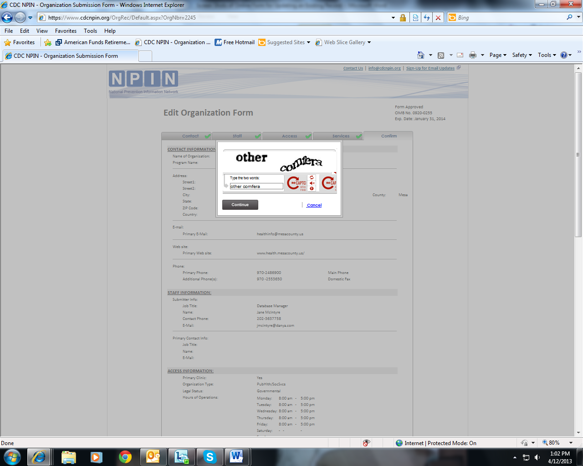
Again, Recaptcha is used as a security precaution before submission.
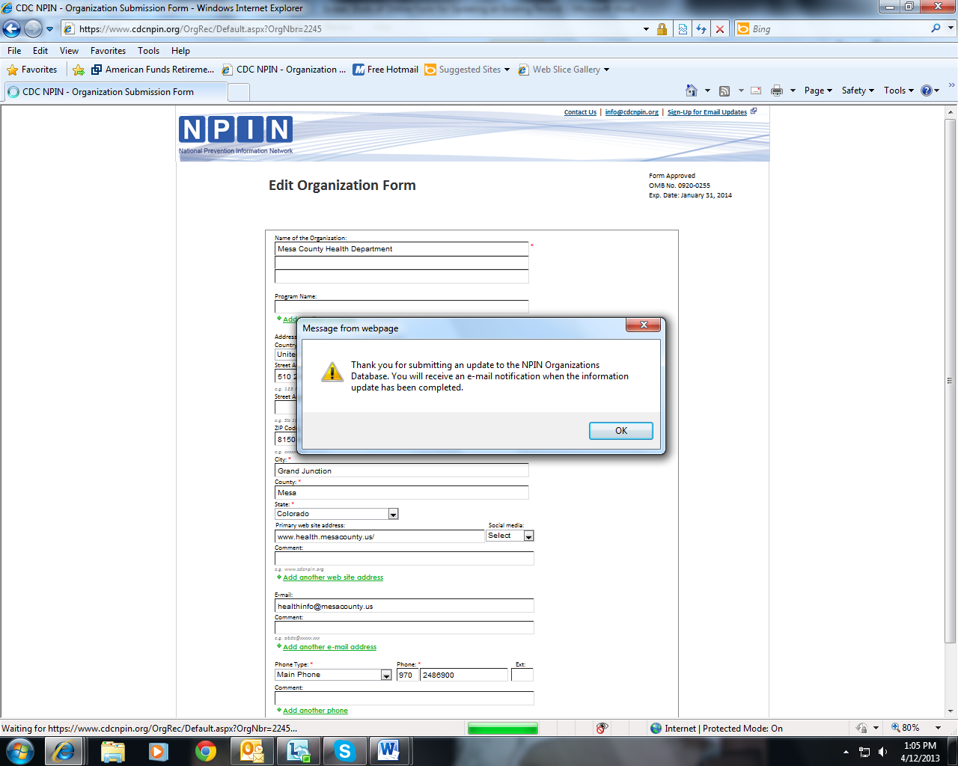
After the form is submitted, the user sees a message confirming the receipt of the form. Additionally, an e-mail notification is sent to the submitter confirming submission.

