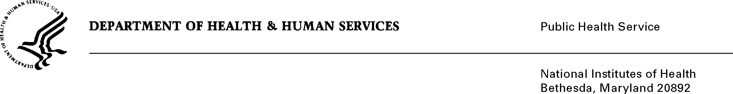

DATE: May 13, 2013

TO: Eileen Newman, M.S., R.D., Associate Director
National Institute of Diabetes and Digestive and Kidney Diseases

FROM: NIH Privacy Act Officer

SUBJECT: Applicability of the Privacy Act: “Evaluation of a Kidney Disease Education and Awareness Program in the Hispanic Community”

The National Kidney Disease Education Program (NKDEP), NIDDK, is planning an evaluation of a Kidney Disease Health Education Program for the Hispanic Community. The purpose of the evaluation is to inform NKDEP on whether quantitative and qualitative instruments and the intervention will be effective in educating the Hispanic community on a national level about the behavior changes needed to identify and manage chronic kidney disease. Draft materials and training guides will be revised and finalized for delivery and used to evaluate the change in the knowledge, awareness and behavior of the clients and promotores (Spanish speaking community health workers). Results of the information collected will enable NKDEP to 1) identify weaknesses or areas of the overall training program that are ineffective, 2) determine if the training curriculum and content achieves the desired results, 3) if the clients understand and receive the information as intended, and 4) if the promotores appropriately facilitate and lead the training program.

Research Works/Ogilvy will support NIDDK under contract. They will obtain a list of interested clients who have diabetes, randomly select participants in both NY and CA, obtain informed consent verbally or in writing, and store name and contact information (i.e., address, phone) on password protected computers and in locked file cabinets, separate from the test results. A patient ID number will be assigned to the participants. The key that links the patient ID to the participants as well as the signed and verbal informed consent documents will be stored separately for use in retrieval. The data received by NIDDK will only include de-identified data.
The applicable NIH Privacy Act Systems of Record Notice is 09-25-0156 entitled Records of Participants in Programs and Respondents in Surveys Used to Evaluate Programs of the Public Health Service, HHS/PHS/NIH/OD.

If you have questions, contact me at (301) 402-6201.

Karen M. Plá
Enclosure

cc: NIDDK Project Clearance Liaison Officer (w/o enclosure)

