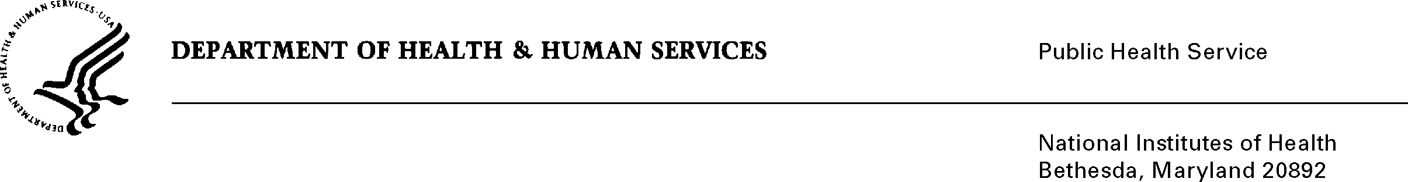

**DATE:** August 19, 2013

**TO:** CAPT Michael Montello, Pharm. D., MBA

Cancer Therapy Evaluation Program, OIB, NCI

**FROM:** NIH Privacy Act Officer

**SUBJECT:** Applicability of the Privacy Act: NIH NCI Central Institutional Review Board (CIRB) Initiative

The NCI CIRB initiative utilizes the time and expertise of board members who are representatives of the oncology community outside the NCI to review Cancer Therapy Evaluation Program sponsored studies. It provides a centralized and cost efficient approach to human subject protection by avoiding duplication of effort at each research institution.

The initiative consists of three central Institutional Review Boards (late phase emphasis, adult early phase emphasis, and pediatric). I reviewed the submission and forms/worksheets to be completed by board members and institutions. The information is needed to ensure that no CIRB member can unduly influence the approval of a study when there is an appearance of conflict due to professional or personal relationships such as financial gain or professional growth.

I have determined the Privacy Act will apply to this data collection, which includes the collection of personally identifiable information (PII) such as name, address, telephone numbers, email address, Social Security Number, bank and financial information, employment information, and educational level. The CIRB system was designed to request members provide profile and other information in the areas of application, enrollment, membership, review, direct deposit and customer satisfaction. The data will be stored within the system indefinitely as legacy data for review and analysis of CIRB activities. Individual names and other identifiers will be combined for all participants and reported as summaries. Institution names will appear when enrollment and study involvement is referenced.

The data collection is covered by NIH Privacy Act Systems of Record 09-25-0200, “Clinical, Basic and Population-based Research Studies of the National Institutes of Health (NIH), HHS/NIH/OD.”

If you have any questions, please contact my office at (301) 496-2832.

Karen M. Plá

Enclosure