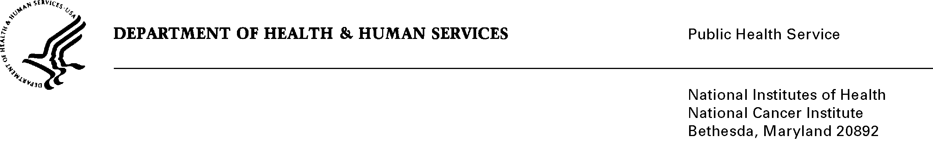
Date: November 7, 2013

TO: Office of Management and Budget (OMB)

Through: Keith Tucker, Report Clearance Officer, HHS
Seleda Perryman, Project Clearance Officer, NIH
Vivian Horovitch-Kelley, PRA Clearance Liaison, NCI

FROM: Michael Montello, Cancer Therapy Evaluation Program (CTEP)
National Cancer Institute/NIH

SUBJECT: Revision for NIH NCI Central Institutional Review Board (CIRB) Initiative (NCI)
(OMB No. 0925-0625, Expiration Date: 1/31/2014).

This is a request for OMB to approve the revision of, “NIH NCI Central Institutional Review Board (CIRB) Initiative (NCI)” for 3 years. The National Cancer Institute (NCI) Central Institutional Review Board (CIRB) provides a centralized approach to human subject protection and provides a cost efficient approach avoiding duplication of effort at each institution. The CIRB provides services of a fully constituted IRB and provides a comprehensive and efficient mechanism to meet regulatory requirements pertaining to human subject protections including initial and continuing reviews, review of amendments, and adverse events.

The Initiative consists of three central IRBs: Adult CIRB – late phase emphasis, Adult CIRB – early phase emphasis, and Pediatric CIRB. CIRB membership includes oncology physicians, surgeons, nurses, patient advocates, ethicists, statisticians, pharmacists, attorneys and other health professionals. The benefits of the CIRB Initiative reaches research participants, investigators and research staff, Institutional Review Boards (IRB), and Institutions. Benefits include: study participants having dedicated review of NCI-sponsored trials for participant protections, access to more trials more quickly and access to trials for rare diseases, accrual to trials begin more rapidly, ease of opening trials, elimination of need to submit study materials to local IRBs, and elimination of the need for a full board review. The benefits to the National Clinical Trials Network and Experimental Therapy-Clinical Trials Network include a cost efficient approach that avoids duplication of efforts at each institution. A variety of information collection tools to support NCI’s CIRB activities which include: worksheets, forms and a survey that is provided to all customers contacting the CIRB helpdesk.

In 2012, the NCI conducted a pilot program (OMB No. 0925-0046) to change the model for the CIRBs to that of an independent model, which was well accepted. This independent model is now the NCI CIRB operating model and all current members of the NCI CIRB will be transitioned over to the new model during 2013. With the evolving initiative, project efficiencies have been implemented including revised forms with more direct questions and board specific forms/worksheets. Although there has been an increase in the number of forms due in part to the new model and adding of a new board and the number of respondents (from 5,044 to 6,085 respondents; an increase of 1,181 respondents), the total burden has actually decreased by 121 hours (from 2,210 hours to 2,199 hours).

