**Screen Shots Submission Flow**

The screen shots below illustrate the workflow (submission + Attestation) of a user uploading a file containing general payments records.

**File Upload-General Payments**

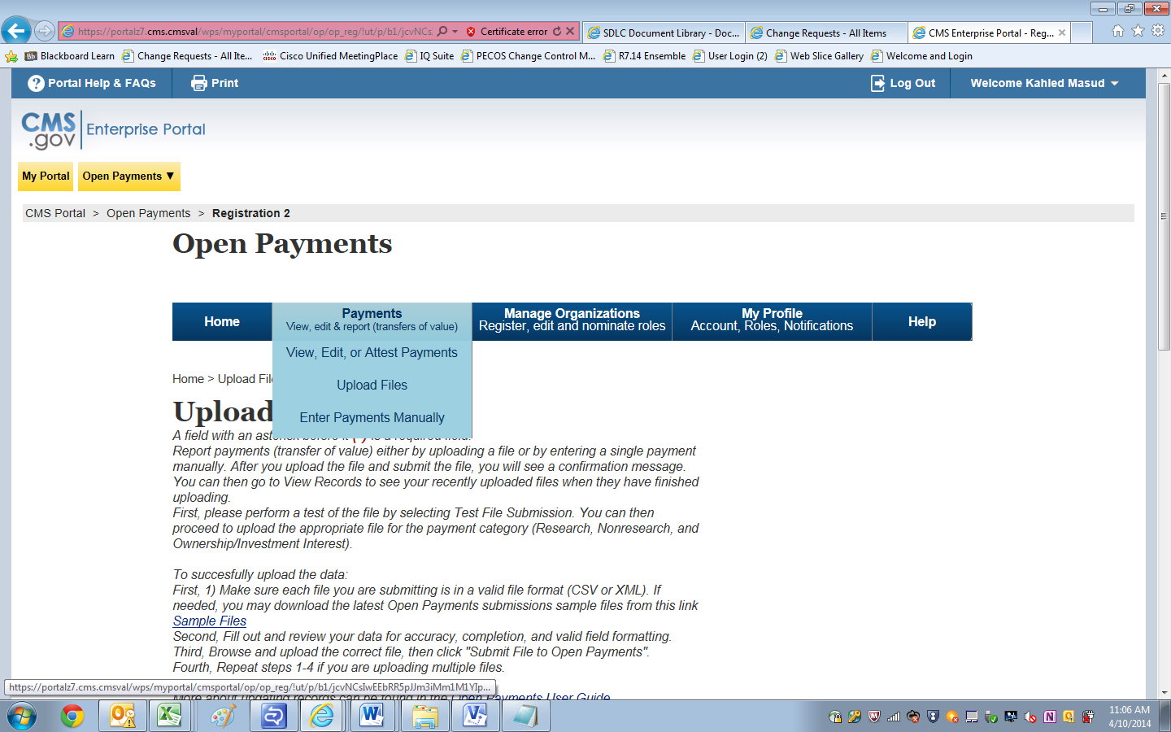

**Select criteria for file upload**

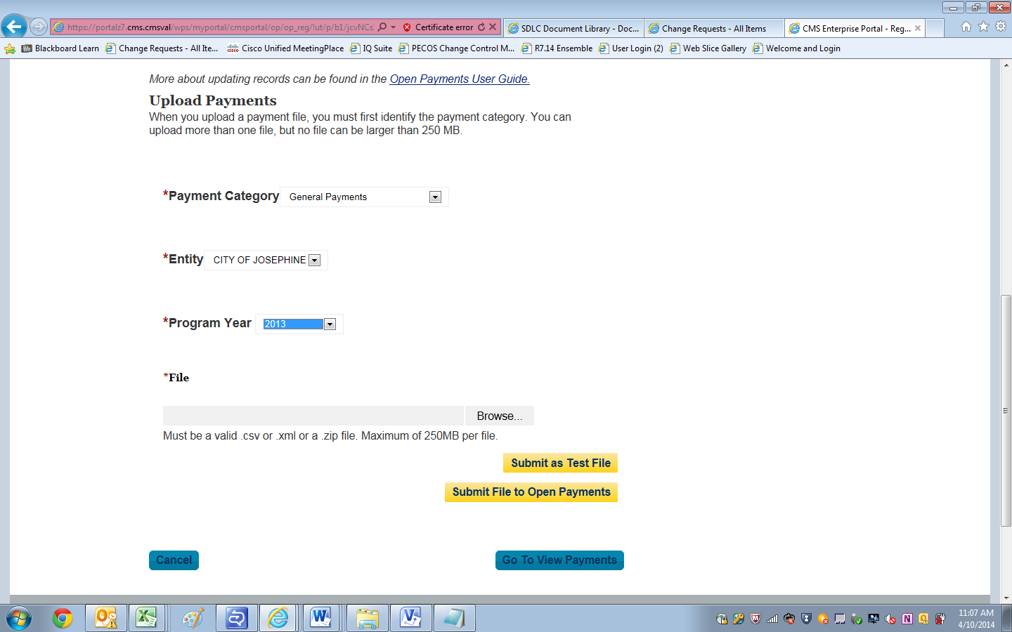

**Successful File Upload**

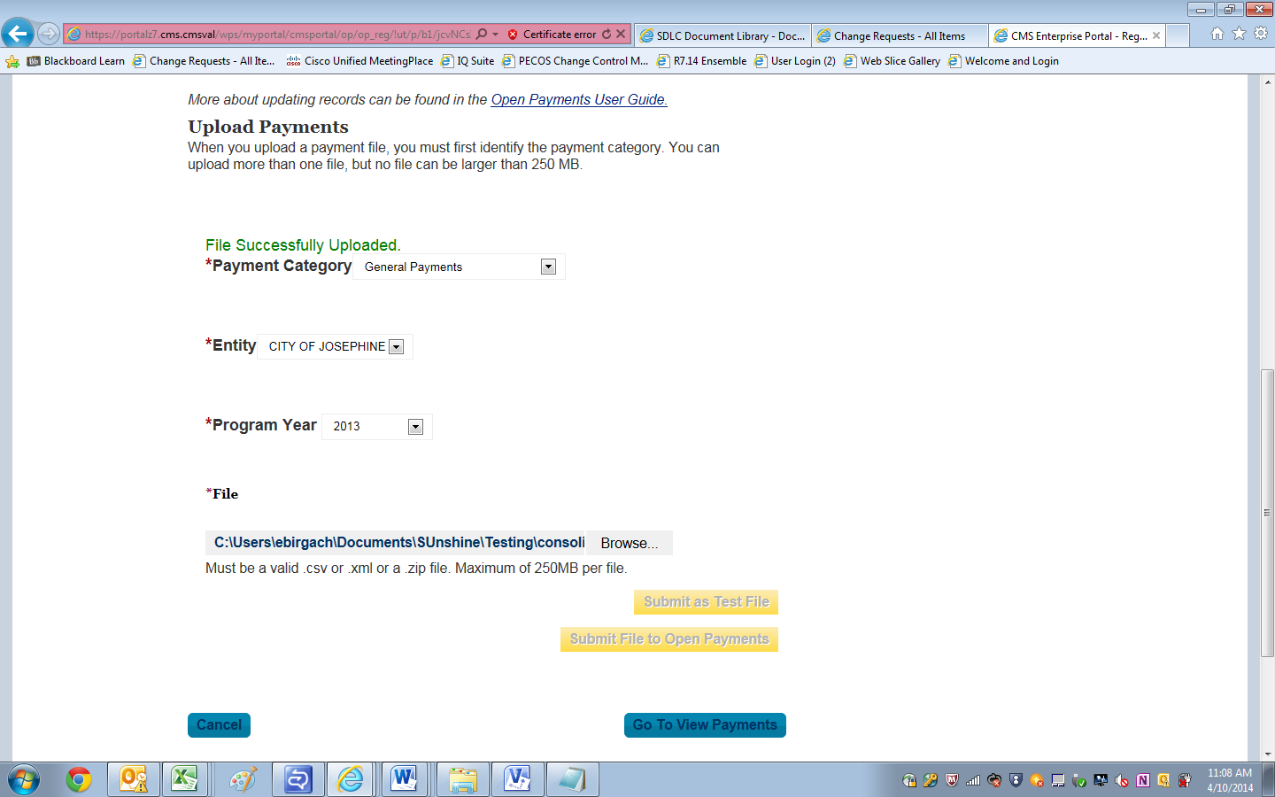

**Payments passed file level validation check and ready for FINAL Submission**

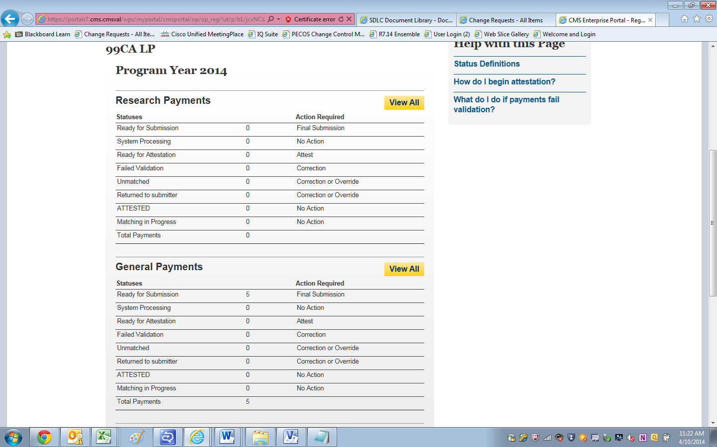

**Final Submission Button Enabled for final Submission**

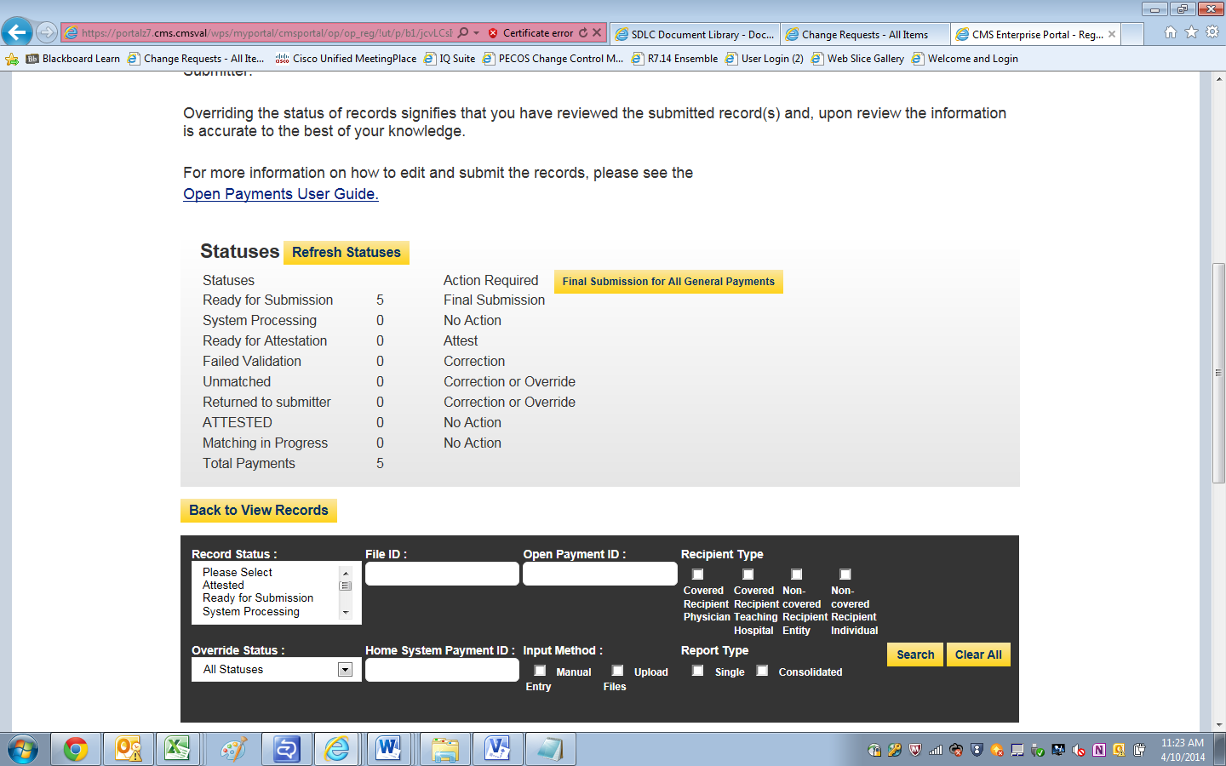

**Final Submission Confirmation**

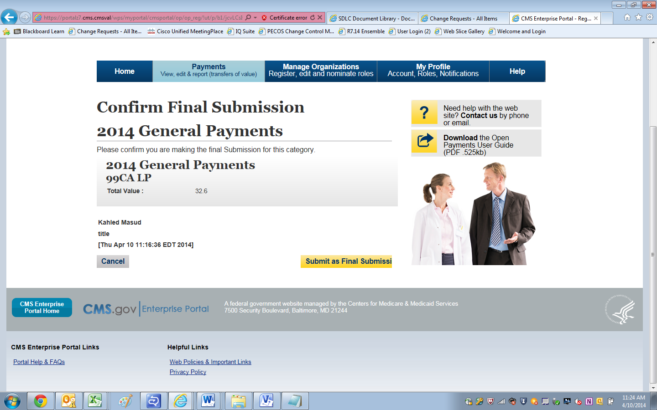

**Post Final Submission Confirmation**

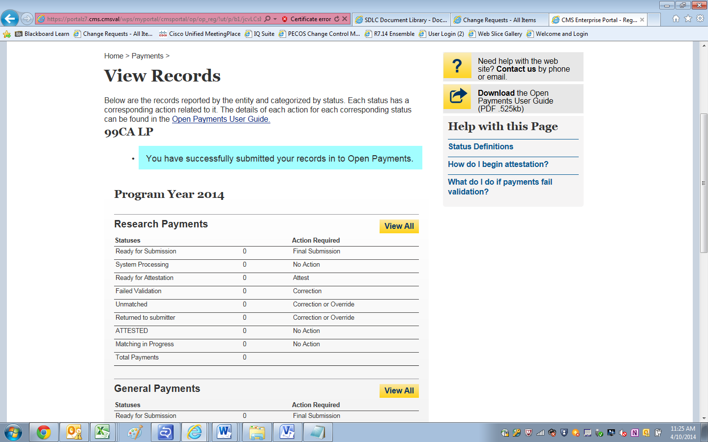

**Begin Attestation**

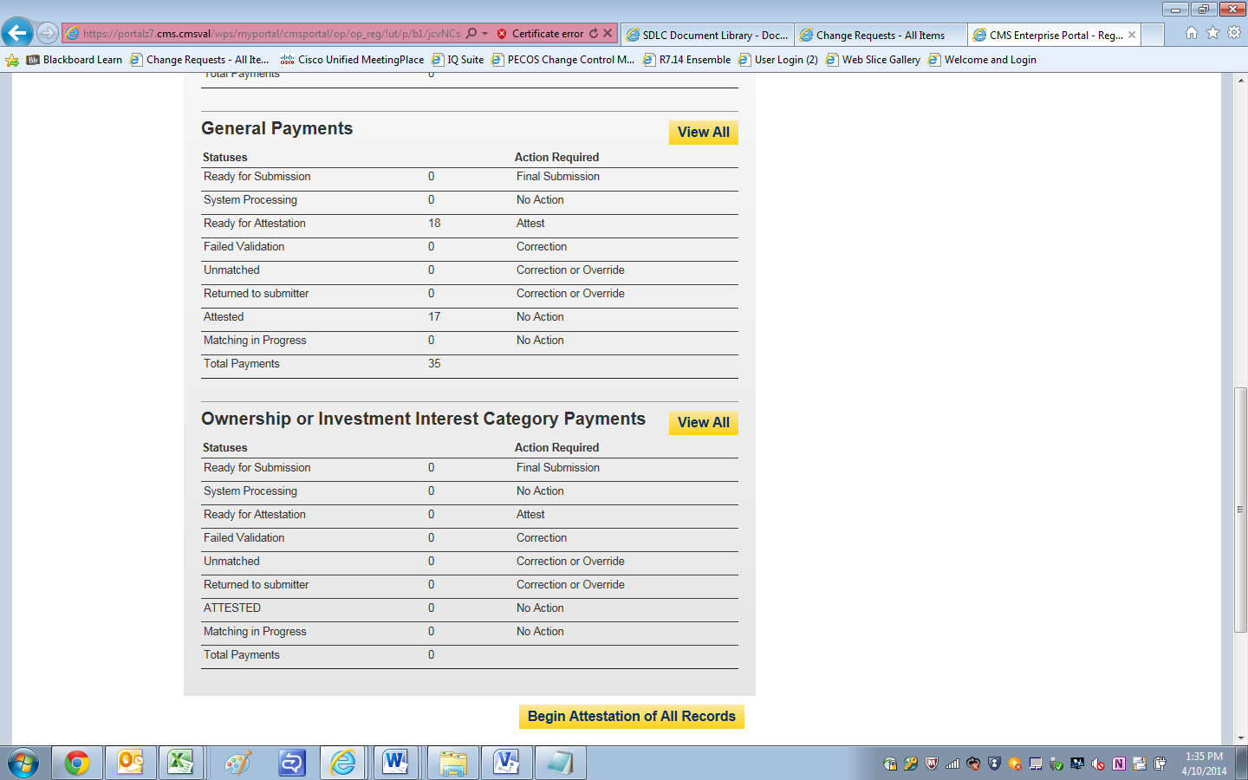

Attestation-Confirm Payments

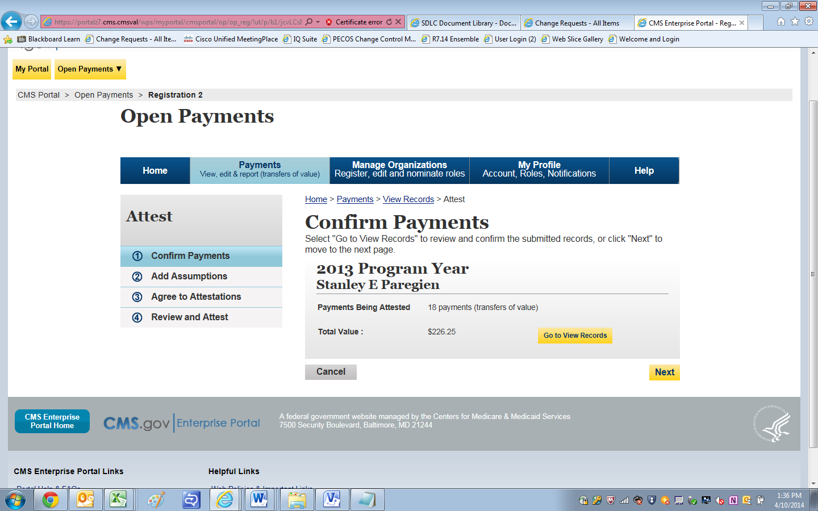

Add Assumptions Yes/No?

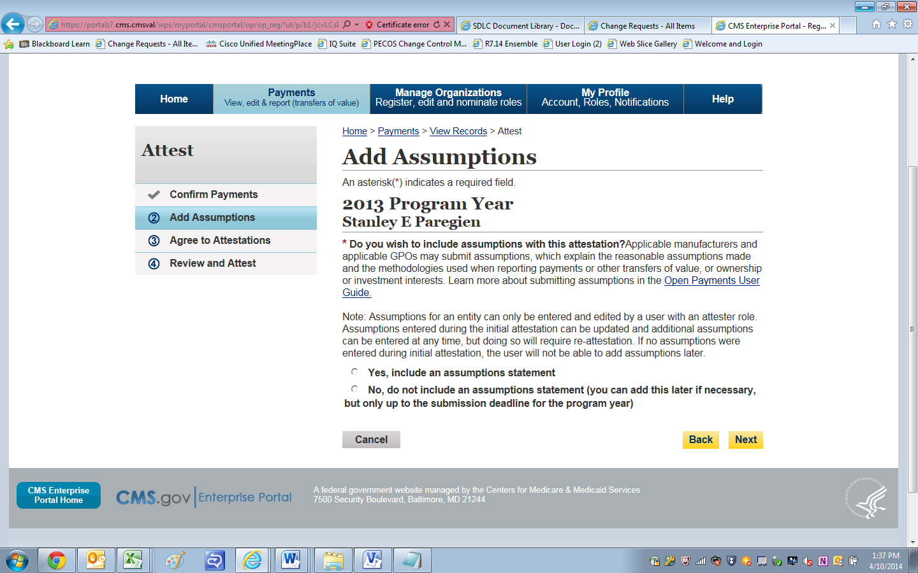

Add Assumptions- Yes workflow

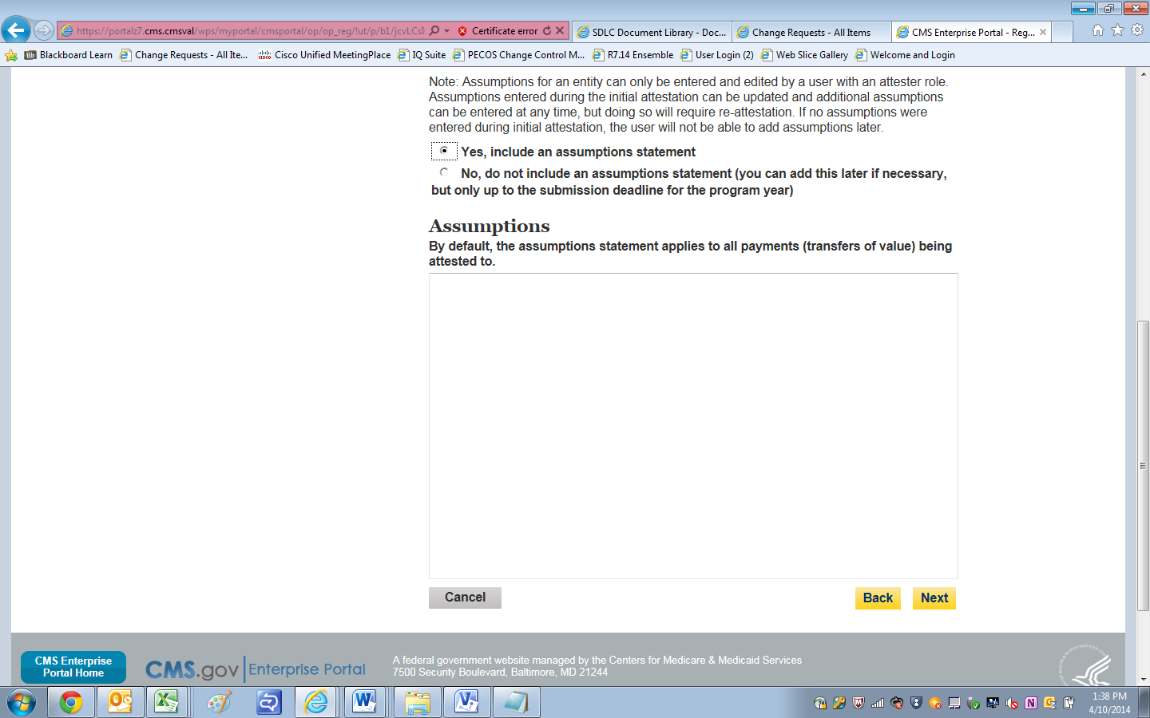

Assumptions Added

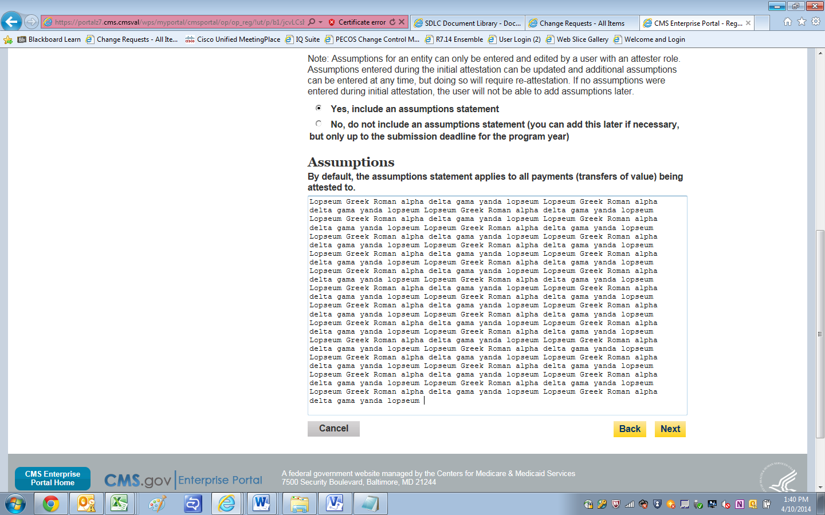

Agree To Attestation

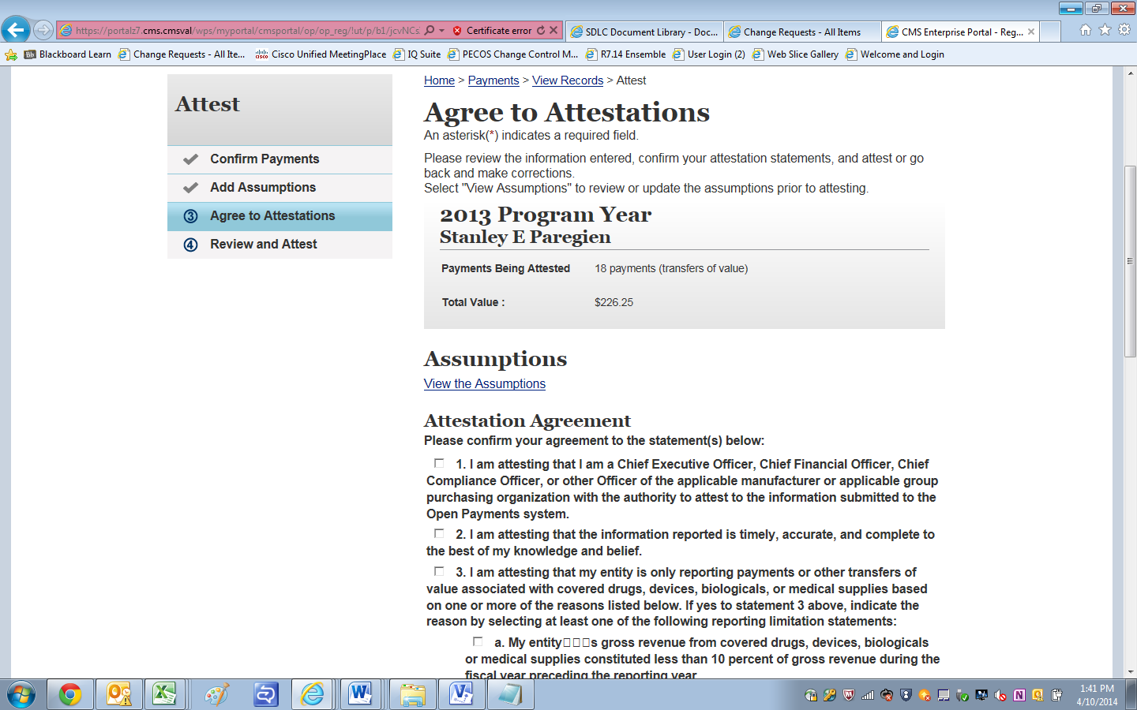

Agree to Attestation_Cont

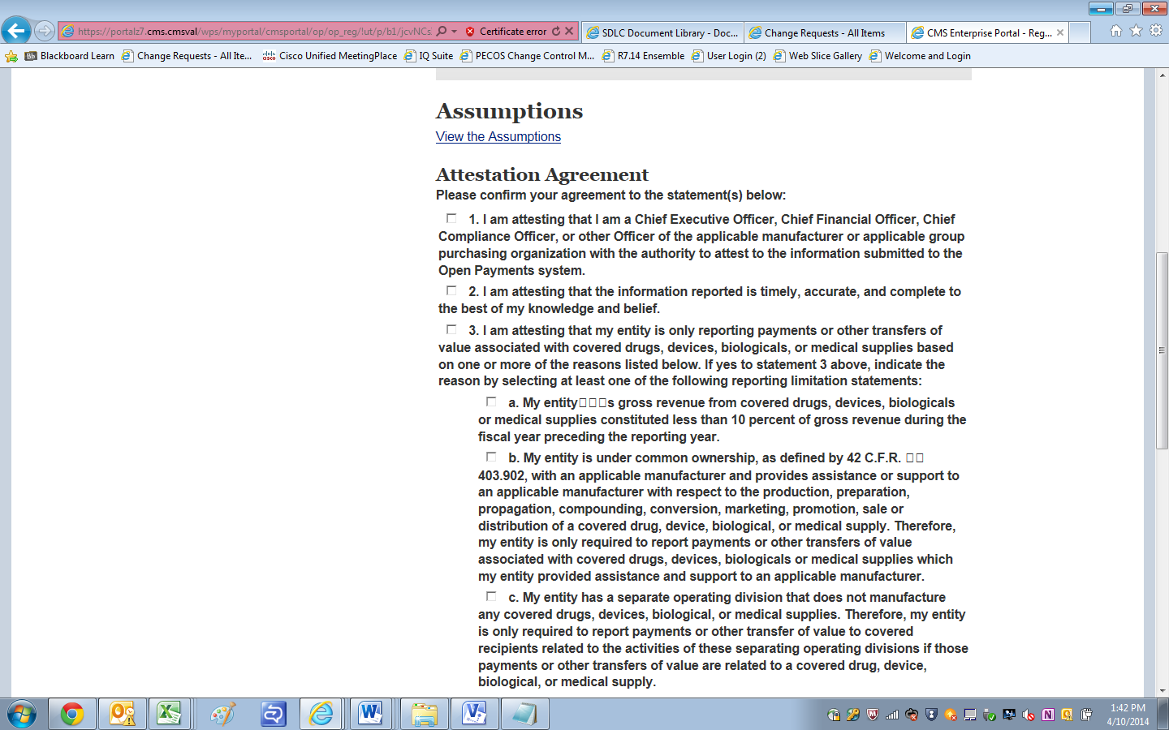

Agree to Attestation_Cont

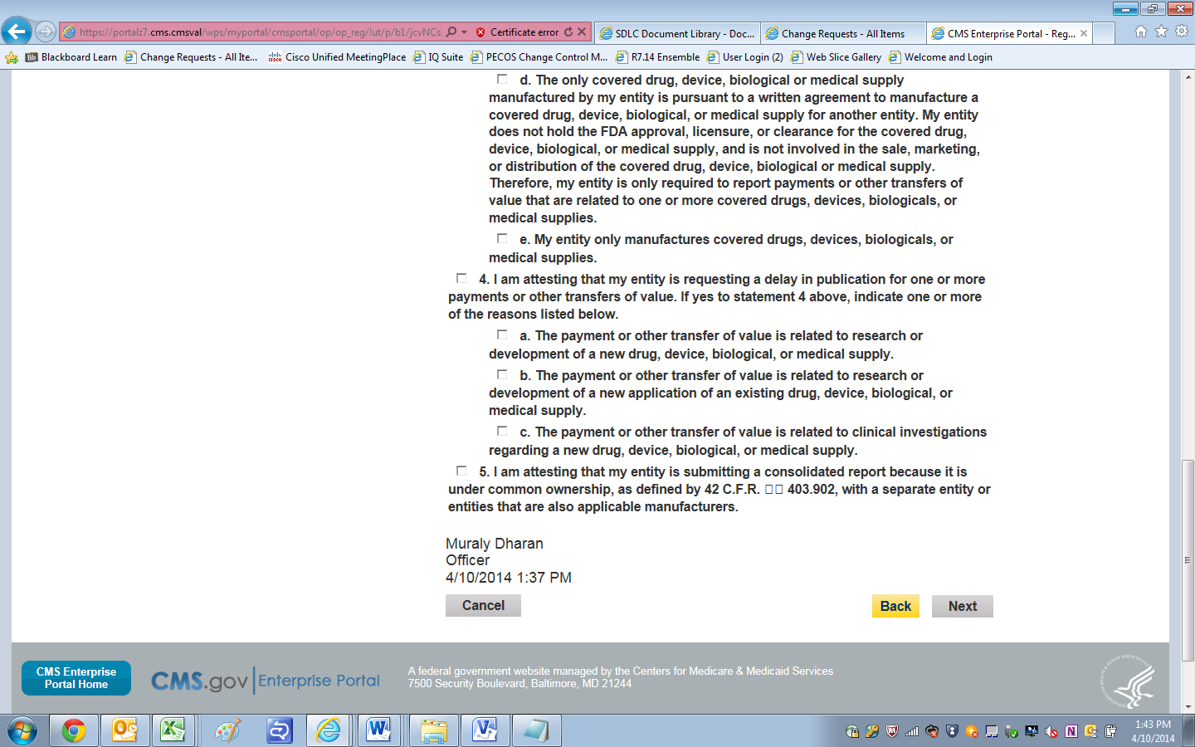

Review and Attest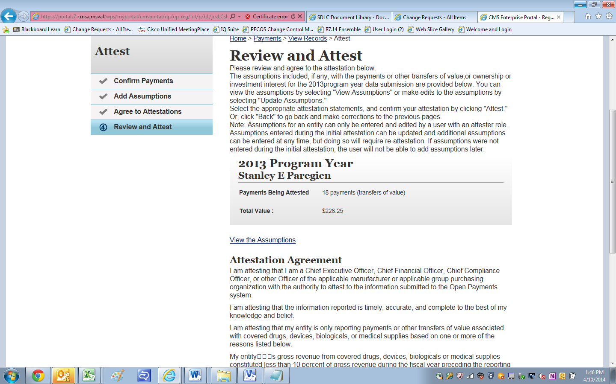

Review and Attest

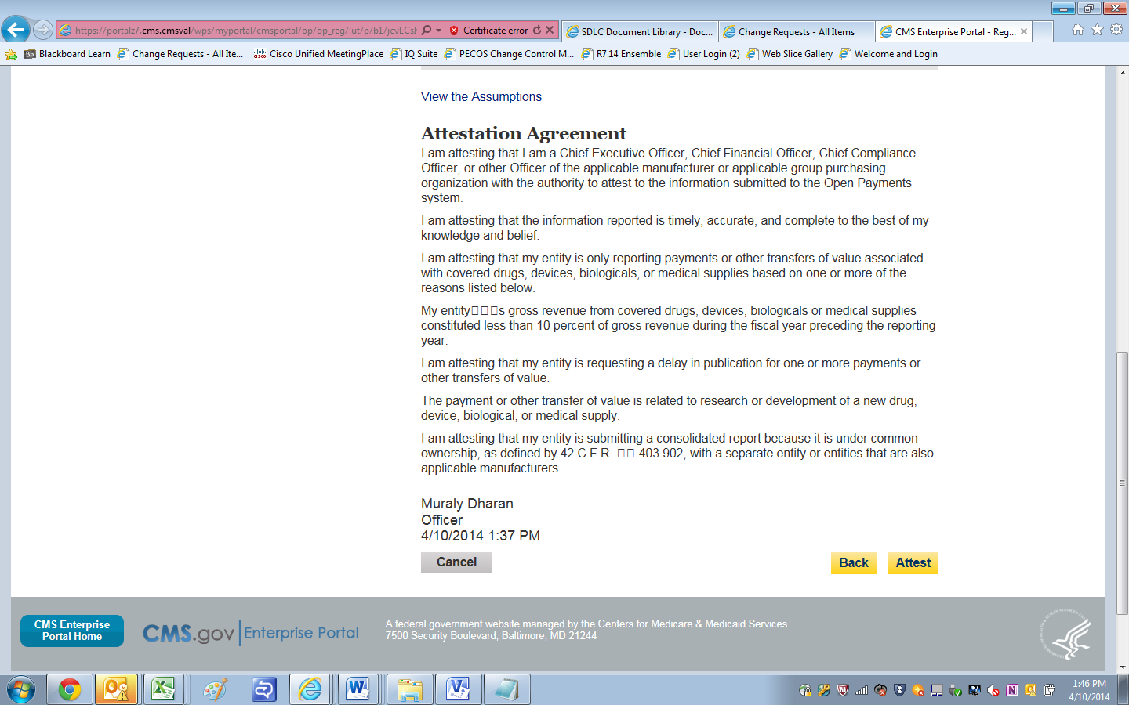

Records shown as attested

