Propagated i3368 questions into the path on Identification with read only answers PIN001-1
(First Party Contact Information screen)
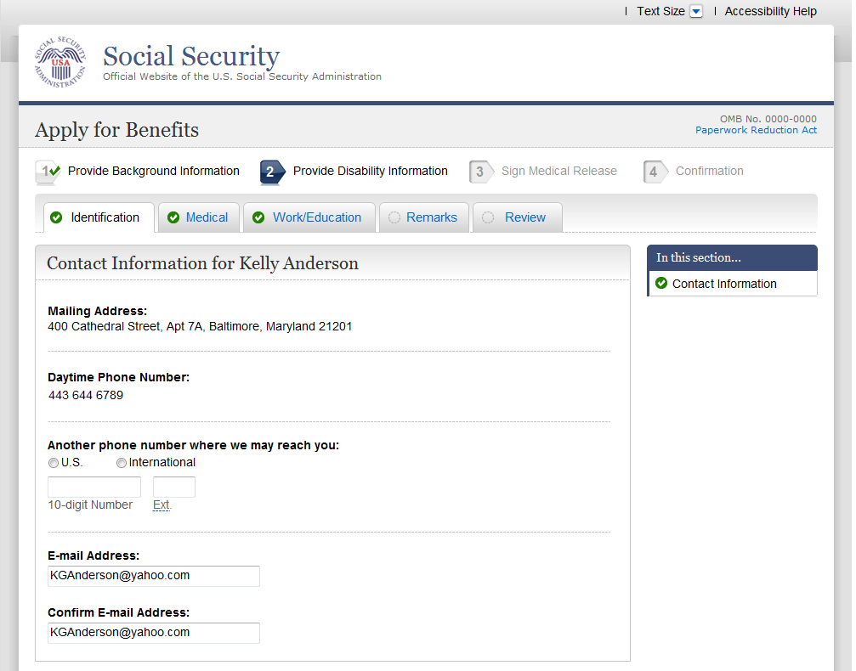
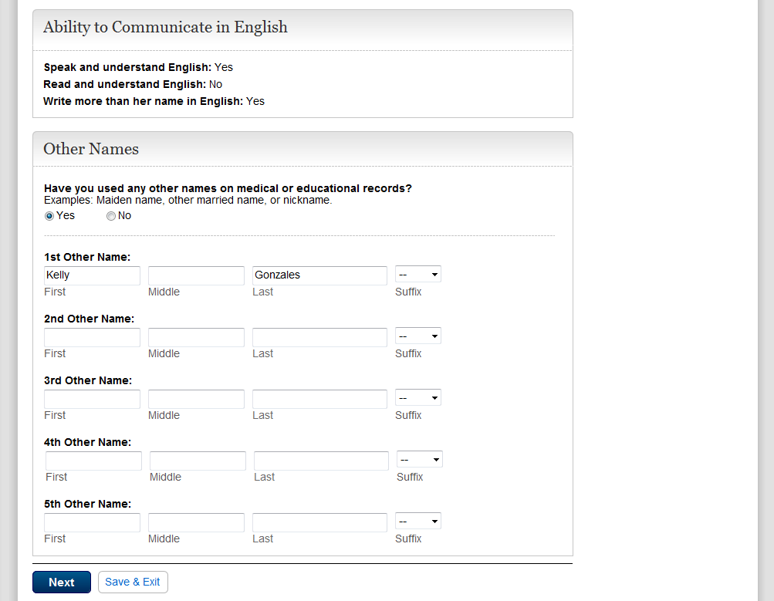
Propagated i3368 questions into the path on Identification with read only answers PIN001-3
(Third Party Contact Information screen)
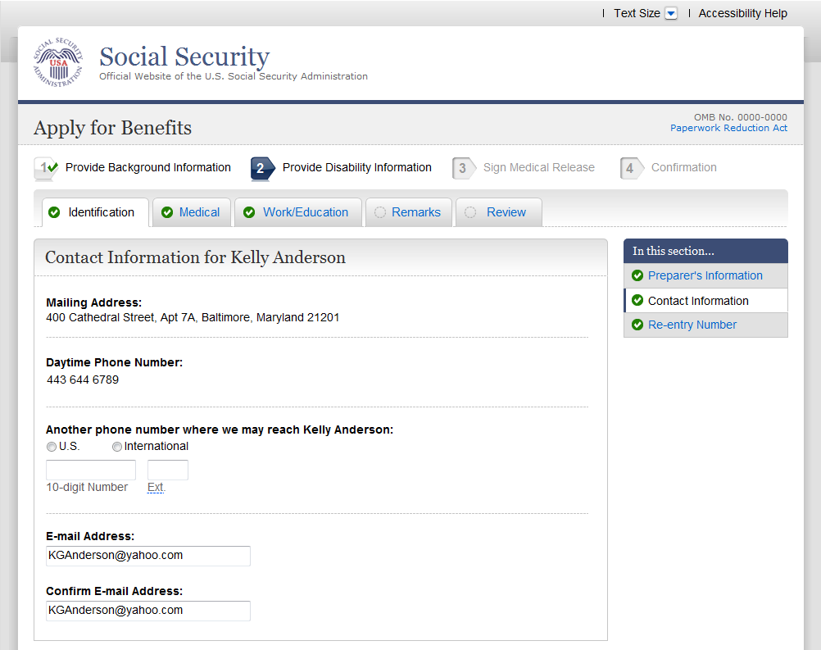
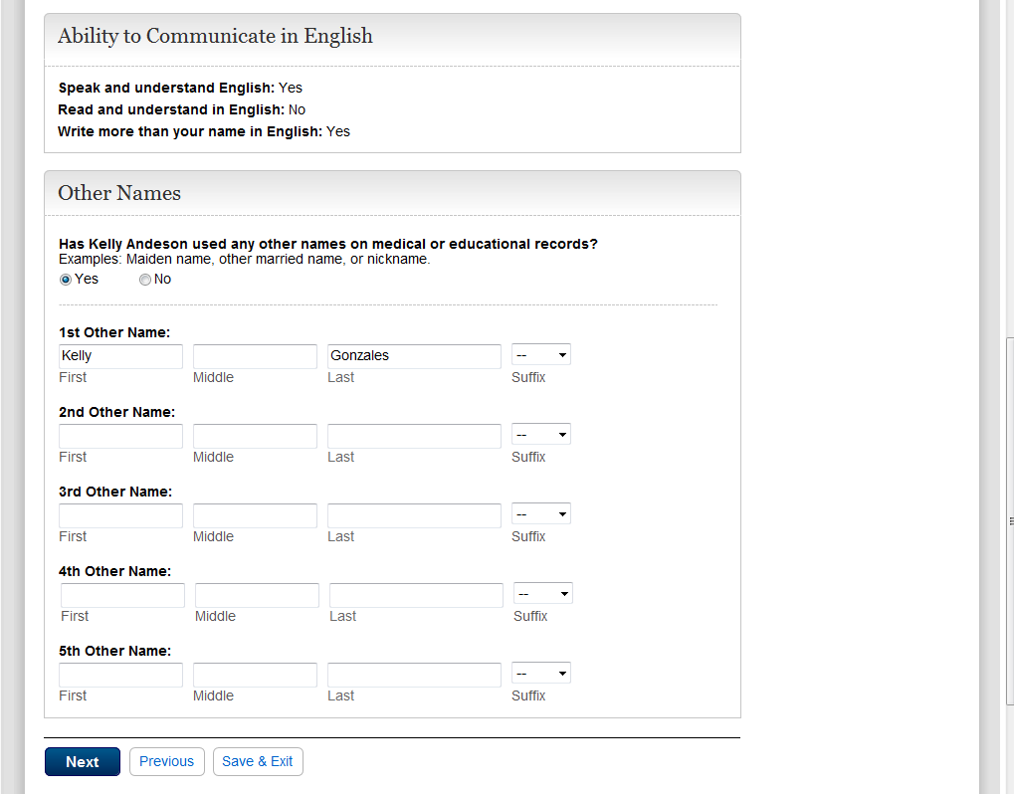
Language questions removed from Education and Training page EDU001-01
(First Party Education screen)
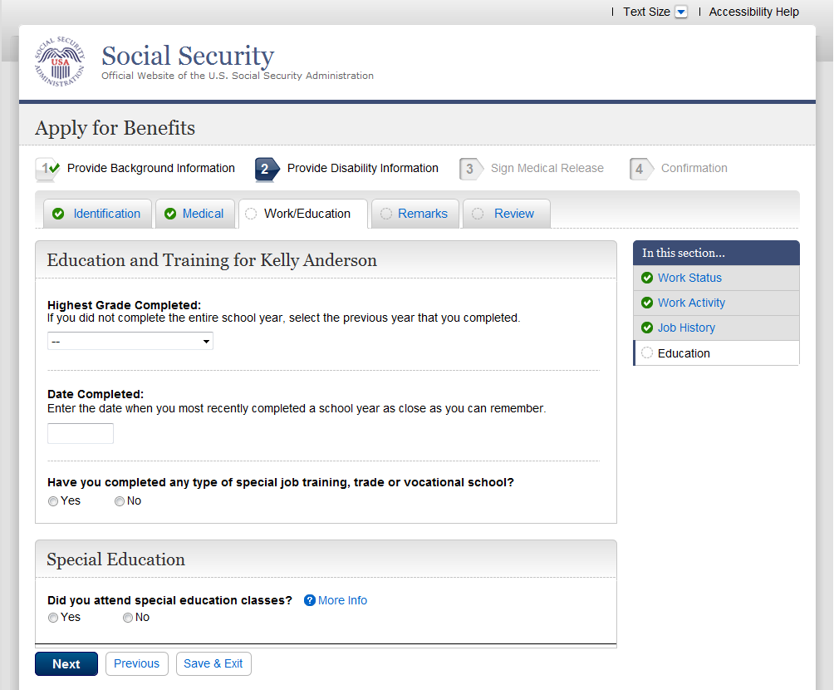
Language questions removed from Education and Training page EDU001-03
(Third Party Education screen)

